**Practical 1 : Installation of Ubuntu and NS3**

**Networking with Linux**

**In this we are going to learn network topology logical working using NS-3 and Wireshark simulator.**

**This simulator nothing but software model in analogus to hardware working of network.**

**For. Transmission of Packet over Network node shown in NS-3 GUI window.**

**To download NS-3 refer below website**

[**https://www.nsnam.org/**](https://www.nsnam.org/)

[**https://www.nsnam.org/**](https://www.nsnam.org/)

**Step 1.**

**On Ubuntu Terminal type command**

**sudo apt update**

**Step 2. After fetching latest package install it**

**command is**

**sudo apt install**

**Step 3. After installation upgrade Ubuntu**

**command is**

**sudo apt upgrade**

**Step 4. To Install C++ complier in Ubuntu then follows following command**

**sudo apt-get install build-essential**

**Step 5 : To install Python compiler use following command**

**sudo apt-get install python python-dev**

**Step 6: To install Mercurial means animation and NS3 supported package use following commands**

**sudo apt-get install mercurial**

**Step 7 : To unzip file install supported package**

**command is**

**sudo apt-get install bzr**

**Step 8: to install TCPDUMP for pcap trace file reading support use following command**

**sudo apt-get install tcpdump**

**Step 9: to Generate XML supported file to be readble file external simulator API use the following command**

**sudo apt-get install libxml2 libxml2-dev**

**Step 10: Unzip the NS3 package**

**we have command**

**tar xjf ns-allinone3.32.tar.bz2**

**Step 11 : To compile all the package in ns-3.32 execute following command**

**./waf configure --enable-examples –enable-tests**

**Step 12 : To run our simulator then every classess must be compile . Use the following command**

**./waf –-run hello-simulator**

**After executing above commands then output will “ Hello Simulator” then assume that all NS3 API are in executable code of Operating System.**

$

$

$

$

$

cd

mkdir workspace

cd workspace

wget <https://www.nsnam.org/release/ns-allinone-3.32.tar.bz2>

tar xjf ns-allinone-3.32.tar.bz2

Notice the use above of the wget utility, which is a command-line tool to fetch objects from the web; if you do not

have this installed, you can use a browser for this step.

Following these steps, if you change into the directory ns-allinone-3.32 , you should see a number of files and

directories

$ cd ns-allinone-3.32

$ ls

bake

constants.py

build.py netanim-3.108

ns-3.32

pybindgen-0.21.0

README

util.py

You are now ready to build the base ns-3 distribution and may skip ahead to the section on building ns-3.

Now go ahead and switch back to the debug build that includes the examples and tests.

$ ./waf clean

to compile all API classes use following commands

$ ./waf configure --build-profile=debug --enable-examples –enable-tests

if you don’t see the “Hello Simulator” output, type

the following:

$ ./waf configure --build-profile=debug --enable-examples –enable-tests

and ten type command

./waf configure –enables-examples

and

./waf --run hello-simulator

**Practical 2: List of Packages for Installing ns-3 in Ubantu/Mint Systems**

Perquisite for installing NS3.32

1. sudo apt upgrade

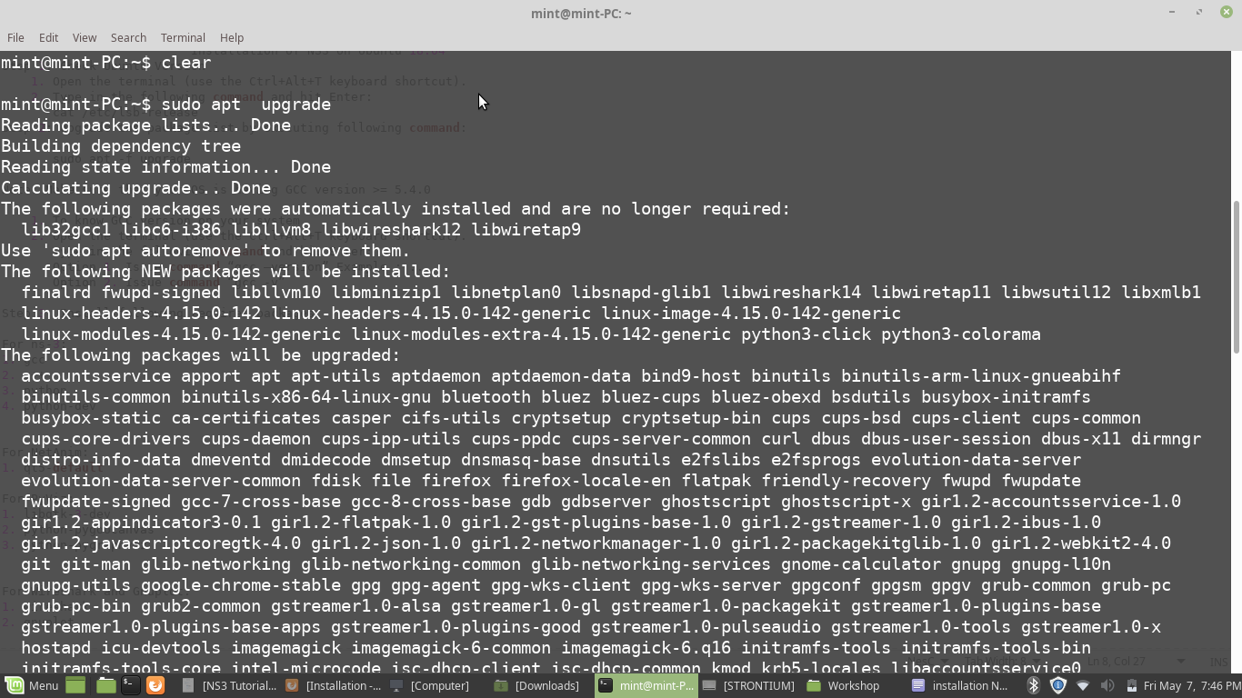

1. Sudo apt update

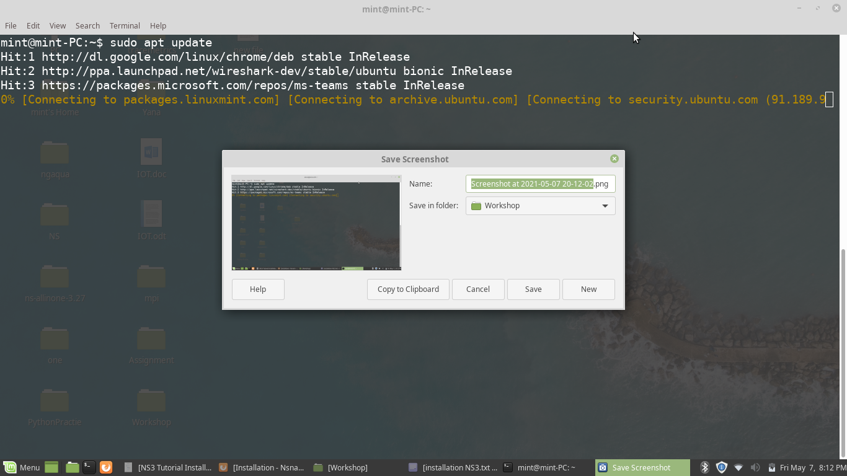

1. **Minimal requirements for C++ users**

apt-get install g++ python3

1. **Minimal requirements for Python API users**

apt-get install g++ python3 python3-dev pkg-config sqlite3

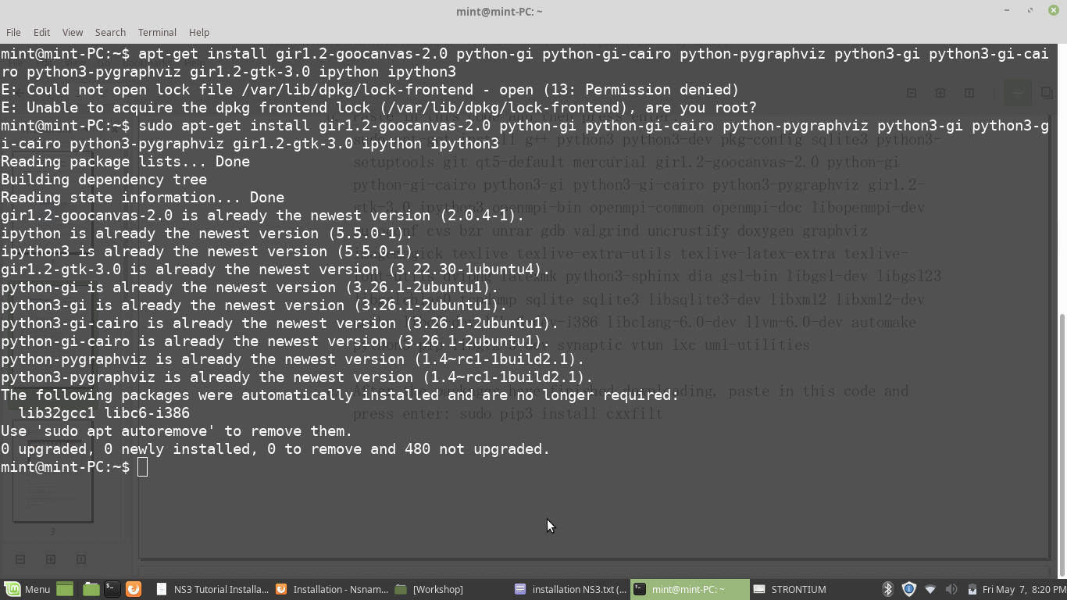

1. **Netanim animator:** qt5 development tools are needed for Netanim animator;

apt-get install qt5-default mercurial

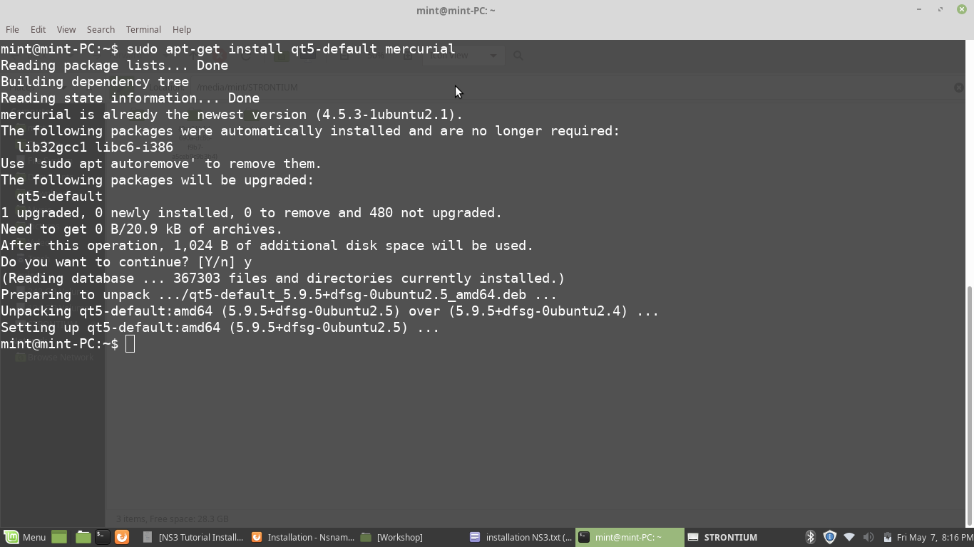

1. **ns-3-pyviz visualizer**

apt-get install gir1.2-goocanvas-2.0 python-gi python-gi-cairo python-pygraphviz python3-gi python3-gi-cairo python3-pygraphviz gir1.2-gtk-3.0 ipython ipython3



1. **Debugging:**
2. apt-get install gdb valgrind

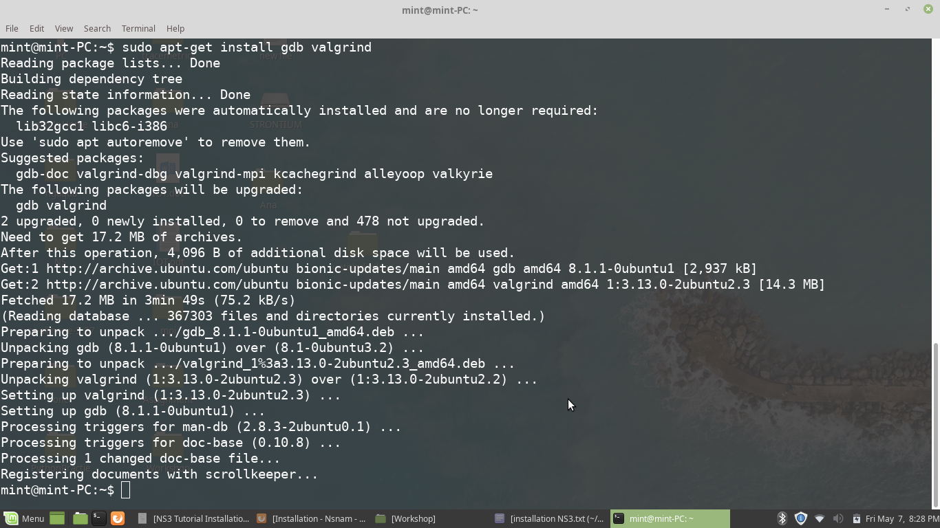

1. **Doxygen and related inline documentation:**

apt-get install doxygen graphviz imagemagick

apt-get install texlive texlive-extra-utils texlive-latex-extra texlive-font-utils dvipng latexmk

1. **The ns-3 manual and tutorial are written in reStructuredText for Sphinx (doc/tutorial, doc/manual, doc/models), and figures typically in dia (also needs the texlive packages above):**

apt-get install python3-sphinx dia

1. **To read pcap packet traces**

apt-get install tcpdump

1. **Support for generating modified python bindings**

apt-get install cmake libc6-dev libc6-dev-i386 libclang-6.0-dev llvm-6.0-dev automake python3-pip

python3 -m pip install -- user cxxfilt

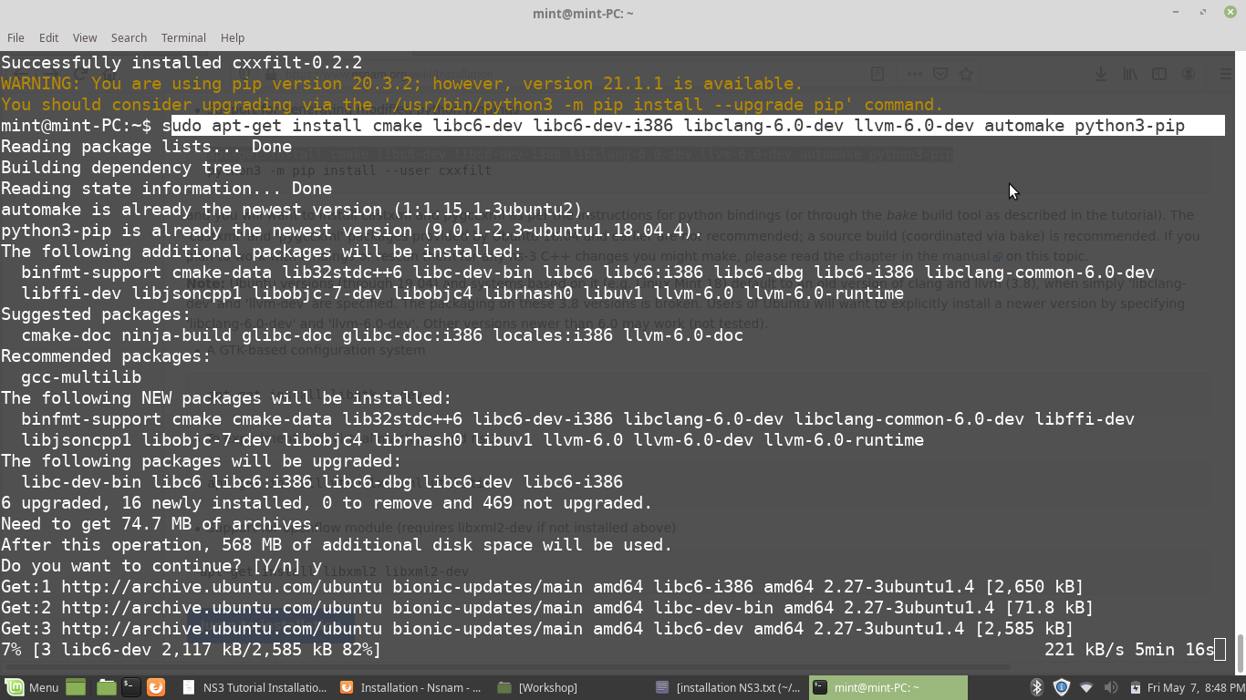

After installing the required packages, create a folder named **workspace** in the home directory and then put the NS3 tar package into the workspace.

Go to terminal and input these commands consecutively after each command finishes executing:

cd

cd workspace

tar xjf <name of NS3 downloaded file name>

cd <name of extracted NS3>

./build.py --enable-examples --enable-tests

It takes time be patient !!

Test the NS3 build and installation success by running test.py in the ns

directory using the following commands:

cd ns-<version number>./test.py

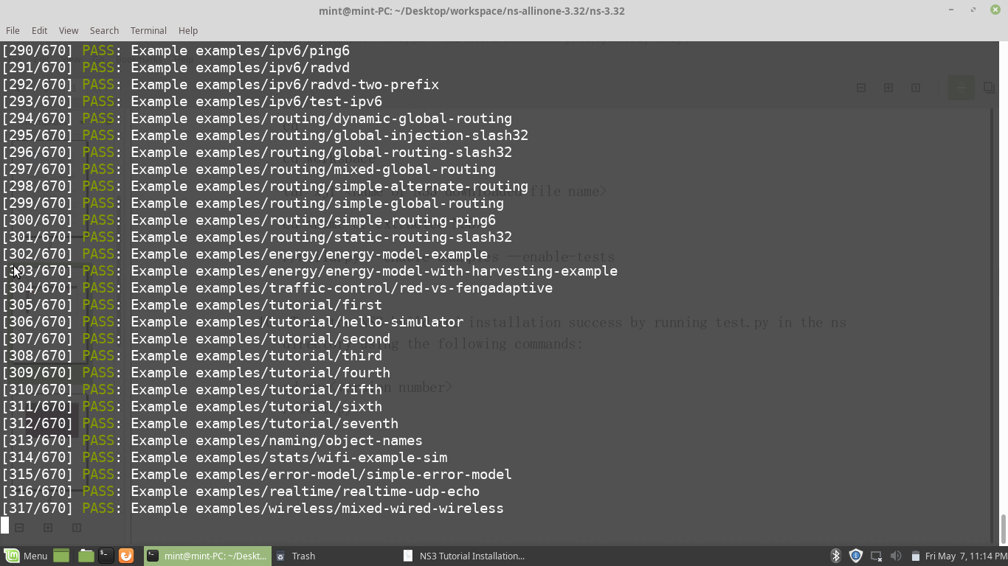

Practical 3: Steps for Installing NetAnim and Wireshark Simulator

**Installation of NS3 on Ubuntu 18.04/Linux Mint 19**

**Step 1**: Check Ubuntu Version

1. Open the terminal (use the Ctrl+Alt+T keyboard shortcut).

2. Type in the following command and hit Enter:

cat /etc/lsb-release

**Step 2**: Upgrade the package list by executing following command:

sudo apt -f upgrade

Note: Make sure that your OS is having GCC version >= 5.4.0

1. To know GCC version on your system

2. Open the terminal (use the Ctrl+Alt+T keyboard shortcut).

Type in the following command and hit Enter:

Option 1. Issue command “gcc –version” Example : ...

Option 2. Issue command “gcc -v”

**Step 3**: Install following required packages:

For ns-3:

1. gcc

2. g++

3. python

4. python-dev

For NetAnim:

1. qt5-default

For PyViz:

1. libgtk-3-dev

2. python-pygoocanvas

3. python-pygraphviz

For Wireshark and Gnuplot:

1. wireshark

2. gnuplot

Command to install all these packages together:

sudo apt-get install gcc g++ python python-dev qt4-dev-tools libgtk-3-dev python-pygoocanvas python-pygraphviz wireshark gnuplot

**Step 4** : Download ns-allinone-3.27.tar.bz2 and unzip it. For unzip write following command.

tar -xvjf ns-allinone-3.27.tar.bz2

**Step 5** : Go to ns-allinone-3.27 folder and install ns3: Follow the bellow command to do so:

cd ns-allinone-3.27

./build.py --enable-examples –enable-tests

This command will install ns-3, NetAnim and PyViz. You will be having a list of built and unbuilt modules after successful installation.

**Step 6**: Once the installation completes, go to ns-3.27 and give the following command for testing the installation:

cd ns-allinone-3.27/ns-3.27/./test.py -c core

./waf –run hello-simulator

You are done!

Step 7: To install the Wireshark

ns-allinone-3.32$sudo apt-get install wireshark

Step 8: To install GNUplot

ns-allinone-3.32$ sudo apt-get gnuplot

Note :

1. Minimal requirements for C++ users

sudo apt-get install g++ python3

2. Minimal requirements for Python API users

sudo apt-get install g++ python3 python3-dev pkg-config sqlite3

3. NetAnim animator : - qt5 development tools are needed for NetAnim animator

sudo apt-get install qt5-default mercurial

Practical 4: **Configure NetAnim Simulaor**

Prerequests : [**NS3 Installation on Ubuntu 1804**](http://homepages.rpi.edu/home/36/wangy52/public_html/PersonalWebsite/build/html/Network/NS/NS3/NS3-installation/NS3-installation-Ubuntu.html#ns3-installation-ubuntu)

 Related folders and files in this document

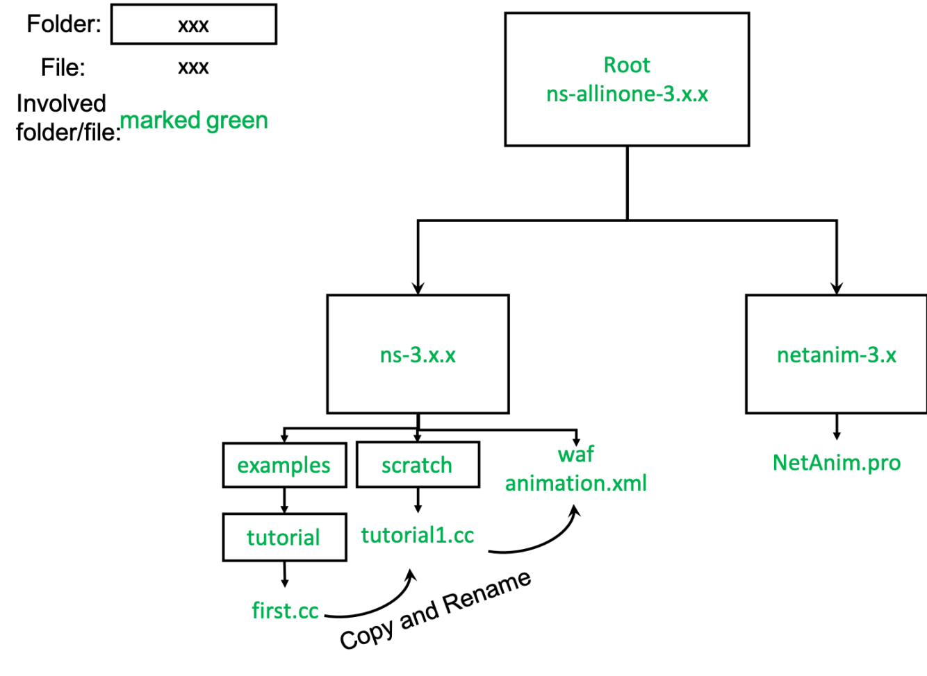

 Configure NetAnim

*# Go to NS3 All-in-one folder and go further into NetAnim folder*

cd ns-allinone-3.30.1/netanim-3.108/

*#*

sudo apt-get install make -y

*# clean the source code, qmake and then make*

make clean

qmake NetAnim.pro

make

Now, NetAnim is ready to use.

 Run Tutorial Examples

Pay attention to the name of the file

*# go to ns3-30.1 examples*

cd .. *# now we are at ns-allinone-3.30.1/*

cd ns-3.30.1/examples/tutorial

*# instead of ruining the example, we copy it to scratch/ Note that, you cannot change the folder unless you have configured the path*

*# Also, you should not reuse the name "first", because NS3 will find out first.cc or first.py instead of your file.*

*# here we use tutorial1.cc*

cp first.cc ../../scratch/tutorial1.cc

cd ../../scratch/

*# use your favourite code editor to edit the first.cc file.*

*# I use vscode.*

 Add Code for NetAnim

1. Add the header file

#include “ns3/netanim-module.h”

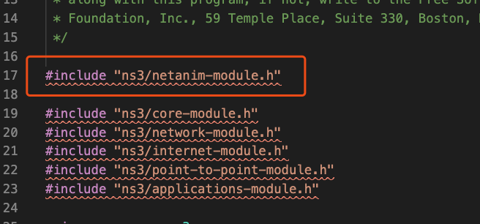

1. Add the following statement before Simulation::Run()

AnimationInterface anim (“animation.xml”);

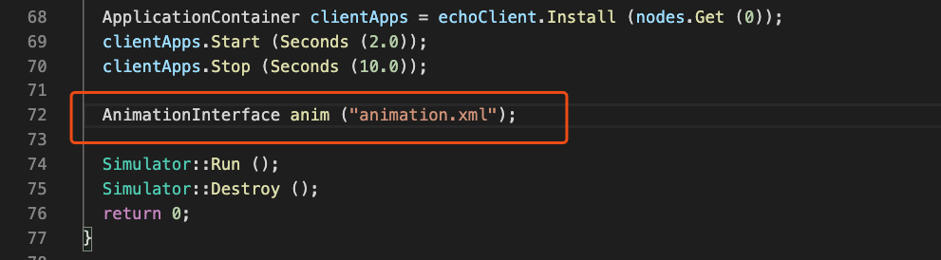

1. Set give positions to your nodes.

anim.SetConstantPosition (node, double x, double y);

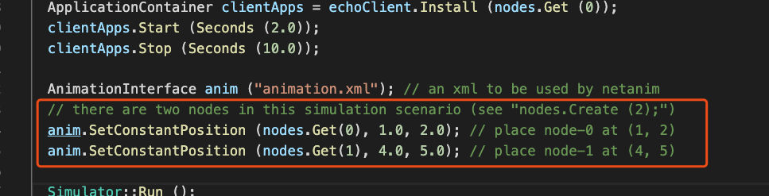

2.2.3.6. Build and Run

*# go back to ns-3.30.1*

cd ../

*# use waf to compile and run the code*

./waf --run tutorial1

You should see

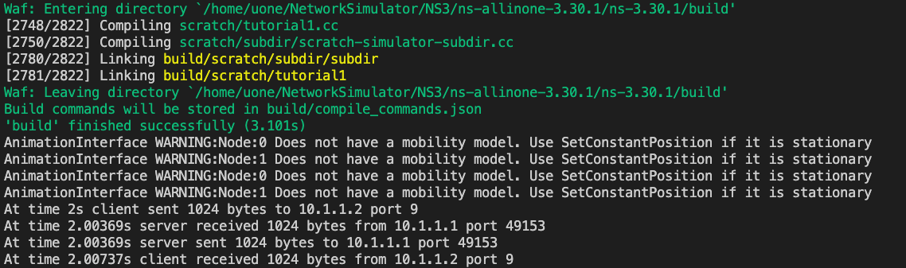

 Use NetAnim to Show The Animation

*# go to netanim-3.108*

cd ../netanim-3.108/

*# run NetAnim*

./NetAnim

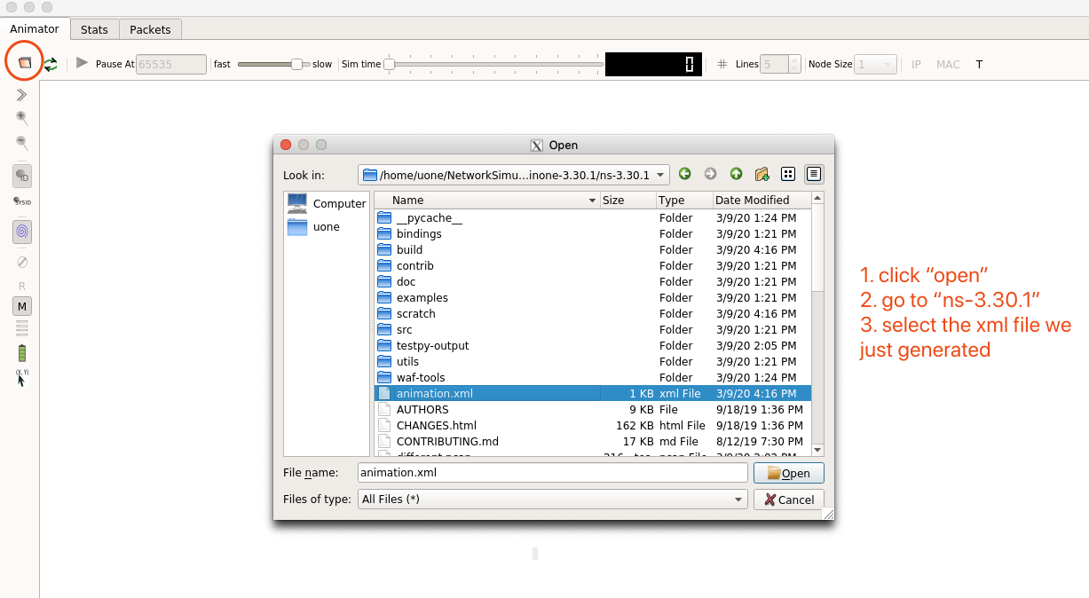 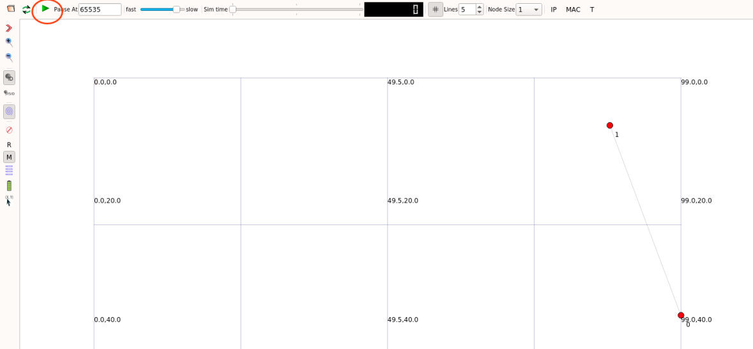

**Practical 5 : Conceptual Explaination of NS3 code**

Conceptual Overview

**Node**

In Internet jargon, a computing device that connects to a

network is called a host or sometimes an end system.

Because |ns3| is a network simulator, not specifically

an Internet simulator, we intentionally do not use the term host

since it is closely associated with the Internet and its protocols.

Instead, we use a more generic term also used by other

simulators that originates in Graph Theory --- the node.

In |ns3| the basic computing device abstraction is called the

node. This abstraction is represented in C++ by the class Node.

The Node class provides methods for managing the

representations of computing devices in simulations.

You should think of a Node as a computer to which you will add

functionality. One adds things like applications, protocol stacks

and peripheral cards with their associated drivers to enable the

computer to do useful work. We use the same basic model

in |ns3|.

**Application**

Typically, computer software is divided into two broad

classes. System Software organizes various computer resources

such as memory, processor cycles, disk, network, etc., according

to some computing model. System software usually does not

1use those resources to complete tasks that directly benefit a

user. A user would typically run an application that acquires

and uses the resources controlled by the system software to

accomplish some goal.

Often, the line of separation between system and application

software is made at the privilege level change that happens in

operating system traps. In |ns3| there is no real concept of

operating system and especially no concept of privilege levels or

system calls. We do, however, have the idea of an application.

Just as software applications run on computers to perform

tasks in the "real world," |ns3| applications run

on |ns3|

Nodes to drive simulations in the simulated world.

In |ns3| the basic abstraction for a user program that generates

some activity to be simulated is the application.

This abstraction is represented in C++ by the class Application.

The Application class provides methods for managing the

representations of our version of user-level applications in

simulations.

Developers are expected to specialize the Application class in the object-oriented programming sense to create new applications.

In this tutorial, we will use specializations of class Application called UdpEchoClientApplication and UdpEchoServerApplication.

As you might expect, these applications compose a client/server application set used to generate and echo simulated network packets

**Channel**

In the real world, one can connect a computer to a network.

Often the media over which data flows in these networks are

called channels. When you connect your Ethernet cable to the

plug in the wall, you are connecting your computer to an

Ethernet communication channel. In the simulated world

of |ns3|, one connects a Node to an object representing a

communication channel.

Here the basic communication subnetwork abstraction is called the channel and is represented in C++ by the class Channel.

The Channel class provides methods for managing

communication subnetwork objects and connecting nodes to

them. Channels may also be specialized by developers in the

object oriented programming sense.

A Channel specializationmay model something as simple as a wire. The

specialized Channel can also model things as complicated as a

large Ethernet switch, or three-dimensional space full of

obstructions in the case of wireless networks.

We will use specialized versions of the Channel called CsmaChannel, PointToPointChannel and WifiChannel.

The CsmaChannel, for example,

models a version of a communication subnetwork that

implements a carrier sense multiple access communication

medium. This gives us Ethernet-like functionality.

**Net Device**

It used to be the case that if you wanted to connect a computer

to a network, you had to buy a specific kind of network cable

and a hardware device called (in PC terminology) a peripheral

card that needed to be installed in your computer. If the

peripheral card implemented some networking function, they

were called Network Interface Cards, or NICs.

Today mostcomputers come with the network interface hardware built in

and users don't see these building blocks.

A NIC will not work without a software driver to control the

hardware. In Unix (or Linux), a piece of peripheral hardware is

classified as a device. Devices are controlled using device

drivers, and network devices (NICs) are controlled

using network device drivers collectively known as net devices.

In Unix and Linux you refer to these net devices by names such

as eth0.

In |ns3| the net device abstraction covers both the software

driver and the simulated hardware. A net device is "installed" in

a Node in order to enable the Node to communicate with

other Nodes in the simulation via Channels.

Just as in a real computer, a Node may be connected to more than

one Channel via multiple NetDevices.

The net device abstraction is represented in C++ by the

class NetDevice.

The NetDevice class provides methods for managing connections to Node and Channel objects; and may be specialized by developers in the object-oriented

programming sense. We will use the several specialized versions of

the NetDevice called CsmaNetDevice, PointToPointNetDevice,

and WifiNetDevice.

Just as an Ethernet NIC is designed to work with an Ethernet network,

the CsmaNetDevice is designed to work with a CsmaChannel;

the PointToPointNetDevice is designed to work with

a PointToPointChannel and a WifiNetNevice is designed to

work with a WifiChannel.

**Topology Helpers**

In a real network, you will find host computers with added (or

built-in) NICs.

In |ns3| we would say that you will find Nodes with attached NetDevices. In a large simulated network you will need to arrange many connections

between Nodes, NetDevices and Channels.

Since connecting NetDevices to Nodes, NetDevices to Channels,

assigning IP addresses, etc., are such common tasks in |ns3|,

we provide what we call topology helpers to make this as easy

as possible.

For example, it may take many distinct |ns3| core operations to create a NetDevice, add a MAC address, install that net device on a Node, configure the node's protocol stack, and then connect the NetDevice to a Channel. Even more operations would be required to connect multiple devices onto

multipoint channels and then to connect individual networks

together into internetworks.

We provide topology helper objects that combine those many distinct operations into an easy to use model for your convenience.

**A First ns-3 Script**

4If you downloaded the system as was suggested above, you will

have a release of |ns3| in a directory called repos under your

home directory. Change into that release directory, and you

should find a directory structure something like the following:

AUTHORS examples scratch utils waf.bat* bindings LICENSE

src utils.py waf-tools build ns3

test.py*

utils.pyc wscript

CHANGES.html README

testpy-output VERSION

wutils.py

doc

RELEASE_NOTES testpy.supp waf*

wutils.pyc

Change into the examples/tutorial directory. You should see a

file named first.cc located there. This is a script that will create

a simple point-to-point link between two nodes and echo a

single packet between the nodes. Let's take a look at that script

line by line, so go ahead and open first.cc in your favorite

editor.

**Boilerplate**

The first line in the file is an emacs mode line. This tells emacs

about the formatting conventions (coding style) we use in our

source code.

/* -*- Mode:C++; c-file-style:"gnu"; indent-tabs-mode:nil; -*-

*/

This is always a somewhat controversial subject, so we might as

well get it out of the way immediately. The |ns3| project, like

most large projects, has adopted a coding style to which all

contributed code must adhere. If you want to contribute your

code to the project, you will eventually have to conform to

the |ns3| coding standard as described in the

file doc/codingstd.txt or shown on the project web page here.

We recommend that you, well, just get used to the look and feel

of |ns3| code and adopt this standard whenever you are

working with our code. All of the development team and

contributors have done so with various amounts of grumbling.

5The emacs mode line above makes it easier to get the

formatting correct if you use the emacs editor.

The |ns3| simulator is licensed using the GNU General Public

License. You will see the appropriate GNU legalese at the head

of every file in the |ns3| distribution. Often you will see a

copyright notice for one of the institutions involved in

the |ns3| project above the GPL text and an author listed below.

/*

* This program is free software; you can redistribute it and/or

modify

* it under the terms of the GNU General Public License version

2 as

* published by the Free Software Foundation;

*

* This program is distributed in the hope that it will be useful,

* but WITHOUT ANY WARRANTY; without even the implied

warranty of

* MERCHANTABILITY or FITNESS FOR A PARTICULAR

PURPOSE. See the

* GNU General Public License for more details.

*

* You should have received a copy of the GNU General Public

License

* along with this program; if not, write to the Free Software

* Foundation, Inc., 59 Temple Place, Suite 330, Boston, MA

02111-1307 USA

*/

**Module Includes**

**The code proper starts with a number of include statements.**

#include "ns3/core-module.h"

#include "ns3/network-module.h"

#include "ns3/internet-module.h"

#include "ns3/point-to-point-module.h"

#include "ns3/applications-module.h"

To help our high-level script users deal with the large number

of include files present in the system, we group includes

according to relatively large modules. We provide a single

include file that will recursively load all of the include files used

in each module. Rather than having to look up exactly what

header you need, and possibly have to get a number of

dependencies right, we give you the ability to load a group of

files at a large granularity. This is not the most efficient

approach but it certainly makes writing scripts much easier.

Each of the |ns3| include files is placed in a directory

called ns3 (under the build directory) during the build process

to help avoid include file name collisions.

The ns3/core-module.h file corresponds to the ns-3 module you will find in

the directory src/core in your downloaded release distribution.

If you list this directory you will find a large number of header

files.

When you do a build, Waf will place public header files in

an ns3 directory under the appropriate build/debug or build/optimized directory depending on your configuration. Waf will also automatically

generate a module include file to load all of the public header

files.

Since you are, of course, following this tutorial religiously, you

will already have done a

$ ./waf -d debug --enable-examples --enable-tests configure

in order to configure the project to perform debug builds that

include examples and tests. You will also have done a

$ ./waf

to build the project.

So now if you look in the directory ../../build/debug/ns3

you will find the four module include files shown above. You can take a look at the contents of these files and find that they do include all of the public include files in their respective modules.

**Ns3 Namespace**

The next line in the first.cc script is a namespace declaration.

using namespace ns3;

The |ns3| project is implemented in a C++ namespace

called ns3.

This groups all |ns3|-related declarations in a scope

outside the global namespace, which we hope will help with

integration with other code.

The C++ using statement introduces the |ns3| namespace into the current (global) declarative region.

This is a fancy way of saying that after this

declaration, you will not have to type ns3:: scope resolution

operator before all of the |ns3| code in order to use it.

If you are unfamiliar with namespaces, please consult almost any C++

tutorial and compare the ns3 namespace and usage here with

instances of the std namespace and the using namespace

std; statements you will often find in discussions of cout and streams.

**Logging**

The next line of the script is the following,

NS_LOG_COMPONENT_DEFINE ("FirstScriptExample");

We will use this statement as a convenient place to talk about

our Doxygen documentation system.

If you look at the project web site, ns-3 project, you will find a link to "Documentation" in the navigation bar. If you select this link, you will be taken to our documentation page.

There is a link to "Latest Release" that will take you to the documentation for the latest stable release of |ns3|.

If you select the "API Documentation" link, you will be taken to the |ns3| API documentation page.

Along the left side, you will find a graphical representation of

the structure of the documentation.

A good place to start is the NS-3 Modules "book" in the |ns3| navigation tree.

If you expand Modules you will see a list of |ns3| module

documentation. The concept of module here ties directly into

the module include files discussed above.

The |ns3| logging subsystem is discussed in the :ref:`UsingLogging` section, so we'll get to it later in this tutorial, but you can find out about the

8above statement by looking at the Core module, then expanding

the Debugging tools book, and then selecting the Logging page.

**Click on Logging.**

You should now be looking at the Doxygen documentation for

the Logging module.

In the list of Macros's at the top of the page you will see the entry

for NS_LOG_COMPONENT_DEFINE.

Before jumping in, it would probably be good to look for the "Detailed Description" of the logging module to get a feel for the overall operation. You

can either scroll down or select the "More..." link under the

collaboration diagram to do this.

Once you have a general idea of what is going on, go ahead and

take a look at the specific NS_LOG_COMPONENT_DEFINE documentation.

It summarize, this line declares a logging component

called FirstScriptExample that allows you to enable and disable

console message logging by reference to the name.

**Main Function**

The next lines of the script you will find are,

int

main (int argc, char *argv[])

{

This is just the declaration of the main function of your

program (script). Just as in any C++ program, you need to

define a main function that will be the first function run. There

is nothing at all special here. Your |ns3| script is just a C++

program.

The next line sets the time resolution to one nanosecond, which

happens to be the default value:

Time::SetResolution (Time::NS);

The resolution is the smallest time value that can be

represented (as well as the smallest representable difference

9between two time values).

You can change the resolution exactly once. The mechanism enabling this flexibility is somewhat memory hungry, so once the resolution has been set

explicitly we release the memory, preventing further updates.

(If you don't set the resolution explicitly, it will default to one

nanosecond, and the memory will be released when the

simulation starts.)

The next two lines of the script are used to enable two logging

components that are built into the Echo Client and Echo Server

applications:

LogComponentEnable("UdpEchoClientApplication",

LOG_LEVEL_INFO);

LogComponentEnable("UdpEchoServerApplication",

LOG_LEVEL_INFO);

If you have read over the Logging component documentation

you will have seen that there are a number of levels of logging

verbosity/detail that you can enable on each component.

These two lines of code enable debug logging at the INFO level for

echo clients and servers. This will result in the application

printing out messages as packets are sent and received during

the simulation.

Now we will get directly to the business of creating a topology

and running a simulation. We use the topology helper objects to

make this job as easy as possible.

**Topology Helpers**

**NodeContainer**

The next two lines of code in our script will actually create

the |ns3| Node objects that will represent the computers in the

simulation.

NodeContainer nodes;

nodes.Create (2);

Let's find the documentation for the NodeContainer class

before we continue. Another way to get into the documentation

for a given class is via the Classes tab in the Doxygen pages.

If you still have the Doxygen handy, just scroll up to the top of the

page and select the Classes tab. You should see a new set of tabs

appear, one of which is Class List.

Under that tab you will see a list of all of the |ns3| classes. Scroll down, looking for ns3::NodeContainer.

When you find the class, go ahead and select it to go to the documentation for the class.

You may recall that one of our key abstractions is the Node.

This represents a computer to which we are going to add things

like protocol stacks, applications and peripheral cards.

The NodeContainer topology helper provides a convenient way

to create, manage and access any Node objects that we create in

order to run a simulation.

The first line above just declares a **NodeContainer** which we call nodes. The second line calls the Create method on the nodes object and asks the container to create two nodes.

As described in the Doxygen, the container calls down into the |ns3| system proper to create two Node objects and stores pointers to those objects internally.

The nodes as they stand in the script do nothing. The next step

in constructing a topology is to connect our nodes together into

a network.

The simplest form of network we support is a single

point-to-point link between two nodes. We'll construct one of

those links here.

**PointToPointHelper**

We are constructing a point to point link, and, in a pattern

which will become quite familiar to you, we use a topology

helper object to do the low-level work required to put the link

together.

Recall that two of our key abstractions are the NetDevice and the Channel.

In the real world, these terms correspond roughly to peripheral cards and network cables.

Typically these two things are intimately tied together and one

cannot expect to interchange, for example, Ethernet devices

and wireless channels.

Our Topology Helpers follow this intimate coupling and therefore you will use a single PointToPointHelper to configure and connect |ns3| PointToPointNetDevice and PointToPointChannel objects in this script.

The next three lines in the script are,

**PointToPointHelper pointToPoint;**

**pointToPoint.SetDeviceAttribute ("DataRate", StringValue("5Mbps"));**

**pointToPoint.SetChannelAttribute ("Delay", StringValue("2ms"));**

The first line, PointToPointHelper pointToPoint;

instantiates a PointToPointHelper object on the stack. From a high-level perspective the next line,

pointToPoint.SetDeviceAttribute ("DataRate", StringValue("5Mbps"));

tells the PointToPointHelper object to use the value "5Mbps"

(five megabits per second) as the "DataRate" when it creates a PointToPointNetDevice object.

From a more detailed perspective, the string "DataRate"

corresponds to what we call an Attribute of the PointToPointNetDevice.

If you look at the Doxygen for class ns3::PointToPointNetDevice and find the documentation for the GetTypeId method, you will find a list

of Attributes defined for the device. Among these is the

"DataRate" Attribute.

Most user-visible |ns3| objects have similar lists of Attributes. We use this mechanism to easily configure simulations without recompiling as you will see in a

following section.

Similar to the "DataRate" on the PointToPointNetDevice you will find a "Delay" Attribute associated with the PointToPointChannel.

The final line,

pointToPoint.SetChannelAttribute ("Delay", StringValue("2ms"));

tells the PointToPointHelper to use the value "2ms" (two milliseconds) as the value of the propagation delay of every point to point channel it subsequently creates.

**NetDeviceContainer**

At this point in the script, we have a NodeContainer that

contains two nodes.

We have a PointToPointHelper that is primed and ready to make PointToPointNetDevices and wire PointToPointChannel objects between them.

Just as we used the NodeContainer topology helper object to create

the Nodes for our simulation, we will ask

the PointToPointHelper to do the work involved in creating,

configuring and installing our devices for us.

We will need to have a list of all of the NetDevice objects that are created, so we

use a NetDeviceContainer to hold them just as we used a

NodeContainer to hold the nodes we created.

The following two lines of code,

NetDeviceContainer devices;

devices = pointToPoint.Install (nodes);

will finish configuring the devices and channel. The first line

declares the device container mentioned above and the second

does the heavy lifting.

The Install method of the PointToPointHelper takes a NodeContainer as a parameter.

Internally, a NetDeviceContainer is created.

For each node in the NodeContainer (there must be exactly two for a point-to-

point link) a PointToPointNetDevice is created and saved in the

device container.

A PointToPointChannel is created and the two PointToPointNetDevices are attached. When objects are created by the PointToPointHelper, the Attributes previously set in the helper are used to initialize the corresponding Attributes in the created objects.

After executing the pointToPoint.Install (nodes) call we will

have two nodes, each with an installed point-to-point net device

and a single point-to-point channel between them.

Both devices will be configured to transmit data at five megabits per second

over the channel which has a two millisecond transmission delay.

**InternetStackHelper**

We now have nodes and devices configured, but we don't have any protocol stacks installed on our nodes. The next two lines of code will take care of that.

InternetStackHelper stack;

stack.Install (nodes);

The InternetStackHelper is a topology helper that is to internet stacks what the PointToPointHelper is to point-to-point net devices.

The Install method takes a NodeContainer as a parameter. When it is executed, it will install an Internet Stack(TCP, UDP, IP, etc.) on each of the nodes in the node container.

**Ipv4AddressHelper**

Next we need to associate the devices on our nodes with IP addresses. We provide a topology helper to manage the allocation of IP addresses. The only user-visible API is to set the base IP address and network mask to use when performing the

actual address allocation (which is done at a lower level inside the helper).

The next two lines of code in our example script, first.cc,

Ipv4AddressHelper address;

address.SetBase ("10.1.1.0", "255.255.255.0");

declare an address helper object and tell it that it should begin allocating IP addresses from the network 10.1.1.0 using the mask 255.255.255.0 to define the allocatable bits.

By default the addresses allocated will start at one and increase monotonically, so the first address allocated from this base will be 10.1.1.1, followed by 10.1.1.2, etc. The low level |ns3| system actually remembers all of the IP addresses allocated and will generate a fatal error if you accidentally cause the same address

to be generated twice (which is a very hard to debug error, by the way).

The next line of code,

Ipv4InterfaceContainer interfaces = address.Assign (devices);

performs the actual address assignment.

In |ns3| we make the association between an IP address and a device using

an Ipv4Interface object.

Just as we sometimes need a list of net devices created by a helper for future reference we sometimes need a list of Ipv4Interface objects.

The Ipv4InterfaceContainer provides this functionality.

Now we have a point-to-point network built, with stacks installed and IP addresses assigned. What we need at this point are applications to generate traffic.

**Applications**

Another one of the core abstractions of the ns-3 system is the Application. In this script we use two specializations of the core |ns3| class Application called UdpEchoServerApplication and UdpEchoClientApplication.

Just as we have in our previous explanations, we use helper objects to help configure and manage the underlying objects.

Here, we use UdpEchoServerHelper and UdpEchoClientHelper objects to

make our lives easier.

**UdpEchoServerHelper**

The following lines of code in our example script, first.cc, are

used to set up a UDP echo server application on one of the

nodes we have previously created.

UdpEchoServerHelper echoServer (9);

ApplicationContainer serverApps = echoServer.Install(nodes.Get (1));

serverApps.Start (Seconds (1.0));

serverApps.Stop (Seconds (10.0));

The first line of code in the above snippet declares the UdpEchoServerHelper.

As usual, this isn't the application itself, it is an object used to help us create the actual applications. One of our conventions is to place required Attributes in the helper constructor.

In this case, the helper can't do anything useful unless it is provided with a

port number that the client also knows about. Rather than just picking one and hoping it all works out, we require the port number as a parameter to the constructor.

The constructor, in turn, simply does a SetAttribute with the passed value.

If you want, you can set the "Port" Attribute to another value later using SetAttribute.

Similar to many other helper objects, the UdpEchoServerHelper object has an Install method.

It is the execution of this method that actually causes the underlying echo server application to be instantiated and attached to a node.

Interestingly, the Install method takes a NodeContainter as a parameter just as the

other Install methods we have seen.

This is actually what is passed to the method even though it doesn't look so in this case.

There is a C++ implicit conversion at work here that takes the result of nodes.Get (1) (which returns a smart pointer to a node object --- Ptr<Node>) and uses that in a constructor for an unnamed NodeContainer that is then passed to Install.

If you are ever at a loss to find a particular method signature in C++ code that compiles and runs just fine, look for these kinds of implicit conversions.

We now see that echoServer.Install is going to install a UdpEchoServerApplication on the node found at index number one of the NodeContainer we used to manage our nodes.

Install will return a container that holds pointers to all of the applications (one in this case since we passed a NodeContainer containing one node) created by the helper.

Applications require a time to "start" generating traffic and may take an optional time to "stop". We provide both.

These times are set using the ApplicationContainer methods Start and Stop.

These methods take Time parameters.

In this case, we use an explicit C++ conversion sequence to take the C++ double 1.0

and convert it to an |ns3| Time object using a Seconds cast.

Be aware that the conversion rules may be controlled by the model author, and C++ has its own rules, so you can't always just assume that parameters will be happily converted for you.

The two lines,

serverApps.Start (Seconds (1.0));

serverApps.Stop (Seconds (10.0));

will cause the echo server application to Start (enable itself) at one second into the simulation and to Stop (disable itself) at ten seconds into the simulation.

By virtue of the fact that we have declared a simulation event (the application stop event) to be executed at ten seconds, the simulation will last at least ten seconds.

**UdpEchoClientHelper**

The echo client application is set up in a method substantially similar to that for the server. There is an underlying UdpEchoClientApplication that is managed by

an UdpEchoClientHelper.

UdpEchoClientHelper echoClient (interfaces.GetAddress (1),9);

echoClient.SetAttribute ("MaxPackets", UintegerValue (1));

echoClient.SetAttribute ("Interval", TimeValue (Seconds(1.0)));

echoClient.SetAttribute ("PacketSize", UintegerValue (1024));

ApplicationContainer clientApps = echoClient.Install(nodes.Get (0));

clientApps.Start (Seconds (2.0));

clientApps.Stop (Seconds (10.0));

For the echo client, however, we need to set five different Attributes. The first two Attributes are set during construction of the UdpEchoClientHelper.

We pass parameters that are used (internally to the helper) to set the "RemoteAddress" and "RemotePort" Attributes in accordance with our convention to make required Attributes parameters in the helper constructors.

Recall that we used an Ipv4InterfaceContainer to keep track of the IP addresses we assigned to our devices.

The zeroth interface in the interfaces container is going to correspond to the IP address of the zeroth node in the nodes container.

The first interface in the interfaces container corresponds to the IP address of the first node in the nodes container. So, in the first line of code (from above), we are creating the helper and telling it so set the remote address of the client to be the IP address assigned to the node on which the server resides. We also tell it to arrange to send packets to port nine.

The "MaxPackets" Attribute tells the client the maximum number of packets we allow it to send during the simulation.

The "Interval" Attribute tells the client how long to wait between packets, and the "PacketSize" Attribute tells the client how large its packet payloads should be.

With this particular combination of Attributes, we are telling the client to send one

1024-byte packet.

Just as in the case of the echo server, we tell the echo client to Start and Stop, but here we start the client one second after the server is enabled (at two seconds into the simulation).

**Simulator**

What we need to do at this point is to actually run the simulation. This is done using the global function Simulator::Run.

Simulator::Run ();

When we previously called the methods,

serverApps.Start (Seconds (1.0));

serverApps.Stop (Seconds (10.0));

...

clientApps.Start (Seconds (2.0));

clientApps.Stop (Seconds (10.0));

we actually scheduled events in the simulator at 1.0 seconds, 2.0 seconds and two events at 10.0 seconds.

When Simulator::Run is called, the system will begin looking through the list of scheduled events and executing them.

First it will run the event at 1.0 seconds, which will enable the echo 18server application (this event may, in turn, schedule many other events).

Then it will run the event scheduled for t=2.0 seconds which will start the echo client application. Again, this event may schedule many more events.

The start event implementation in the echo client application will begin the data transfer phase of the simulation by sending a packet to the server.

The act of sending the packet to the server will trigger a chain of events that will be automatically scheduled behind the scenes and which will perform the mechanics of the packet echo according to the various timing parameters that we have set in

the script.

Eventually, since we only send one packet (recall the MaxPackets Attribute was set to one), the chain of events triggered by that single client echo request will taper off and the simulation will go idle. Once this happens, the remaining events

will be the Stop events for the server and the client.

When these events are executed, there are no further events to process

and Simulator::Run returns.

The simulation is then complete.

All that remains is to clean up. This is done by calling the global

function Simulator::Destroy.

As the helper functions (or low level |ns3| code) executed, they arranged it so that hooks were inserted in the simulator to destroy all of the objects that were

created. You did not have to keep track of any of these objects yourself --- all you had to do was to call Simulator::Destroy and exit.

The |ns3| system took care of the hard part for you.

The remaining lines of our first |ns3| script, first.cc, do just that:

Simulator::Destroy ();

return 0;

}

**When the simulator will stop?**

|ns3| is a Discrete Event (DE) simulator. In such a simulator, each event is associated with its execution time, and the simulation proceeds by executing events in the temporal order of simulation time. Events may cause future events to be

19scheduled (for example, a timer may reschedule itself to expire at the next interval).

The initial events are usually triggered by each object, e.g., Ipv6 will schedule Router Advertisements, Neighbor Solicitations, etc., an Application schedule the first packet sending event, etc.

When an event is processed, it may generate zero, one or more events. As a simulation executes, events are consumed, but more events may (or may not) be generated.

The simulation will stop automatically when no further events are in the event

queue, or when a special Stop event is found. The Stop event is created through the Simulator::Stop (stopTime); function.

There is a typical case where Simulator::Stop is absolutely necessary to stop the simulation: when there is a self-sustaining event. Self-sustaining (or recurring) events are events that always reschedule themselves. As a consequence, they always

keep the event queue non-empty.

There are many protocols and modules containing recurring

events, e.g.:

FlowMonitor - periodic check for lost packets

RIPng - periodic broadcast of routing tables update etc.

In these cases, Simulator::Stop is necessary to gracefully stop the simulation.

In addition, when |ns3| is in emulation mode, the RealtimeSimulator is used to keep the simulation clock aligned with the machine clock, and Simulator::Stop is

necessary to stop the process.

Many of the simulation programs in the tutorial do not explicitly call Simulator::Stop, since the event queue will automatically run out of events. However, these programs will also accept a call to Simulator::Stop.

For example, the following additional statement in the first example program will schedule an explicit stop at 11 seconds:

+ Simulator::Stop (Seconds (11.0));

Simulator::Run ();

Simulator::Destroy ();

return 0;

}

The above will not actually change the behavior of this program, since this particular simulation naturally ends after 10 seconds.

But if you were to change the stop time in the above statement from 11 seconds to 1 second, you would notice that the simulation stops before any output is printed to the screen (since the output occurs around time 2 seconds of simulation time).

It is important to call Simulator::Stop before calling Simulator::Run;

otherwise, Simulator::Run may never return control to the main program to execute the stop!

**Building Your Script**

We have made it trivial to build your simple scripts. All you have to do is to drop your script into the scratch directory and it will automatically be built if you run Waf.

Let's try it.

Copy examples/tutorial/first.cc into the scratch directory after changing back into the top level directory.

$ cd ../..

$ cp examples/tutorial/first.cc scratch/myfirst.cc

Now build your first example script using waf:

$ ./waf

You should see messages reporting that your myfirst example was built successfully.

Waf: Entering directory `/home/craigdo/repos/ns-3-allinone/ns-3-dev/build'

[614/708] cxx: scratch/myfirst.cc ->

build/debug/scratch/myfirst_3.o

[706/708] cxx_link: build/debug/scratch/myfirst_3.o -> build/debug/scratch/myfirst

Waf: Leaving directory `/home/craigdo/repos/ns-3-allinone/ns-3-dev/build'

'build' finished successfully (2.357s)

You can now run the example (note that if you build your program in the scratch directory you must run it out of the scratch directory):

**$ ./waf --run scratch/myfirst**

You should see some output:

Waf: Entering directory `/home/craigdo/repos/ns-3-allinone/ns-3-dev/build'

Waf: Leaving directory `/home/craigdo/repos/ns-3-allinone/ns-3-dev/build'

'build' finished successfully (0.418s)

Sent 1024 bytes to 10.1.1.2

Received 1024 bytes from 10.1.1.1

Received 1024 bytes from 10.1.1.2

Here you see that the build system checks to make sure that the file has been build and then runs it.

You see the logging component on the echo client indicate that it has sent one 1024

byte packet to the Echo Server on 10.1.1.2.

You also see the logging component on the echo server say that it has received

the 1024 bytes from 10.1.1.1.

The echo server silently echoes the packet and you see the echo client log that it has received its packet back from the server.

Practical 6: **Experiment Specific Instructions**

Create two nodes: an access point (AP) and a base station (BS). The BS will sends message to the AP, also the AP will sends a response back to the base station. Since the medium of communication is wireless (over air), the BS could send (or receive) messages to (or from) the AP only when ir is within a certain distance from the AP.

**1. Create the nodes and hold them in a container:**

NodeContainer wifiStaNodes, wifiApNode;

wifiStaNodes.Create (nWifi);

wifiApNode = wifiStaNodes.Get (0);

**2.Create channel for communication:**

|  |  |
| --- | --- |
| YansWifiChannelHelper channel = YansWifiChannelHelper::Default (); | |
| YansWifiPhyHelper phy = YansWifiPhyHelper::Default (); |  |

|  |
| --- |
| phy.SetChannel (channel.Create ()); |
| WifiHelper wifi = WifiHelper::Default (); |

|  |
| --- |
| wifi.SetRemoteStationManager ("ns3::AarfWifiManager"); |
| NqosWifiMacHelper mac = NqosWifiMacHelper::Default (); |

**3. Set up MAC for base station**

|  |
| --- |
| Ssid ssid = Ssid ("ns-3-ssid"); |
| mac.SetType ("ns3::StaWifiMac","Ssid", SsidValue (ssid),"ActiveProbing", BooleanValue (false)); |

|  |  |
| --- | --- |
|  | NetDeviceContainer staDevices; |
| staDevices = wifi.Install (phy, mac, wifiStaNodes.Get (1)); | |

**4. Set up MAC for AP:**

|  |
| --- |
| mac.SetType ("ns3::ApWifiMac","Ssid", SsidValue(ssid),"BeaconGeneration",BooleanValue (true),"BeaconInterval",TimeValue (Seconds (5))); |

|  |
| --- |
| NetDeviceContainer apDevice; |
| apDevice = wifi.Install (phy, mac, wifiApNode); |

**5. Set mobility of the nodes:**

|  |
| --- |
| MobilityHelper mobility; |
| mobility.SetPositionAllocator ("ns3::GridPositionAllocator",   |  | | --- | | "MinX", DoubleValue (0.0), |  |  | | --- | | "MinY", DoubleValue (0.0),"DeltaX", DoubleValue (xDistance),"DeltaY", DoubleValue (10.0),"GridWidth", UintegerValue (3),"LayoutType", StringValue"RowFirst")); | |

mobility.SetMobilityModel ("ns3::ConstantPositionMobilityModel");

mobility.Install (wifiStaNodes);

**6.Add Internet layers stack:**

InternetStackHelper stack;

stack.Install (wifiStaNodes);

**7. Assign IP address to each device:**

Ipv4AddressHelper address;

Ipv4InterfaceContainer wifiInterfaces, wifiApInterface;

|  |
| --- |
| address.SetBase(10.1.1.0","255.255.255.0"); |

wifiApInterface = address.Assign (apDevice);

wifiInterfaces = address.Assign (staDevices);

**8.Create and setup applications (traffic sink):**

|  |
| --- |
| UdpEchoServerHelper echoServer (9);// Port # 9 |

ApplicationContainer serverApps = echoServer.Install (wifiApNode);

|  |
| --- |
| serverApps.Start (Seconds (1.0)); |
| serverApps.Stop (Seconds (4.0)); |

**9. Create and setup applications (traffic source):**

|  |
| --- |
| UdpEchoClientHelper echoClient (wifiApInterface.GetAddress (0), 9); |

echoClient.SetAttribute ("MaxPackets", UintegerValue (1));

|  |
| --- |
| echoClient.SetAttribute ("Interval", TimeValue (Seconds (1.))); |
| echoClient.SetAttribute ("PacketSize", UintegerValue (1024)); |

ApplicationContainer clientApps = echoClient.Install (wifiStaNodes.Get (1));

clientApps.Start (Seconds (2.0));

clientApps.Stop (Seconds (3.0));

Ipv4GlobalRoutingHelper::PopulateRoutingTables ();

Simulator::Stop (Seconds (4.0));

Practical No. 7 : Defualt Network Topology (Point-to-Point)

/* -*- Mode:C++; c-file-style:"gnu"; indent-tabs-mode:nil; -*- */

/*

* This program is free software; you can redistribute it and/or modify

* it under the terms of the GNU General Public License version 2 as

* published by the Free Software Foundation;

*

* This program is distributed in the hope that it will be useful,

* but WITHOUT ANY WARRANTY; without even the implied warranty of

* MERCHANTABILITY or FITNESS FOR A PARTICULAR PURPOSE. See the

* GNU General Public License for more details.

*

* You should have received a copy of the GNU General Public License

* along with this program; if not, write to the Free Software

* Foundation, Inc., 59 Temple Place, Suite 330, Boston, MA 02111-1307 USA

*/

#include "ns3/core-module.h"

#include "ns3/network-module.h"

#include "ns3/internet-module.h"

#include "ns3/point-to-point-module.h"

#include "ns3/applications-module.h"

//netAnimation

#include "ns3/netanim-module.h"

#include "ns3/mobility-module.h"

// Default Network Topology

//

// 10.1.1.0

// n0 -------------- n1

// point-to-point

//

using namespace ns3;

NS_LOG_COMPONENT_DEFINE ("FirstScriptExample");

int

main (int argc, char *argv[])

{

CommandLine cmd (__FILE__);

cmd.Parse (argc, argv);

Time::SetResolution (Time::NS);

LogComponentEnable ("UdpEchoClientApplication", LOG_LEVEL_INFO);

LogComponentEnable ("UdpEchoServerApplication", LOG_LEVEL_INFO);

NodeContainer nodes;

nodes.Create (2);

PointToPointHelper pointToPoint;

pointToPoint.SetDeviceAttribute ("DataRate", StringValue ("5Mbps"));

pointToPoint.SetChannelAttribute ("Delay", StringValue ("2ms"));

NetDeviceContainer devices;

devices = pointToPoint.Install (nodes);

InternetStackHelper stack;

stack.Install (nodes);

Ipv4AddressHelper address;

address.SetBase ("10.1.1.0", "255.255.255.0");

Ipv4InterfaceContainer interfaces = address.Assign (devices);

UdpEchoServerHelper echoServer (9);

ApplicationContainer serverApps = echoServer.Install (nodes.Get (1));

serverApps.Start (Seconds (1.0));

serverApps.Stop (Seconds (10.0));

UdpEchoClientHelper echoClient (interfaces.GetAddress (1), 9);

echoClient.SetAttribute ("MaxPackets", UintegerValue (1));

echoClient.SetAttribute ("Interval", TimeValue (Seconds (1.0)));

echoClient.SetAttribute ("PacketSize", UintegerValue (1024));

ApplicationContainer clientApps = echoClient.Install (nodes.Get (0));

clientApps.Start (Seconds (2.0));

clientApps.Stop (Seconds (10.0));

MobilityHelper mobility;

mobility.SetMobilityModel("ns3::ConstantPositionMobilityModel");

mobility.Install(nodes);

AnimationInterface anim("first.xml");

AnimationInterface::SetConstantPosition (nodes.Get(0), 10, 25);

AnimationInterface ::SetConstantPosition(nodes.Get(1), 40,25);

anim.EnablePacketMetadata(true);

pointToPoint.EnablePcapAll("first");

Simulator::Run ();

Simulator::Destroy ();

return 0;

}

Output :

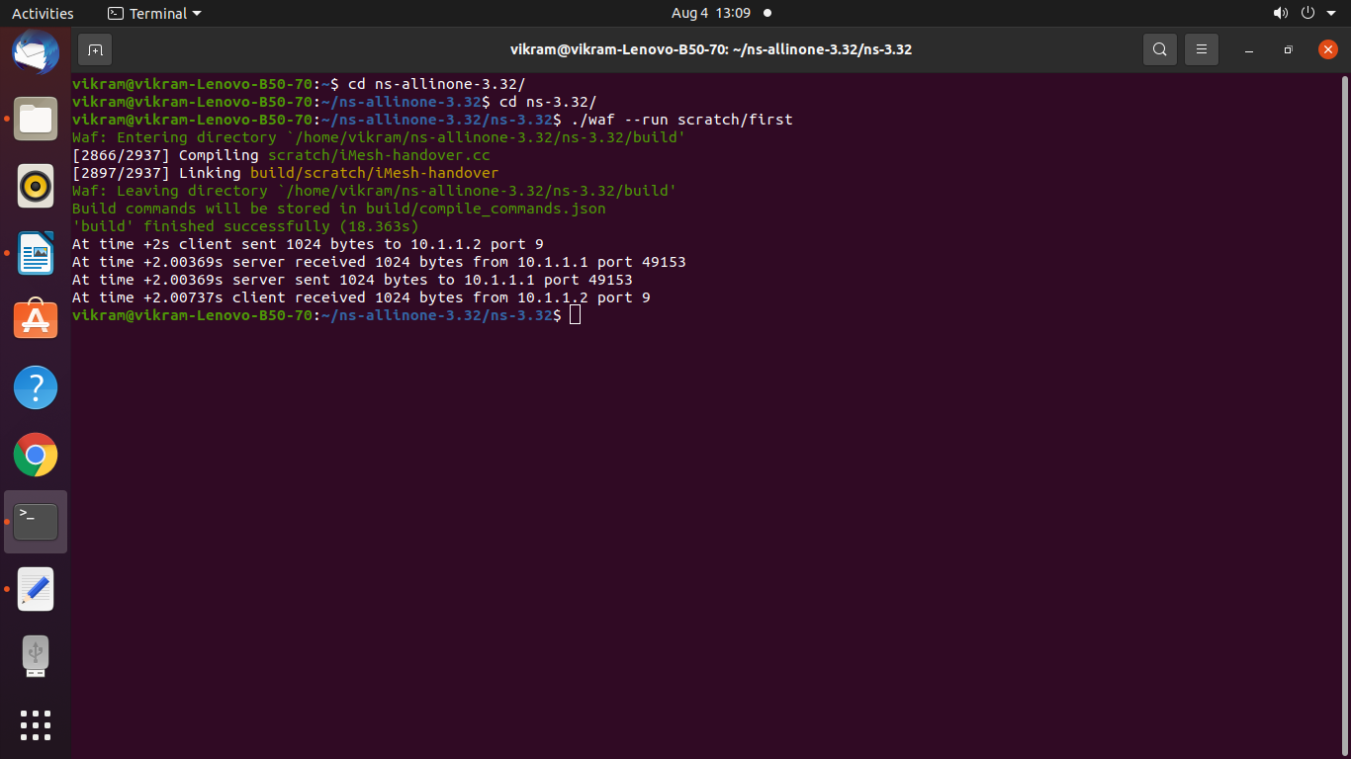

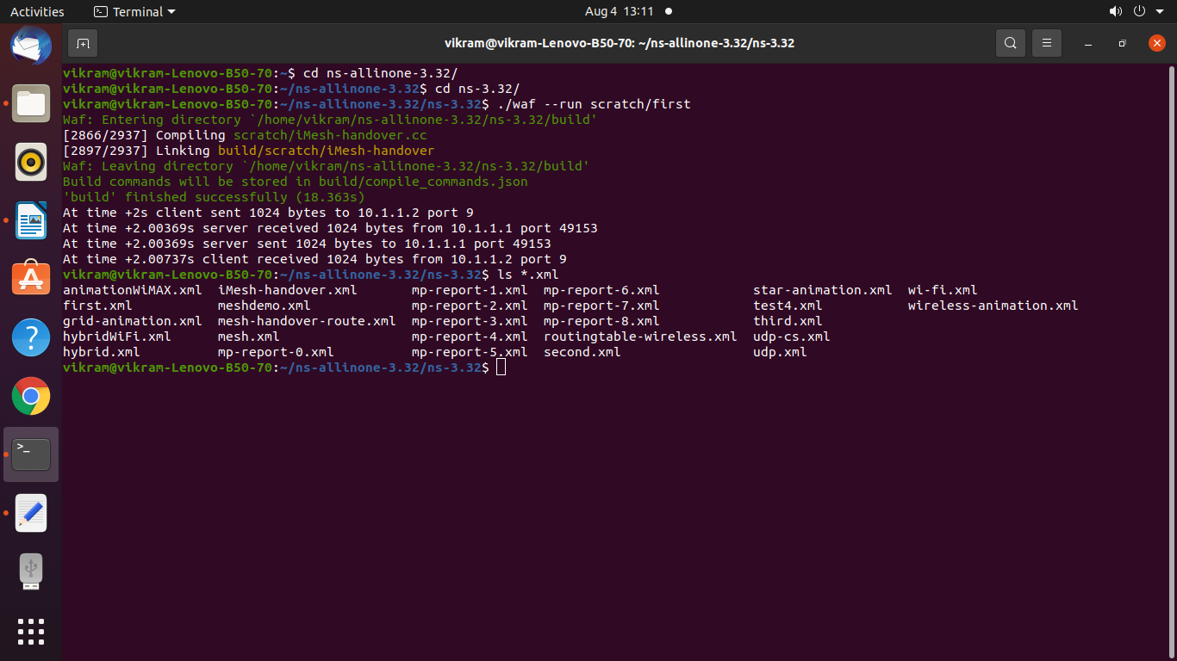

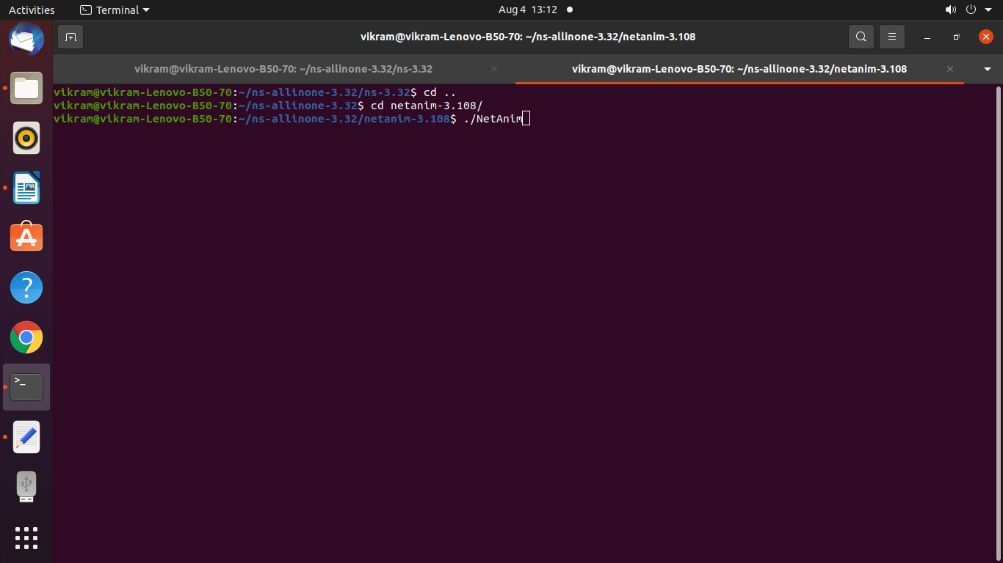

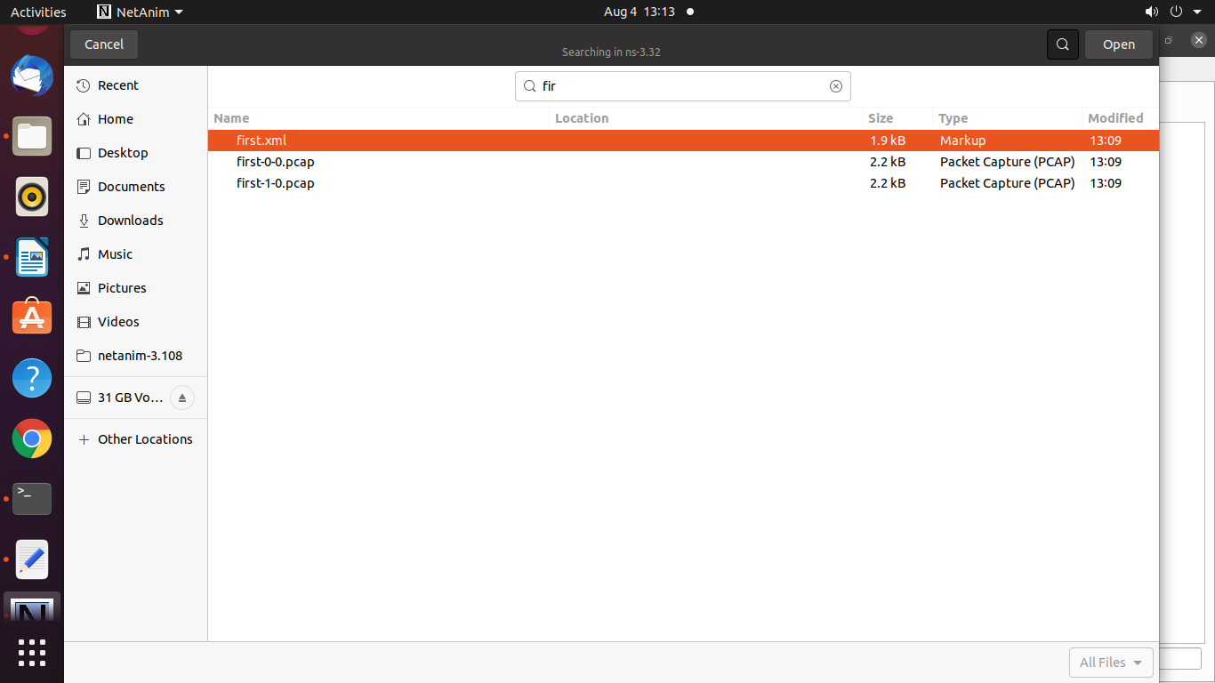

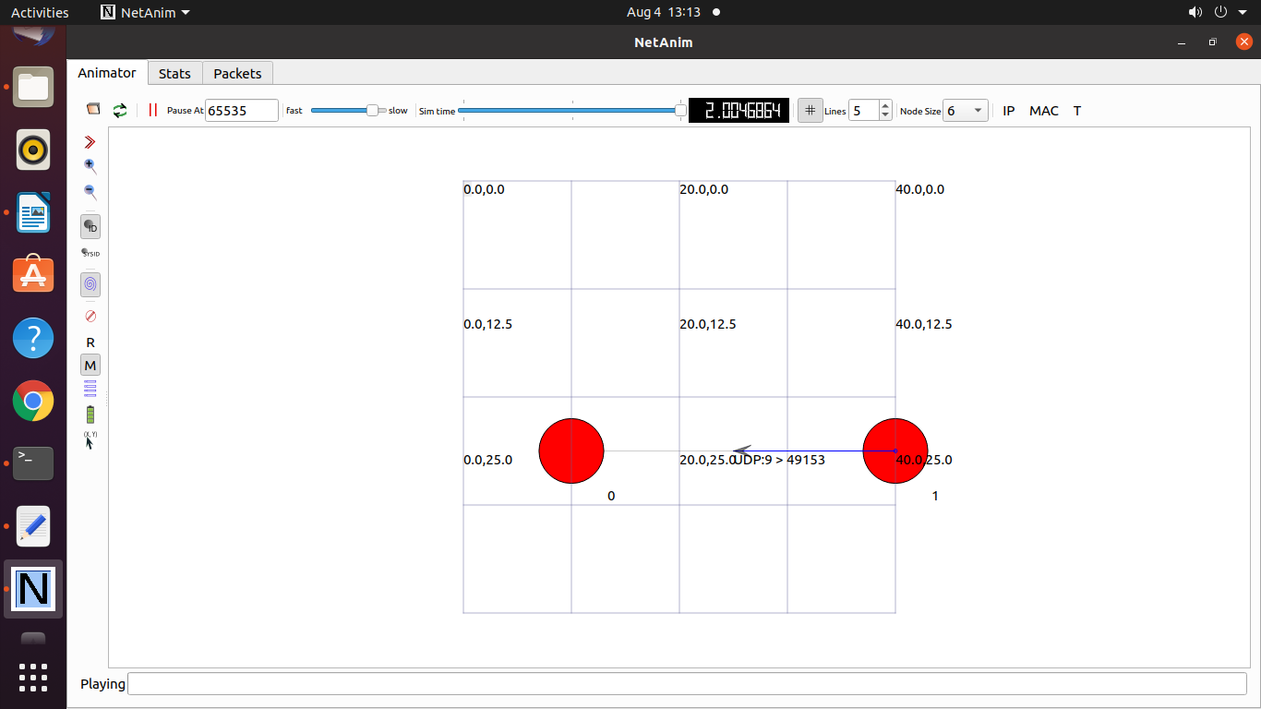

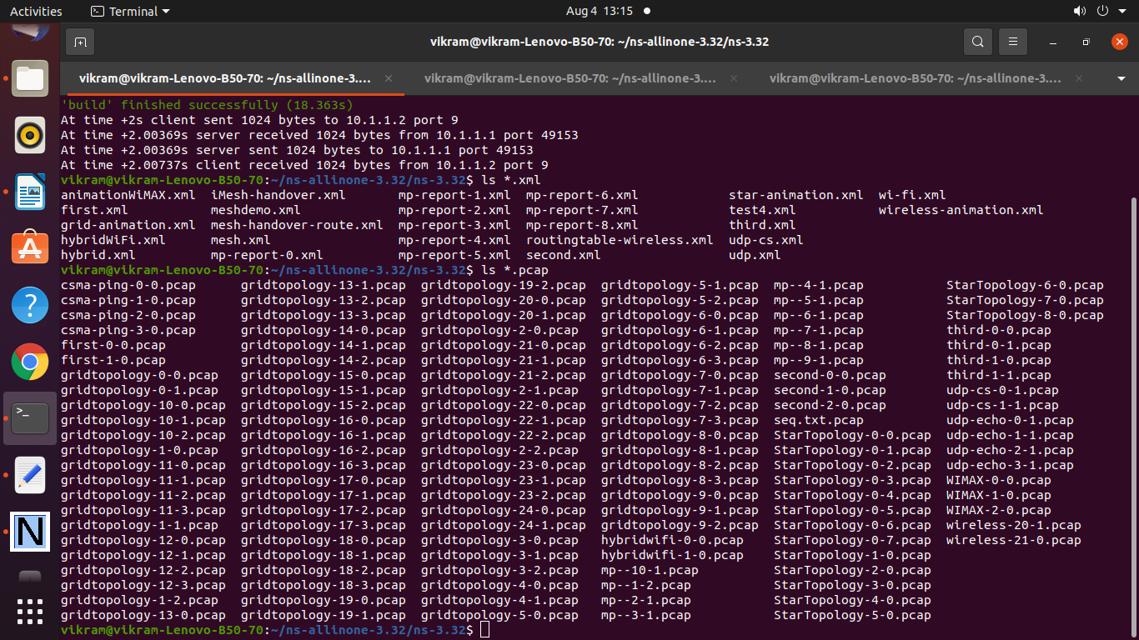

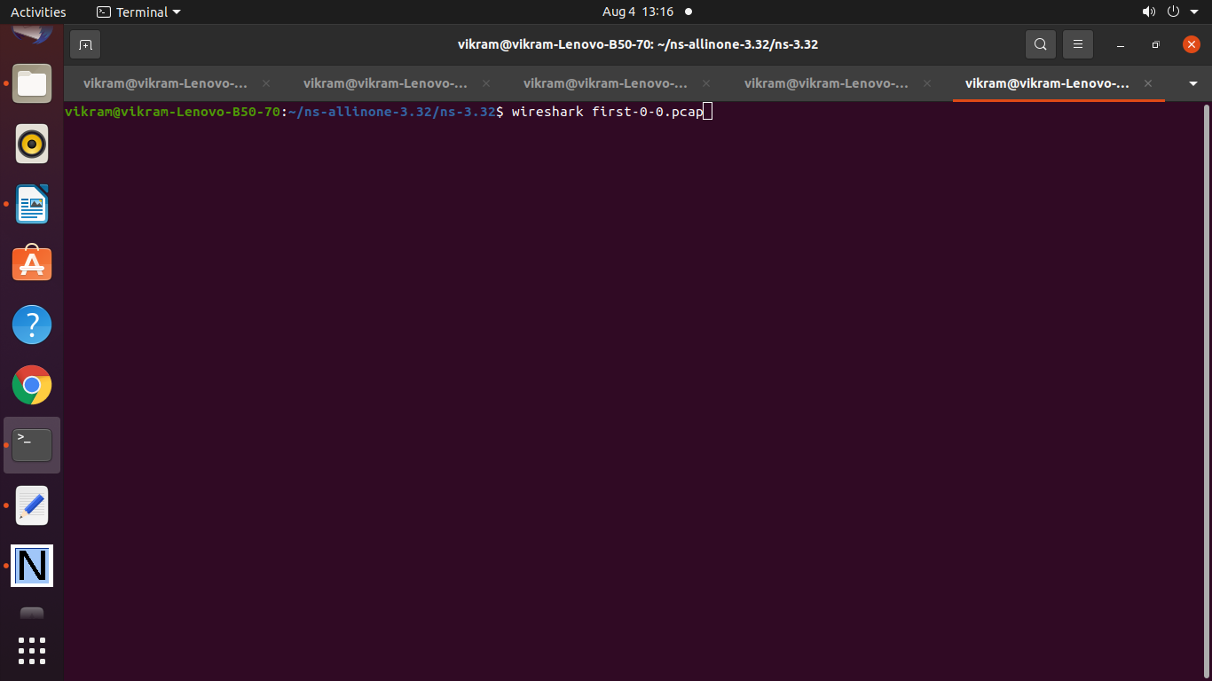

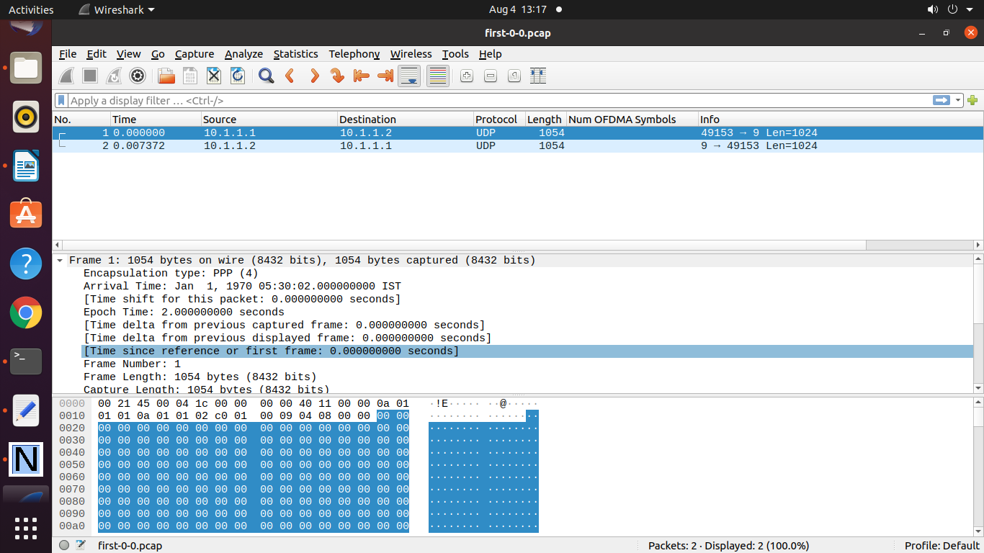

To Generate the Graph refer data.txt file

20 1 10080 4480 0.444444444444444 0.711796246648794

100 1 177457 36594 0.206213336188485 0.427518656716418

200 1 615864 107739 0.174939597053895 0.307852186936455

300 1 1264802 195851 0.154847161848258 0.264189805352033

400 3 2036278 254648 0.125055616178145 0.218597530952615

500 3 3142241 341094 0.108551190058306 0.193741027075484

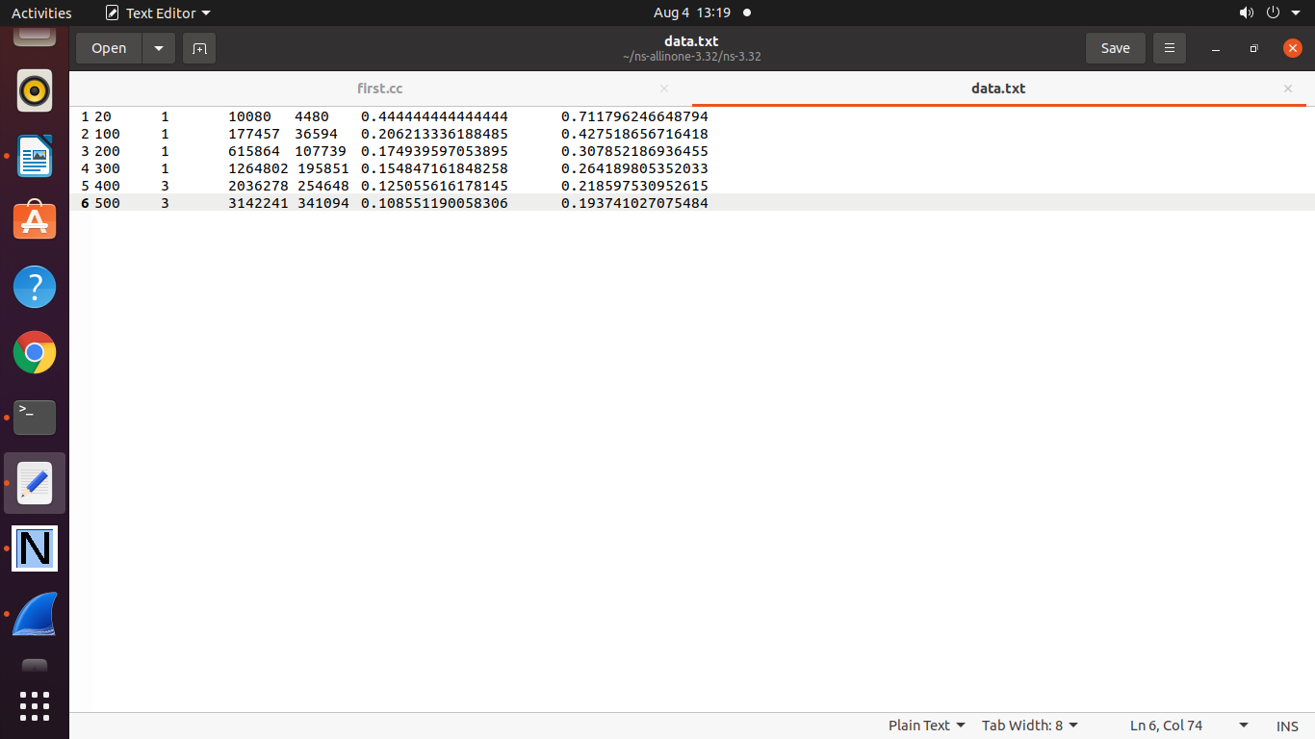

**gplot.plt file to Generate Graph**

set terminal png

set output "Lalit.png"

set title "Point to Point Toplogy end to end delay"

set xlabel "nodes"

set ylabel "end to end delay"

plot "data.txt" using 1: 5 with linespoint title "TimeDelay" lw 4,"data.txt" using 1: 6 with linespoint title "DBR " lw 2

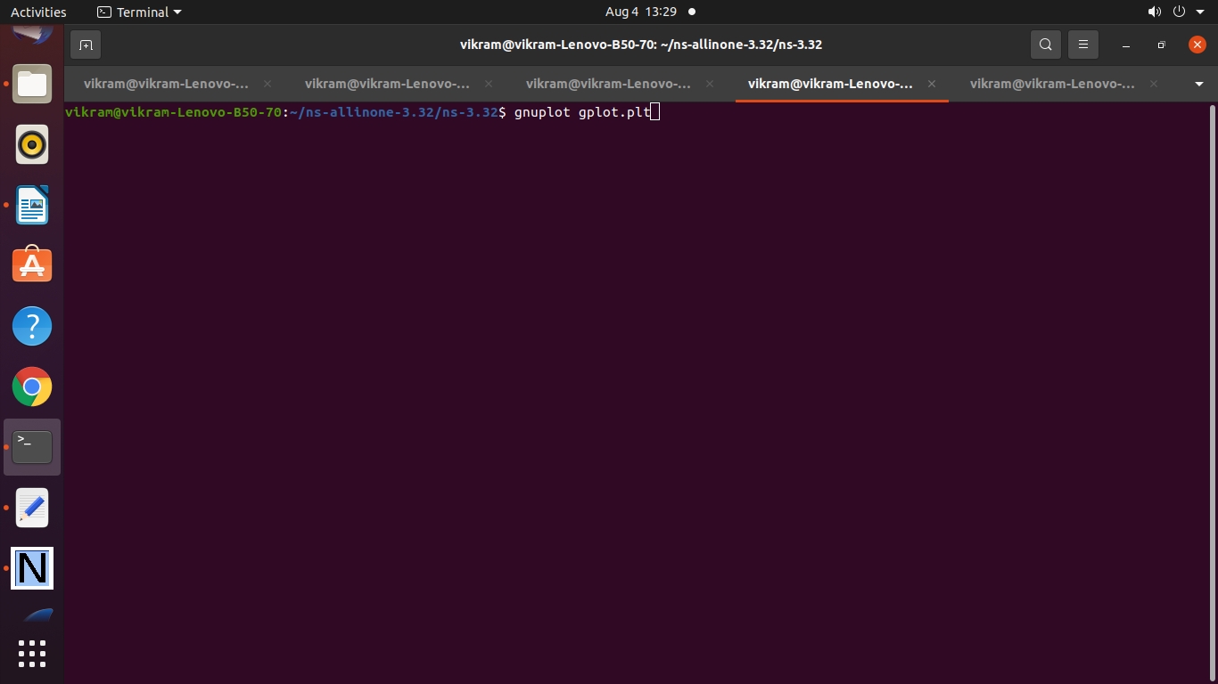

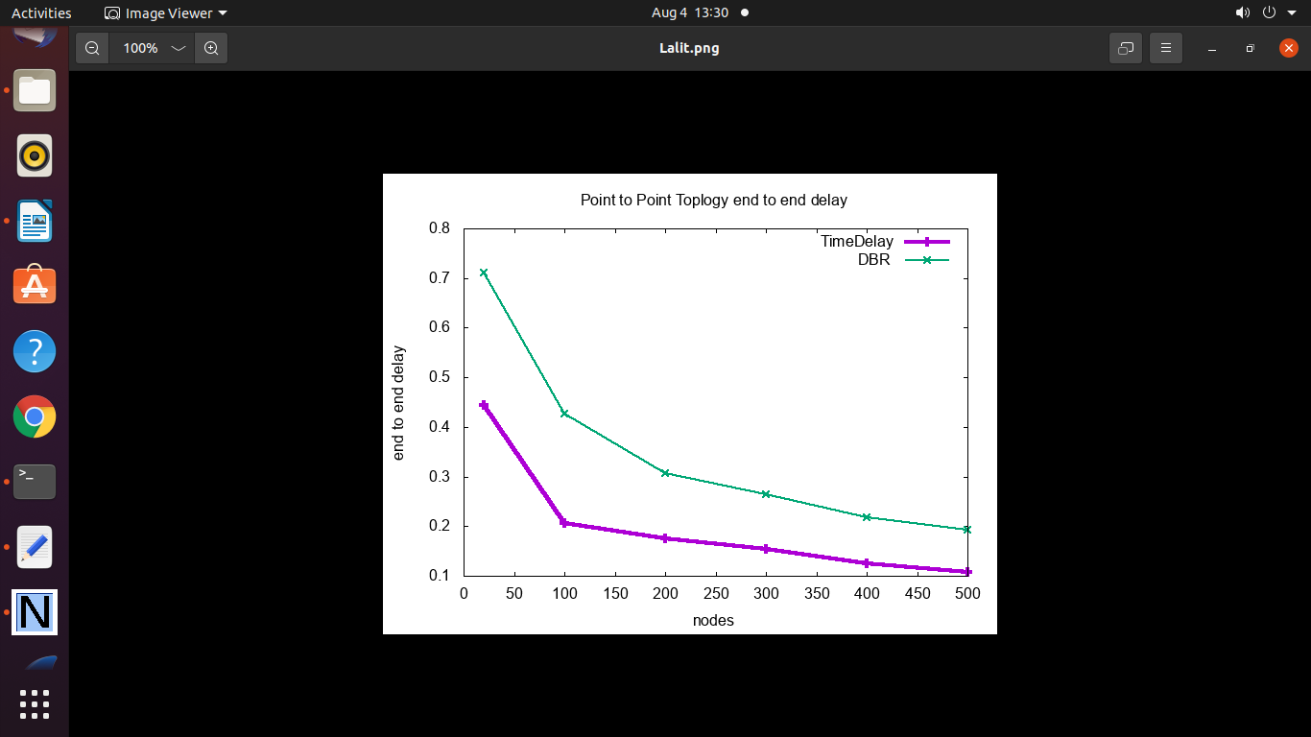======================================================

Practical 8: **Program to simulate Hybrid Topology**

**( Point-to-Point + Bus Toplogy)**

/* -*- Mode:C++; c-file-style:"gnu"; indent-tabs-mode:nil; -*- */

/*

* This program is free software; you can redistribute it and/or modify

* it under the terms of the GNU General Public License version 2 as

* published by the Free Software Foundation;

*

* This program is distributed in the hope that it will be useful,

* but WITHOUT ANY WARRANTY; without even the implied warranty of

* MERCHANTABILITY or FITNESS FOR A PARTICULAR PURPOSE. See the

* GNU General Public License for more details.

*

* You should have received a copy of the GNU General Public License

* along with this program; if not, write to the Free Software

* Foundation, Inc., 59 Temple Place, Suite 330, Boston, MA 02111-1307 USA

*/

#include "ns3/core-module.h"

#include "ns3/network-module.h"

#include "ns3/csma-module.h"

#include "ns3/internet-module.h"

#include "ns3/point-to-point-module.h"

#include "ns3/applications-module.h"

#include "ns3/ipv4-global-routing-helper.h"

// Default Network Topology

//

// 10.1.1.0

// n0 -------------- n1 n2 n3 n4

// point-to-point | | | |

// ================

// LAN 10.1.2.0

//netAnimation

#include "ns3/netanim-module.h"

#include "ns3/mobility-module.h"

using namespace ns3;

NS_LOG_COMPONENT_DEFINE ("SecondScriptExample");

int

main (int argc, char *argv[])

{

bool verbose = true;

uint32_t nCsma = 3;

CommandLine cmd (__FILE__);

cmd.AddValue ("nCsma", "Number of \"extra\" CSMA nodes/devices", nCsma);

cmd.AddValue ("verbose", "Tell echo applications to log if true", verbose);

cmd.Parse (argc,argv);

if (verbose)

{

LogComponentEnable ("UdpEchoClientApplication", LOG_LEVEL_INFO);

LogComponentEnable ("UdpEchoServerApplication", LOG_LEVEL_INFO);

}

nCsma = nCsma == 0 ? 1 : nCsma;

NodeContainer p2pNodes;

p2pNodes.Create (2);

NodeContainer csmaNodes;

csmaNodes.Add (p2pNodes.Get (1));

csmaNodes.Create (nCsma);

PointToPointHelper pointToPoint;

pointToPoint.SetDeviceAttribute ("DataRate", StringValue ("5Mbps"));

pointToPoint.SetChannelAttribute ("Delay", StringValue ("2ms"));

NetDeviceContainer p2pDevices;

p2pDevices = pointToPoint.Install (p2pNodes);

CsmaHelper csma;

csma.SetChannelAttribute ("DataRate", StringValue ("100Mbps"));

csma.SetChannelAttribute ("Delay", TimeValue (NanoSeconds (6560)));

NetDeviceContainer csmaDevices;

csmaDevices = csma.Install (csmaNodes);

InternetStackHelper stack;

stack.Install (p2pNodes.Get (0));

stack.Install (csmaNodes);

Ipv4AddressHelper address;

address.SetBase ("10.1.1.0", "255.255.255.0");

Ipv4InterfaceContainer p2pInterfaces;

p2pInterfaces = address.Assign (p2pDevices);

address.SetBase ("10.1.2.0", "255.255.255.0");

Ipv4InterfaceContainer csmaInterfaces;

csmaInterfaces = address.Assign (csmaDevices);

UdpEchoServerHelper echoServer (9);

ApplicationContainer serverApps = echoServer.Install (csmaNodes.Get (nCsma));

serverApps.Start (Seconds (1.0));

serverApps.Stop (Seconds (10.0));

UdpEchoClientHelper echoClient (csmaInterfaces.GetAddress (nCsma), 9);

echoClient.SetAttribute ("MaxPackets", UintegerValue (1));

echoClient.SetAttribute ("Interval", TimeValue (Seconds (1.0)));

echoClient.SetAttribute ("PacketSize", UintegerValue (1024));

ApplicationContainer clientApps = echoClient.Install (p2pNodes.Get (0));

clientApps.Start (Seconds (2.0));

clientApps.Stop (Seconds (10.0));

Ipv4GlobalRoutingHelper::PopulateRoutingTables ();

pointToPoint.EnablePcapAll ("second");

csma.EnablePcap ("second", csmaDevices.Get (1), true);

//For Net Anim

MobilityHelper mobility;

mobility.SetMobilityModel("ns3::ConstantPositionMobilityModel");

mobility.Install(p2pNodes);

mobility.Install(csmaNodes);

AnimationInterface anim("second.xml");

AnimationInterface::SetConstantPosition (p2pNodes.Get(0), 10, 25);

AnimationInterface ::SetConstantPosition(p2pNodes.Get(1), 20,25);

AnimationInterface ::SetConstantPosition(csmaNodes.Get(1),40,25);

AnimationInterface ::SetConstantPosition(csmaNodes.Get(2),50,25);

AnimationInterface ::SetConstantPosition(csmaNodes.Get(3),60,25);

anim.EnablePacketMetadata(true);

Simulator::Run ();

Simulator::Destroy ();

return 0;

}

**Output :**

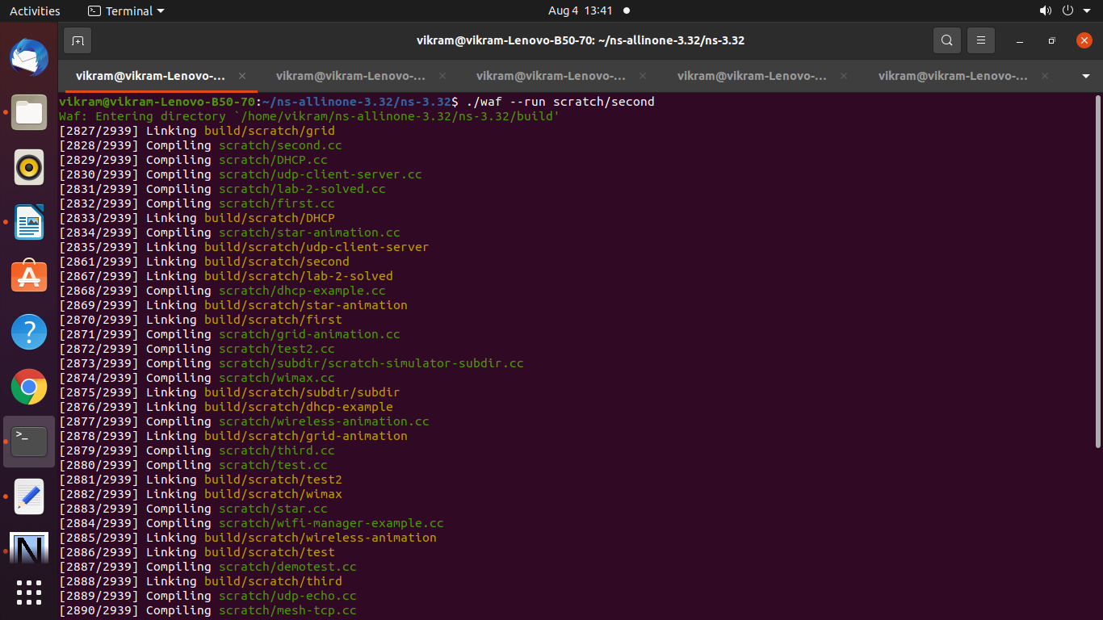

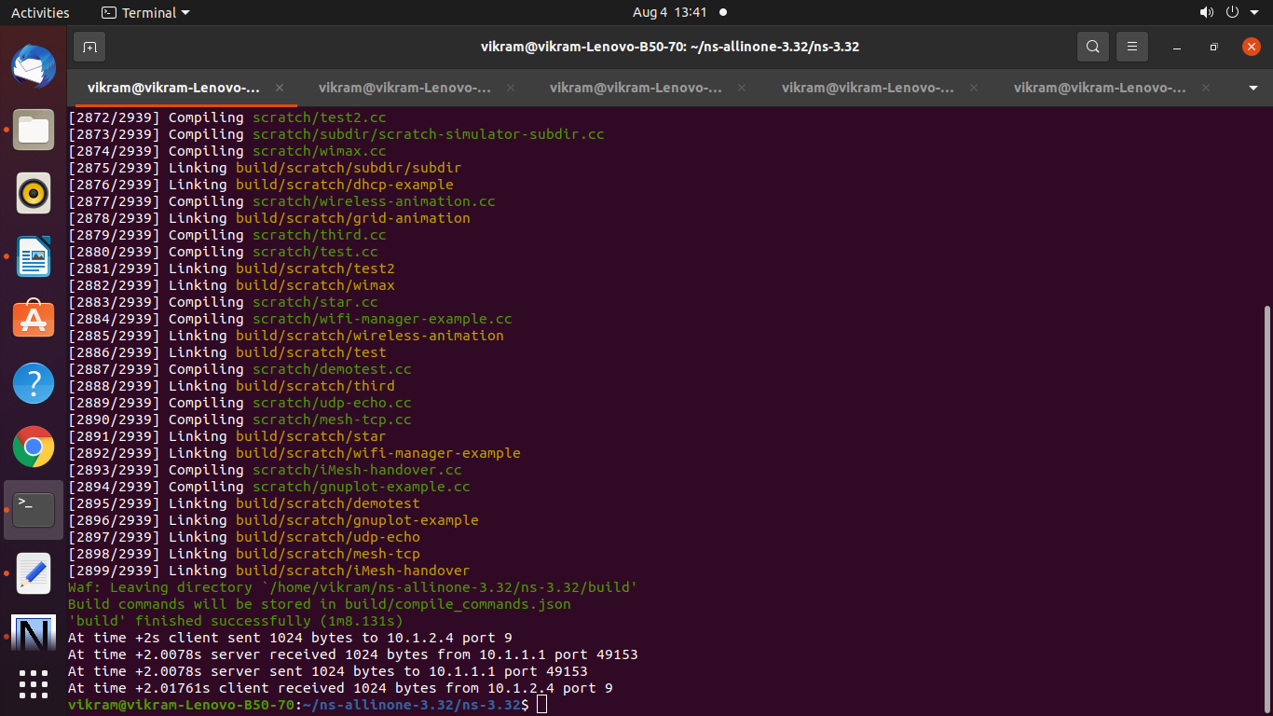

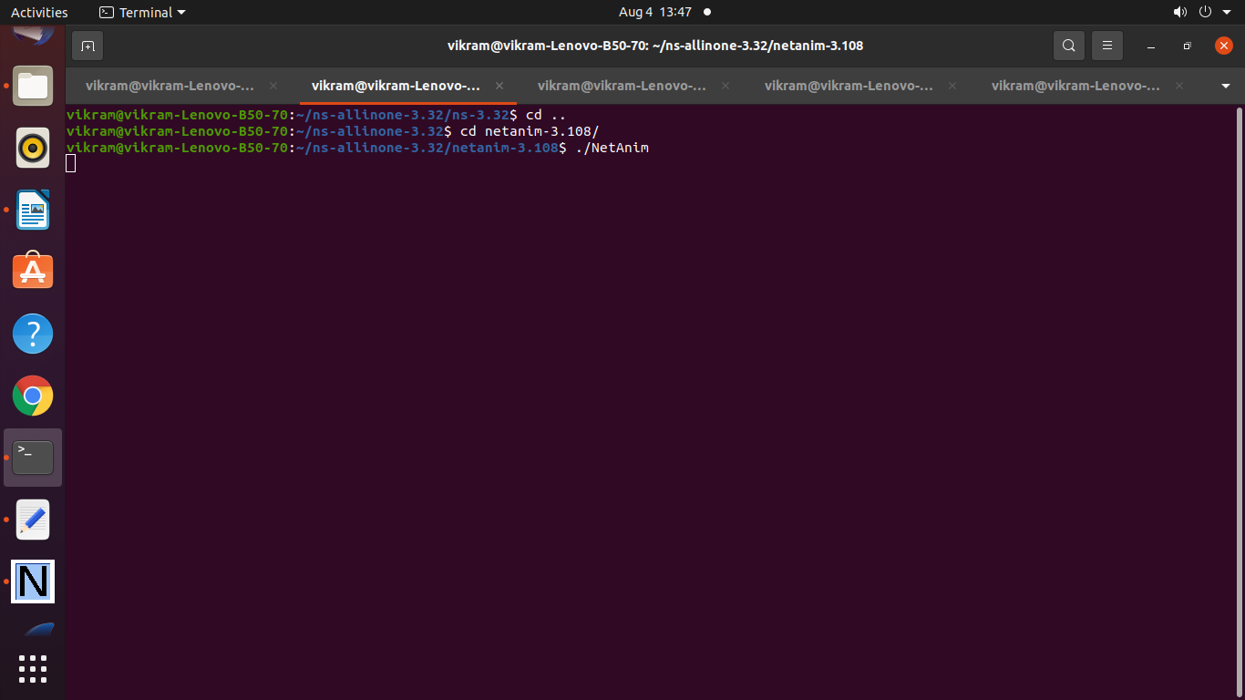

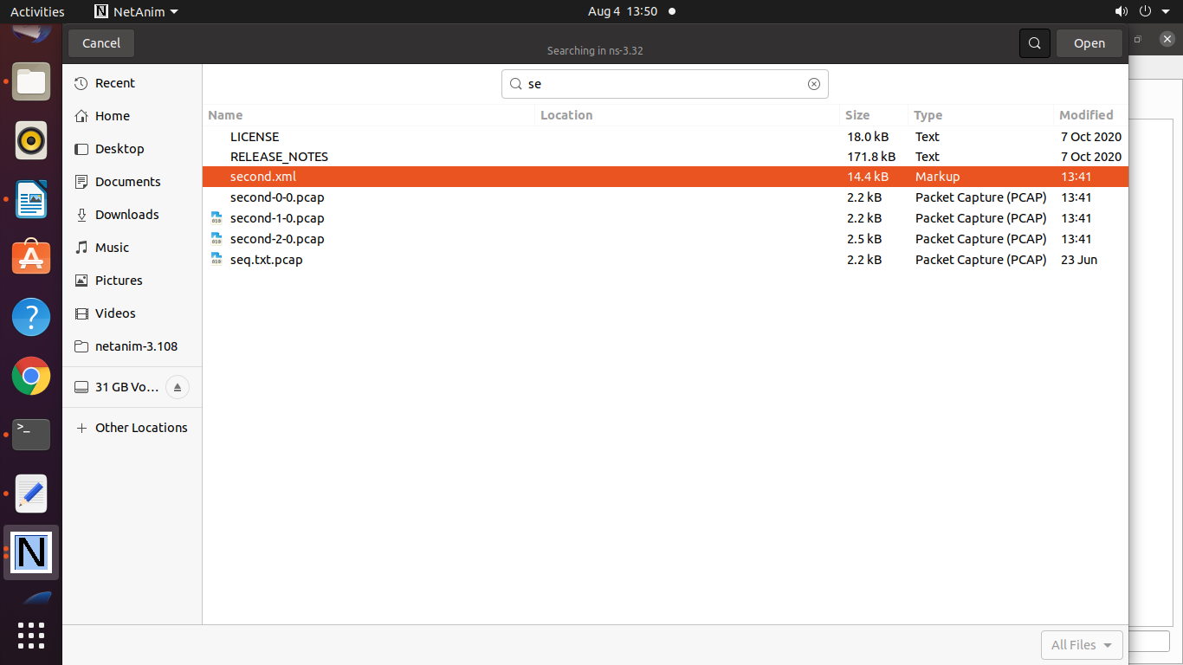

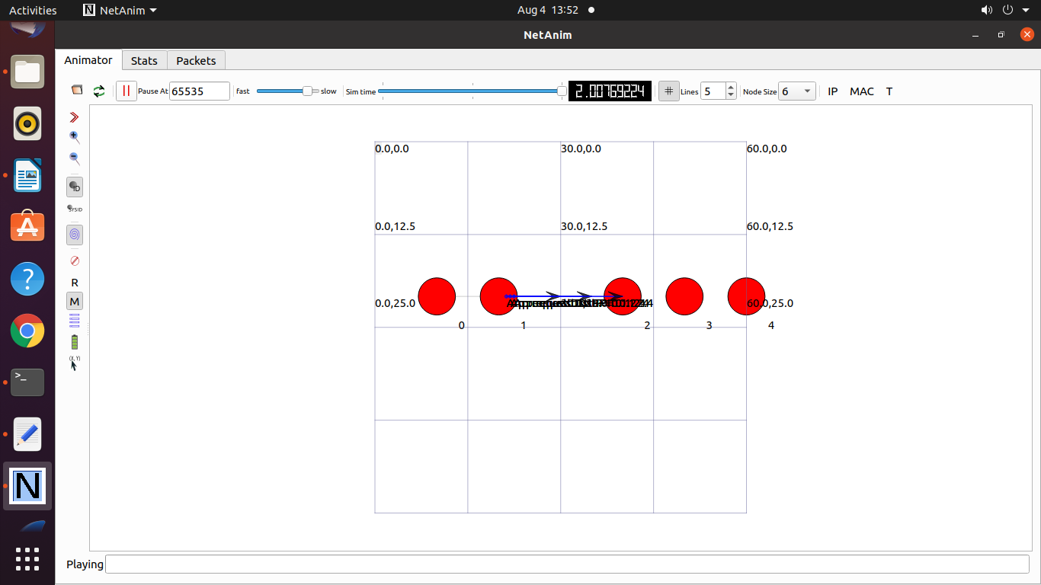

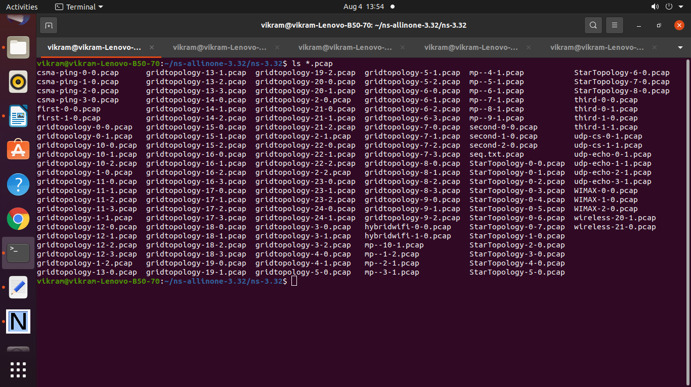

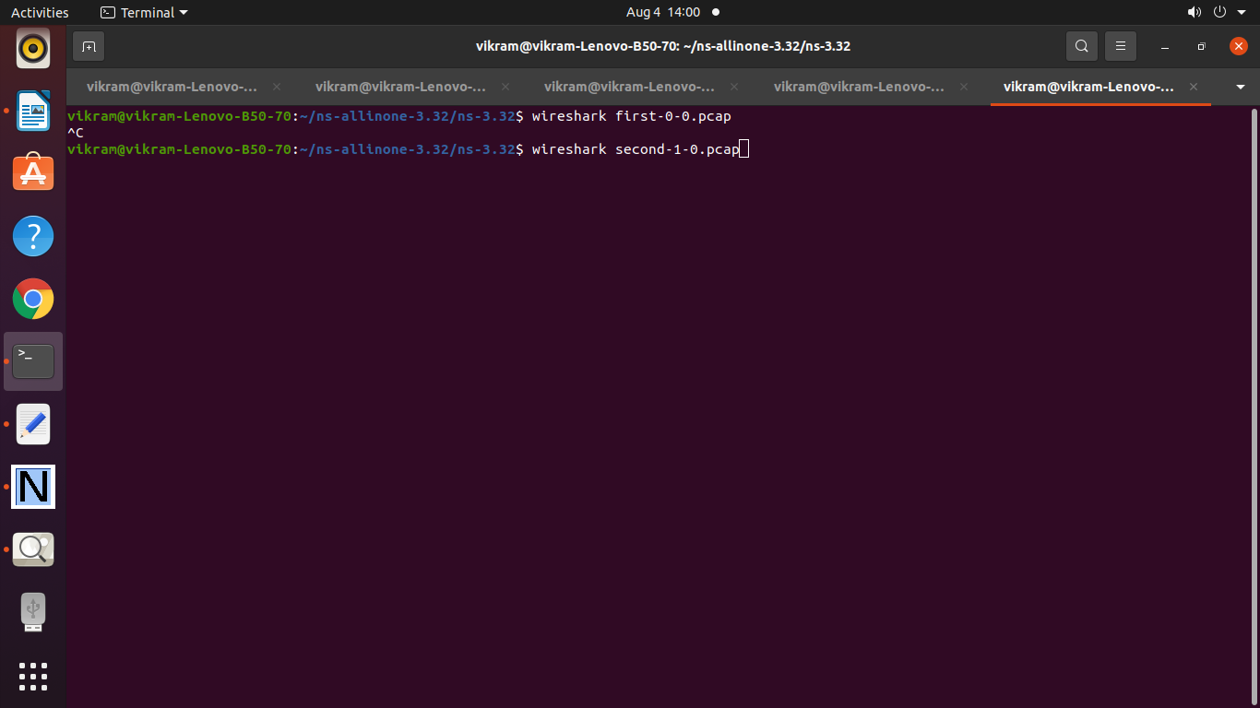

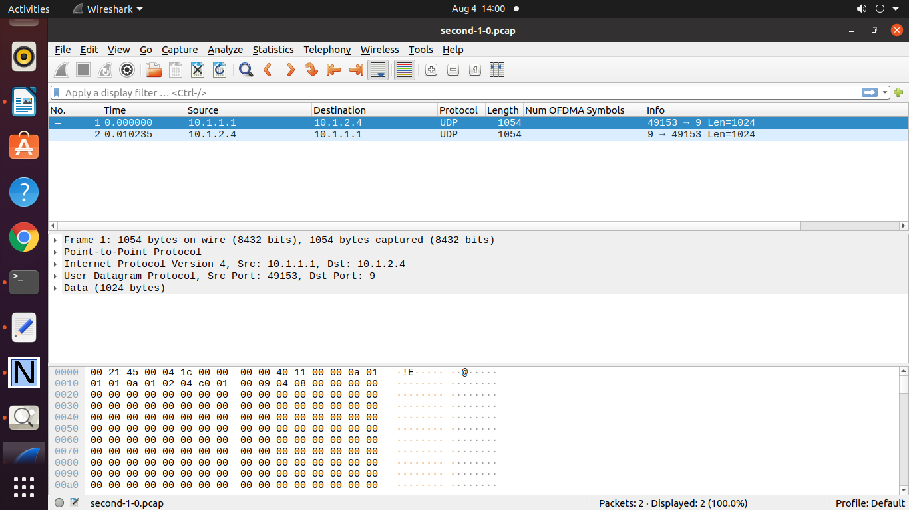

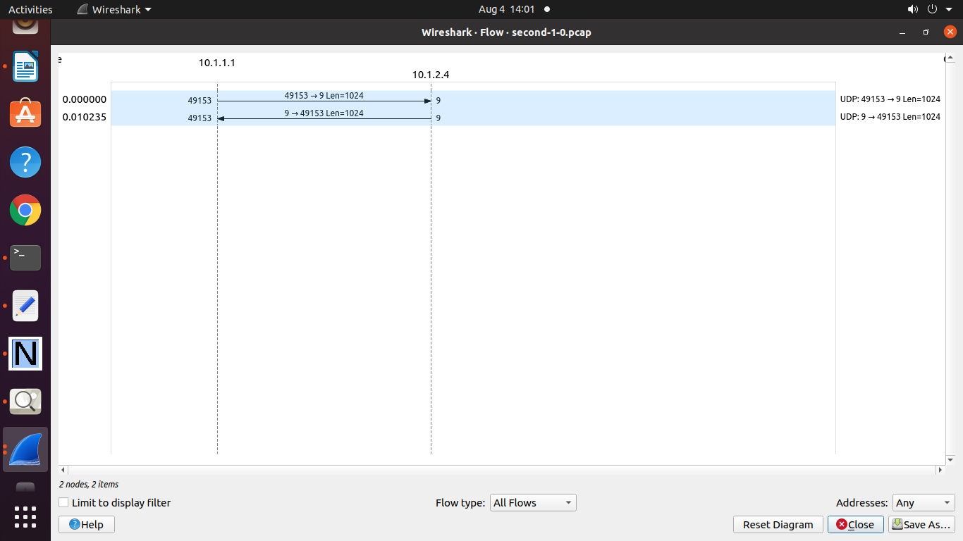

To draw a Graph

**lan.txt**

2 123 345 2.0067 3.009

3 123 45 1.09 2.45

4

5

--------------

**lan.plt**

set terminal pdf

set output "Anas.pdf"

set title "PtoP and Bus topology"

set xlabel "Nodes"

set ylabel "time delay"

plot "aaa.txt" using 1: 5 with linespoint title "LAN" lw 4

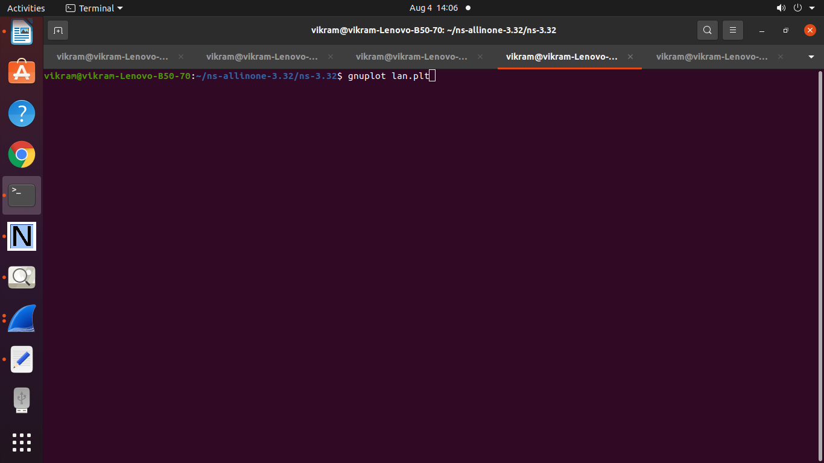

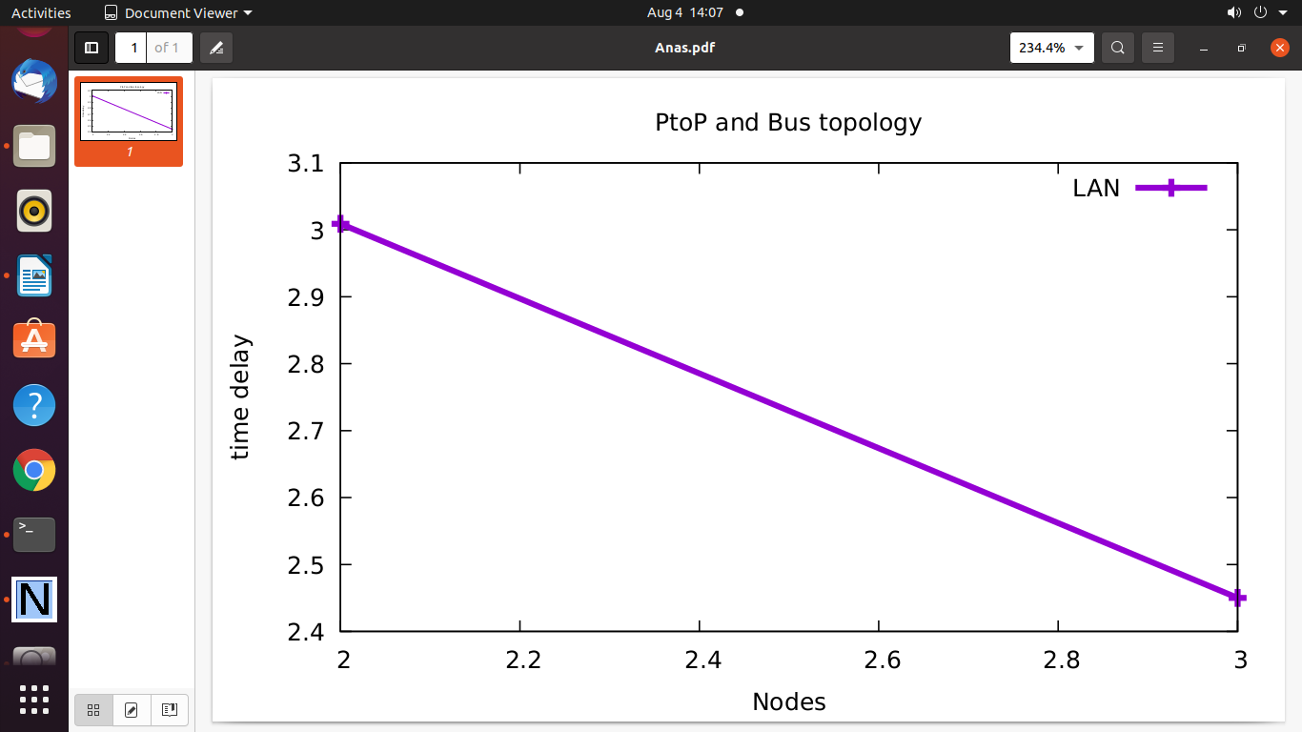

=========================================

**Practical 9: Program to Simulate Hybrid LAN with Wi-Fi**

/* -*- Mode:C++; c-file-style:"gnu"; indent-tabs-mode:nil; -*- */

/*

* This program is free software; you can redistribute it and/or modify

* it under the terms of the GNU General Public License version 2 as

* published by the Free Software Foundation;

*

* This program is distributed in the hope that it will be useful,

* but WITHOUT ANY WARRANTY; without even the implied warranty of

* MERCHANTABILITY or FITNESS FOR A PARTICULAR PURPOSE. See the

* GNU General Public License for more details.

*

* You should have received a copy of the GNU General Public License

* along with this program; if not, write to the Free Software

* Foundation, Inc., 59 Temple Place, Suite 330, Boston, MA 02111-1307 USA

*/

#include "ns3/core-module.h"

#include "ns3/point-to-point-module.h"

#include "ns3/network-module.h"

#include "ns3/applications-module.h"

#include "ns3/mobility-module.h"

#include "ns3/csma-module.h"

#include "ns3/internet-module.h"

#include "ns3/yans-wifi-helper.h"

#include "ns3/ssid.h"

//netanimation

#include "ns3/netanim-module.h"

// Default Network Topology

//

// Wifi 10.1.3.0

// AP

// * * * *

// | | | | 10.1.1.0

// n5 n6 n7 n0 -------------- n1 n2 n3 n4

// point-to-point | | | |

// ================

// LAN 10.1.2.0

using namespace ns3;

NS_LOG_COMPONENT_DEFINE ("ThirdScriptExample");

int

main (int argc, char *argv[])

{

bool verbose = true;

uint32_t nCsma = 3;

uint32_t nWifi = 3;

bool tracing = false;

CommandLine cmd (__FILE__);

cmd.AddValue ("nCsma", "Number of \"extra\" CSMA nodes/devices", nCsma);

cmd.AddValue ("nWifi", "Number of wifi STA devices", nWifi);

cmd.AddValue ("verbose", "Tell echo applications to log if true", verbose);

cmd.AddValue ("tracing", "Enable pcap tracing", tracing);

cmd.Parse (argc,argv);

// The underlying restriction of 18 is due to the grid position

// allocator's configuration; the grid layout will exceed the

// bounding box if more than 18 nodes are provided.

if (nWifi > 18)

{

std::cout << "nWifi should be 18 or less; otherwise grid layout exceeds the bounding box" << std::endl;

return 1;

}

if (verbose)

{

LogComponentEnable ("UdpEchoClientApplication", LOG_LEVEL_INFO);

LogComponentEnable ("UdpEchoServerApplication", LOG_LEVEL_INFO);

}

NodeContainer p2pNodes;

p2pNodes.Create (2);

PointToPointHelper pointToPoint;

pointToPoint.SetDeviceAttribute ("DataRate", StringValue ("5Mbps"));

pointToPoint.SetChannelAttribute ("Delay", StringValue ("2ms"));

NetDeviceContainer p2pDevices;

p2pDevices = pointToPoint.Install (p2pNodes);

NodeContainer csmaNodes;

csmaNodes.Add (p2pNodes.Get (1));

csmaNodes.Create (nCsma);

CsmaHelper csma;

csma.SetChannelAttribute ("DataRate", StringValue ("100Mbps"));

csma.SetChannelAttribute ("Delay", TimeValue (NanoSeconds (6560)));

NetDeviceContainer csmaDevices;

csmaDevices = csma.Install (csmaNodes);

NodeContainer wifiStaNodes;

wifiStaNodes.Create (nWifi);

NodeContainer wifiApNode = p2pNodes.Get (0);

YansWifiChannelHelper channel = YansWifiChannelHelper::Default ();

YansWifiPhyHelper phy = YansWifiPhyHelper::Default ();

phy.SetChannel (channel.Create ());

WifiHelper wifi;

wifi.SetRemoteStationManager ("ns3::AarfWifiManager");

WifiMacHelper mac;

Ssid ssid = Ssid ("ns-3-ssid");

mac.SetType ("ns3::StaWifiMac",

"Ssid", SsidValue (ssid),

"ActiveProbing", BooleanValue (false));

NetDeviceContainer staDevices;

staDevices = wifi.Install (phy, mac, wifiStaNodes);

mac.SetType ("ns3::ApWifiMac",

"Ssid", SsidValue (ssid));

NetDeviceContainer apDevices;

apDevices = wifi.Install (phy, mac, wifiApNode);

MobilityHelper mobility;

mobility.SetPositionAllocator ("ns3::GridPositionAllocator",

"MinX", DoubleValue (0.0),

"MinY", DoubleValue (0.0),

"DeltaX", DoubleValue (5.0),

"DeltaY", DoubleValue (10.0),

"GridWidth", UintegerValue (3),

"LayoutType", StringValue ("RowFirst"));

mobility.SetMobilityModel ("ns3::RandomWalk2dMobilityModel",

"Bounds", RectangleValue (Rectangle (-50, 50, -50, 50)));

mobility.Install (wifiStaNodes);

mobility.SetMobilityModel ("ns3::ConstantPositionMobilityModel");

mobility.Install (wifiApNode);

InternetStackHelper stack;

stack.Install (csmaNodes);

stack.Install (wifiApNode);

stack.Install (wifiStaNodes);

Ipv4AddressHelper address;

address.SetBase ("10.1.1.0", "255.255.255.0");

Ipv4InterfaceContainer p2pInterfaces;

p2pInterfaces = address.Assign (p2pDevices);

address.SetBase ("10.1.2.0", "255.255.255.0");

Ipv4InterfaceContainer csmaInterfaces;

csmaInterfaces = address.Assign (csmaDevices);

address.SetBase ("10.1.3.0", "255.255.255.0");

address.Assign (staDevices);

address.Assign (apDevices);

UdpEchoServerHelper echoServer (9);

ApplicationContainer serverApps = echoServer.Install (csmaNodes.Get (nCsma));

serverApps.Start (Seconds (1.0));

serverApps.Stop (Seconds (10.0));

UdpEchoClientHelper echoClient (csmaInterfaces.GetAddress (nCsma), 9);

echoClient.SetAttribute ("MaxPackets", UintegerValue (1));

echoClient.SetAttribute ("Interval", TimeValue (Seconds (1.0)));

echoClient.SetAttribute ("PacketSize", UintegerValue (1024));

ApplicationContainer clientApps =

echoClient.Install (wifiStaNodes.Get (nWifi - 1));

clientApps.Start (Seconds (2.0));

clientApps.Stop (Seconds (10.0));

Ipv4GlobalRoutingHelper::PopulateRoutingTables ();

AnimationInterface anim("hybridWiFi.xml");

AnimationInterface::SetConstantPosition (p2pNodes.Get(0), 10, 25);

AnimationInterface ::SetConstantPosition(csmaNodes.Get(1), 40,25);

anim.EnablePacketMetadata(true);

pointToPoint.EnablePcapAll("hybridwifi");

Simulator::Stop (Seconds (10.0));

if (tracing == true)

{

pointToPoint.EnablePcapAll ("third");

phy.EnablePcap ("third", apDevices.Get (0));

csma.EnablePcap ("third", csmaDevices.Get (0), true);

}

Simulator::Run ();

Simulator::Destroy();

return 0;

}

**Output :**

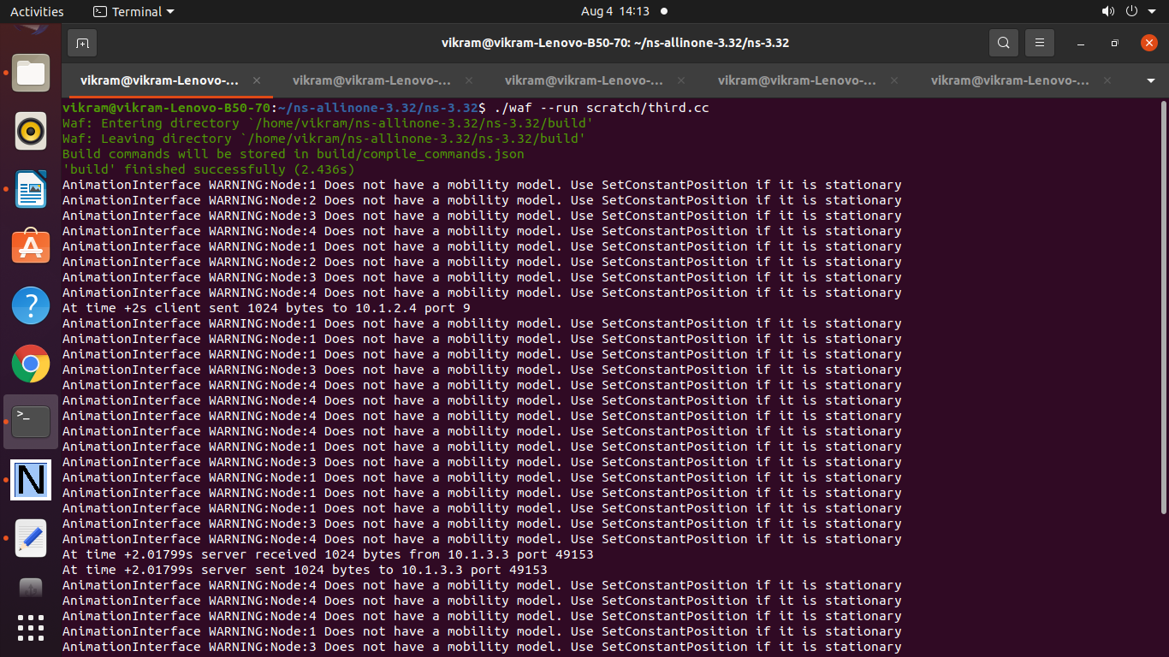

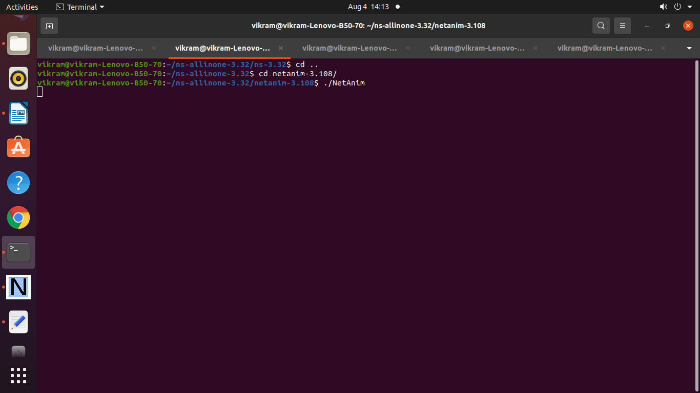

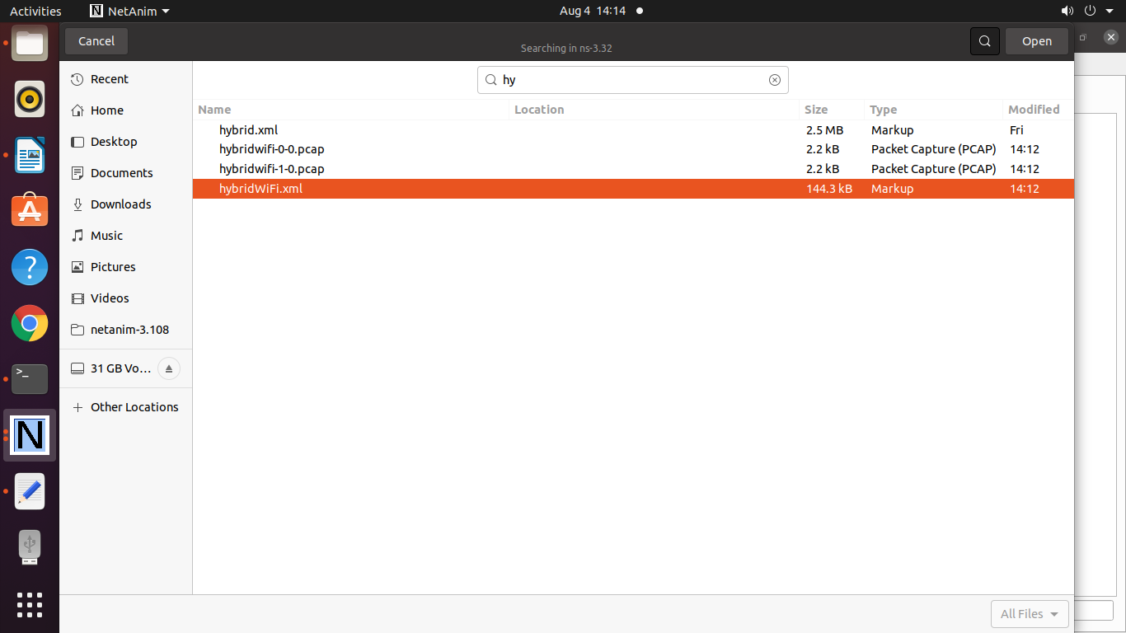

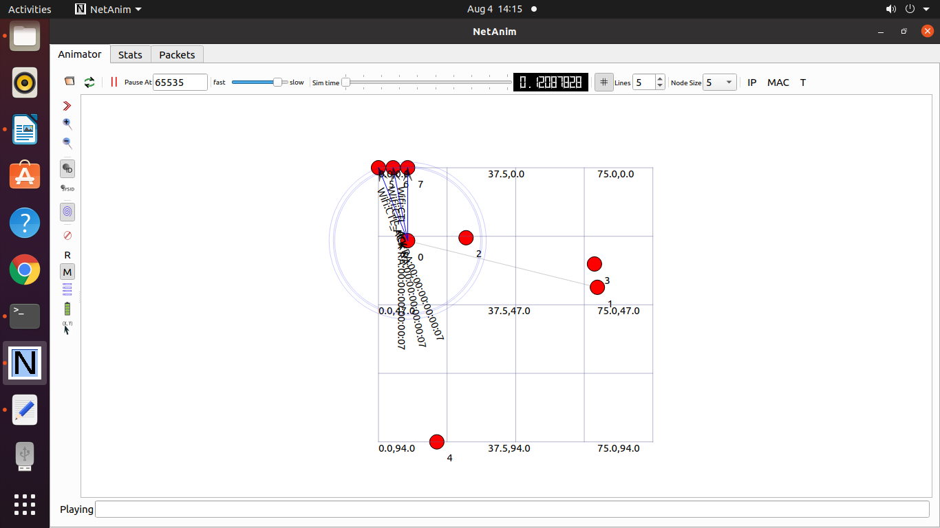

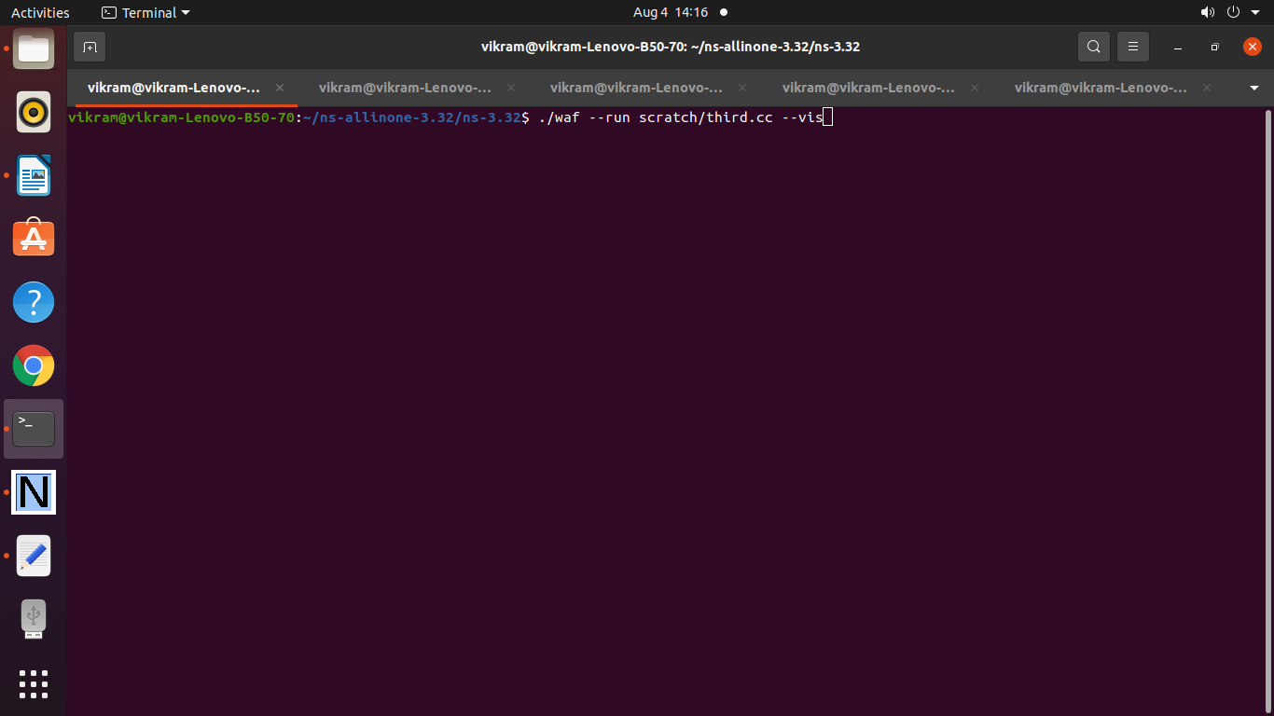

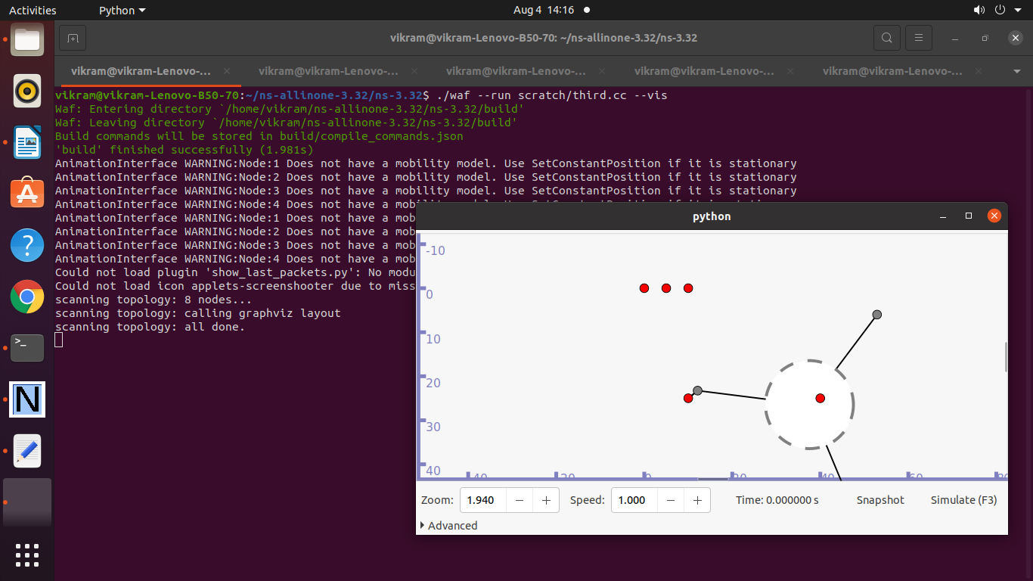

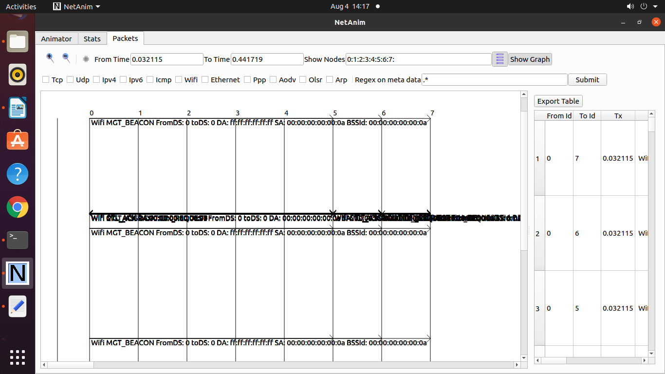

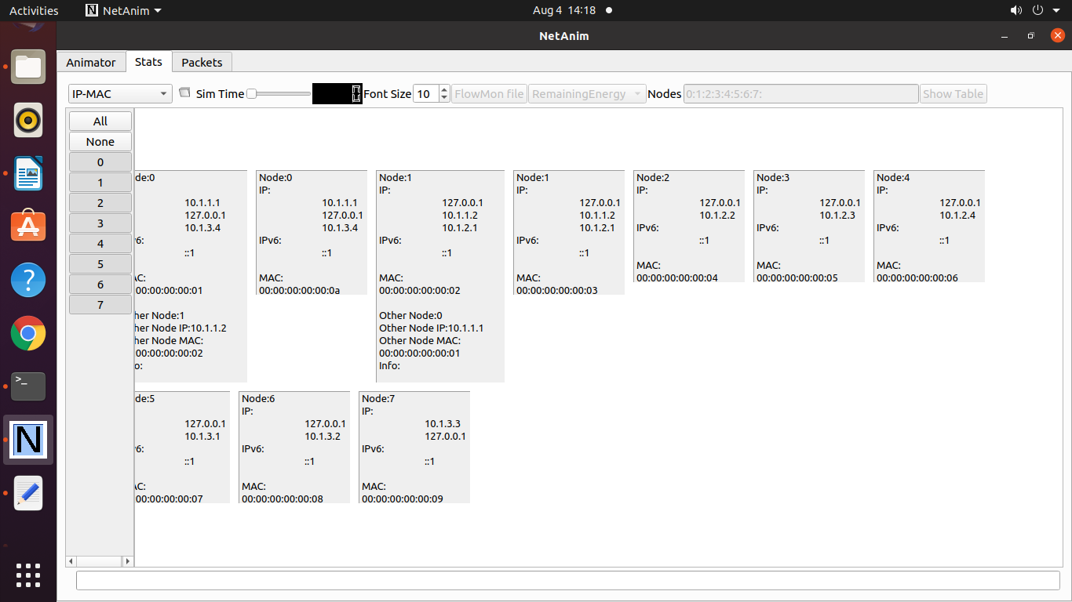

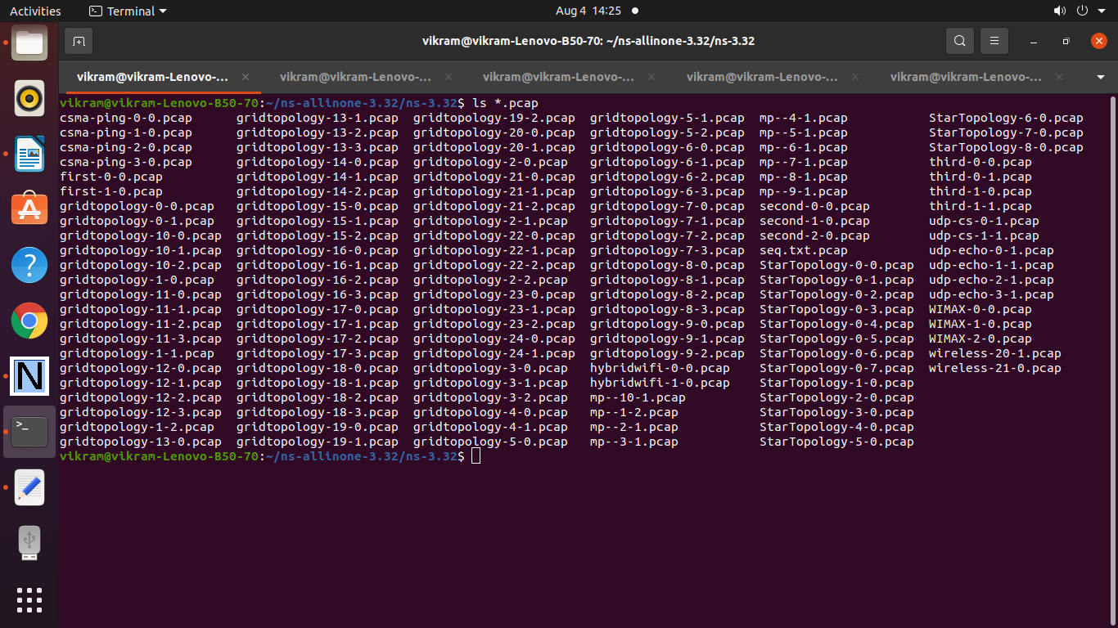

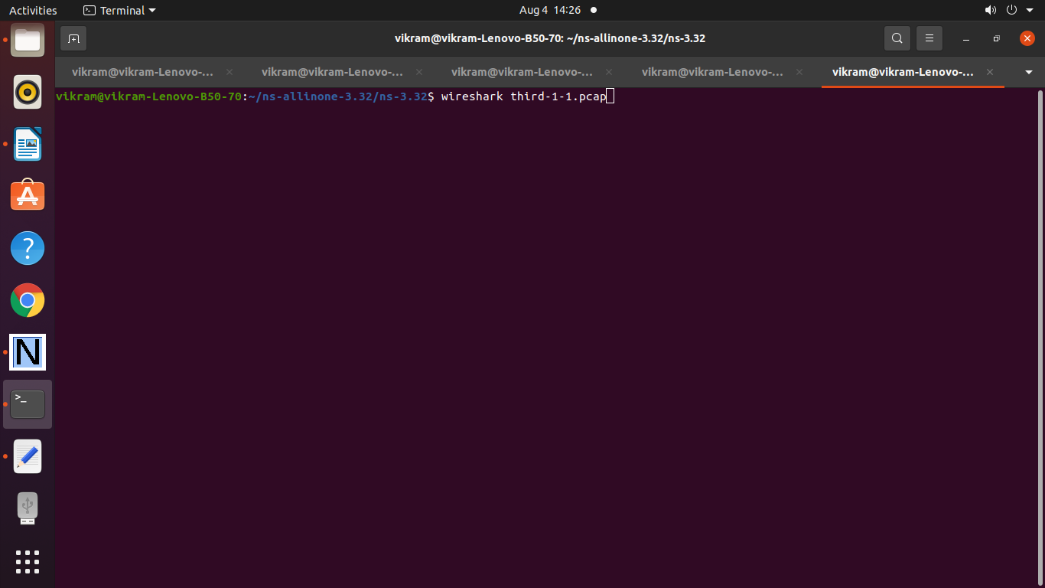

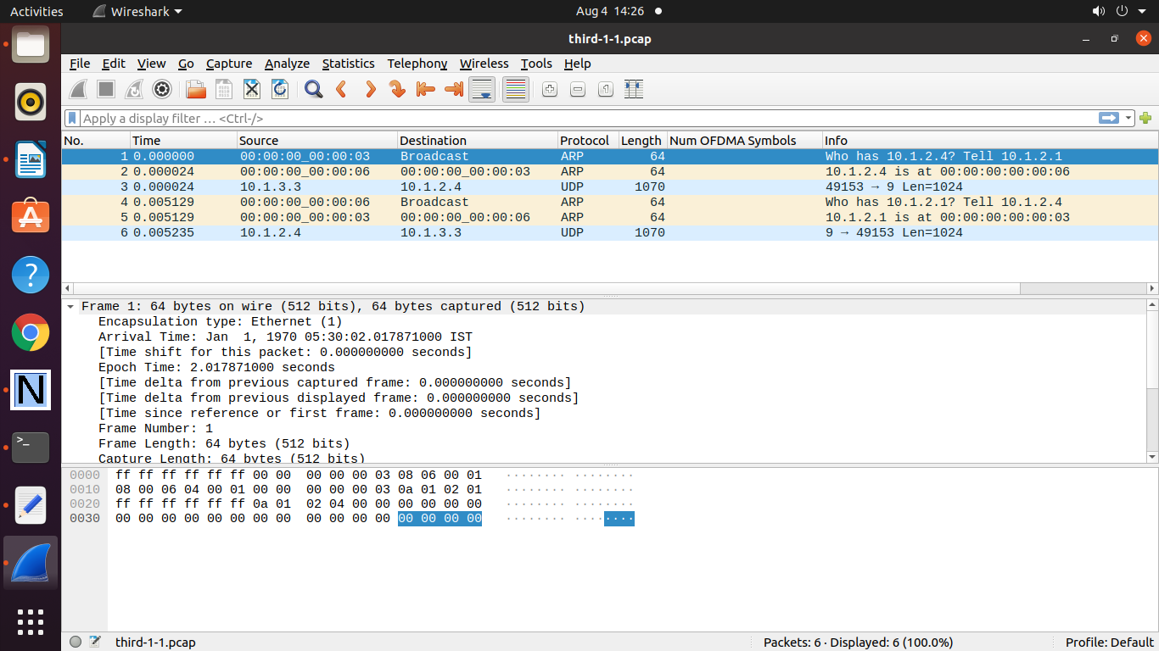

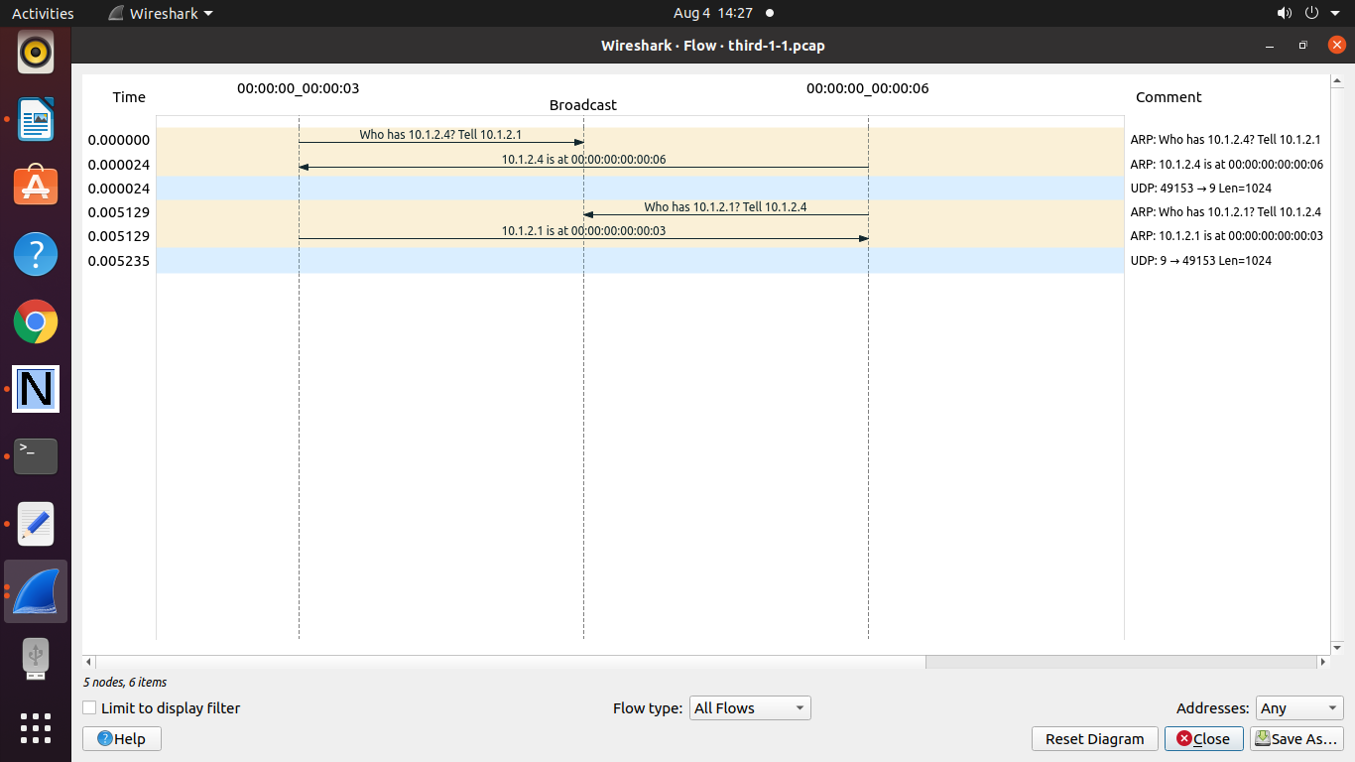

**To Plot a Graph**

**vikram.txt**

1 10 300 400 0.0045 0.0056

10 123 100 340 00.67 0.65

15 121 88 999 0.78 0.45

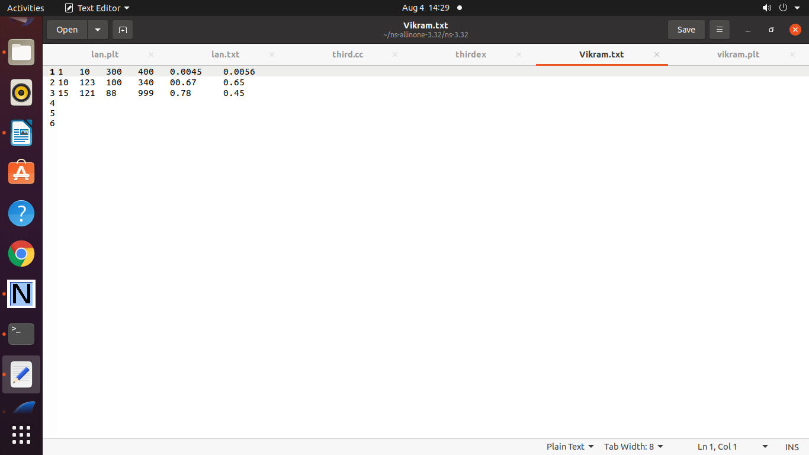

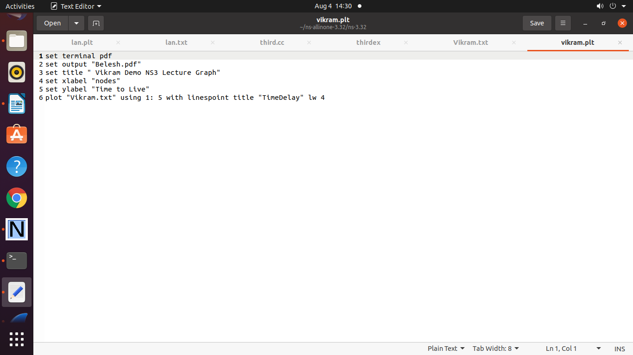

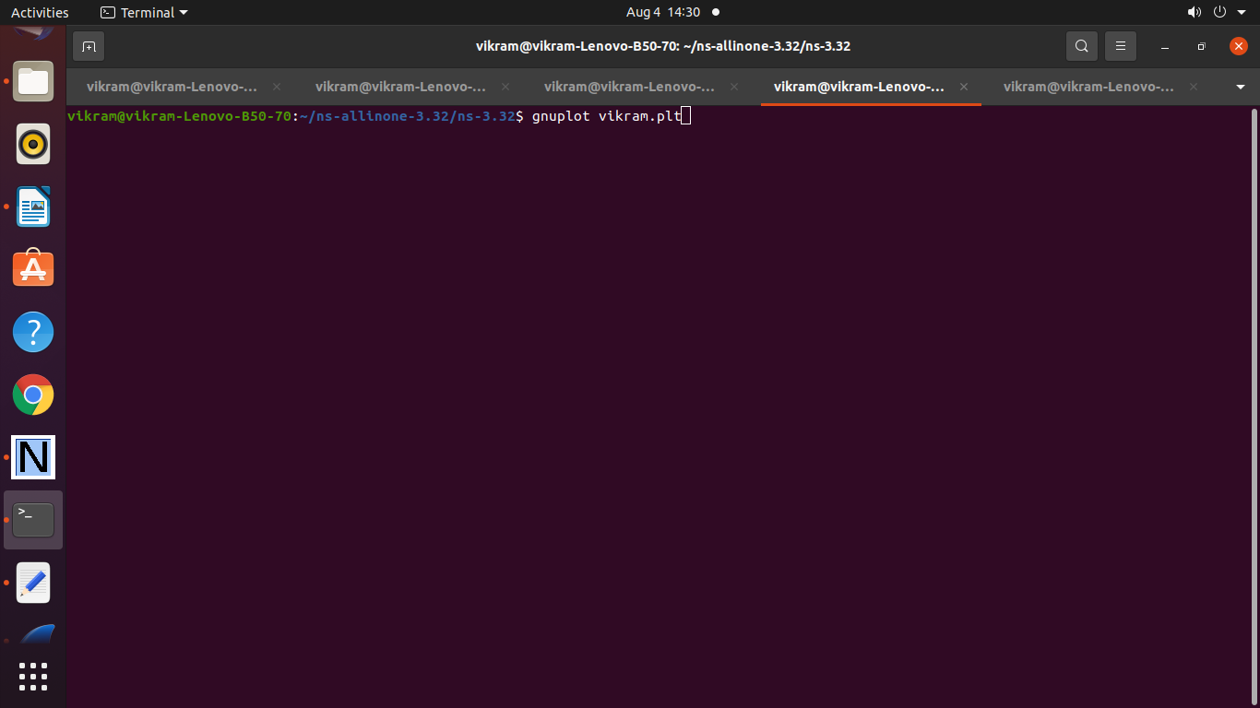

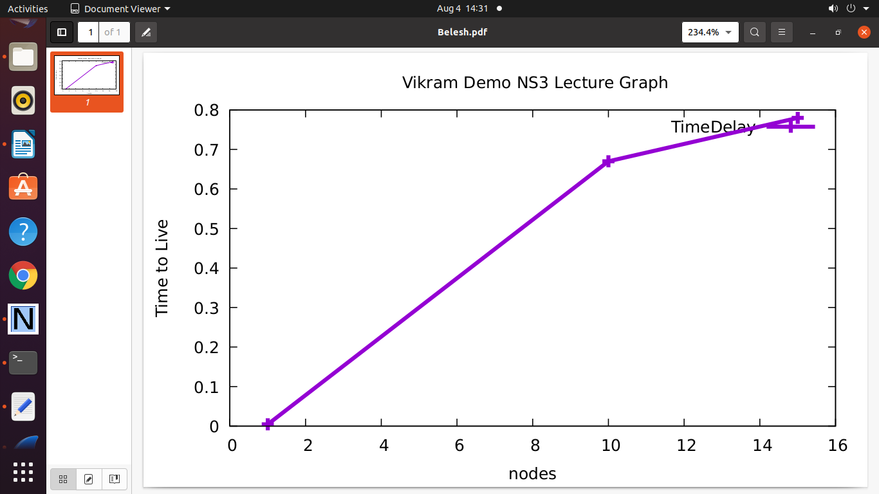

======================================================

**Practical 10: Program to Simulate Star Topology**

/* -*- Mode:C++; c-file-style:"gnu"; indent-tabs-mode:nil; -*- */

/*

* This program is free software; you can redistribute it and/or modify

* it under the terms of the GNU General Public License version 2 as

* published by the Free Software Foundation;

*

* This program is distributed in the hope that it will be useful,

* but WITHOUT ANY WARRANTY; without even the implied warranty of

* MERCHANTABILITY or FITNESS FOR A PARTICULAR PURPOSE. See the

* GNU General Public License for more details.

*

* You should have received a copy of the GNU General Public License

* along with this program; if not, write to the Free Software

* Foundation, Inc., 59 Temple Place, Suite 330, Boston, MA 02111-1307 USA

*

*/

#include "ns3/core-module.h"

#include "ns3/network-module.h"

#include "ns3/netanim-module.h"

#include "ns3/internet-module.h"

#include "ns3/point-to-point-module.h"

#include "ns3/applications-module.h"

#include "ns3/point-to-point-layout-module.h"

// Network topology (default)

//

// n2 n3 n4 .

// \ | / .

// \|/ .

// n1--- n0---n5 .

// /|\ .

// / | \ .

// n8 n7 n6 .

//

using namespace ns3;

NS_LOG_COMPONENT_DEFINE ("StarAnimation");

int

main (int argc, char *argv[])

{

//

// Set up some default values for the simulation.

//

Config::SetDefault ("ns3::OnOffApplication::PacketSize", UintegerValue (137));

// ??? try and stick 15kb/s into the data rate

Config::SetDefault ("ns3::OnOffApplication::DataRate", StringValue ("14kb/s"));

//

// Default number of nodes in the star. Overridable by command line argument.

//

uint32_t nSpokes = 8;

std::string animFile = "star-animation.xml";

uint8_t useIpv6 = 0;

Ipv6Address ipv6AddressBase = Ipv6Address("2001::");

Ipv6Prefix ipv6AddressPrefix = Ipv6Prefix(64);

CommandLine cmd;

cmd.AddValue ("nSpokes", "Number of spoke nodes to place in the star", nSpokes);

cmd.AddValue ("animFile", "File Name for Animation Output", animFile);

cmd.AddValue ("useIpv6", "use Ipv6", useIpv6);

cmd.Parse (argc, argv);

NS_LOG_INFO ("Build star topology.");

PointToPointHelper pointToPoint;

pointToPoint.SetDeviceAttribute ("DataRate", StringValue ("5Mbps"));

pointToPoint.SetChannelAttribute ("Delay", StringValue ("2ms"));

PointToPointStarHelper star (nSpokes, pointToPoint);

NS_LOG_INFO ("Install internet stack on all nodes.");

InternetStackHelper internet;

star.InstallStack (internet);

NS_LOG_INFO ("Assign IP Addresses.");

if (useIpv6 == 0)

{

star.AssignIpv4Addresses (Ipv4AddressHelper ("10.1.1.0", "255.255.255.0"));

}

else

{

star.AssignIpv6Addresses (ipv6AddressBase, ipv6AddressPrefix);

}

NS_LOG_INFO ("Create applications.");

//

// Create a packet sink on the star "hub" to receive packets.

//

uint16_t port = 50000;

Address hubLocalAddress;

if (useIpv6 == 0)

{

hubLocalAddress = InetSocketAddress (Ipv4Address::GetAny (), port);

}

else

{

hubLocalAddress = Inet6SocketAddress (Ipv6Address::GetAny (), port);

}

PacketSinkHelper packetSinkHelper ("ns3::TcpSocketFactory", hubLocalAddress);

ApplicationContainer hubApp = packetSinkHelper.Install (star.GetHub ());

hubApp.Start (Seconds (1.0));

hubApp.Stop (Seconds (10.0));

//

// Create OnOff applications to send TCP to the hub, one on each spoke node.

//

OnOffHelper onOffHelper ("ns3::TcpSocketFactory", Address ());

onOffHelper.SetAttribute ("OnTime", StringValue ("ns3::ConstantRandomVariable[Constant=1]"));

onOffHelper.SetAttribute ("OffTime", StringValue ("ns3::ConstantRandomVariable[Constant=0]"));

ApplicationContainer spokeApps;

for (uint32_t i = 0; i < star.SpokeCount (); ++i)

{

AddressValue remoteAddress;

if (useIpv6 == 0)

{

remoteAddress = AddressValue(InetSocketAddress (star.GetHubIpv4Address (i), port));

}

else

{

remoteAddress = AddressValue(Inet6SocketAddress (star.GetHubIpv6Address (i), port));

}

onOffHelper.SetAttribute ("Remote", remoteAddress);

spokeApps.Add (onOffHelper.Install (star.GetSpokeNode (i)));

}

spokeApps.Start (Seconds (1.0));

spokeApps.Stop (Seconds (10.0));

NS_LOG_INFO ("Enable static global routing.");

//

// Turn on global static routing so we can actually be routed across the star.

//

if (useIpv6 == 0)

{

Ipv4GlobalRoutingHelper::PopulateRoutingTables ();

}

// Set the bounding box for animation

star.BoundingBox (1, 1, 100, 100);

// Create the animation object and configure for specified output

AnimationInterface anim (animFile);

NS_LOG_INFO ("Run Simulation.");

Simulator::Run ();

Simulator::Destroy ();

NS_LOG_INFO ("Done.");

return 0;

}

**Output :**

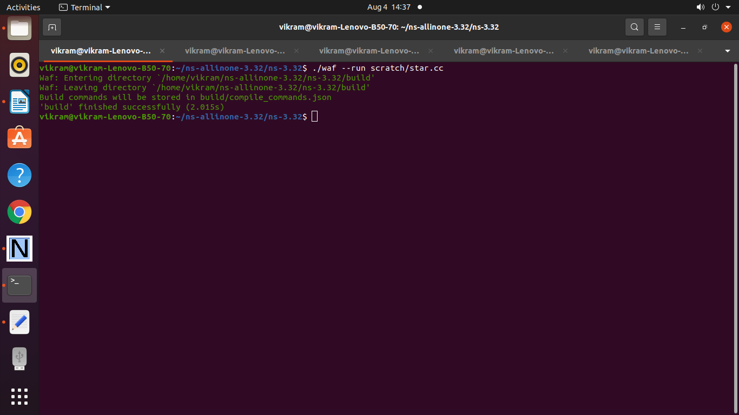

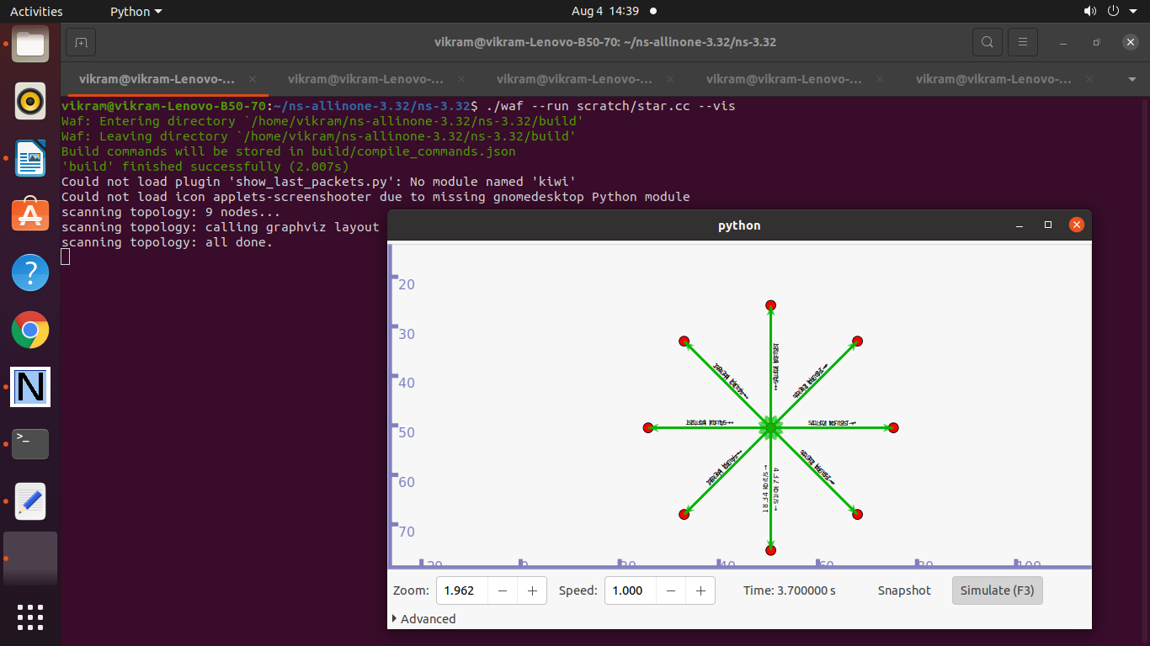

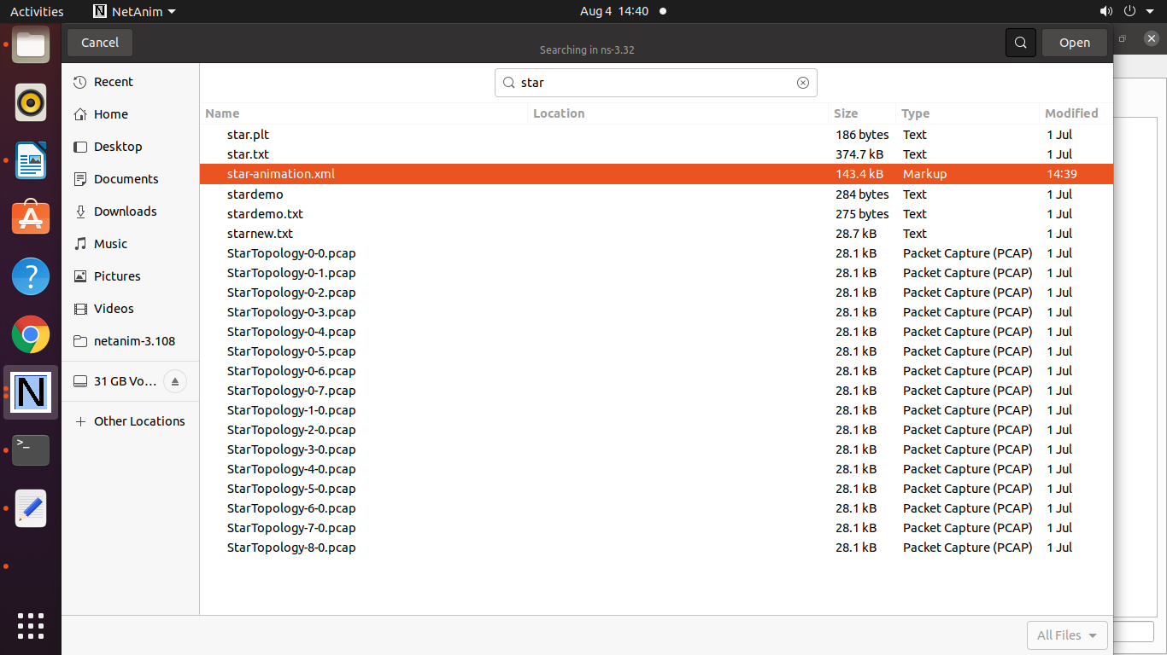

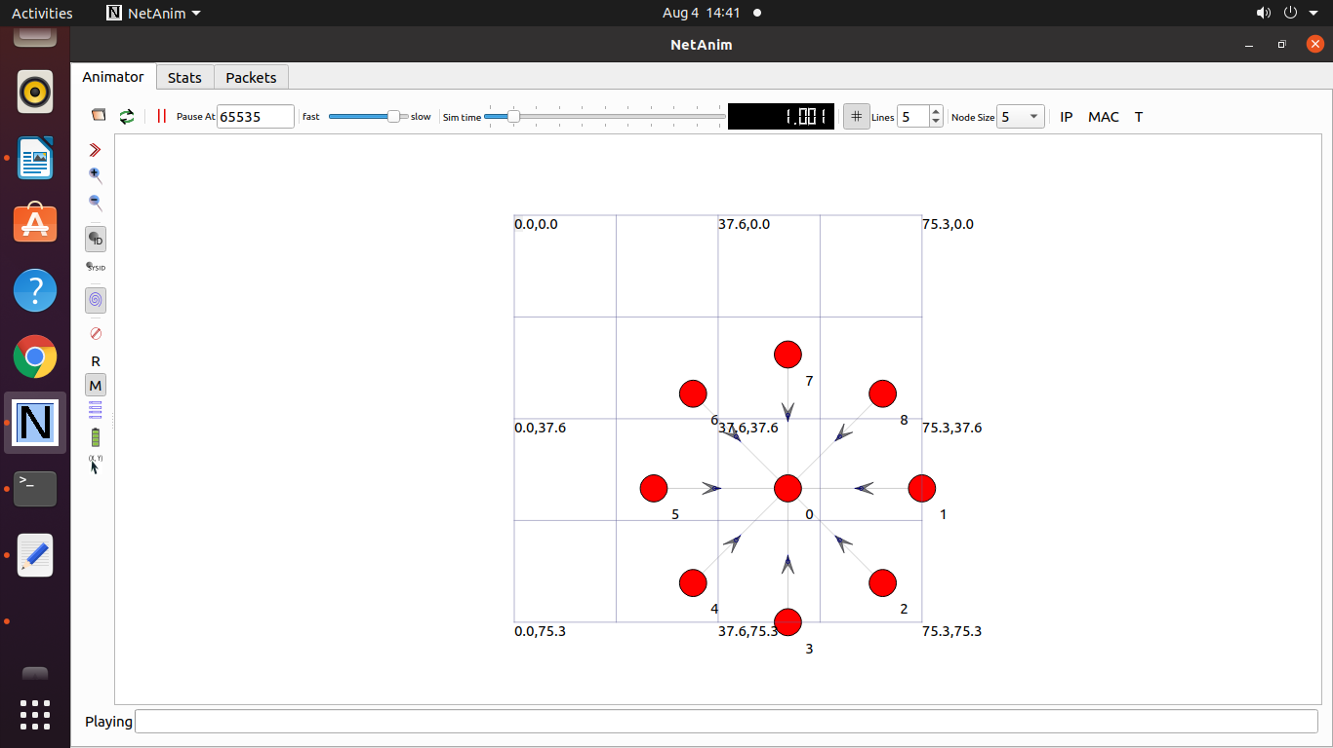

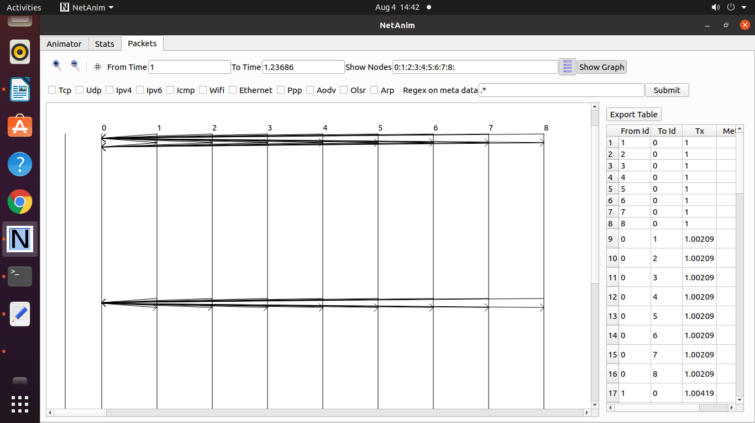

**To Plot the graph consider the following files**

**starnew.txt**

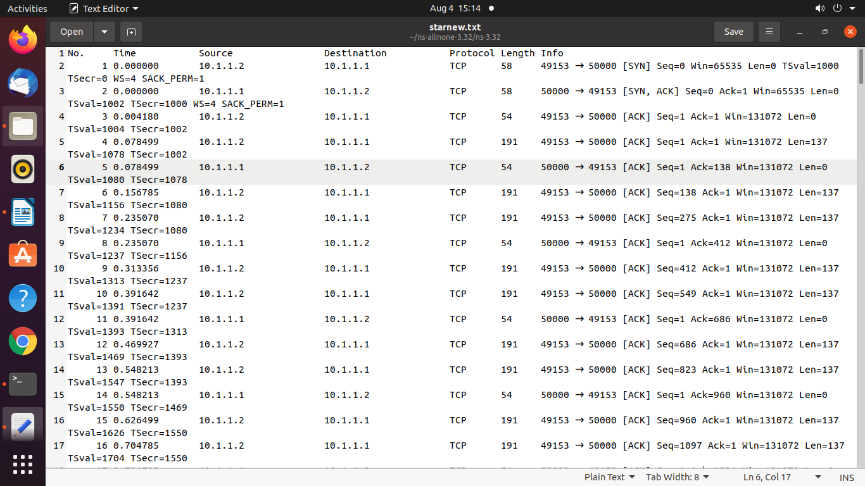

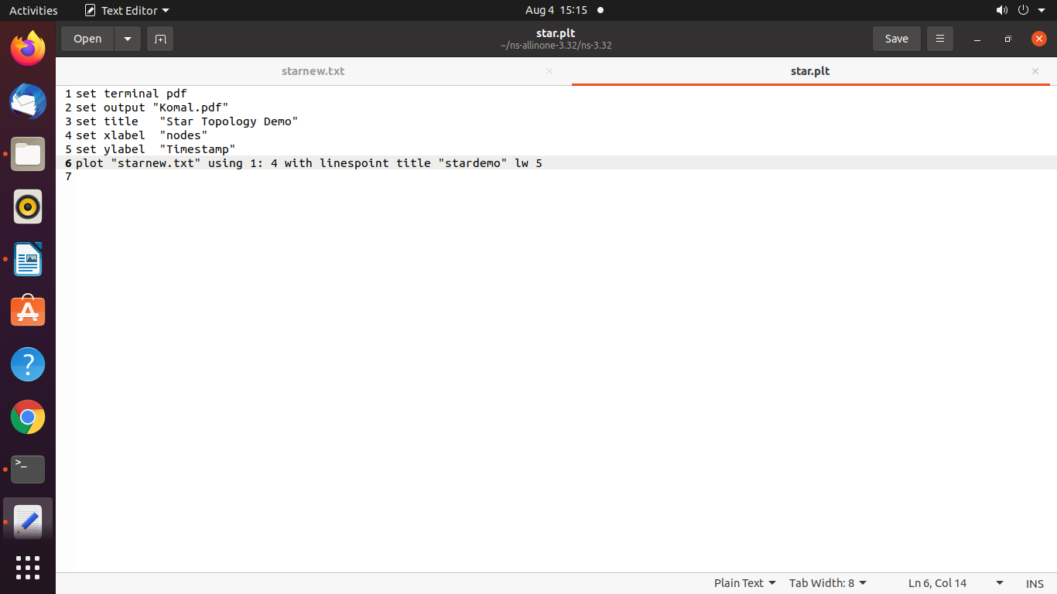

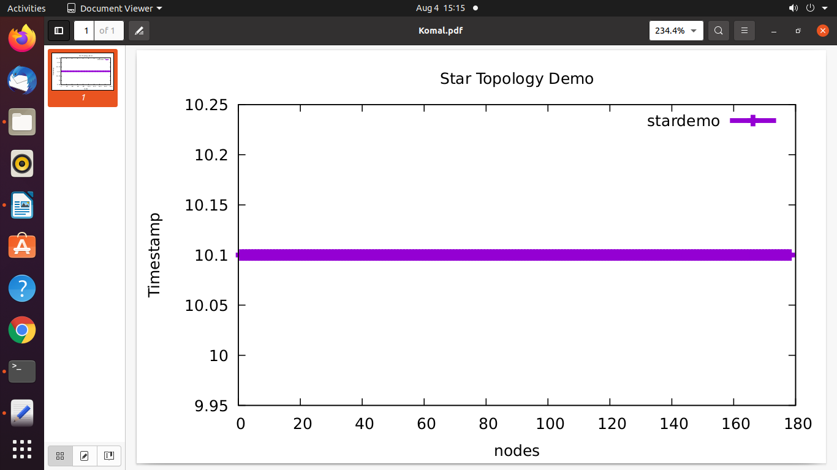

**Practical 11 : Program to simulate UDP Server – Client communication.**

/* -*- Mode:C++; c-file-style:"gnu"; indent-tabs-mode:nil; -*- */

/*

* This program is free software; you can redistribute it and/or modify

* it under the terms of the GNU General Public License version 2 as

* published by the Free Software Foundation;

*

* This program is distributed in the hope that it will be useful,

* but WITHOUT ANY WARRANTY; without even the implied warranty of

* MERCHANTABILITY or FITNESS FOR A PARTICULAR PURPOSE. See the

* GNU General Public License for more details.

*

* You should have received a copy of the GNU General Public License

* along with this program; if not, write to the Free Software

* Foundation, Inc., 59 Temple Place, Suite 330, Boston, MA 02111-1307 USA

*/

// Network topology

//

// n0 n1

// | |

// =======

// LAN

//

// - UDP flows from n0 to n1

#include <fstream>

#include "ns3/core-module.h"

#include "ns3/csma-module.h"

#include "ns3/applications-module.h"

#include "ns3/internet-module.h"

//netAnimation

#include "ns3/netanim-module.h"

#include "ns3/mobility-module.h"

using namespace ns3;

NS_LOG_COMPONENT_DEFINE ("UdpClientServerExample");

int

main (int argc, char *argv[])

{

//

// Enable logging for UdpClient and

//

LogComponentEnable ("UdpClient", LOG_LEVEL_INFO);

LogComponentEnable ("UdpServer", LOG_LEVEL_INFO);

bool useV6 = false;

Address serverAddress;

CommandLine cmd (__FILE__);

cmd.AddValue ("useIpv6", "Use Ipv6", useV6);

cmd.Parse (argc, argv);

//

// Explicitly create the nodes required by the topology (shown above).

//

NS_LOG_INFO ("Create nodes.");

NodeContainer n;

n.Create (2);

InternetStackHelper internet;

internet.Install (n);

NS_LOG_INFO ("Create channels.");

//

// Explicitly create the channels required by the topology (shown above).

//

CsmaHelper csma;

csma.SetChannelAttribute ("DataRate", DataRateValue (DataRate (5000000)));

csma.SetChannelAttribute ("Delay", TimeValue (MilliSeconds (2)));

csma.SetDeviceAttribute ("Mtu", UintegerValue (1400));

NetDeviceContainer d = csma.Install (n);

//

// We've got the "hardware" in place. Now we need to add IP addresses.

//

NS_LOG_INFO ("Assign IP Addresses.");

if (useV6 == false)

{

Ipv4AddressHelper ipv4;

ipv4.SetBase ("10.1.1.0", "255.255.255.0");

Ipv4InterfaceContainer i = ipv4.Assign (d);

serverAddress = Address (i.GetAddress (1));

}

else

{

Ipv6AddressHelper ipv6;

ipv6.SetBase ("2001:0000:f00d:cafe::", Ipv6Prefix (64));

Ipv6InterfaceContainer i6 = ipv6.Assign (d);

serverAddress = Address(i6.GetAddress (1,1));

}

NS_LOG_INFO ("Create Applications.");

//

// Create one udpServer applications on node one.

//

uint16_t port = 4000;

UdpServerHelper server (port);

ApplicationContainer apps = server.Install (n.Get (1));

apps.Start (Seconds (1.0));

apps.Stop (Seconds (10.0));

//

// Create one UdpClient application to send UDP datagrams from node zero to

// node one.

//

uint32_t MaxPacketSize = 1024;

Time interPacketInterval = Seconds (0.05);

uint32_t maxPacketCount = 320;

UdpClientHelper client (serverAddress, port);

client.SetAttribute ("MaxPackets", UintegerValue (maxPacketCount));

client.SetAttribute ("Interval", TimeValue (interPacketInterval));

client.SetAttribute ("PacketSize", UintegerValue (MaxPacketSize));

apps = client.Install (n.Get (0));

apps.Start (Seconds (2.0));

apps.Stop (Seconds (10.0));

AnimationInterface anim("udp-cs.xml");

AnimationInterface::SetConstantPosition (n.Get(0), 10, 25);

AnimationInterface ::SetConstantPosition(n.Get(1), 40,25);

anim.EnablePacketMetadata(true);

csma.EnablePcapAll("udp-cs");

//

// Now, do the actual simulation.

//

NS_LOG_INFO ("Run Simulation.");

Simulator::Run ();

Simulator::Destroy ();

NS_LOG_INFO ("Done.");

}

**Output :**

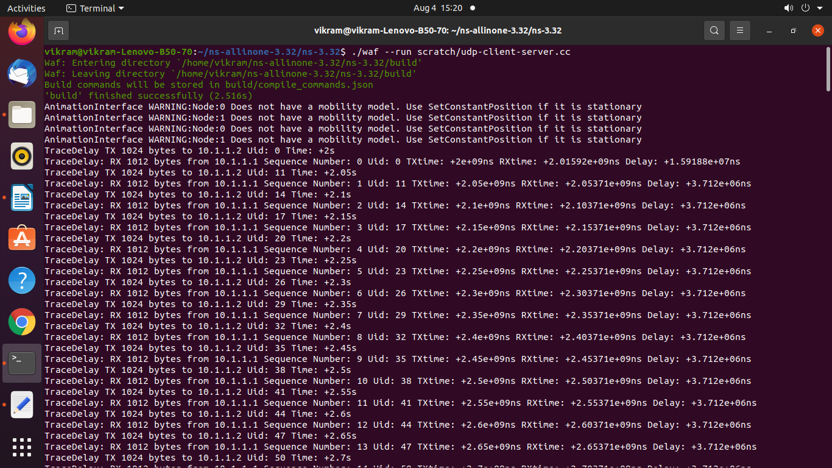

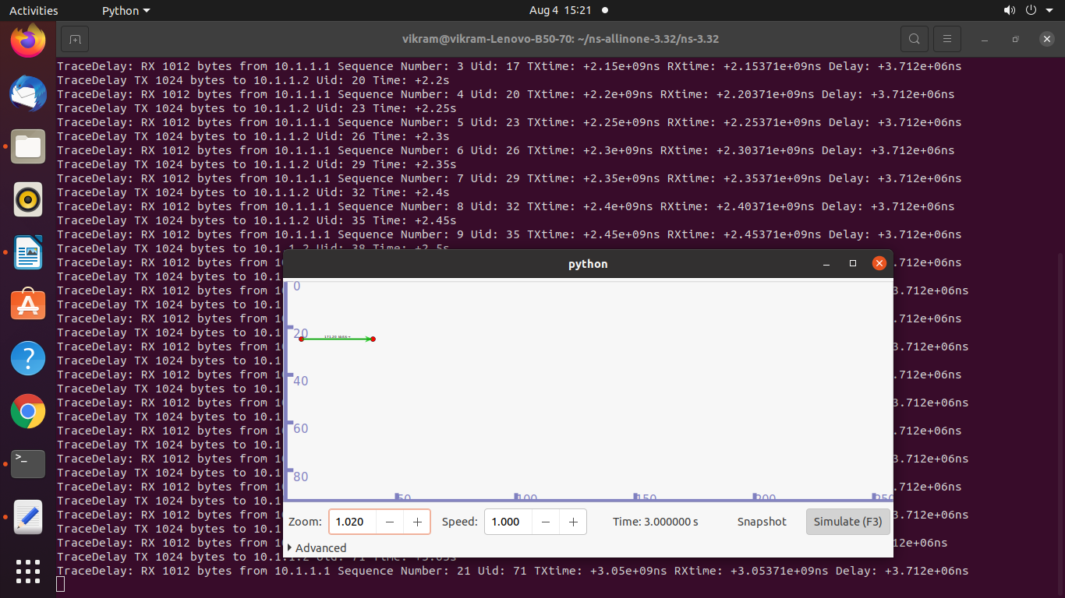

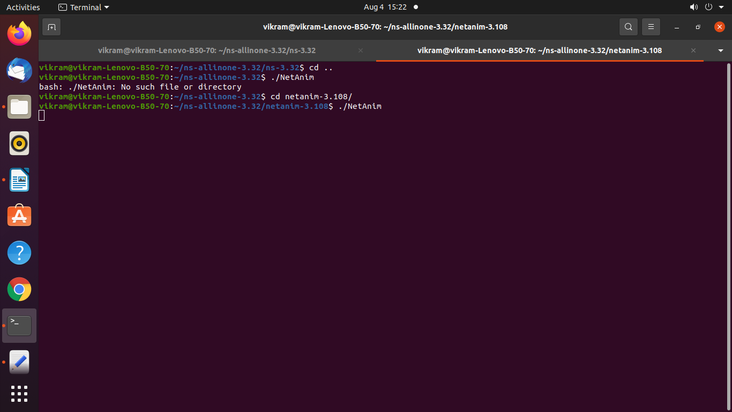

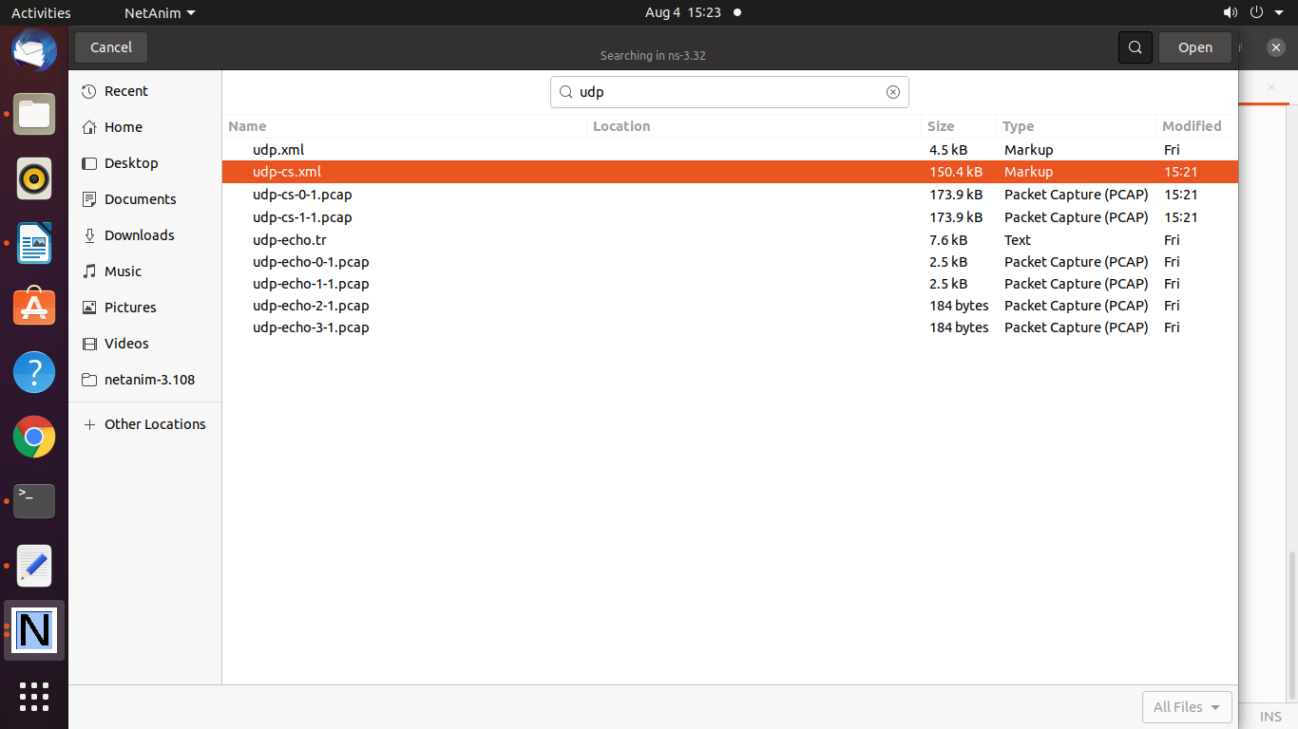

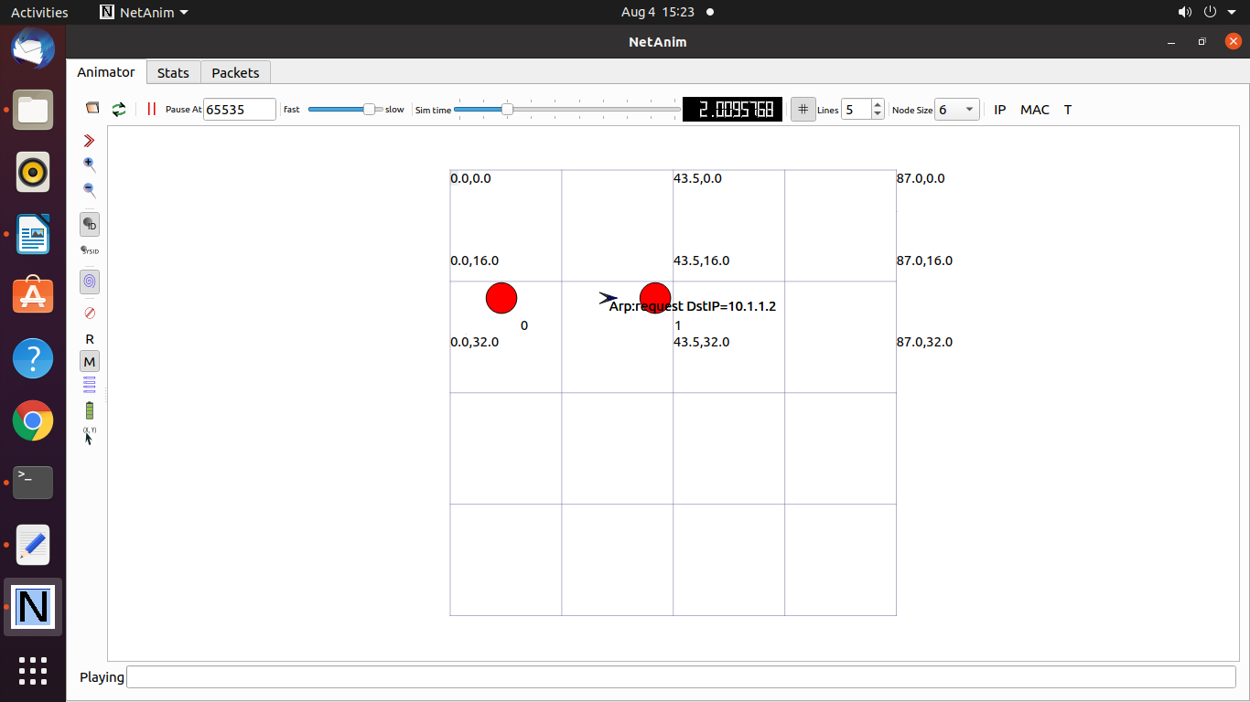

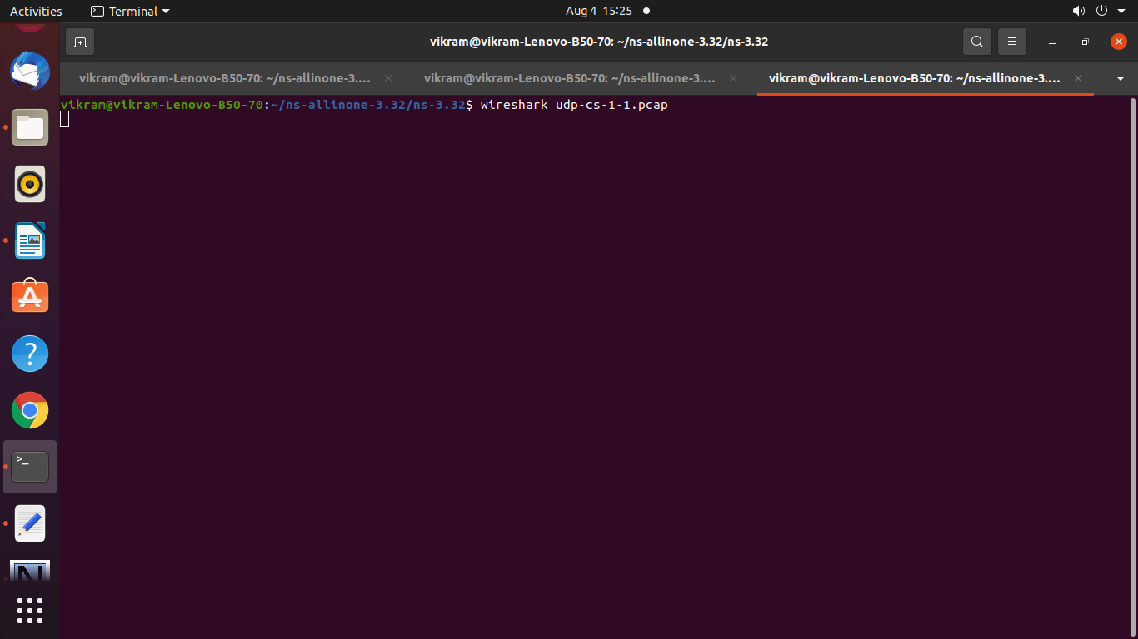

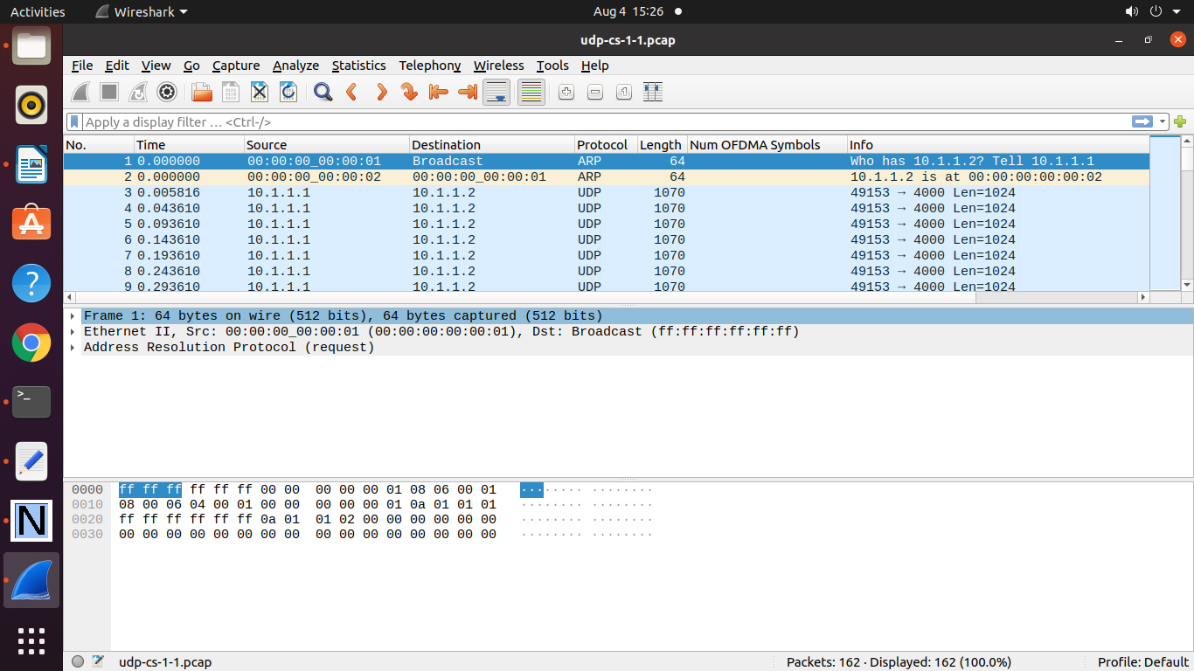

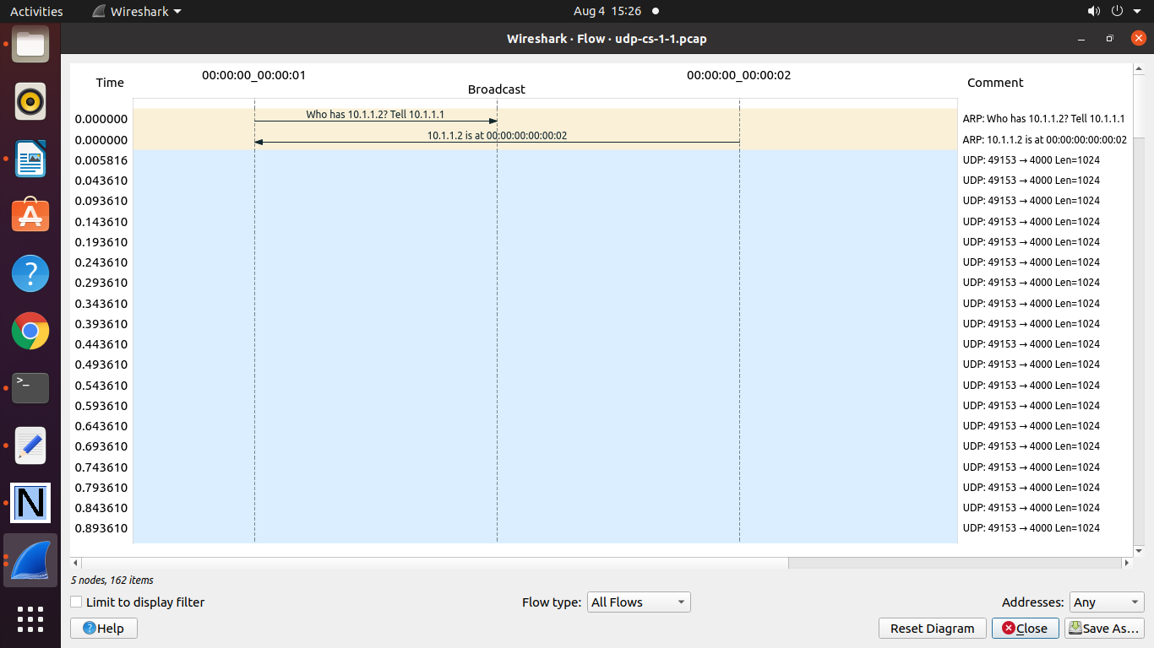

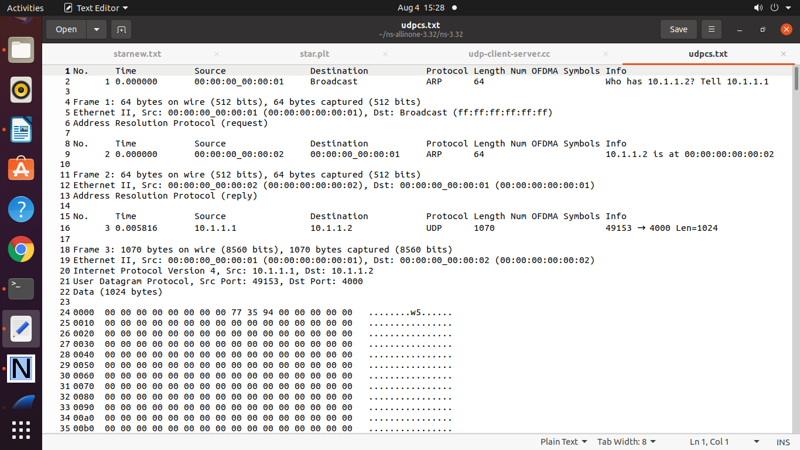

================================================

**Practical 12 : Program to simulatr Bus Toplogy using UDP Protocol**

/* -*- Mode:C++; c-file-style:"gnu"; indent-tabs-mode:nil; -*- */

/*

* This program is free software; you can redistribute it and/or modify

* it under the terms of the GNU General Public License version 2 as

* published by the Free Software Foundation;

*

* This program is distributed in the hope that it will be useful,

* but WITHOUT ANY WARRANTY; without even the implied warranty of

* MERCHANTABILITY or FITNESS FOR A PARTICULAR PURPOSE. See the

* GNU General Public License for more details.

*

* You should have received a copy of the GNU General Public License

* along with this program; if not, write to the Free Software

* Foundation, Inc., 59 Temple Place, Suite 330, Boston, MA 02111-1307 USA

*/

// Network topology

//

// n0 n1 n2 n3

// | | | |

// =================

// LAN

//

// - UDP flows from n0 to n1 and back

// - DropTail queues

// - Tracing of queues and packet receptions to file "udp-echo.tr"

#include <fstream>

#include "ns3/core-module.h"

#include "ns3/csma-module.h"

#include "ns3/applications-module.h"

#include "ns3/internet-module.h"

#include "ns3/netanim-module.h"

#include "ns3/mobility-module.h"

using namespace ns3;

NS_LOG_COMPONENT_DEFINE ("UdpEchoExample");

int

main (int argc, char *argv[])

{

//

// Users may find it convenient to turn on explicit debugging

// for selected modules; the below lines suggest how to do this

//

#if 1

LogComponentEnable ("UdpEchoExample", LOG_LEVEL_INFO);

LogComponentEnable ("UdpEchoClientApplication", LOG_LEVEL_ALL);

LogComponentEnable ("UdpEchoServerApplication", LOG_LEVEL_ALL);

#endif

//

// Allow the user to override any of the defaults and the above Bind() at

// run-time, via command-line arguments

//

bool useV6 = false;

Address serverAddress;

CommandLine cmd;

cmd.AddValue ("useIpv6", "Use Ipv6", useV6);

cmd.Parse (argc, argv);

//

// Explicitly create the nodes required by the topology (shown above).

//

NS_LOG_INFO ("Create nodes.");

NodeContainer n;

n.Create (4);

InternetStackHelper internet;

internet.Install (n);

NS_LOG_INFO ("Create channels.");

//

// Explicitly create the channels required by the topology (shown above).

//

CsmaHelper csma;

csma.SetChannelAttribute ("DataRate", DataRateValue (DataRate (5000000)));

csma.SetChannelAttribute ("Delay", TimeValue (MilliSeconds (2)));

csma.SetDeviceAttribute ("Mtu", UintegerValue (1400));

NetDeviceContainer d = csma.Install (n);

//

// We've got the "hardware" in place. Now we need to add IP addresses.

//

NS_LOG_INFO ("Assign IP Addresses.");

if (useV6 == false)

{

Ipv4AddressHelper ipv4;

ipv4.SetBase ("10.1.1.0", "255.255.255.0");

Ipv4InterfaceContainer i = ipv4.Assign (d);

serverAddress = Address(i.GetAddress (1));

}

else

{

Ipv6AddressHelper ipv6;

ipv6.SetBase ("2001:0000:f00d:cafe::", Ipv6Prefix (64));

Ipv6InterfaceContainer i6 = ipv6.Assign (d);

serverAddress = Address(i6.GetAddress (1,1));

}

NS_LOG_INFO ("Create Applications.");

//

// Create a UdpEchoServer application on node one.

//

uint16_t port = 9; // well-known echo port number

UdpEchoServerHelper server (port);

ApplicationContainer apps = server.Install (n.Get (1));

apps.Start (Seconds (1.0));

apps.Stop (Seconds (10.0));

//

// Create a UdpEchoClient application to send UDP datagrams from node zero to

// node one.

//

uint32_t packetSize = 1024;

uint32_t maxPacketCount = 1;

Time interPacketInterval = Seconds (1.);

UdpEchoClientHelper client (serverAddress, port);

client.SetAttribute ("MaxPackets", UintegerValue (maxPacketCount));

client.SetAttribute ("Interval", TimeValue (interPacketInterval));

client.SetAttribute ("PacketSize", UintegerValue (packetSize));

apps = client.Install (n.Get (0));

apps.Start (Seconds (2.0));

apps.Stop (Seconds (10.0));

#if 1

//

// Users may find it convenient to initialize echo packets with actual data;

// the below lines suggest how to do this

//

client.SetFill (apps.Get (0), "Hello World");

client.SetFill (apps.Get (0), 0xa5, 1024);

uint8_t fill[] = { 0, 1, 2, 3, 4, 5, 6};

client.SetFill (apps.Get (0), fill, sizeof(fill), 1024);

#endif

AnimationInterface anim("udp.xml");

AsciiTraceHelper ascii;

csma.EnableAsciiAll (ascii.CreateFileStream ("udp-echo.tr"));

csma.EnablePcapAll ("udp-echo", false);

//

// Now, do the actual simulation.

//

NS_LOG_INFO ("Run Simulation.");

Simulator::Run ();

Simulator::Destroy ();

NS_LOG_INFO ("Done.");

}

**Output :**

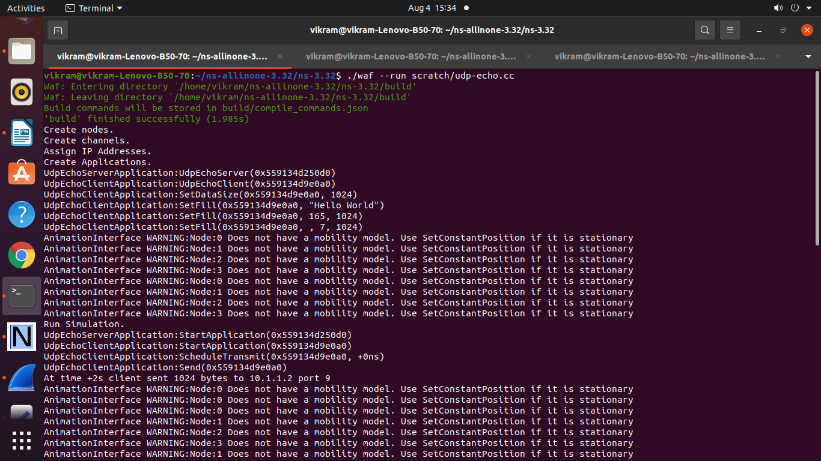

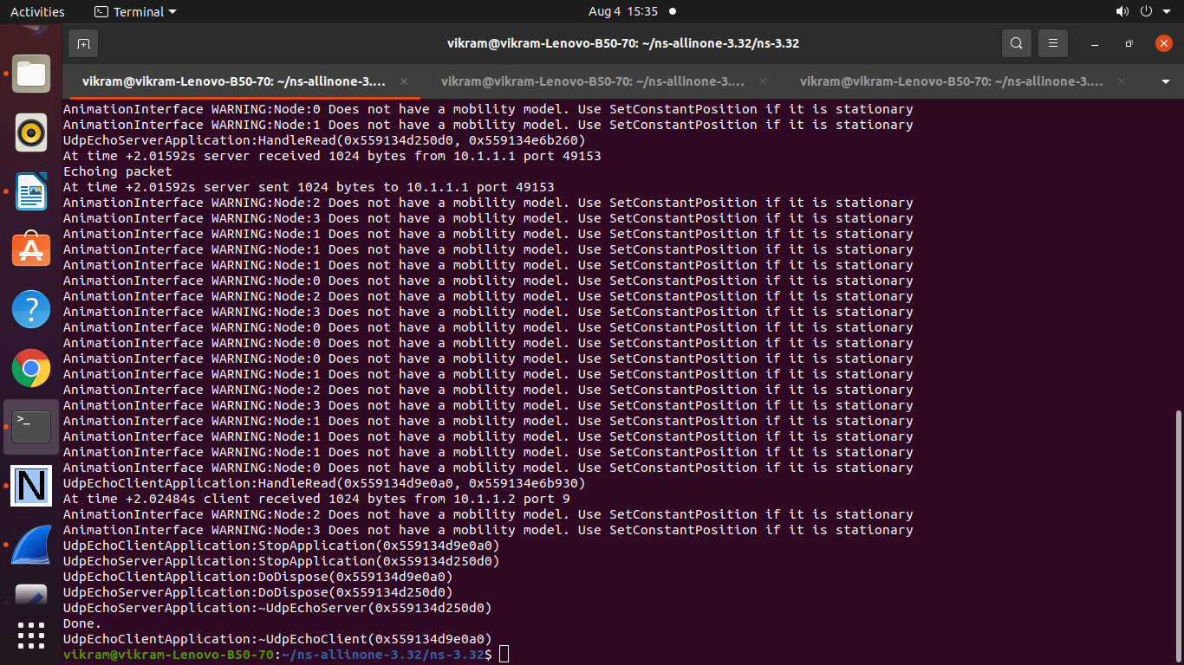

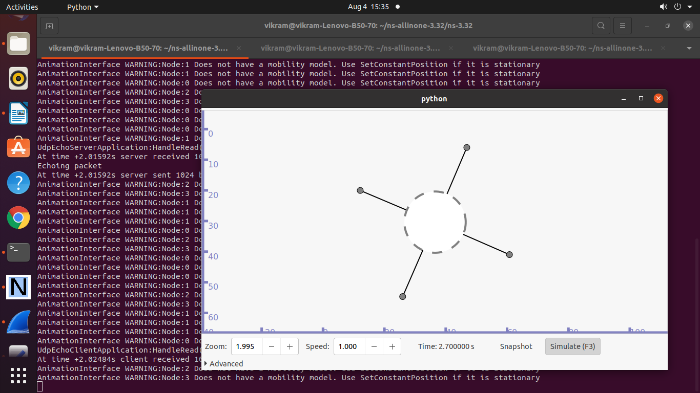

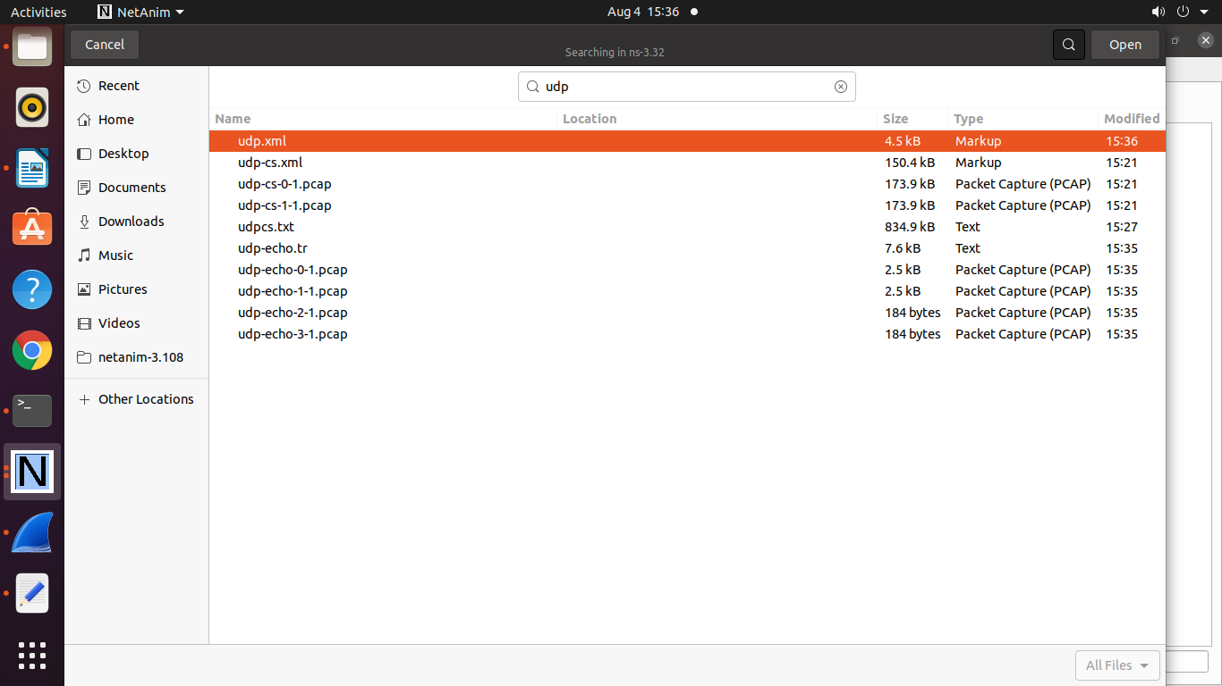

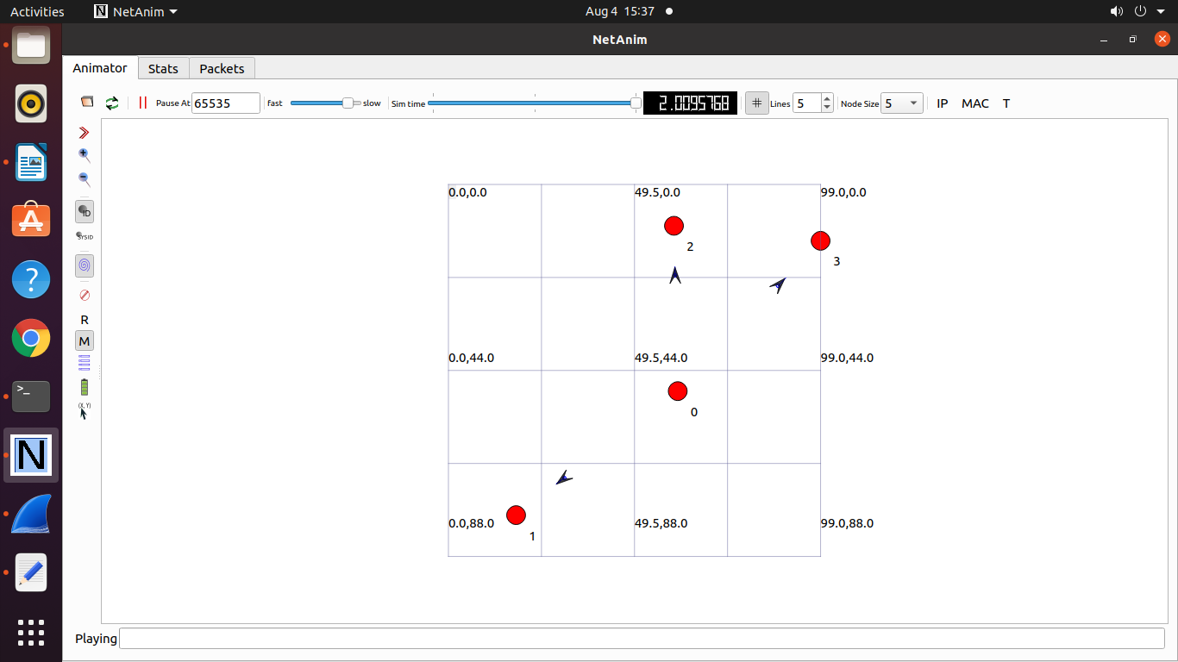

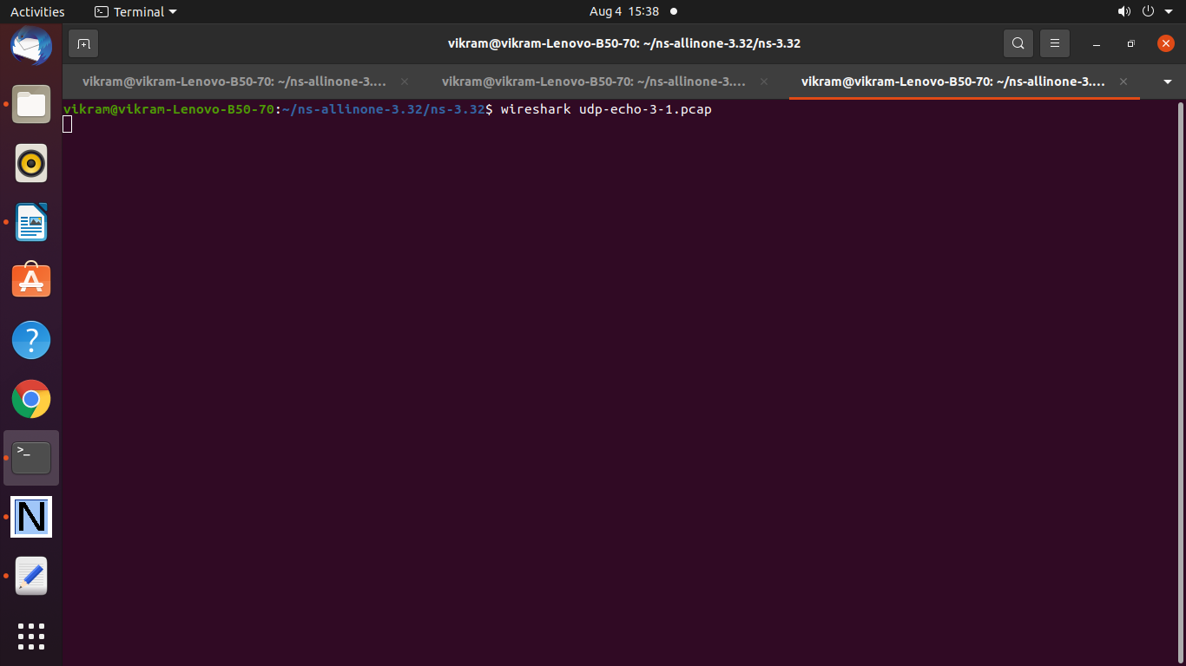

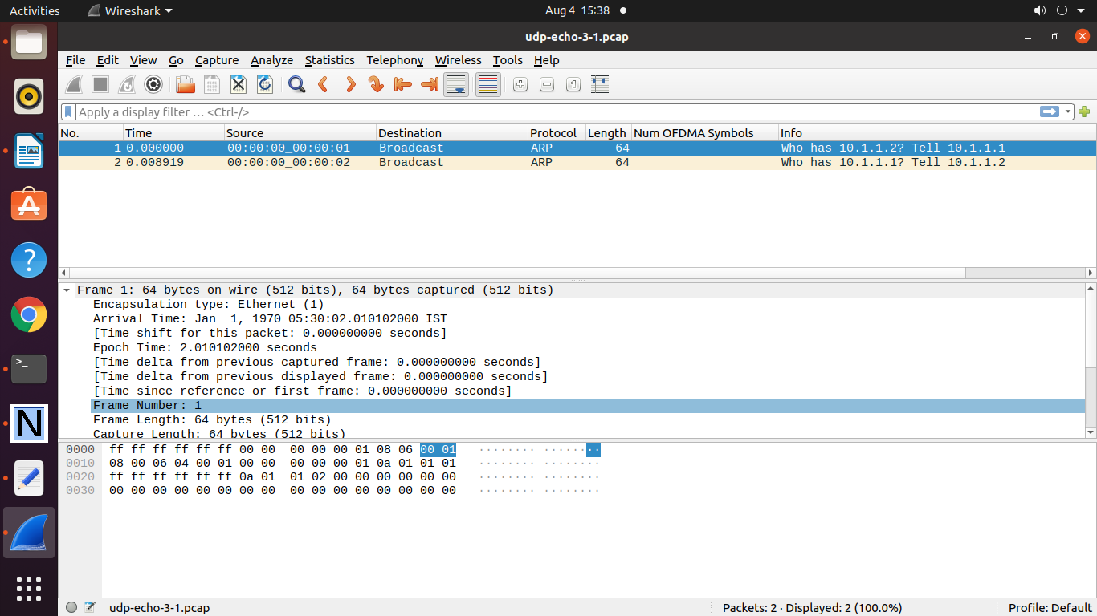

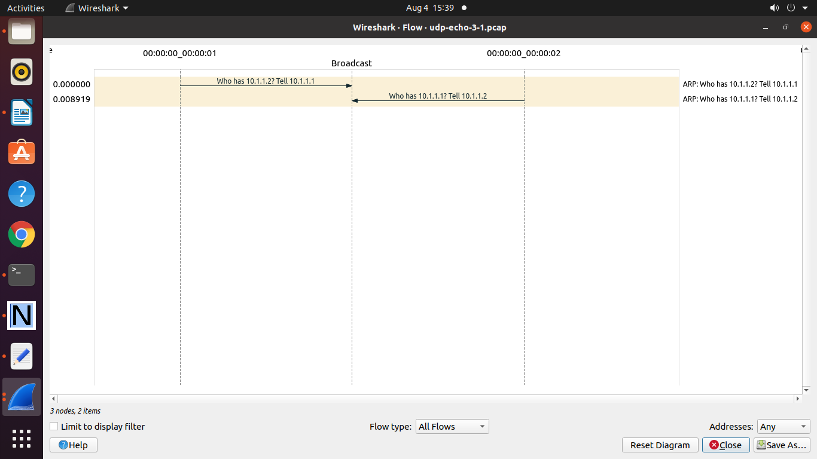

===================================================

**Practical 13: Program to Simulate Wireless Wi-Fi Network .**

/* -*- Mode:C++; c-file-style:"gnu"; indent-tabs-mode:nil; -*- */

/*

* This program is free software; you can redistribute it and/or modify

* it under the terms of the GNU General Public License version 2 as

* published by the Free Software Foundation;

*

* This program is distributed in the hope that it will be useful,

* but WITHOUT ANY WARRANTY; without even the implied warranty of

* MERCHANTABILITY or FITNESS FOR A PARTICULAR PURPOSE. See the

* GNU General Public License for more details.

*

* You should have received a copy of the GNU General Public License

* along with this program; if not, write to the Free Software

* Foundation, Inc., 59 Temple Place, Suite 330, Boston, MA 02111-1307 USA

*

* (Adapted from third.cc)

*/

#include "ns3/core-module.h"

#include "ns3/point-to-point-module.h"

#include "ns3/csma-module.h"

#include "ns3/network-module.h"

#include "ns3/applications-module.h"

#include "ns3/mobility-module.h"

#include "ns3/internet-module.h"

#include "ns3/netanim-module.h"

#include "ns3/basic-energy-source.h"

#include "ns3/simple-device-energy-model.h"

#include "ns3/yans-wifi-helper.h"

#include "ns3/ssid.h"

#include "ns3/wifi-radio-energy-model.h"

using namespace ns3;

NS_LOG_COMPONENT_DEFINE ("WirelessAnimationExample");

int

main (int argc, char *argv[])

{

uint32_t nWifi = 20;

CommandLine cmd (__FILE__);

cmd.AddValue ("nWifi", "Number of wifi STA devices", nWifi);

cmd.Parse (argc,argv);

NodeContainer allNodes;

NodeContainer wifiStaNodes;

wifiStaNodes.Create (nWifi);

allNodes.Add (wifiStaNodes);

NodeContainer wifiApNode ;

wifiApNode.Create (1);

allNodes.Add (wifiApNode);

YansWifiChannelHelper channel = YansWifiChannelHelper::Default ();

YansWifiPhyHelper phy = YansWifiPhyHelper::Default ();

phy.SetChannel (channel.Create ());

WifiHelper wifi;

wifi.SetRemoteStationManager ("ns3::AarfWifiManager");

WifiMacHelper mac;

Ssid ssid = Ssid ("ns-3-ssid");

mac.SetType ("ns3::StaWifiMac",

"Ssid", SsidValue (ssid),

"ActiveProbing", BooleanValue (false));

NetDeviceContainer staDevices;

staDevices = wifi.Install (phy, mac, wifiStaNodes);

mac.SetType ("ns3::ApWifiMac",

"Ssid", SsidValue (ssid));

NetDeviceContainer apDevices;

apDevices = wifi.Install (phy, mac, wifiApNode);

NodeContainer p2pNodes;

p2pNodes.Add (wifiApNode);

p2pNodes.Create (1);

allNodes.Add (p2pNodes.Get (1));

PointToPointHelper pointToPoint;

pointToPoint.SetDeviceAttribute ("DataRate", StringValue ("5Mbps"));

pointToPoint.SetChannelAttribute ("Delay", StringValue ("2ms"));

NetDeviceContainer p2pDevices;

p2pDevices = pointToPoint.Install (p2pNodes);

NodeContainer csmaNodes;

csmaNodes.Add (p2pNodes.Get (1));

csmaNodes.Create (1);

allNodes.Add (csmaNodes.Get (1));

CsmaHelper csma;

csma.SetChannelAttribute ("DataRate", StringValue ("100Mbps"));

csma.SetChannelAttribute ("Delay", TimeValue (NanoSeconds (6560)));

NetDeviceContainer csmaDevices;

csmaDevices = csma.Install (csmaNodes);

// Mobility

MobilityHelper mobility;

mobility.SetPositionAllocator ("ns3::GridPositionAllocator",

"MinX", DoubleValue (10.0),

"MinY", DoubleValue (10.0),

"DeltaX", DoubleValue (5.0),

"DeltaY", DoubleValue (2.0),

"GridWidth", UintegerValue (5),

"LayoutType", StringValue ("RowFirst"));

mobility.SetMobilityModel ("ns3::RandomWalk2dMobilityModel",

"Bounds", RectangleValue (Rectangle (-50, 50, -25, 50)));

mobility.Install (wifiStaNodes);

mobility.SetMobilityModel ("ns3::ConstantPositionMobilityModel");

mobility.Install (wifiApNode);

AnimationInterface::SetConstantPosition (p2pNodes.Get (1), 10, 30);

AnimationInterface::SetConstantPosition (csmaNodes.Get (1), 10, 33);

Ptr<BasicEnergySource> energySource = CreateObject<BasicEnergySource>();

Ptr<WifiRadioEnergyModel> energyModel = CreateObject<WifiRadioEnergyModel>();

energySource->SetInitialEnergy (300);

energyModel->SetEnergySource (energySource);

energySource->AppendDeviceEnergyModel (energyModel);

// aggregate energy source to node

wifiApNode.Get (0)->AggregateObject (energySource);

// Install internet stack

InternetStackHelper stack;

stack.Install (allNodes);

// Install Ipv4 addresses

Ipv4AddressHelper address;

address.SetBase ("10.1.1.0", "255.255.255.0");

Ipv4InterfaceContainer p2pInterfaces;

p2pInterfaces = address.Assign (p2pDevices);

address.SetBase ("10.1.2.0", "255.255.255.0");

Ipv4InterfaceContainer csmaInterfaces;

csmaInterfaces = address.Assign (csmaDevices);

address.SetBase ("10.1.3.0", "255.255.255.0");

Ipv4InterfaceContainer staInterfaces;

staInterfaces = address.Assign (staDevices);

Ipv4InterfaceContainer apInterface;

apInterface = address.Assign (apDevices);

// Install applications

UdpEchoServerHelper echoServer (9);

ApplicationContainer serverApps = echoServer.Install (csmaNodes.Get (1));

serverApps.Start (Seconds (1.0));

serverApps.Stop (Seconds (15.0));

UdpEchoClientHelper echoClient (csmaInterfaces.GetAddress (1), 9);

echoClient.SetAttribute ("MaxPackets", UintegerValue (10));

echoClient.SetAttribute ("Interval", TimeValue (Seconds (1.)));

echoClient.SetAttribute ("PacketSize", UintegerValue (1024));

ApplicationContainer clientApps = echoClient.Install (wifiStaNodes);

clientApps.Start (Seconds (2.0));

clientApps.Stop (Seconds (15.0));

Ipv4GlobalRoutingHelper::PopulateRoutingTables ();

Simulator::Stop (Seconds (15.0));

AnimationInterface anim ("wireless-animation.xml"); // Mandatory

for (uint32_t i = 0; i < wifiStaNodes.GetN (); ++i)

{

anim.UpdateNodeDescription (wifiStaNodes.Get (i), "STA"); // Optional

anim.UpdateNodeColor (wifiStaNodes.Get (i), 255, 0, 0); // Optional

}

for (uint32_t i = 0; i < wifiApNode.GetN (); ++i)

{

anim.UpdateNodeDescription (wifiApNode.Get (i), "AP"); // Optional

anim.UpdateNodeColor (wifiApNode.Get (i), 0, 255, 0); // Optional

}

for (uint32_t i = 0; i < csmaNodes.GetN (); ++i)

{

anim.UpdateNodeDescription (csmaNodes.Get (i), "CSMA"); // Optional

anim.UpdateNodeColor (csmaNodes.Get (i), 0, 0, 255); // Optional

}

anim.EnablePacketMetadata (true); // Optional

anim.EnableIpv4RouteTracking ("routingtable-wireless.xml", Seconds (0), Seconds (5), Seconds (0.25)); //Optional

anim.EnableWifiMacCounters (Seconds (0), Seconds (10)); //Optional

anim.EnableWifiPhyCounters (Seconds (0), Seconds (10)); //Optional

pointToPoint.EnablePcapAll("wireless");

Simulator::Run ();

Simulator::Destroy ();

return 0;

}

**Output :**

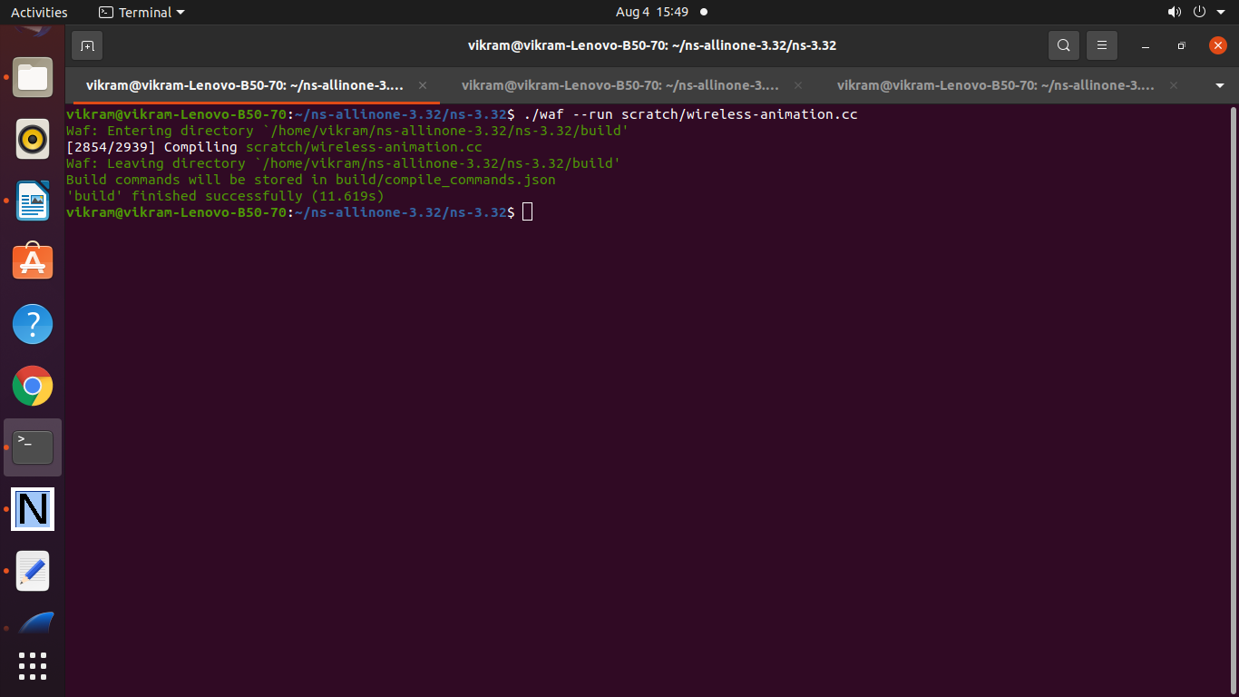

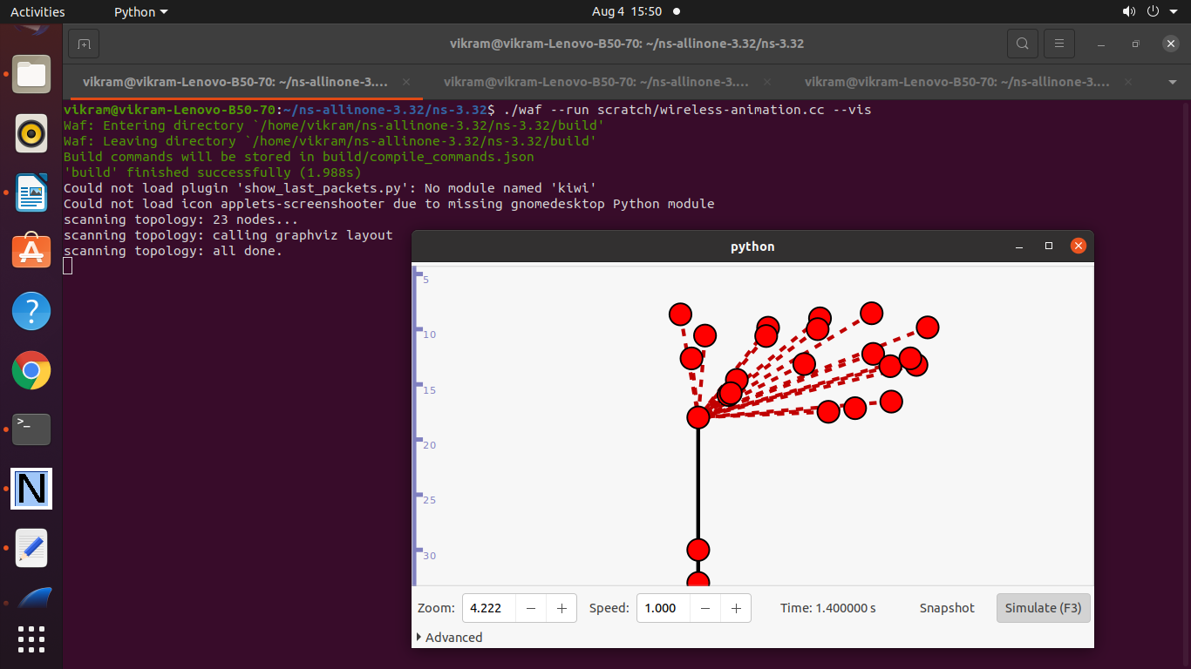

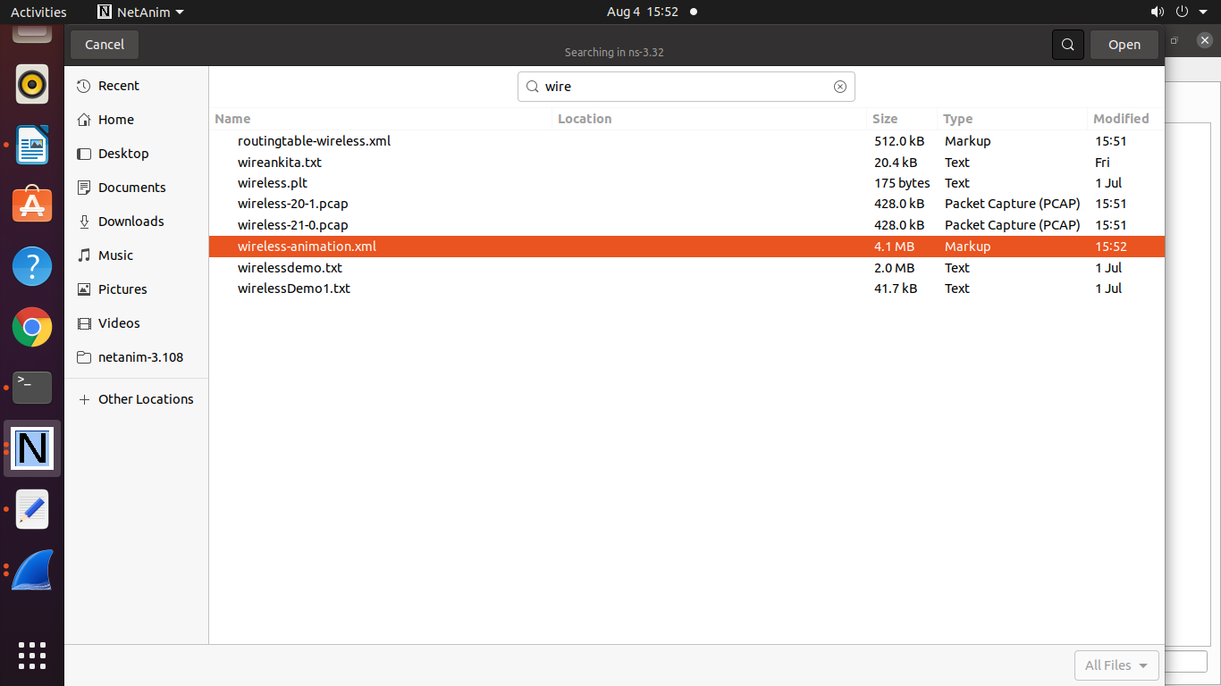

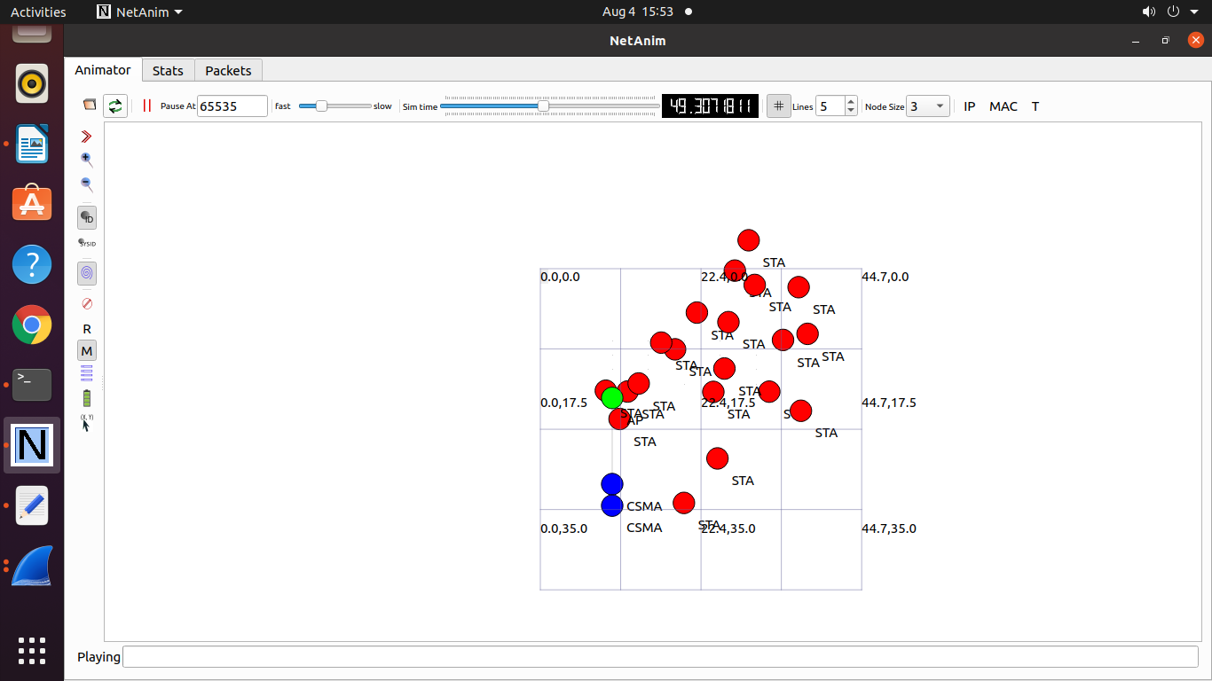

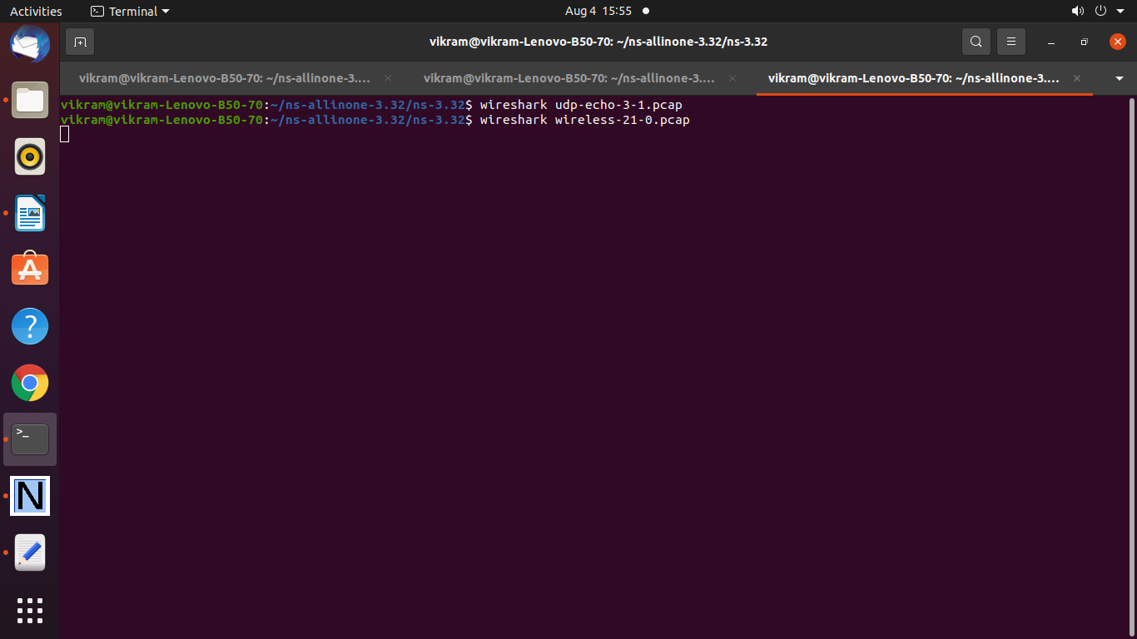

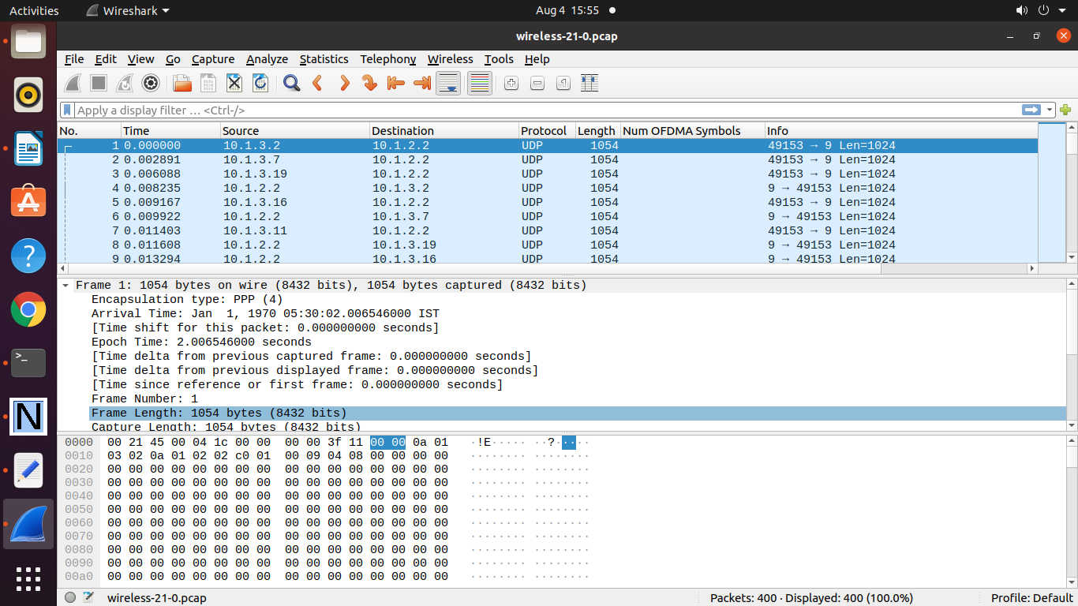

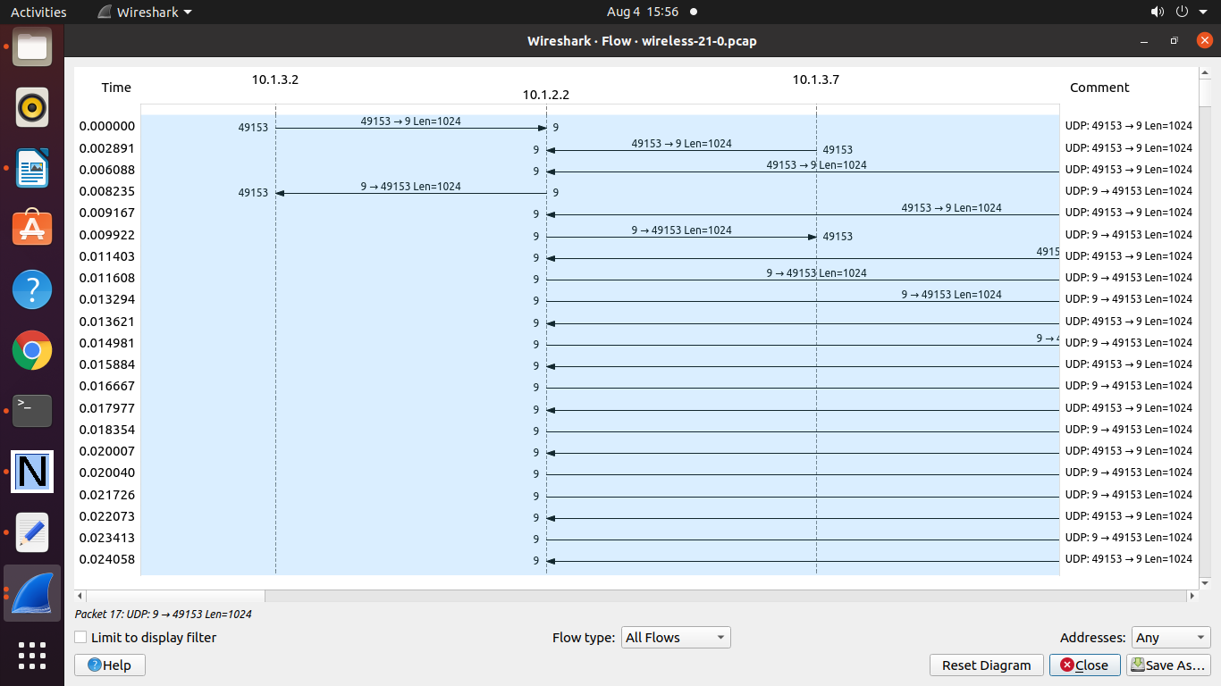

**Practical 13 : Program to simulate WiMax wireless network.**

#include "ns3/core-module.h"

#include "ns3/network-module.h"

#include "ns3/applications-module.h"

#include "ns3/mobility-module.h"

#include "ns3/config-store-module.h"

#include "ns3/wimax-module.h"

#include "ns3/internet-module.h"

#include "ns3/global-route-manager.h"

#include "ns3/ipcs-classifier-record.h"

#include "ns3/service-flow.h"

#include <iostream>

#include "ns3/netanim-module.h"

#include "ns3/net-device-container.h"

#include "ns3/netanim-module.h"

using namespace ns3;

int main (int argc, char *argv[]){

WimaxHelper::SchedulerType scheduler =WimaxHelper::SCHED_TYPE_SIMPLE;

LogComponentEnable ("UdpClient", LOG_LEVEL_INFO);

LogComponentEnable ("UdpServer", LOG_LEVEL_INFO);

NodeContainer ssNodes;

NodeContainer bsNodes;

ssNodes.Create (2);

bsNodes.Create (1);

WimaxHelper wimax;

NetDeviceContainer ssDevs;

NetDeviceContainer bsDevs;

ssDevs = wimax.Install(ssNodes, WimaxHelper::DEVICE_TYPE_SUBSCRIBER_STATION,

WimaxHelper::SIMPLE_PHY_TYPE_OFDM, scheduler);

bsDevs = wimax.Install(bsNodes,

WimaxHelper::DEVICE_TYPE_BASE_STATION,WimaxHelper::SIMPLE_PHY_TYPE_OFDM,

scheduler);

Ptr<SubscriberStationNetDevice> ss[2];

for (int i = 0; i < 2; i++) {

ss[i] = ssDevs.Get (i)->

GetObject<SubscriberStationNetDevice> ();

ss[i]->SetModulationType

(WimaxPhy::MODULATION_TYPE_QAM64_34);

}

Ptr<BaseStationNetDevice> bs;

bs = bsDevs.Get (0)->

GetObject<BaseStationNetDevice> ();

InternetStackHelper stack;

stack.Install (bsNodes);

stack.Install (ssNodes);

Ipv4AddressHelper address;

address.SetBase ("10.1.7.0", "255.255.255.0");

Ipv4InterfaceContainer SSinterfaces = address.Assign (ssDevs);

Ipv4InterfaceContainer BSinterface = address.Assign (bsDevs);

Ptr<ListPositionAllocator>

positionAlloc = CreateObject

<ListPositionAllocator> ();

positionAlloc->Add (Vector(15, 25, 0));

positionAlloc->Add (Vector(25, 15, 0));

positionAlloc->Add (Vector(5, 15, 0));

MobilityHelper bs_mobility;

bs_mobility.SetMobilityModel("ns3::ConstantPositionMobilityModel");

bs_mobility.SetPositionAllocator(positionAlloc);

bs_mobility.Install(bsNodes);

UdpServerHelper udpServer;

ApplicationContainer serverApps;

UdpClientHelper udpClient;

ApplicationContainer clientApps;

udpServer = UdpServerHelper (22000);

serverApps = udpServer.Install (ssNodes.Get (0));

serverApps.Start (Seconds (4.0));

serverApps.Stop (Seconds (10.0));

udpClient=UdpClientHelper(SSinterfaces.GetAddress (0),22000);

udpClient.SetAttribute ("MaxPackets", UintegerValue (15000));

udpClient.SetAttribute ("Interval", TimeValue (Seconds (0.1)));

udpClient.SetAttribute ("PacketSize", UintegerValue (512));

clientApps = udpClient.Install (ssNodes.Get (1));

clientApps.Start (Seconds (5.0));

clientApps.Stop (Seconds (9.5));

Simulator::Stop (Seconds (15.0));

IpcsClassifierRecord DlClassifierUgs (Ipv4Address ("0.0.0.0"),

Ipv4Mask ("0.0.0.0"), SSinterfaces.GetAddress (0), Ipv4Mask ("255.255.255.255"), 0, 65000,

22000, 22000, 17, 1);

ServiceFlow DlServiceFlowUgs = wimax.CreateServiceFlow

(ServiceFlow::SF_DIRECTION_DOWN,ServiceFlow::SF_TYPE_RTPS, DlClassifierUgs);

ss[0]->AddServiceFlow (DlServiceFlowUgs);

IpcsClassifierRecord UlClassifierUgs (SSinterfaces.GetAddress(1), Ipv4Mask ("255.255.255.255"),

Ipv4Address ("0.0.0.0"),Ipv4Mask ("0.0.0.0"), 0, 65000, 22000, 22000, 17, 1);

ServiceFlow UlServiceFlowUgs = wimax.CreateServiceFlow(ServiceFlow::SF_DIRECTION_UP,

ServiceFlow::SF_TYPE_RTPS,UlClassifierUgs);

ss[1]->AddServiceFlow (UlServiceFlowUgs);

AnimationInterface anim("animationWiMAX.xml");

anim.SetConstantPosition (ssNodes.Get(0),1.0,3.0);

anim.SetConstantPosition (ssNodes.Get(1),4.0,6.0);

anim.SetConstantPosition (bsNodes.Get(0),17.0,18.0);

anim.EnablePacketMetadata(true);

wimax.EnablePcapAll("WIMAX");

Simulator::Run ();

Simulator::Destroy ();

return 0;

}

**output :**

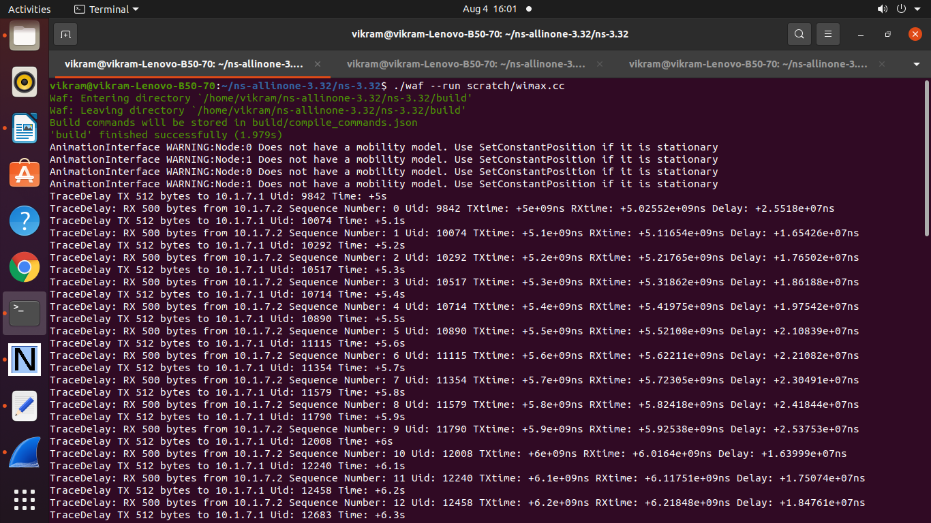

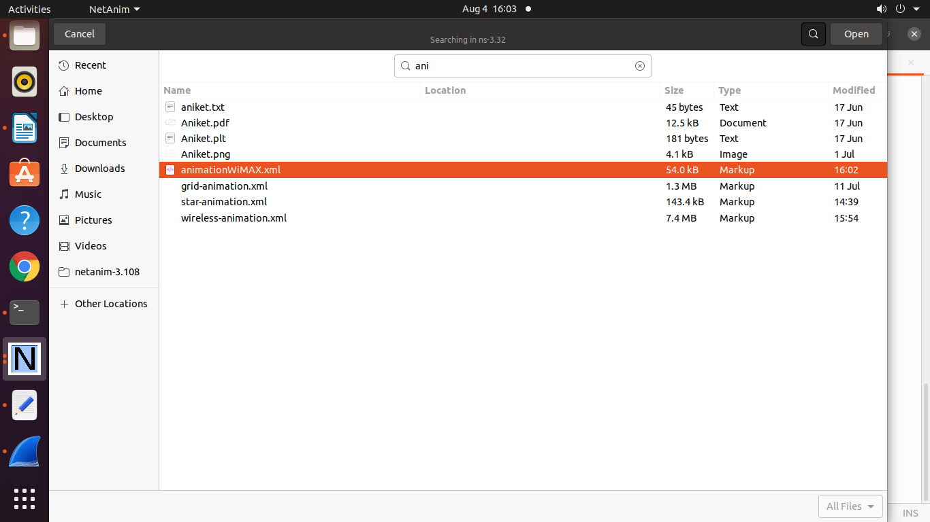

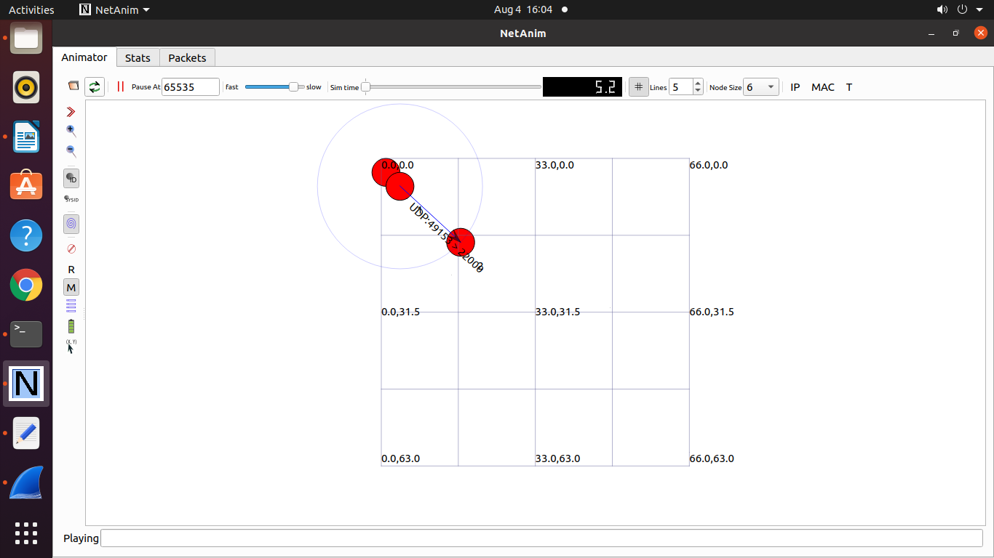

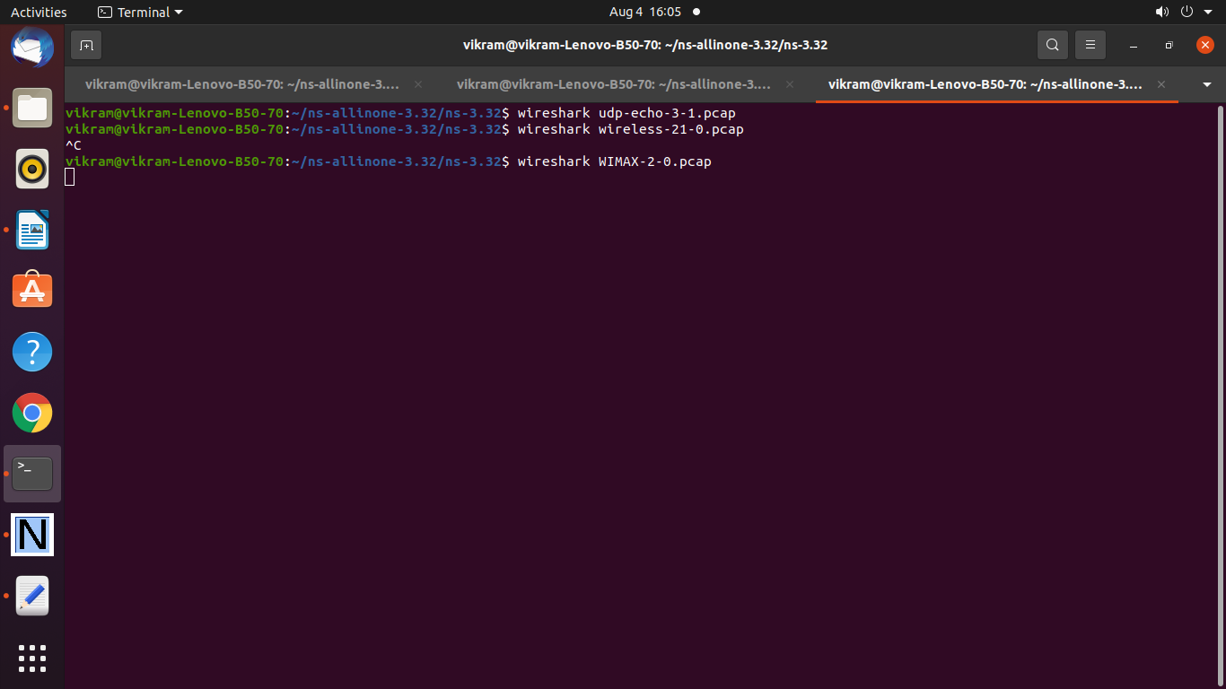

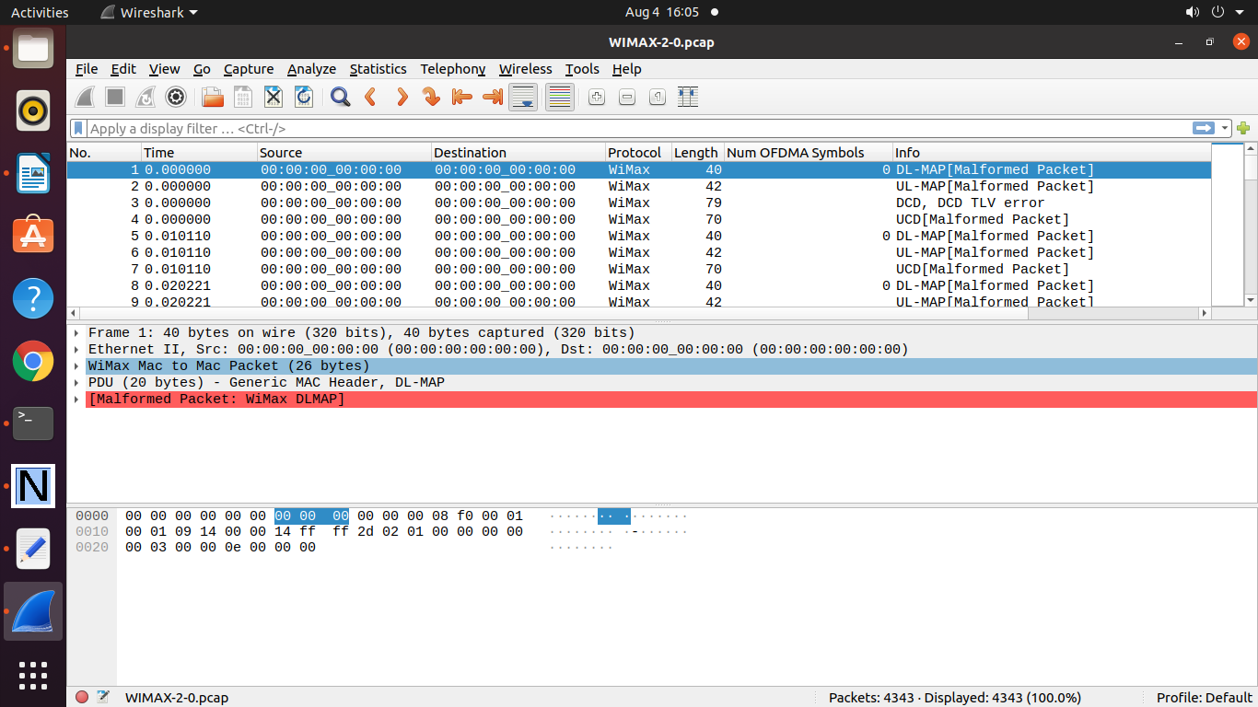

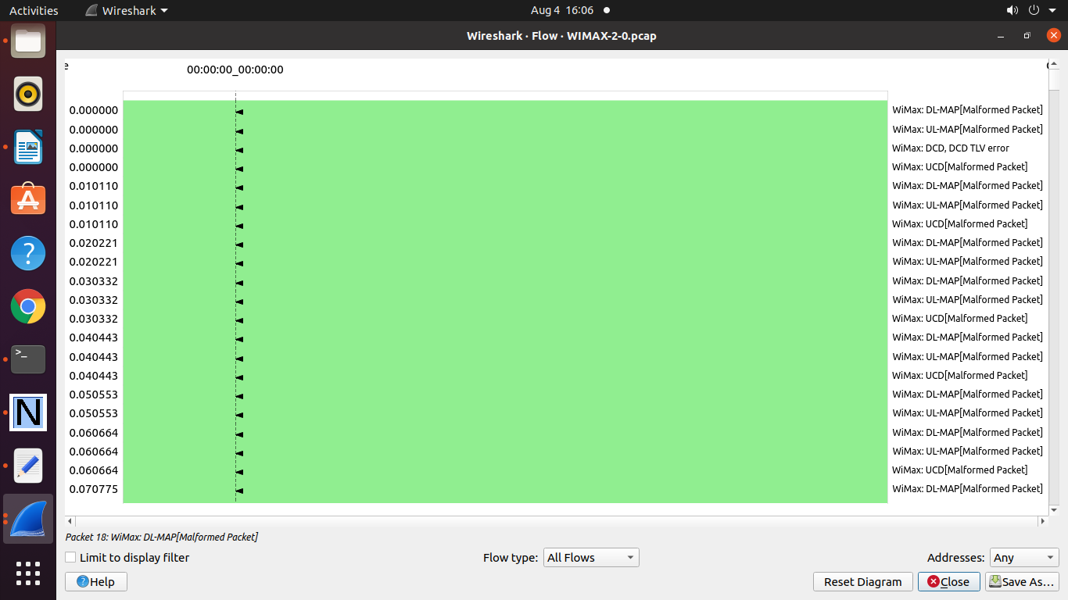

**To Plot a Graph Assume following files**

wimaxdemo.txt

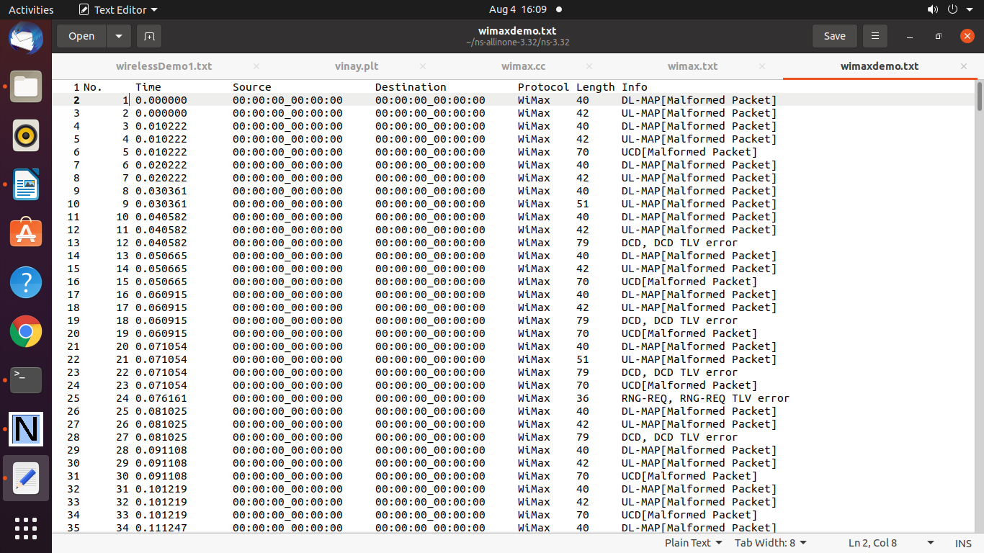

And

wimax.plt

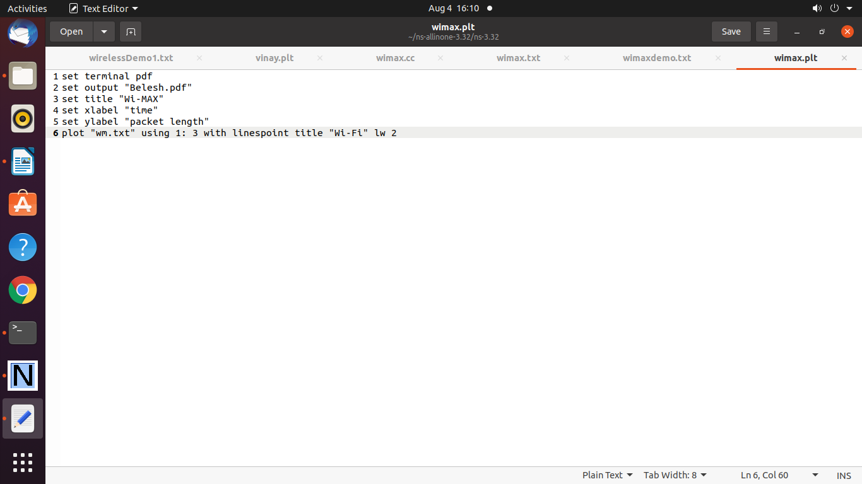

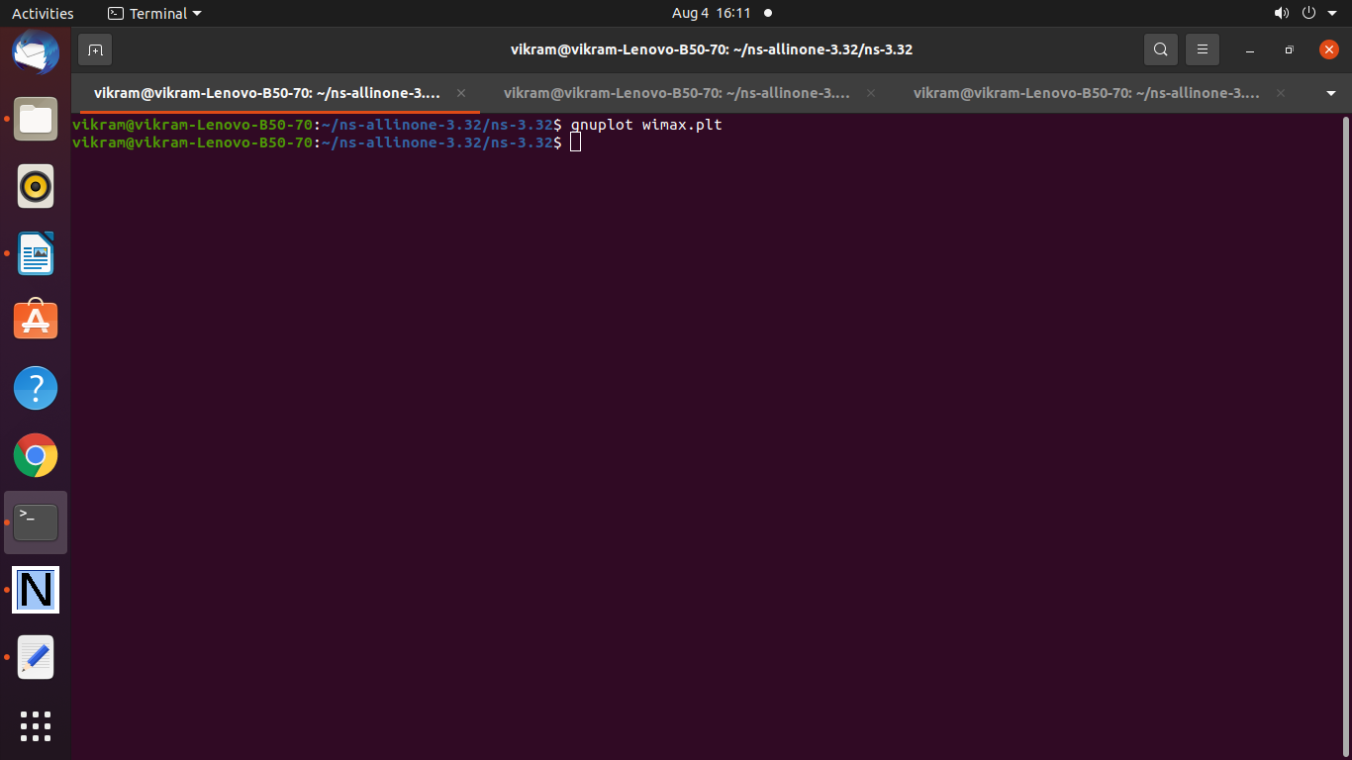

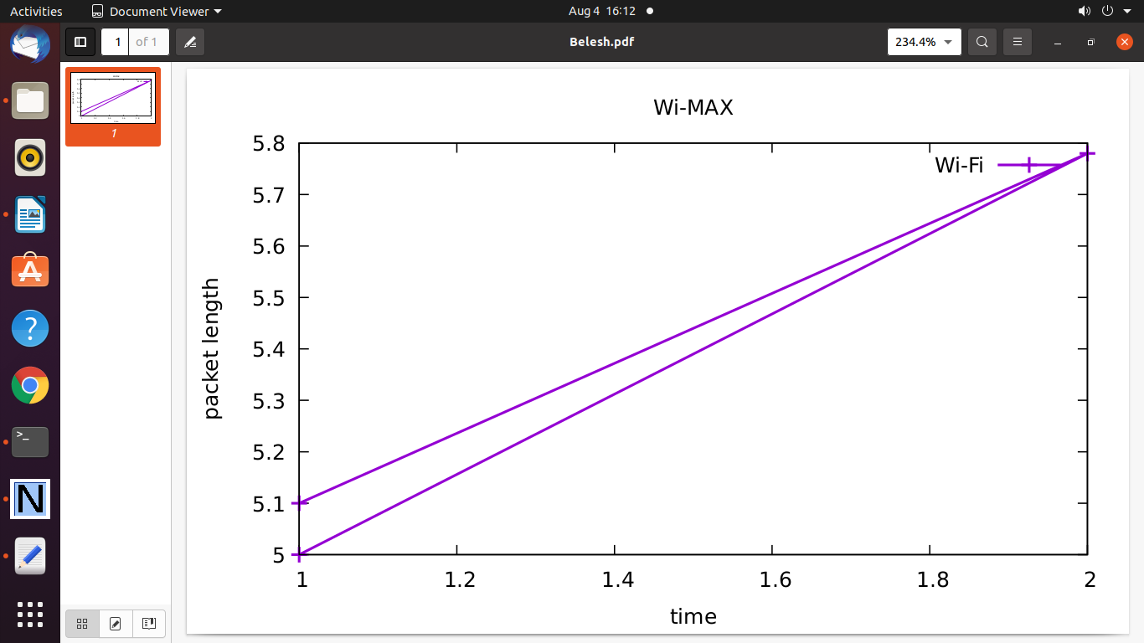

==================================

**Practical 14. Program to simulate IEEE 802.11 Wi-Fi Manager Nodes**

/* -*- Mode:C++; c-file-style:"gnu"; indent-tabs-mode:nil; -*- */

/*

* Copyright (c) 2016 University of Washington

*

* This program is free software; you can redistribute it and/or modify

* it under the terms of the GNU General Public License version 2 as

* published by the Free Software Foundation;

*

* This program is distributed in the hope that it will be useful,

* but WITHOUT ANY WARRANTY; without even the implied warranty of

* MERCHANTABILITY or FITNESS FOR A PARTICULAR PURPOSE. See the

* GNU General Public License for more details.

*

* You should have received a copy of the GNU General Public License

* along with this program; if not, write to the Free Software

* Foundation, Inc., 59 Temple Place, Suite 330, Boston, MA 02111-1307 USA

*

* Authors: Tom Henderson <tomhend@u.washington.edu>

* Matías Richart <mrichart@fing.edu.uy>

* Sébastien Deronne <sebastien.deronne@gmail.com>

*/

// Test the operation of a wifi manager as the SNR is varied, and create

// a gnuplot output file for plotting.

//

// The test consists of a device acting as server and a device as client generating traffic.

//

// The output consists of a plot of the rate observed and selected at the client device.

//

// By default, the 802.11a standard using IdealWifiManager is plotted. Several command line

// arguments can change the following options:

// --wifiManager (Aarf, Aarfcd, Amrr, Arf, Cara, Ideal, Minstrel, MinstrelHt, Onoe, Rraa)

// --standard (802.11a, 802.11b, 802.11g, 802.11n-5GHz, 802.11n-2.4GHz, 802.11ac, 802.11-holland, 802.11p-10MHz, 802.11p-5MHz)

// --serverShortGuardInterval and --clientShortGuardInterval (for 802.11n/ac)

// --serverNss and --clientNss (for 802.11n/ac)

// --serverChannelWidth and --clientChannelWidth (for 802.11n/ac)

// --broadcast instead of unicast (default is unicast)

// --rtsThreshold (by default, value of 99999 disables it)

#include "ns3/log.h"

#include "ns3/config.h"

#include "ns3/uinteger.h"

#include "ns3/boolean.h"

#include "ns3/double.h"

#include "ns3/gnuplot.h"

#include "ns3/command-line.h"

#include "ns3/yans-wifi-helper.h"

#include "ns3/ssid.h"

#include "ns3/propagation-loss-model.h"

#include "ns3/propagation-delay-model.h"

#include "ns3/rng-seed-manager.h"

#include "ns3/mobility-helper.h"

#include "ns3/wifi-net-device.h"

#include "ns3/packet-socket-helper.h"

#include "ns3/packet-socket-client.h"

#include "ns3/packet-socket-server.h"

#include "ns3/ht-configuration.h"

#include "ns3/he-configuration.h"

#include "ns3/netanim-module.h"

using namespace ns3;

NS_LOG_COMPONENT_DEFINE ("WifiManagerExample");

// 290K @ 20 MHz

const double NOISE_DBM_Hz = -174.0;

double noiseDbm = NOISE_DBM_Hz;

double g_intervalBytes = 0;

uint64_t g_intervalRate = 0;

void

PacketRx (Ptr<const Packet> pkt, const Address &addr)

{

g_intervalBytes += pkt->GetSize ();

}

void

RateChange (uint64_t oldVal, uint64_t newVal)

{

NS_LOG_DEBUG ("Change from " << oldVal << " to " << newVal);

g_intervalRate = newVal;

}

/// Step structure

struct Step

{

double stepSize; ///< step size in dBm

double stepTime; ///< step size in seconds

};

/// StandardInfo structure

struct StandardInfo

{

StandardInfo ()

{

m_name = "none";

}

/**

* Constructor

*

* \param name reference name

* \param standard wifi standard

* \param width channel width

* \param snrLow SNR low

* \param snrHigh SNR high

* \param xMin x minimum

* \param xMax x maximum

* \param yMax y maximum

*/

StandardInfo (std::string name, WifiStandard standard, uint16_t width, double snrLow, double snrHigh, double xMin, double xMax, double yMax)

: m_name (name),

m_standard (standard),

m_width (width),

m_snrLow (snrLow),

m_snrHigh (snrHigh),

m_xMin (xMin),

m_xMax (xMax),

m_yMax (yMax)

{

}

std::string m_name; ///< name

WifiStandard m_standard; ///< standard

uint16_t m_width; ///< channel width

double m_snrLow; ///< lowest SNR

double m_snrHigh; ///< highest SNR

double m_xMin; ///< X minimum

double m_xMax; ///< X maximum

double m_yMax; ///< Y maximum

};

void

ChangeSignalAndReportRate (Ptr<FixedRssLossModel> rssModel, struct Step step, double rss, Gnuplot2dDataset& rateDataset, Gnuplot2dDataset& actualDataset)

{

NS_LOG_FUNCTION (rssModel << step.stepSize << step.stepTime << rss);

double snr = rss - noiseDbm;

rateDataset.Add (snr, g_intervalRate / 1e6);

// Calculate received rate since last interval

double currentRate = ((g_intervalBytes * 8) / step.stepTime) / 1e6; // Mb/s

actualDataset.Add (snr, currentRate);

rssModel->SetRss (rss - step.stepSize);

NS_LOG_INFO ("At time " << Simulator::Now ().As (Time::S) << "; selected rate " << (g_intervalRate / 1e6) << "; observed rate " << currentRate << "; setting new power to " << rss - step.stepSize);

g_intervalBytes = 0;

Simulator::Schedule (Seconds (step.stepTime), &ChangeSignalAndReportRate, rssModel, step, (rss - step.stepSize), rateDataset, actualDataset);

}

int main (int argc, char *argv[])

{

std::vector <StandardInfo> serverStandards;

std::vector <StandardInfo> clientStandards;

uint32_t steps;

uint32_t rtsThreshold = 999999; // disabled even for large A-MPDU

uint32_t maxAmpduSize = 65535;

double stepSize = 1; // dBm

double stepTime = 1; // seconds

uint32_t packetSize = 1024; // bytes

bool broadcast = 0;

int ap1_x = 0;

int ap1_y = 0;

int sta1_x = 5;

int sta1_y = 0;

uint16_t serverNss = 1;

uint16_t clientNss = 1;

uint16_t serverShortGuardInterval = 800;

uint16_t clientShortGuardInterval = 800;

uint16_t serverChannelWidth = 20;

uint16_t clientChannelWidth = 20;

std::string wifiManager ("Ideal");

std::string standard ("802.11a");

StandardInfo serverSelectedStandard;

StandardInfo clientSelectedStandard;

bool infrastructure = false;

uint32_t maxSlrc = 7;

uint32_t maxSsrc = 7;

CommandLine cmd (__FILE__);

cmd.AddValue ("maxSsrc", "The maximum number of retransmission attempts for a RTS packet", maxSsrc);

cmd.AddValue ("maxSlrc", "The maximum number of retransmission attempts for a Data packet", maxSlrc);

cmd.AddValue ("rtsThreshold", "RTS threshold", rtsThreshold);

cmd.AddValue ("maxAmpduSize", "Max A-MPDU size", maxAmpduSize);

cmd.AddValue ("stepSize", "Power between steps (dBm)", stepSize);

cmd.AddValue ("stepTime", "Time on each step (seconds)", stepTime);

cmd.AddValue ("broadcast", "Send broadcast instead of unicast", broadcast);

cmd.AddValue ("serverChannelWidth", "Set channel width of the server (valid only for 802.11n or ac)", serverChannelWidth);

cmd.AddValue ("clientChannelWidth", "Set channel width of the client (valid only for 802.11n or ac)", clientChannelWidth);

cmd.AddValue ("serverNss", "Set nss of the server (valid only for 802.11n or ac)", serverNss);

cmd.AddValue ("clientNss", "Set nss of the client (valid only for 802.11n or ac)", clientNss);

cmd.AddValue ("serverShortGuardInterval", "Set short guard interval of the server (802.11n/ac/ax) in nanoseconds", serverShortGuardInterval);

cmd.AddValue ("clientShortGuardInterval", "Set short guard interval of the client (802.11n/ac/ax) in nanoseconds", clientShortGuardInterval);

cmd.AddValue ("standard", "Set standard (802.11a, 802.11b, 802.11g, 802.11n-5GHz, 802.11n-2.4GHz, 802.11ac, 802.11-holland, 802.11p-10MHz, 802.11p-5MHz, 802.11ax-5GHz, 802.11ax-2.4GHz)", standard);

cmd.AddValue ("wifiManager", "Set wifi rate manager (Aarf, Aarfcd, Amrr, Arf, Cara, Ideal, Minstrel, MinstrelHt, Onoe, Rraa)", wifiManager);

cmd.AddValue ("infrastructure", "Use infrastructure instead of adhoc", infrastructure);

cmd.Parse (argc,argv);

// Print out some explanation of what this program does

std::cout << std::endl << "This program demonstrates and plots the operation of different " << std::endl;

std::cout << "Wi-Fi rate controls on different station configurations," << std::endl;

std::cout << "by stepping down the received signal strength across a wide range" << std::endl;

std::cout << "and observing the adjustment of the rate." << std::endl;

std::cout << "Run 'wifi-manager-example --PrintHelp' to show program options." << std::endl << std::endl;

if (infrastructure == false)

{

NS_ABORT_MSG_IF (serverNss != clientNss, "In ad hoc mode, we assume sender and receiver are similarly configured");

}

if (standard == "802.11b")

{

NS_ABORT_MSG_IF (serverChannelWidth != 22 && serverChannelWidth != 22, "Invalid channel width for standard " << standard);

NS_ABORT_MSG_IF (serverNss != 1, "Invalid nss for standard " << standard);

NS_ABORT_MSG_IF (clientChannelWidth != 22 && clientChannelWidth != 22, "Invalid channel width for standard " << standard);

NS_ABORT_MSG_IF (clientNss != 1, "Invalid nss for standard " << standard);

}

else if (standard == "802.11a" || standard == "802.11g")

{

NS_ABORT_MSG_IF (serverChannelWidth != 20, "Invalid channel width for standard " << standard);

NS_ABORT_MSG_IF (serverNss != 1, "Invalid nss for standard " << standard);

NS_ABORT_MSG_IF (clientChannelWidth != 20, "Invalid channel width for standard " << standard);

NS_ABORT_MSG_IF (clientNss != 1, "Invalid nss for standard " << standard);

}

else if (standard == "802.11n-5GHz" || standard == "802.11n-2.4GHz")

{

NS_ABORT_MSG_IF (serverChannelWidth != 20 && serverChannelWidth != 40, "Invalid channel width for standard " << standard);

NS_ABORT_MSG_IF (serverNss == 0 || serverNss > 4, "Invalid nss " << serverNss << " for standard " << standard);

NS_ABORT_MSG_IF (clientChannelWidth != 20 && clientChannelWidth != 40, "Invalid channel width for standard " << standard);

NS_ABORT_MSG_IF (clientNss == 0 || clientNss > 4, "Invalid nss " << clientNss << " for standard " << standard);

}

else if (standard == "802.11ac")

{

NS_ABORT_MSG_IF (serverChannelWidth != 20 && serverChannelWidth != 40 && serverChannelWidth != 80 && serverChannelWidth != 160, "Invalid channel width for standard " << standard);

NS_ABORT_MSG_IF (serverNss == 0 || serverNss > 4, "Invalid nss " << serverNss << " for standard " << standard);

NS_ABORT_MSG_IF (clientChannelWidth != 20 && clientChannelWidth != 40 && clientChannelWidth != 80 && clientChannelWidth != 160, "Invalid channel width for standard " << standard);

NS_ABORT_MSG_IF (clientNss == 0 || clientNss > 4, "Invalid nss " << clientNss << " for standard " << standard);

}

else if (standard == "802.11ax-5GHz" || standard == "802.11ax-2.4GHz")

{

NS_ABORT_MSG_IF (serverChannelWidth != 20 && serverChannelWidth != 40 && serverChannelWidth != 80 && serverChannelWidth != 160, "Invalid channel width for standard " << standard);

NS_ABORT_MSG_IF (serverNss == 0 || serverNss > 4, "Invalid nss " << serverNss << " for standard " << standard);

NS_ABORT_MSG_IF (clientChannelWidth != 20 && clientChannelWidth != 40 && clientChannelWidth != 80 && clientChannelWidth != 160, "Invalid channel width for standard " << standard);

NS_ABORT_MSG_IF (clientNss == 0 || clientNss > 4, "Invalid nss " << clientNss << " for standard " << standard);

}

// As channel width increases, scale up plot's yRange value

uint32_t channelRateFactor = std::max (clientChannelWidth, serverChannelWidth) / 20;

channelRateFactor = channelRateFactor * std::max (clientNss, serverNss);

// The first number is channel width, second is minimum SNR, third is maximum

// SNR, fourth and fifth provide xrange axis limits, and sixth the yaxis

// maximum

serverStandards.push_back (StandardInfo ("802.11a", WIFI_STANDARD_80211a, 20, 3, 27, 0, 30, 60));

serverStandards.push_back (StandardInfo ("802.11b", WIFI_STANDARD_80211b, 22, -5, 11, -6, 15, 15));

serverStandards.push_back (StandardInfo ("802.11g", WIFI_STANDARD_80211g, 20, -5, 27, -6, 30, 60));

serverStandards.push_back (StandardInfo ("802.11n-5GHz", WIFI_STANDARD_80211n_5GHZ, serverChannelWidth, 3, 30, 0, 35, 80 * channelRateFactor));

serverStandards.push_back (StandardInfo ("802.11n-2.4GHz", WIFI_STANDARD_80211n_2_4GHZ, serverChannelWidth, 3, 30, 0, 35, 80 * channelRateFactor));

serverStandards.push_back (StandardInfo ("802.11ac", WIFI_STANDARD_80211ac, serverChannelWidth, 5, 50, 0, 55, 120 * channelRateFactor));

serverStandards.push_back (StandardInfo ("802.11-holland", WIFI_STANDARD_holland, 20, 3, 27, 0, 30, 60));

serverStandards.push_back (StandardInfo ("802.11p-10MHz", WIFI_STANDARD_80211p, 10, 3, 27, 0, 30, 60));

serverStandards.push_back (StandardInfo ("802.11p-5MHz", WIFI_STANDARD_80211p, 5, 3, 27, 0, 30, 60));

serverStandards.push_back (StandardInfo ("802.11ax-5GHz", WIFI_STANDARD_80211ax_5GHZ, serverChannelWidth, 5, 55, 0, 60, 120 * channelRateFactor));

serverStandards.push_back (StandardInfo ("802.11ax-2.4GHz", WIFI_STANDARD_80211ax_2_4GHZ, serverChannelWidth, 5, 55, 0, 60, 120 * channelRateFactor));

clientStandards.push_back (StandardInfo ("802.11a", WIFI_STANDARD_80211a, 20, 3, 27, 0, 30, 60));

clientStandards.push_back (StandardInfo ("802.11b", WIFI_STANDARD_80211b, 22, -5, 11, -6, 15, 15));

clientStandards.push_back (StandardInfo ("802.11g", WIFI_STANDARD_80211g, 20, -5, 27, -6, 30, 60));

clientStandards.push_back (StandardInfo ("802.11n-5GHz", WIFI_STANDARD_80211n_5GHZ, clientChannelWidth, 3, 30, 0, 35, 80 * channelRateFactor));

clientStandards.push_back (StandardInfo ("802.11n-2.4GHz", WIFI_STANDARD_80211n_2_4GHZ, clientChannelWidth, 3, 30, 0, 35, 80 * channelRateFactor));

clientStandards.push_back (StandardInfo ("802.11ac", WIFI_STANDARD_80211ac, clientChannelWidth, 5, 50, 0, 55, 120 * channelRateFactor));

clientStandards.push_back (StandardInfo ("802.11-holland", WIFI_STANDARD_holland, 20, 3, 27, 0, 30, 60));

clientStandards.push_back (StandardInfo ("802.11p-10MHz", WIFI_STANDARD_80211p, 10, 3, 27, 0, 30, 60));

clientStandards.push_back (StandardInfo ("802.11p-5MHz", WIFI_STANDARD_80211p, 5, 3, 27, 0, 30, 60));

clientStandards.push_back (StandardInfo ("802.11ax-5GHz", WIFI_STANDARD_80211ax_5GHZ, clientChannelWidth, 5, 55, 0, 60, 160 * channelRateFactor));

clientStandards.push_back (StandardInfo ("802.11ax-2.4GHz", WIFI_STANDARD_80211ax_2_4GHZ, clientChannelWidth, 5, 55, 0, 60, 160 * channelRateFactor));

for (std::vector<StandardInfo>::size_type i = 0; i != serverStandards.size (); i++)

{

if (standard == serverStandards[i].m_name)

{

serverSelectedStandard = serverStandards[i];

}

}

for (std::vector<StandardInfo>::size_type i = 0; i != clientStandards.size (); i++)

{

if (standard == clientStandards[i].m_name)

{

clientSelectedStandard = clientStandards[i];

}

}

NS_ABORT_MSG_IF (serverSelectedStandard.m_name == "none", "Standard " << standard << " not found");

NS_ABORT_MSG_IF (clientSelectedStandard.m_name == "none", "Standard " << standard << " not found");

std::cout << "Testing " << serverSelectedStandard.m_name << " with " << wifiManager << " ..." << std::endl;

NS_ABORT_MSG_IF (clientSelectedStandard.m_snrLow >= clientSelectedStandard.m_snrHigh, "SNR values in wrong order");

steps = static_cast<uint32_t> (std::abs (static_cast<double> (clientSelectedStandard.m_snrHigh - clientSelectedStandard.m_snrLow ) / stepSize) + 1);

NS_LOG_DEBUG ("Using " << steps << " steps for SNR range " << clientSelectedStandard.m_snrLow << ":" << clientSelectedStandard.m_snrHigh);

Ptr<Node> clientNode = CreateObject<Node> ();

Ptr<Node> serverNode = CreateObject<Node> ();

std::string plotName = "wifi-manager-example-";

std::string dataName = "wifi-manager-example-";

plotName += wifiManager;

dataName += wifiManager;

plotName += "-";

dataName += "-";

plotName += standard;

dataName += standard;

if (standard == "802.11n-5GHz"

|| standard == "802.11n-2.4GHz"

|| standard == "802.11ac"

|| standard == "802.11ax-5GHz"

|| standard == "802.11ax-2.4GHz")

{

plotName += "-server_";

dataName += "-server_";

std::ostringstream oss;

oss << serverChannelWidth << "MHz_" << serverShortGuardInterval << "ns_" << serverNss << "SS";

plotName += oss.str ();

dataName += oss.str ();

plotName += "-client_";

dataName += "-client_";

oss.str ("");

oss << clientChannelWidth << "MHz_" << clientShortGuardInterval << "ns_" << clientNss << "SS";

plotName += oss.str ();

dataName += oss.str ();

}

plotName += ".eps";

dataName += ".plt";

std::ofstream outfile (dataName.c_str ());

Gnuplot gnuplot = Gnuplot (plotName);

Config::SetDefault ("ns3::WifiRemoteStationManager::MaxSlrc", UintegerValue (maxSlrc));

Config::SetDefault ("ns3::WifiRemoteStationManager::MaxSsrc", UintegerValue (maxSsrc));

Config::SetDefault ("ns3::MinstrelWifiManager::PrintStats", BooleanValue (true));

Config::SetDefault ("ns3::MinstrelWifiManager::PrintSamples", BooleanValue (true));

Config::SetDefault ("ns3::MinstrelHtWifiManager::PrintStats", BooleanValue (true));

WifiHelper wifi;

wifi.SetStandard (serverSelectedStandard.m_standard);

YansWifiPhyHelper wifiPhy = YansWifiPhyHelper::Default ();

Ptr<YansWifiChannel> wifiChannel = CreateObject<YansWifiChannel> ();

Ptr<ConstantSpeedPropagationDelayModel> delayModel = CreateObject<ConstantSpeedPropagationDelayModel> ();

wifiChannel->SetPropagationDelayModel (delayModel);

Ptr<FixedRssLossModel> rssLossModel = CreateObject<FixedRssLossModel> ();

wifiChannel->SetPropagationLossModel (rssLossModel);

wifiPhy.SetChannel (wifiChannel);

wifi.SetRemoteStationManager ("ns3::" + wifiManager + "WifiManager", "RtsCtsThreshold", UintegerValue (rtsThreshold));

NetDeviceContainer serverDevice;

NetDeviceContainer clientDevice;

WifiMacHelper wifiMac;

if (infrastructure)

{

Ssid ssid = Ssid ("ns-3-ssid");

wifiMac.SetType ("ns3::StaWifiMac",

"Ssid", SsidValue (ssid));

serverDevice = wifi.Install (wifiPhy, wifiMac, serverNode);

wifiMac.SetType ("ns3::ApWifiMac",

"Ssid", SsidValue (ssid));

clientDevice = wifi.Install (wifiPhy, wifiMac, clientNode);

}

else

{

wifiMac.SetType ("ns3::AdhocWifiMac");

serverDevice = wifi.Install (wifiPhy, wifiMac, serverNode);

clientDevice = wifi.Install (wifiPhy, wifiMac, clientNode);

}

RngSeedManager::SetSeed (1);

RngSeedManager::SetRun (2);

wifi.AssignStreams (serverDevice, 100);

wifi.AssignStreams (clientDevice, 100);

Config::Set ("/NodeList/*/DeviceList/*/$ns3::WifiNetDevice/Mac/BE_MaxAmpduSize", UintegerValue (maxAmpduSize));

Config::ConnectWithoutContext ("/NodeList/0/DeviceList/*/$ns3::WifiNetDevice/RemoteStationManager/$ns3::" + wifiManager + "WifiManager/Rate", MakeCallback (&RateChange));

// Configure the mobility.

MobilityHelper mobility;

Ptr<ListPositionAllocator> positionAlloc = CreateObject<ListPositionAllocator> ();

//Initial position of AP and STA

positionAlloc->Add (Vector (ap1_x, ap1_y, 0.0));

NS_LOG_INFO ("Setting initial AP position to " << Vector (ap1_x, ap1_y, 0.0));

positionAlloc->Add (Vector (sta1_x, sta1_y, 0.0));

NS_LOG_INFO ("Setting initial STA position to " << Vector (sta1_x, sta1_y, 0.0));

mobility.SetPositionAllocator (positionAlloc);

mobility.SetMobilityModel ("ns3::ConstantPositionMobilityModel");

mobility.Install (clientNode);

mobility.Install (serverNode);

AnimationInterface anim("wi-fi.xml");

AnimationInterface::SetConstantPosition (serverNode, 10, 30);

AnimationInterface::SetConstantPosition (clientNode, 10, 45);

Gnuplot2dDataset rateDataset (clientSelectedStandard.m_name + std::string ("-rate selected"));

Gnuplot2dDataset actualDataset (clientSelectedStandard.m_name + std::string ("-observed"));

struct Step step;

step.stepSize = stepSize;

step.stepTime = stepTime;

// Perform post-install configuration from defaults for channel width,

// guard interval, and nss, if necessary

// Obtain pointer to the WifiPhy

Ptr<NetDevice> ndClient = clientDevice.Get (0);

Ptr<NetDevice> ndServer = serverDevice.Get (0);

Ptr<WifiNetDevice> wndClient = ndClient->GetObject<WifiNetDevice> ();

Ptr<WifiNetDevice> wndServer = ndServer->GetObject<WifiNetDevice> ();

Ptr<WifiPhy> wifiPhyPtrClient = wndClient->GetPhy ();

Ptr<WifiPhy> wifiPhyPtrServer = wndServer->GetPhy ();

uint8_t t_clientNss = static_cast<uint8_t> (clientNss);

uint8_t t_serverNss = static_cast<uint8_t> (serverNss);

wifiPhyPtrClient->SetNumberOfAntennas (t_clientNss);

wifiPhyPtrClient->SetMaxSupportedTxSpatialStreams (t_clientNss);

wifiPhyPtrClient->SetMaxSupportedRxSpatialStreams (t_clientNss);

wifiPhyPtrServer->SetNumberOfAntennas (t_serverNss);

wifiPhyPtrServer->SetMaxSupportedTxSpatialStreams (t_serverNss);

wifiPhyPtrServer->SetMaxSupportedRxSpatialStreams (t_serverNss);

// Only set the channel width and guard interval for HT and VHT modes

if (serverSelectedStandard.m_name == "802.11n-5GHz"

|| serverSelectedStandard.m_name == "802.11n-2.4GHz"

|| serverSelectedStandard.m_name == "802.11ac")

{

wifiPhyPtrServer->SetChannelWidth (serverSelectedStandard.m_width);

wifiPhyPtrClient->SetChannelWidth (clientSelectedStandard.m_width);

Ptr<HtConfiguration> clientHtConfiguration = wndClient->GetHtConfiguration ();

clientHtConfiguration->SetShortGuardIntervalSupported (clientShortGuardInterval == 400);

Ptr<HtConfiguration> serverHtConfiguration = wndServer->GetHtConfiguration ();

serverHtConfiguration->SetShortGuardIntervalSupported (serverShortGuardInterval == 400);

}

else if (serverSelectedStandard.m_name == "802.11ax-5GHz"

|| serverSelectedStandard.m_name == "802.11ax-2.4GHz")

{

wifiPhyPtrServer->SetChannelWidth (serverSelectedStandard.m_width);

wifiPhyPtrClient->SetChannelWidth (clientSelectedStandard.m_width);

wndServer->GetHeConfiguration ()->SetGuardInterval (NanoSeconds (clientShortGuardInterval));

wndClient->GetHeConfiguration ()->SetGuardInterval (NanoSeconds (clientShortGuardInterval));

}

NS_LOG_DEBUG ("Channel width " << wifiPhyPtrClient->GetChannelWidth () << " noiseDbm " << noiseDbm);

NS_LOG_DEBUG ("NSS " << wifiPhyPtrClient->GetMaxSupportedTxSpatialStreams ());

// Configure signal and noise, and schedule first iteration

noiseDbm += 10 * log10 (clientSelectedStandard.m_width * 1000000);

double rssCurrent = (clientSelectedStandard.m_snrHigh + noiseDbm);

rssLossModel->SetRss (rssCurrent);

NS_LOG_INFO ("Setting initial Rss to " << rssCurrent);

//Move the STA by stepsSize meters every stepTime seconds

Simulator::Schedule (Seconds (0.5 + stepTime), &ChangeSignalAndReportRate, rssLossModel, step, rssCurrent, rateDataset, actualDataset);

PacketSocketHelper packetSocketHelper;

packetSocketHelper.Install (serverNode);

packetSocketHelper.Install (clientNode);

PacketSocketAddress socketAddr;

socketAddr.SetSingleDevice (serverDevice.Get (0)->GetIfIndex ());

if (broadcast)

{

socketAddr.SetPhysicalAddress (serverDevice.Get (0)->GetBroadcast ());

}

else

{

socketAddr.SetPhysicalAddress (serverDevice.Get (0)->GetAddress ());

}

// Arbitrary protocol type.

// Note: PacketSocket doesn't have any L4 multiplexing or demultiplexing

// The only mux/demux is based on the protocol field

socketAddr.SetProtocol (1);

Ptr<PacketSocketClient> client = CreateObject<PacketSocketClient> ();

client->SetRemote (socketAddr);

client->SetStartTime (Seconds (0.5)); // allow simulation warmup

client->SetAttribute ("MaxPackets", UintegerValue (0)); // unlimited

client->SetAttribute ("PacketSize", UintegerValue (packetSize));

// Set a maximum rate 10% above the yMax specified for the selected standard

double rate = clientSelectedStandard.m_yMax * 1e6 * 1.10;

double clientInterval = static_cast<double> (packetSize) * 8 / rate;

NS_LOG_DEBUG ("Setting interval to " << clientInterval << " sec for rate of " << rate << " bits/sec");

client->SetAttribute ("Interval", TimeValue (Seconds (clientInterval)));

clientNode->AddApplication (client);

Ptr<PacketSocketServer> server = CreateObject<PacketSocketServer> ();

server->SetLocal (socketAddr);

server->TraceConnectWithoutContext ("Rx", MakeCallback (&PacketRx));

serverNode->AddApplication (server);

Simulator::Stop (Seconds ((steps + 1) * stepTime));

Simulator::Run ();

Simulator::Destroy ();

gnuplot.AddDataset (rateDataset);

gnuplot.AddDataset (actualDataset);

std::ostringstream xMinStr, xMaxStr, yMaxStr;

std::string xRangeStr ("set xrange [");

xMinStr << clientSelectedStandard.m_xMin;

xRangeStr.append (xMinStr.str ());

xRangeStr.append (":");

xMaxStr << clientSelectedStandard.m_xMax;

xRangeStr.append (xMaxStr.str ());

xRangeStr.append ("]");

std::string yRangeStr ("set yrange [0:");

yMaxStr << clientSelectedStandard.m_yMax;

yRangeStr.append (yMaxStr.str ());

yRangeStr.append ("]");

std::string title ("Results for ");

title.append (standard);

title.append (" with ");

title.append (wifiManager);

title.append ("\\n");

if (standard == "802.11n-5GHz"

|| standard == "802.11n-2.4GHz"

|| standard == "802.11ac"

|| standard == "802.11n-5GHz"

|| standard == "802.11ax-2.4GHz")

{

std::ostringstream serverGiStrStr;

std::ostringstream serverWidthStrStr;

std::ostringstream serverNssStrStr;

title.append ("server: width=");

serverWidthStrStr << serverSelectedStandard.m_width;

title.append (serverWidthStrStr.str ());

title.append ("MHz");

title.append (" GI=");

serverGiStrStr << serverShortGuardInterval;

title.append (serverGiStrStr.str ());

title.append ("ns");

title.append (" nss=");

serverNssStrStr << serverNss;

title.append (serverNssStrStr.str ());

title.append ("\\n");

std::ostringstream clientGiStrStr;

std::ostringstream clientWidthStrStr;

std::ostringstream clientNssStrStr;

title.append ("client: width=");

clientWidthStrStr << clientSelectedStandard.m_width;

title.append (clientWidthStrStr.str ());

title.append ("MHz");

title.append (" GI=");

clientGiStrStr << clientShortGuardInterval;

title.append (clientGiStrStr.str ());

title.append ("ns");

title.append (" nss=");

clientNssStrStr << clientNss;

title.append (clientNssStrStr.str ());

}

gnuplot.SetTerminal ("postscript eps color enh \"Times-BoldItalic\"");

gnuplot.SetLegend ("SNR (dB)", "Rate (Mb/s)");

gnuplot.SetTitle (title);

gnuplot.SetExtra (xRangeStr);

gnuplot.AppendExtra (yRangeStr);

gnuplot.AppendExtra ("set key top left");

gnuplot.GenerateOutput (outfile);

outfile.close ();

return 0;

}

**Output :**

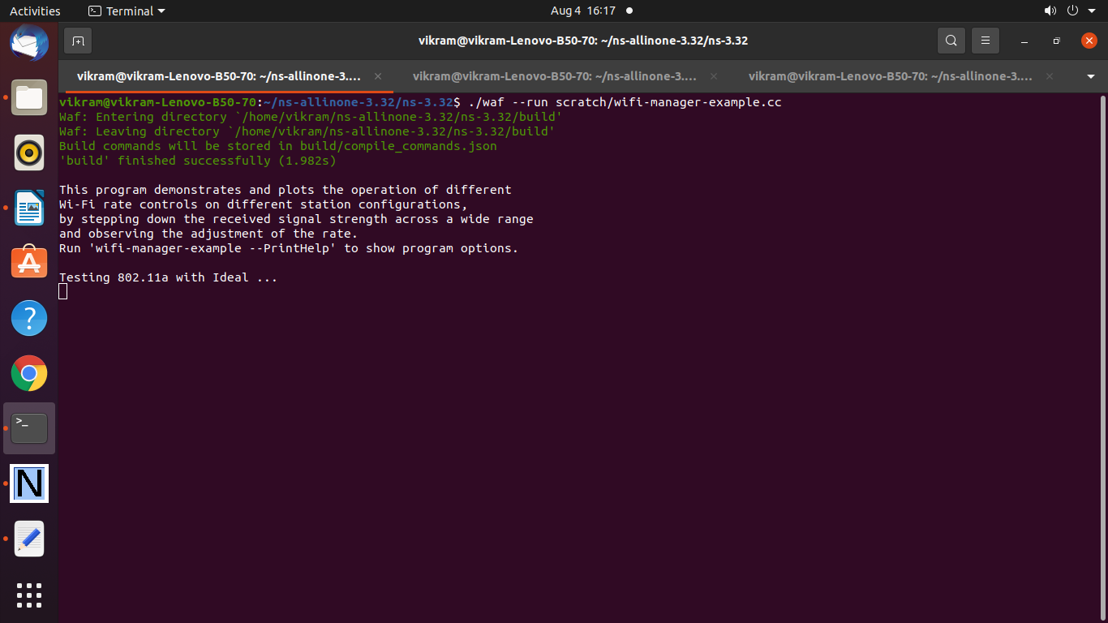

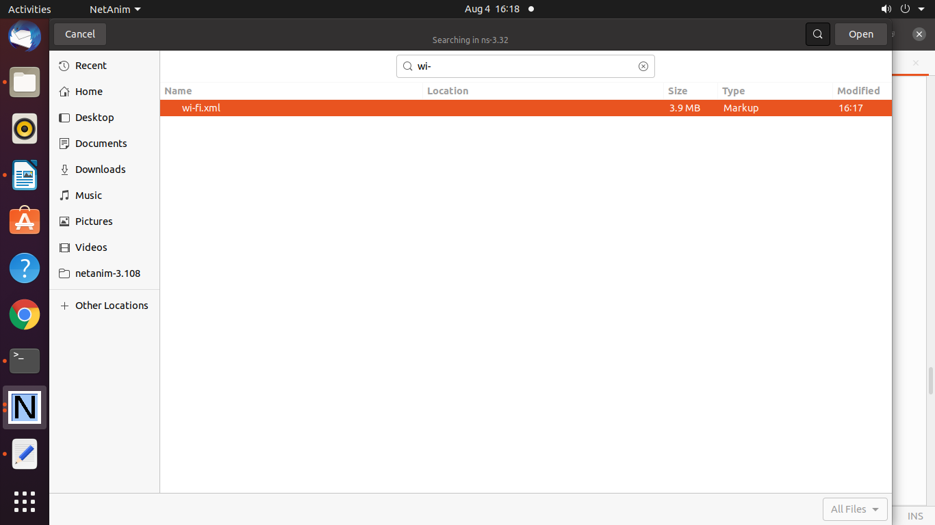

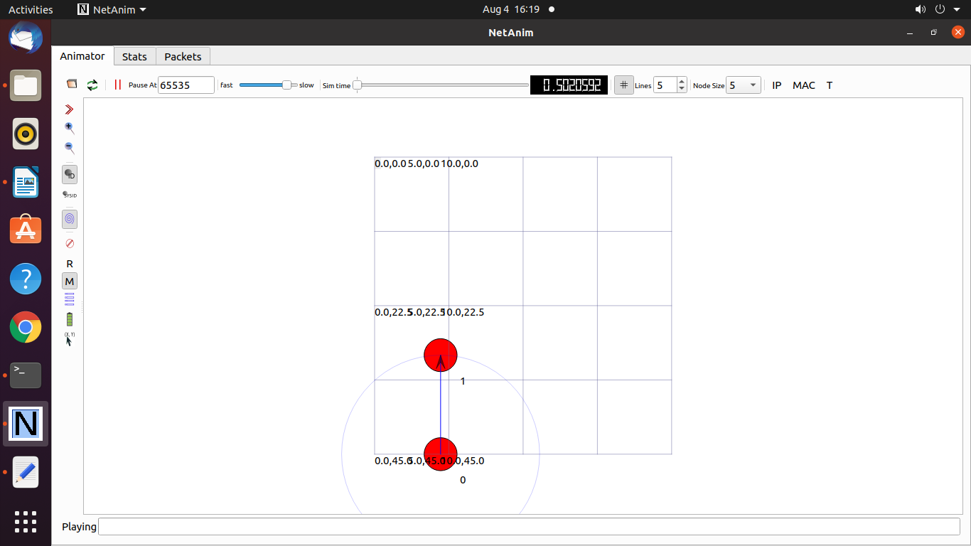

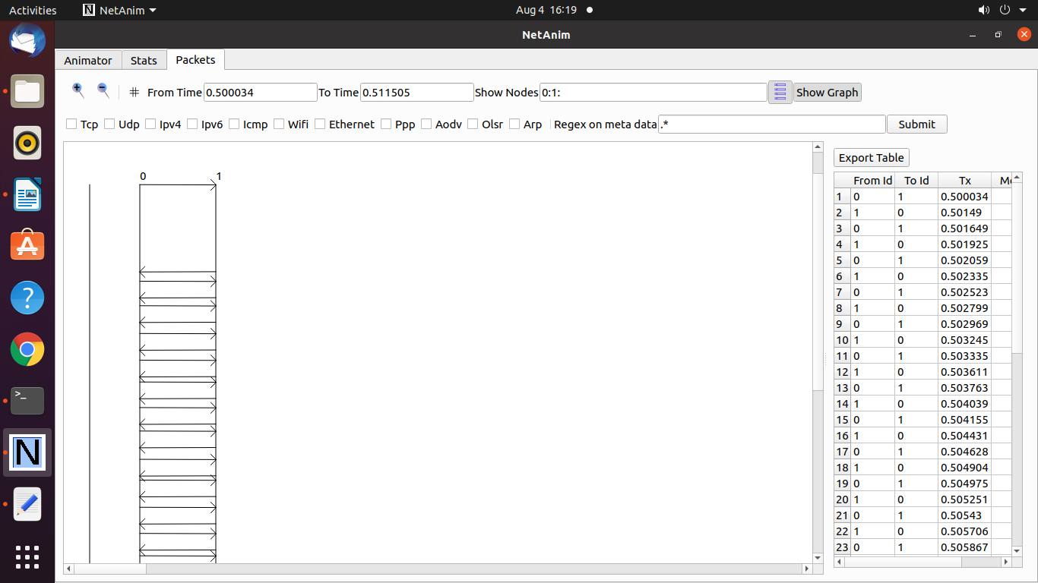

To Draw the Graph consider the following file

**wifi-manager-example-Ideal-802.11a.plt**

set terminal postscript eps color enh "Times-BoldItalic"

set output "wifi-manager-example-Ideal-802.11a.eps"

set title "Results for 802.11a with Ideal\n"

set xlabel "SNR (dB)"

set ylabel "Rate (Mb/s)"

set xrange [0:30]

set yrange [0:60]

set key top left

plot "-" title "802.11a-rate selected" with lines, "-" title "802.11a-observed" with lines

27 36

26 36

25 36

24 36

23 24

22 24

21 24

20 18

19 18

18 6

17 6

16 6

15 6

14 6

13 6

12 6

11 6

10 6

9 6

8 6

7 6

6 6

5 6

4 6

3 6

e

27 20.1851

26 20.1851

25 20.2015

24 19.7345

23 15.7041

22 15.6631

21 15.4993

20 12.6566

19 12.714

18 0.008192

17 0

16 0

15 0

14 0

13 0

12 0

11 0

10 0

9 0

8 0

7 0

6 0

5 0

4 0

3 0

e

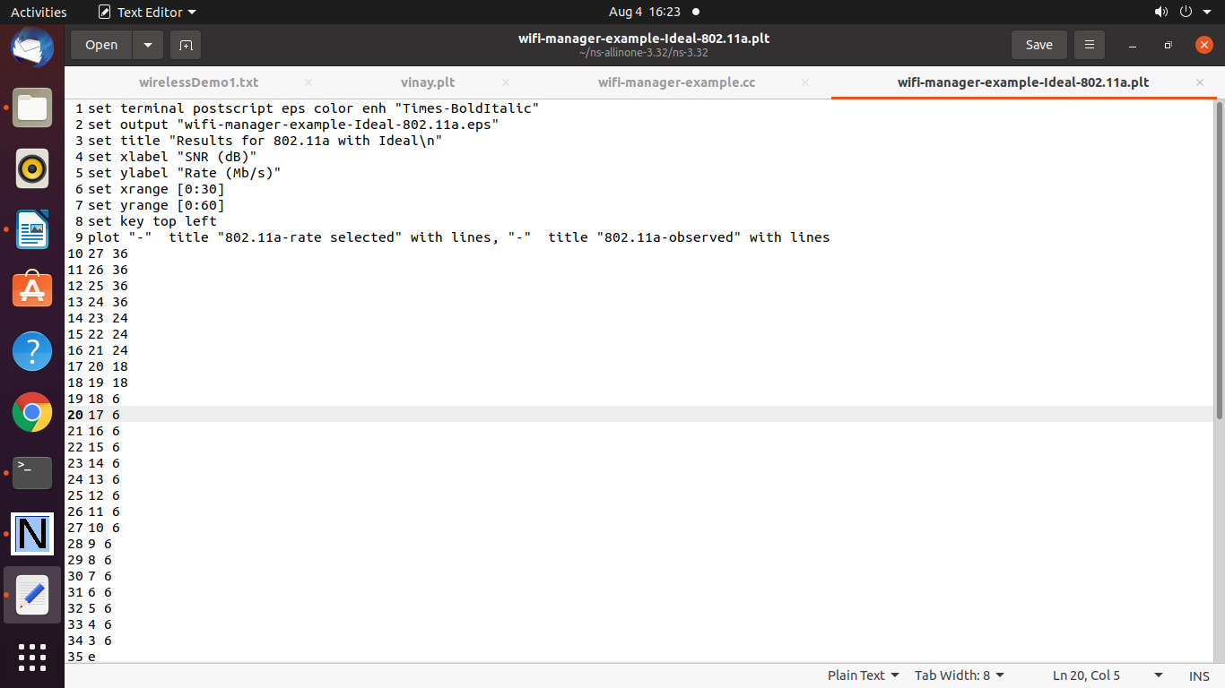

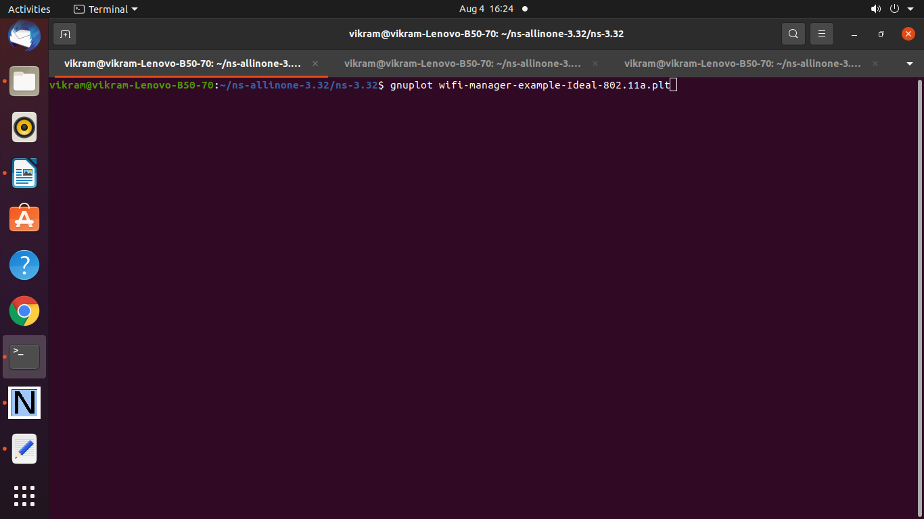

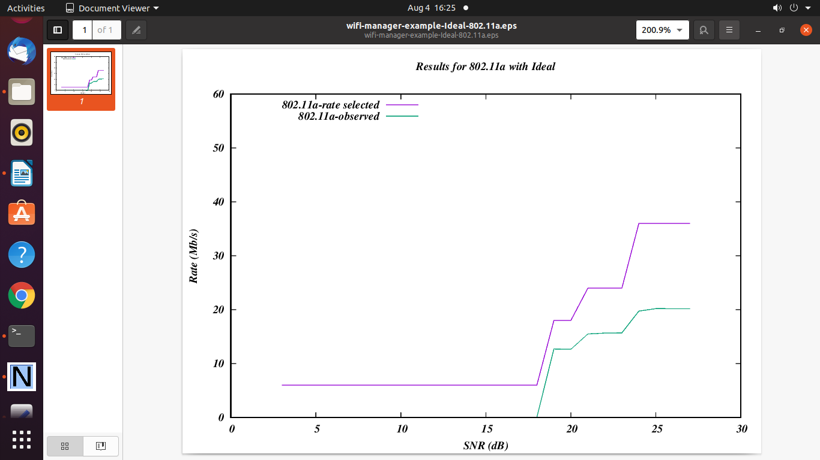

==========================================

**Practical 16 : Program to Simulatr Wi-Fi nodes**

**test.cc**

#include <stdio.h>

#include <math.h>

#include <ctype.h>

#include <string.h>

#include <fstream>

#include <iterator>

#include "ns3/core-module.h"

#include "ns3/network-module.h"

#include "ns3/applications-module.h"

#include "ns3/mobility-module.h"

#include "ns3/internet-module.h"

#include "ns3/yans-wifi-helper.h"

#include "ns3/energy-module.h"

#include "ns3/wifi-radio-energy-model-helper.h"

#include "ns3/config-store-module.h"

#include "ns3/netanim-module.h"

#include "ns3/energy-source-container.h"

using namespace ns3;

using namespace std;

NS_LOG_COMPONENT_DEFINE ("Test1");

static void

GenerateTraffic (Ptr<Socket> socket, uint32_t pktSize, uint32_t pktCount,

Time pktInterval)

{

if(pktCount > 0)

{

socket->Send (Create<Packet> (pktSize));

Simulator::Schedule(pktInterval, &GenerateTraffic, socket, pktSize,

pktCount - 1, pktInterval);

}

}

void EnergyPrint(EnergySourceContainer source, int rounds)

{

int id = 0;

int k = 1;

double remain = 50;

for (EnergySourceContainer::Iterator c = source.Begin(); c != source.End(); c++)

{

double energyRemain = (*c)->GetRemainingEnergy();

if (energyRemain < remain)

{

remain = energyRemain;

id = k;

}

NS_LOG_UNCOND("Node "<<k<<":"<<energyRemain<<"J");

k++;

}

NS_LOG_UNCOND("Rounds "<<rounds<<": Node "<<id<<" lowest energy "<<remain<<"J");

}

void SendPacket(Ptr<Socket> source[], int Cluster_Size, double start, Ptr<DeviceEnergyModel> modelPtr)

{

double interval = 0.1;

uint32_t PpacketSize = 5000;

uint32_t numPackets = 1;

Time interPacketInterval = Seconds (interval);

for (int i = 0; i < Cluster_Size; i++)

{

if (i == 1)

{

modelPtr->SetAttribute("RxCurrentA", DoubleValue (0.45));

modelPtr->SetAttribute("TxCurrentA", DoubleValue (0.21));

modelPtr->SetAttribute("IdleCurrentA", DoubleValue (0.1));

modelPtr->SetAttribute("SleepCurrentA", DoubleValue (0.03));

}

Time time = Seconds(start + i*interval*1.5);

Simulator::Schedule (time, &GenerateTraffic, source[i], PpacketSize,

numPackets, interPacketInterval);

if (i == 1)

{

modelPtr->SetAttribute("RxCurrentA", DoubleValue (0.00001));

modelPtr->SetAttribute("TxCurrentA", DoubleValue (0.00001));

modelPtr->SetAttribute("IdleCurrentA", DoubleValue (0.00001));

modelPtr->SetAttribute("SleepCurrentA", DoubleValue (0.00001));

}

}

}

void Remain(double old, double newv)

{

NS_LOG_UNCOND(Simulator::Now().GetSeconds()<<"s "<<newv<<"J");

}

int main(int argc, const char** argv) {

int Cluster_Size = 15;

// Create nodes

Ptr<Node> sink = CreateObject<Node>();

NodeContainer sensor;

sensor.Create(Cluster_Size);

NodeContainer allnode;

allnode.Add(sink);

allnode.Add(sensor);

// set up the phy layer (Wifi model used)

YansWifiChannelHelper channel;

channel.SetPropagationDelay("ns3::ConstantSpeedPropagationDelayModel"); // propagation delay & loss

channel.AddPropagationLoss("ns3::RangePropagationLossModel",

"MaxRange", DoubleValue(35.36));

YansWifiPhyHelper phy = YansWifiPhyHelper::Default();

phy.SetChannel(channel.Create()); // error rate

// mac layer

WifiHelper wifi;

wifi.SetStandard(WIFI_STANDARD_80211b);

wifi.SetRemoteStationManager("ns3::ConstantRateWifiManager",

"DataMode", StringValue ("DsssRate1Mbps"),

"ControlMode", StringValue ("DsssRate1Mbps"));

WifiMacHelper mac;

mac.SetType("ns3::AdhocWifiMac");

NetDeviceContainer wifide;

NetDeviceContainer sinkde;

wifide = wifi.Install(phy, mac, sensor);

sinkde = wifi.Install(phy, mac, sink);

NetDeviceContainer allde;

allde.Add(sinkde);

allde.Add(wifide);

// The location of the nodes

MobilityHelper model;

model.SetMobilityModel("ns3::ConstantPositionMobilityModel");

model.SetPositionAllocator("ns3::RandomRectanglePositionAllocator",

"X", StringValue("ns3::UniformRandomVariable[Min=0|Max=50]"),

"Y", StringValue("ns3::UniformRandomVariable[Min=0|Max=50]"));

model.Install(sensor);

model.SetPositionAllocator("ns3::GridPositionAllocator",

"MinX", DoubleValue(25),

"MinY", DoubleValue(25));

model.Install(sink);

// energy module

BasicEnergySourceHelper energyhelper;

energyhelper.Set("BasicEnergySourceInitialEnergyJ", DoubleValue(5));

EnergySourceContainer sources = energyhelper.Install(sensor);

WifiRadioEnergyModelHelper energymodel;

energymodel.Set("TxCurrentA", DoubleValue(0.45));

energymodel.Set("RxCurrentA", DoubleValue(0.21));

energymodel.Set("IdleCurrentA", DoubleValue(0.1));

energymodel.Set("SleepCurrentA", DoubleValue(0.03));

DeviceEnergyModelContainer energydevice = energymodel.Install(wifide, sources);

Ptr<BasicEnergySource> sourcePtr = DynamicCast<BasicEnergySource>(sources.Get(0));

sourcePtr->TraceConnectWithoutContext("RemainingEnergy", MakeCallback(&Remain));

Ptr<DeviceEnergyModel> modelPtr = sourcePtr->FindDeviceEnergyModels("ns3::WifiRadioEnergyModel").Get(0);

/** Internet stack **/

InternetStackHelper internet;

internet.Install (allnode);

Ipv4AddressHelper ipv4;

ipv4.SetBase ("10.1.1.0", "255.255.255.0");

Ipv4InterfaceContainer il = ipv4.Assign (allde);

TypeId tid = UdpSocketFactory::GetTypeId();

Ptr<Socket> recvSink = Socket::CreateSocket (sink, tid);

InetSocketAddress local = InetSocketAddress (Ipv4Address(il.GetAddress(0)), 80);

recvSink->Bind (local);

recvSink->SetAllowBroadcast(false);

Ptr<Socket> source[Cluster_Size];

for(int i=0; i < Cluster_Size; i++){

InetSocketAddress remote = InetSocketAddress (Ipv4Address(il.GetAddress(i+1)), 80);

source[i] = Socket::CreateSocket(sensor.Get(i), tid);

source[i]->Bind(remote);

source[i]->SetAllowBroadcast(false);

source[i]->Connect(local);

}

/** simulation setup **/

AnimationInterface anim ("test4.xml");

// start traffic

int rounds = 5;

// The Send Packet function: In each round, every node will send a packet to sink node.

// And it will repeat for given figure, at last, the energyprint function will list the

// remain energy of each node and tell the one with lowest energy.

// A real time trace function will tell the time energy stop tracing.

for (int i = 0; i < rounds; i++)

{

SendPacket(source, Cluster_Size, double(2.2*i), modelPtr);

}

Simulator::Stop (Seconds (2.2*(rounds+1)));

Simulator::Run ();

EnergyPrint(sources, rounds);

Simulator::Destroy ();

return 0;

}

**Output**

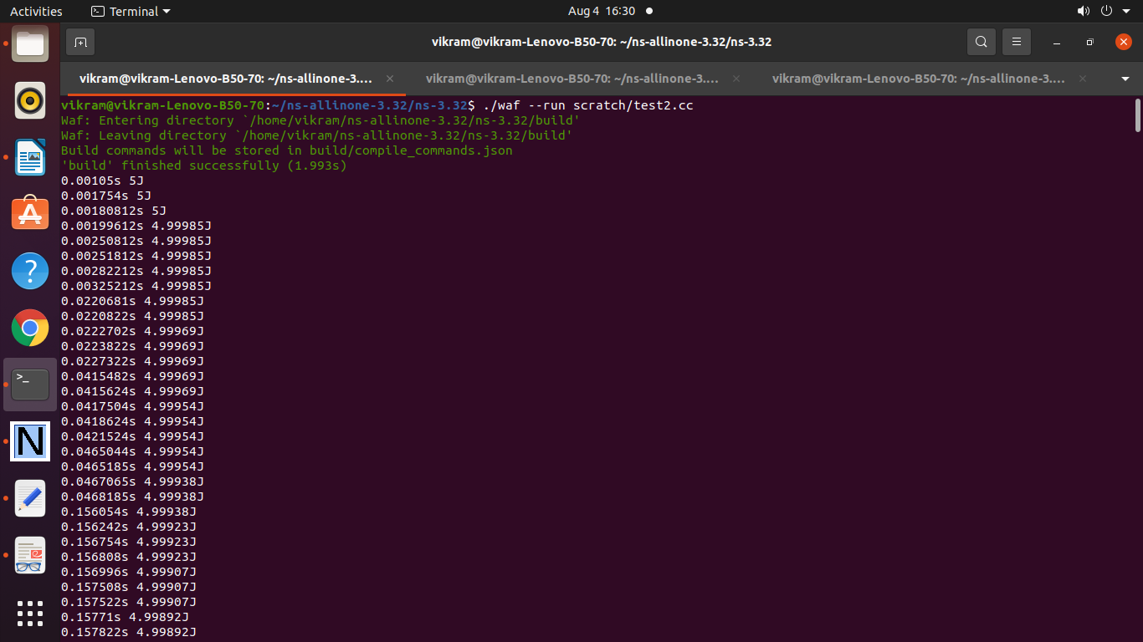

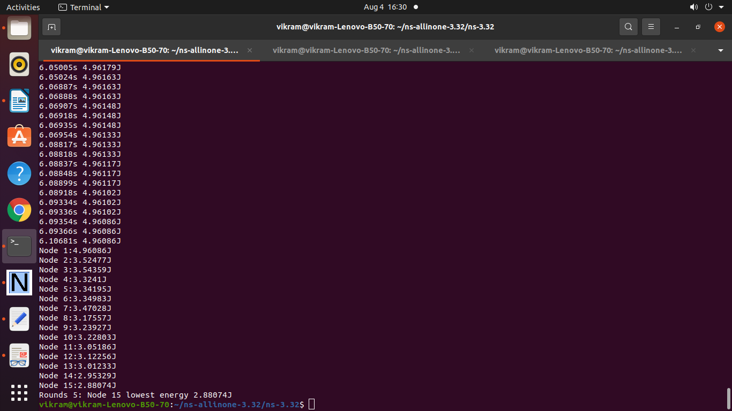

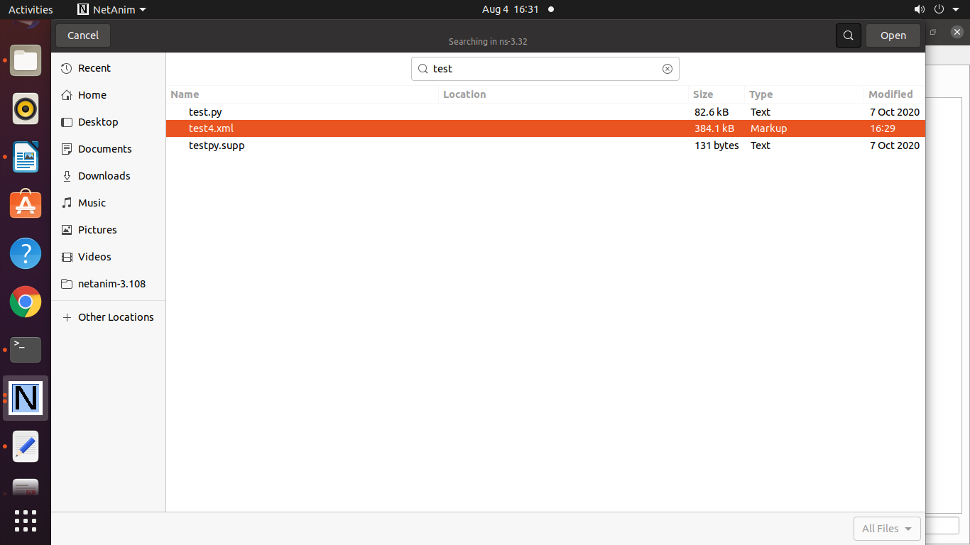

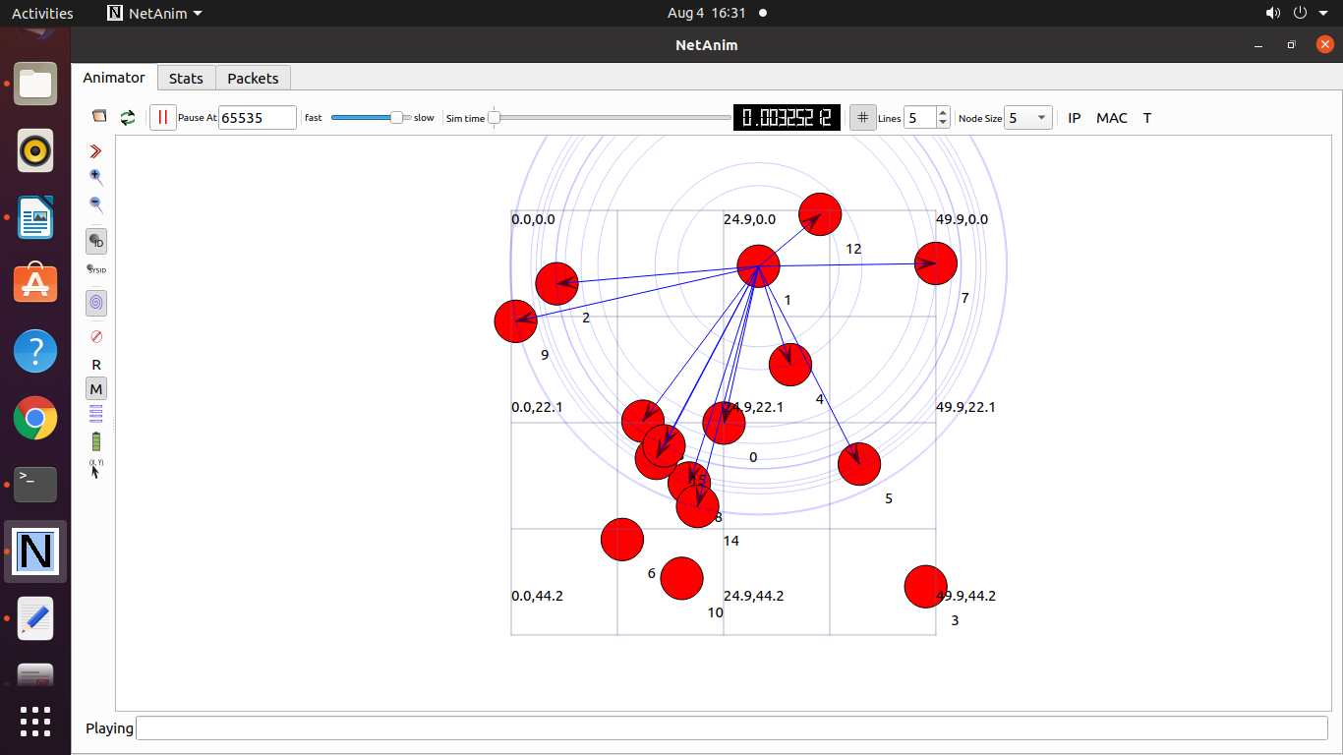

**Program 17 : Program to Simulatr Grid-Topology**

/* -*- Mode:C++; c-file-style:"gnu"; indent-tabs-mode:nil; -*- */

/*

* This program is free software; you can redistribute it and/or modify

* it under the terms of the GNU General Public License version 2 as

* published by the Free Software Foundation;

*

* This program is distributed in the hope that it will be useful,

* but WITHOUT ANY WARRANTY; without even the implied warranty of

* MERCHANTABILITY or FITNESS FOR A PARTICULAR PURPOSE. See the

* GNU General Public License for more details.

*

* You should have received a copy of the GNU General Public License

* along with this program; if not, write to the Free Software

* Foundation, Inc., 59 Temple Place, Suite 330, Boston, MA 02111-1307 USA

*

* Author: Josh Pelkey <jpelkey@gatech.edu>

*/

#include <iostream>

#include "ns3/core-module.h"

#include "ns3/network-module.h"

#include "ns3/internet-module.h"

#include "ns3/point-to-point-module.h"

#include "ns3/netanim-module.h"

#include "ns3/applications-module.h"

#include "ns3/point-to-point-layout-module.h"

using namespace ns3;

int main (int argc, char *argv[])

{

Config::SetDefault ("ns3::OnOffApplication::PacketSize", UintegerValue (512));

Config::SetDefault ("ns3::OnOffApplication::DataRate", StringValue ("500kb/s"));

uint32_t xSize = 5;

uint32_t ySize = 5;

std::string animFile = "grid-animation.xml";

CommandLine cmd;

cmd.AddValue ("xSize", "Number of rows of nodes", xSize);

cmd.AddValue ("ySize", "Number of columns of nodes", ySize);

cmd.AddValue ("animFile", "File Name for Animation Output", animFile);

cmd.Parse (argc,argv);

if (xSize < 1 || ySize < 1 || (xSize < 2 && ySize < 2))

{

NS_FATAL_ERROR ("Need more nodes for grid.");

}

PointToPointHelper pointToPoint;

pointToPoint.SetDeviceAttribute ("DataRate", StringValue ("5Mbps"));

pointToPoint.SetChannelAttribute ("Delay", StringValue ("2ms"));

// Create Grid

PointToPointGridHelper grid (xSize, ySize, pointToPoint);

// Install stack on Grid

InternetStackHelper stack;

grid.InstallStack (stack);

// Assign Addresses to Grid

grid.AssignIpv4Addresses (Ipv4AddressHelper ("10.1.1.0", "255.255.255.0"),

Ipv4AddressHelper ("10.2.1.0", "255.255.255.0"));

OnOffHelper clientHelper ("ns3::UdpSocketFactory", Address ());

clientHelper.SetAttribute ("OnTime", StringValue ("ns3::ConstantRandomVariable[Constant=1]"));

clientHelper.SetAttribute ("OffTime", StringValue ("ns3::ConstantRandomVariable[Constant=0]"));

ApplicationContainer clientApps;

// Create an on/off app sending packets

AddressValue remoteAddress (InetSocketAddress (grid.GetIpv4Address (xSize-1,ySize-1), 1000));

clientHelper.SetAttribute ("Remote", remoteAddress);

clientApps.Add (clientHelper.Install (grid.GetNode (0,0)));

clientApps.Start (Seconds (0.0));

clientApps.Stop (Seconds (1.5));

// Set the bounding box for animation

grid.BoundingBox (1, 1, 100, 100);

// Create the animation object and configure for specified output

AnimationInterface anim (animFile);

// Set up the actual simulation

Ipv4GlobalRoutingHelper::PopulateRoutingTables ();

Simulator::Run ();

Simulator::Destroy ();

return 0;

}

**Output :**

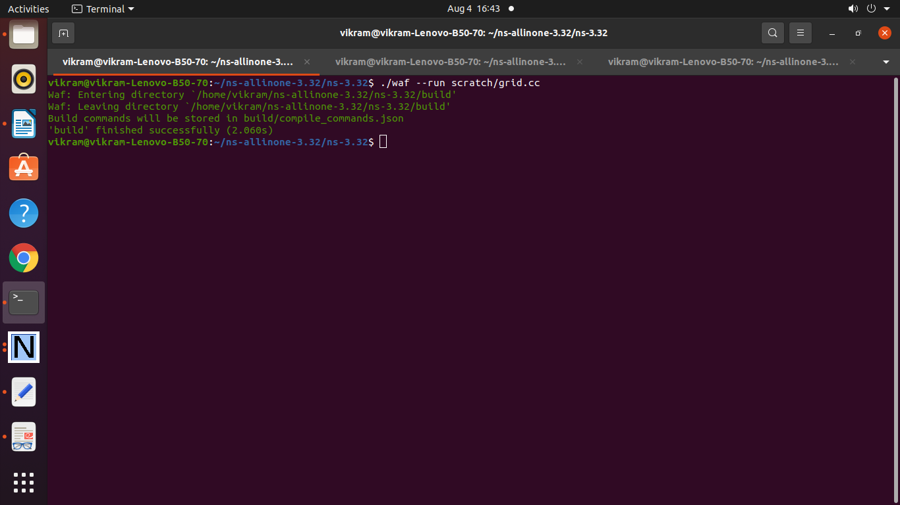

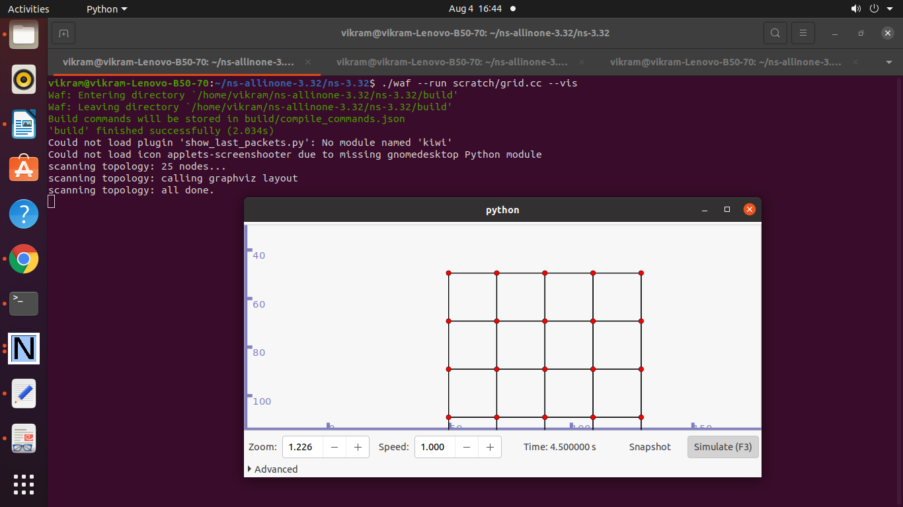

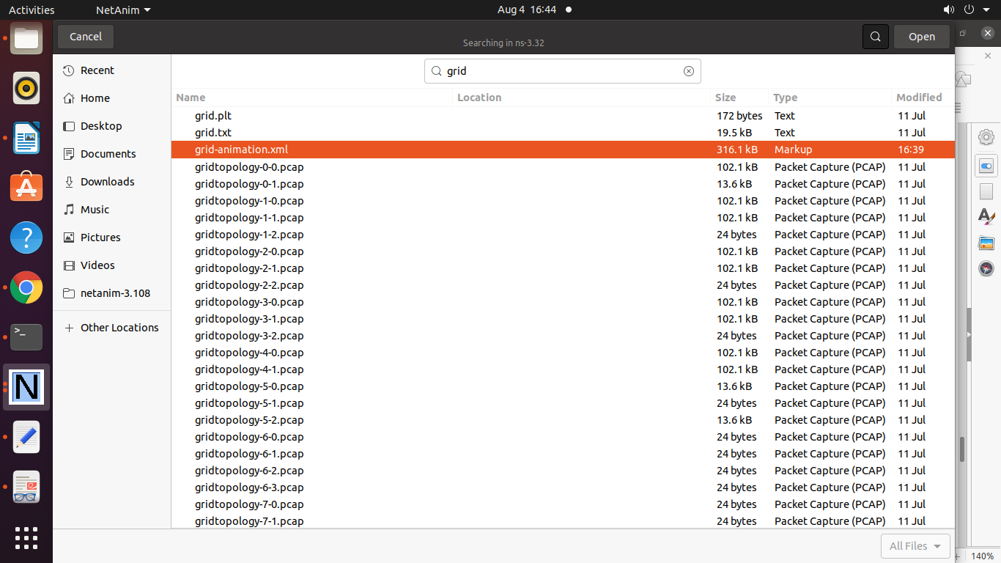

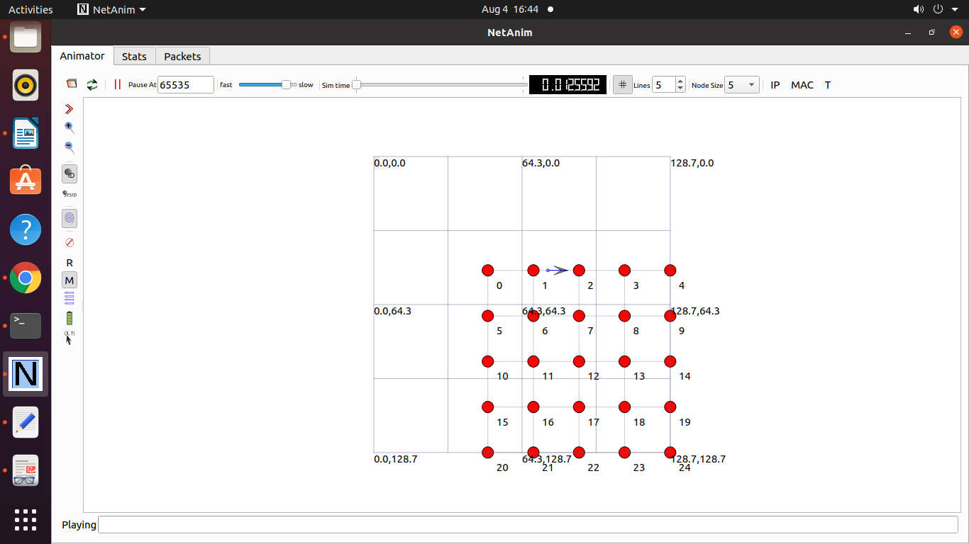

To draw the Graph consider the following files

**grid.txt**

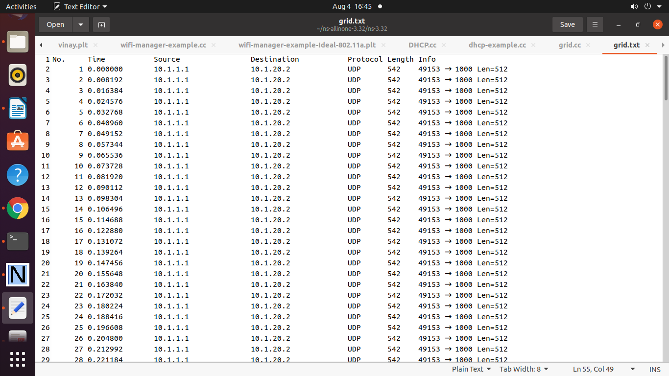

**grid.plt**

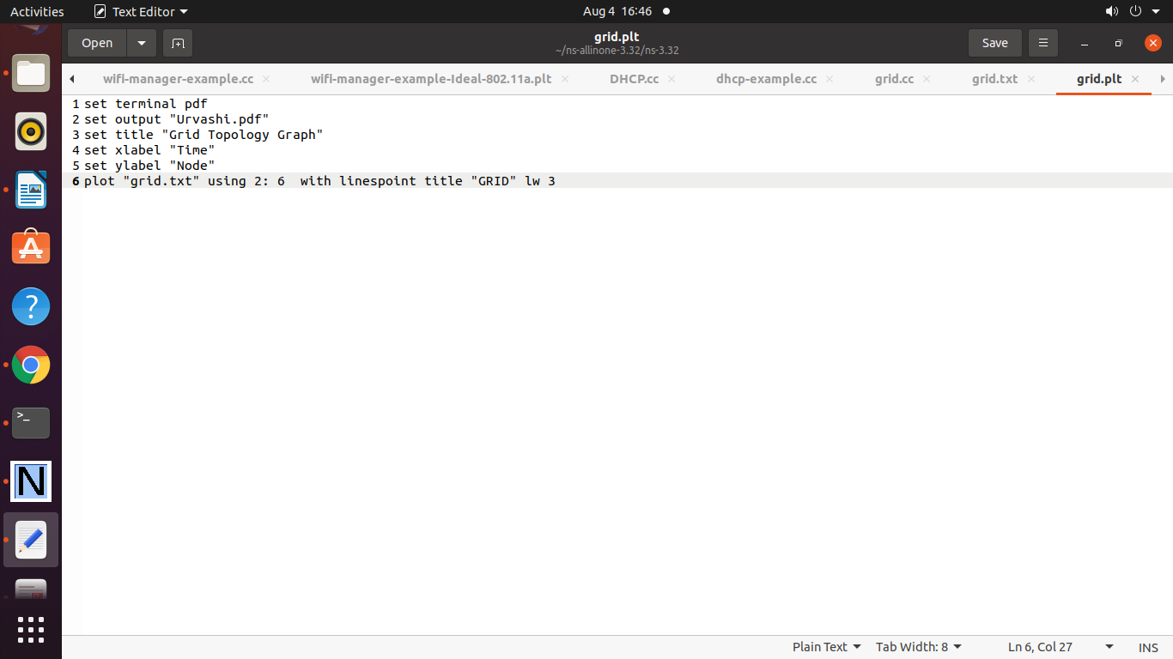

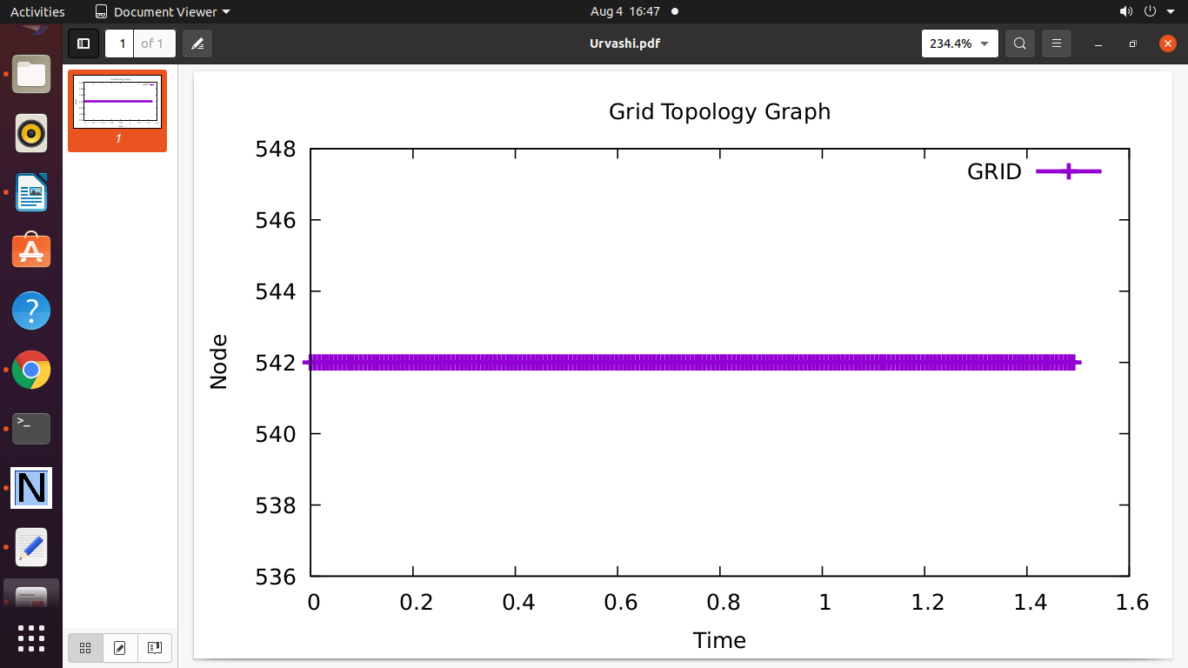

**Practical 18 : Program to Simulate Hybird Topology**

/* -*- Mode:C++; c-file-style:"gnu"; indent-tabs-mode:nil; -*- */

/*

* This program is free software; you can redistribute it and/or modify

* it under the terms of the GNU General Public License version 2 as

* published by the Free Software Foundation;

*

* This program is distributed in the hope that it will be useful,

* but WITHOUT ANY WARRANTY; without even the implied warranty of

* MERCHANTABILITY or FITNESS FOR A PARTICULAR PURPOSE. See the

* GNU General Public License for more details.

*

* You should have received a copy of the GNU General Public License

* along with this program; if not, write to the Free Software

* Foundation, Inc., 59 Temple Place, Suite 330, Boston, MA 02111-1307 USA

*/

/*

LAB Assignment #2

1. Create a simple dumbbell topology, two client Node1 and Node2 on

the left side of the dumbbell and server nodes Node3 and Node4 on the

right side of the dumbbell. Let Node5 and Node6 form the bridge of the

dumbbell. Use point to point links.

2. Install a TCP socket instance on Node1 that will connect to Node3.

3. Install a UDP socket instance on Node2 that will connect to Node4.

4. Start the TCP application at time 1s.

5. Start the UDP application at time 20s at rate Rate1 such that it clogs

half the dumbbell bridge's link capacity.

6. Increase the UDP application's rate at time 30s to rate Rate2

such that it clogs the whole of the dumbbell bridge's capacity.

7. Use the ns-3 tracing mechanism to record changes in congestion window

size of the TCP instance over time. Use gnuplot/matplotlib to visualise plots of cwnd vs time.

8. Mark points of fast recovery and slow start in the graphs.

9. Perform the above experiment for TCP variants Tahoe, Reno and New Reno,

all of which are available with ns-3.

Solution by: Konstantinos Katsaros (K.Katsaros@surrey.ac.uk)

based on fifth.cc

*/

// Network topology

//

// n0 ---+ +--- n2

// | |

// n4 -- n5

// | |

// n1 ---+ +--- n3

//

// - All links are P2P with 500kb/s and 2ms

// - TCP flow form n0 to n2

// - UDP flow from n1 to n3

#include <fstream>

#include <string>

#include "ns3/core-module.h"

#include "ns3/network-module.h"

#include "ns3/point-to-point-module.h"

#include "ns3/applications-module.h"

#include "ns3/internet-module.h"

#include "ns3/flow-monitor-module.h"

#include "ns3/ipv4-global-routing-helper.h"

#include "ns3/netanim-module.h"

#include "ns3/mobility-module.h"

using namespace ns3;

NS_LOG_COMPONENT_DEFINE ("Lab2");

class MyApp : public Application

{

public:

MyApp ();

virtual ~MyApp();

void Setup (Ptr<Socket> socket, Address address, uint32_t packetSize, uint32_t nPackets, DataRate dataRate);

void ChangeRate(DataRate newrate);

private:

virtual void StartApplication (void);

virtual void StopApplication (void);

void ScheduleTx (void);

void SendPacket (void);

Ptr<Socket> m_socket;

Address m_peer;

uint32_t m_packetSize;

uint32_t m_nPackets;

DataRate m_dataRate;

EventId m_sendEvent;

bool m_running;

uint32_t m_packetsSent;

};

MyApp::MyApp ()

: m_socket (0),

m_peer (),

m_packetSize (0),

m_nPackets (0),

m_dataRate (0),

m_sendEvent (),

m_running (false),

m_packetsSent (0)

{

}

MyApp::~MyApp()

{

m_socket = 0;

}

void

MyApp::Setup (Ptr<Socket> socket, Address address, uint32_t packetSize, uint32_t nPackets, DataRate dataRate)

{

m_socket = socket;

m_peer = address;

m_packetSize = packetSize;

m_nPackets = nPackets;

m_dataRate = dataRate;

}

void

MyApp::StartApplication (void)

{

m_running = true;

m_packetsSent = 0;

m_socket->Bind ();

m_socket->Connect (m_peer);

SendPacket ();

}

void

MyApp::StopApplication (void)

{

m_running = false;

if (m_sendEvent.IsRunning ())

{

Simulator::Cancel (m_sendEvent);

}

if (m_socket)

{

m_socket->Close ();

}

}

void

MyApp::SendPacket (void)

{

Ptr<Packet> packet = Create<Packet> (m_packetSize);

m_socket->Send (packet);

if (++m_packetsSent < m_nPackets)

{

ScheduleTx ();

}

}

void

MyApp::ScheduleTx (void)

{

if (m_running)

{

Time tNext (Seconds (m_packetSize * 8 / static_cast<double> (m_dataRate.GetBitRate ())));

m_sendEvent = Simulator::Schedule (tNext, &MyApp::SendPacket, this);

}

}

void

MyApp::ChangeRate(DataRate newrate)

{

m_dataRate = newrate;

return;

}

static void

CwndChange (uint32_t oldCwnd, uint32_t newCwnd)

{

std::cout << Simulator::Now ().GetSeconds () << "\t" << newCwnd <<"\n";

}

void

IncRate (Ptr<MyApp> app, DataRate rate)

{

app->ChangeRate(rate);

return;

}

int main (int argc, char *argv[])

{

std::string lat = "2ms";

std::string rate = "500kb/s"; // P2P link

bool enableFlowMonitor = false;

CommandLine cmd;

cmd.AddValue ("latency", "P2P link Latency in miliseconds", lat);

cmd.AddValue ("rate", "P2P data rate in bps", rate);

cmd.AddValue ("EnableMonitor", "Enable Flow Monitor", enableFlowMonitor);

cmd.Parse (argc, argv);

//

// Explicitly create the nodes required by the topology (shown above).

//

NS_LOG_INFO ("Create nodes.");

NodeContainer c; // ALL Nodes

c.Create(6);

NodeContainer n0n4 = NodeContainer (c.Get (0), c.Get (4));

NodeContainer n1n4 = NodeContainer (c.Get (1), c.Get (4));

NodeContainer n2n5 = NodeContainer (c.Get (2), c.Get (5));

NodeContainer n3n5 = NodeContainer (c.Get (3), c.Get (5));

NodeContainer n4n5 = NodeContainer (c.Get (4), c.Get (5));

//

// Install Internet Stack

//

InternetStackHelper internet;

internet.Install (c);

// We create the channels first without any IP addressing information

NS_LOG_INFO ("Create channels.");

PointToPointHelper p2p;

p2p.SetDeviceAttribute ("DataRate", StringValue (rate));

p2p.SetChannelAttribute ("Delay", StringValue (lat));

NetDeviceContainer d0d4 = p2p.Install (n0n4);

NetDeviceContainer d1d4 = p2p.Install (n1n4);

NetDeviceContainer d4d5 = p2p.Install (n4n5);

NetDeviceContainer d2d5 = p2p.Install (n2n5);

NetDeviceContainer d3d5 = p2p.Install (n3n5);

// Later, we add IP addresses.

NS_LOG_INFO ("Assign IP Addresses.");

Ipv4AddressHelper ipv4;

ipv4.SetBase ("10.1.1.0", "255.255.255.0");

Ipv4InterfaceContainer i0i4 = ipv4.Assign (d0d4);

ipv4.SetBase ("10.1.2.0", "255.255.255.0");

Ipv4InterfaceContainer i1i4 = ipv4.Assign (d1d4);

ipv4.SetBase ("10.1.3.0", "255.255.255.0");

Ipv4InterfaceContainer i4i5 = ipv4.Assign (d4d5);

ipv4.SetBase ("10.1.4.0", "255.255.255.0");

Ipv4InterfaceContainer i2i5 = ipv4.Assign (d2d5);

ipv4.SetBase ("10.1.5.0", "255.255.255.0");

Ipv4InterfaceContainer i3i5 = ipv4.Assign (d3d5);

NS_LOG_INFO ("Enable static global routing.");

//

// Turn on global static routing so we can actually be routed across the network.

//

Ipv4GlobalRoutingHelper::PopulateRoutingTables ();

NS_LOG_INFO ("Create Applications.");

// TCP connfection from N0 to N2

uint16_t sinkPort = 8080;

Address sinkAddress (InetSocketAddress (i2i5.GetAddress (0), sinkPort)); // interface of n2

PacketSinkHelper packetSinkHelper ("ns3::TcpSocketFactory", InetSocketAddress (Ipv4Address::GetAny (), sinkPort));

ApplicationContainer sinkApps = packetSinkHelper.Install (c.Get (2)); //n2 as sink

sinkApps.Start (Seconds (0.));

sinkApps.Stop (Seconds (100.));

Ptr<Socket> ns3TcpSocket = Socket::CreateSocket (c.Get (0), TcpSocketFactory::GetTypeId ()); //source at n0

// Trace Congestion window

ns3TcpSocket->TraceConnectWithoutContext ("CongestionWindow", MakeCallback (&CwndChange));

// Create TCP application at n0

Ptr<MyApp> app = CreateObject<MyApp> ();

app->Setup (ns3TcpSocket, sinkAddress, 1040, 100000, DataRate ("250Kbps"));

c.Get (0)->AddApplication (app);

app->SetStartTime (Seconds (1.));

app->SetStopTime (Seconds (100.));

// UDP connfection from N1 to N3

uint16_t sinkPort2 = 6;

Address sinkAddress2 (InetSocketAddress (i3i5.GetAddress (0), sinkPort2)); // interface of n3

PacketSinkHelper packetSinkHelper2 ("ns3::UdpSocketFactory", InetSocketAddress (Ipv4Address::GetAny (), sinkPort2));

ApplicationContainer sinkApps2 = packetSinkHelper2.Install (c.Get (3)); //n3 as sink

sinkApps2.Start (Seconds (0.));

sinkApps2.Stop (Seconds (100.));

Ptr<Socket> ns3UdpSocket = Socket::CreateSocket (c.Get (1), UdpSocketFactory::GetTypeId ()); //source at n1

// Create UDP application at n1

Ptr<MyApp> app2 = CreateObject<MyApp> ();

app2->Setup (ns3UdpSocket, sinkAddress2, 1040, 100000, DataRate ("250Kbps"));

c.Get (1)->AddApplication (app2);

app2->SetStartTime (Seconds (20.));

app2->SetStopTime (Seconds (100.));

// Increase UDP Rate

Simulator::Schedule (Seconds(30.0), &IncRate, app2, DataRate("500kbps"));

// Flow Monitor

Ptr<FlowMonitor> flowmon;

if (enableFlowMonitor)

{

FlowMonitorHelper flowmonHelper;

flowmon = flowmonHelper.InstallAll ();

}

AnimationInterface anim("hybrid.xml");

//

// Now, do the actual simulation.

//

NS_LOG_INFO ("Run Simulation.");

Simulator::Stop (Seconds(100.0));

Simulator::Run ();

if (enableFlowMonitor)

{

flowmon->CheckForLostPackets ();

flowmon->SerializeToXmlFile("lab-2.flowmon", true, true);

}

Simulator::Destroy ();

NS_LOG_INFO ("Done.");

}

**Output**

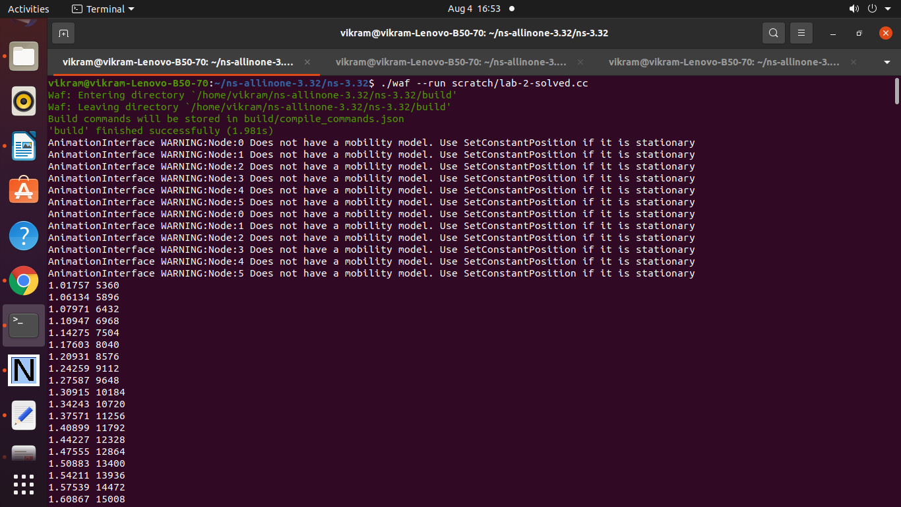

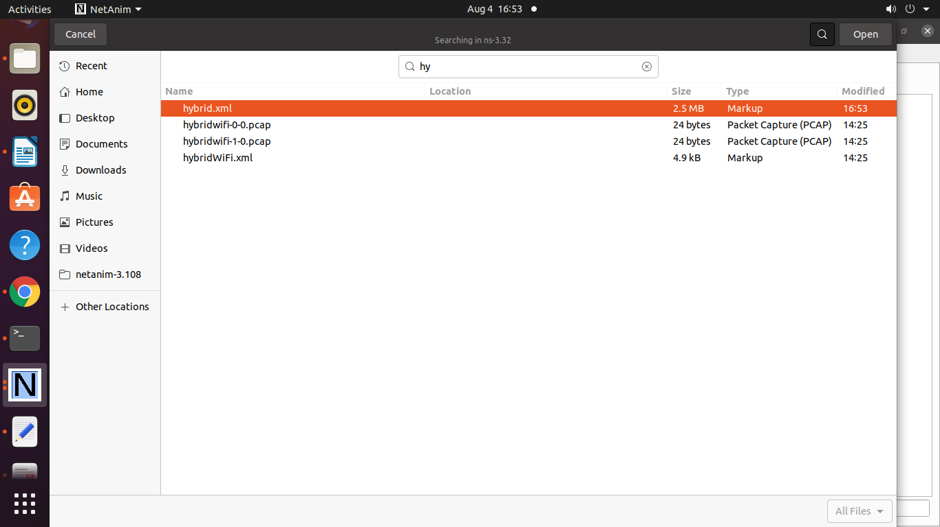

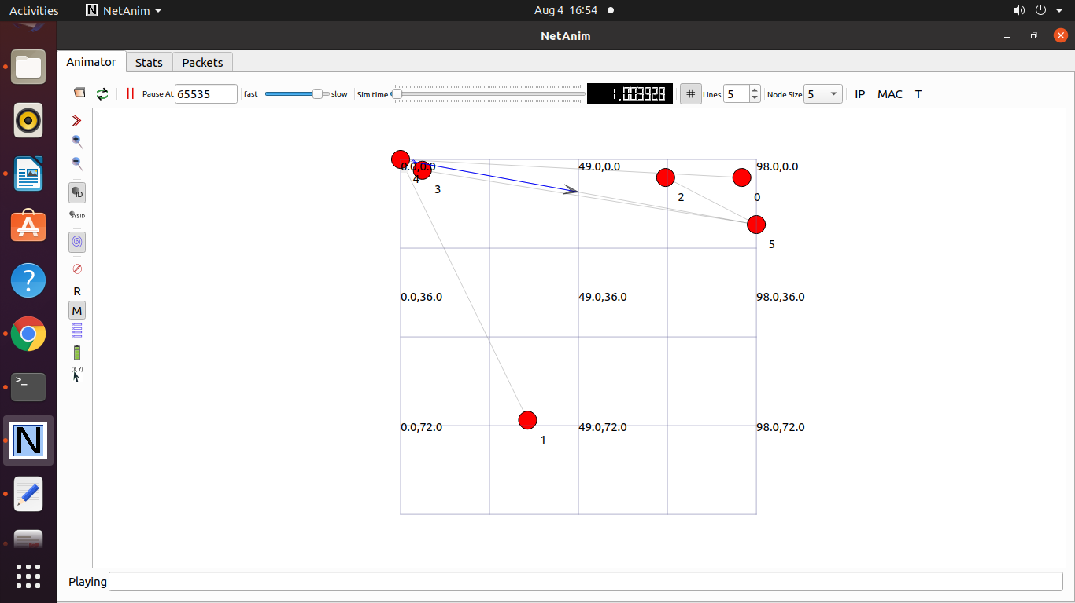

**Program 20 : Program to simulatr Mesh Topology**

/* -*- Mode:C++; c-file-style:"gnu"; indent-tabs-mode:nil; -*- */

/*

* Copyright (c) 2008,2009 IITP RAS

*

* This program is free software; you can redistribute it and/or modify

* it under the terms of the GNU General Public License version 2 as

* published by the Free Software Foundation;

*

* This program is distributed in the hope that it will be useful,

* but WITHOUT ANY WARRANTY; without even the implied warranty of

* MERCHANTABILITY or FITNESS FOR A PARTICULAR PURPOSE. See the

* GNU General Public License for more details.

*

* You should have received a copy of the GNU General Public License

* along with this program; if not, write to the Free Software

* Foundation, Inc., 59 Temple Place, Suite 330, Boston, MA 02111-1307 USA

*

* Author: Kirill Andreev <andreev@iitp.ru>

*

*

* By default this script creates m_xSize * m_ySize square grid topology with

* IEEE802.11s stack installed at each node with peering management

* and HWMP protocol.

* The side of the square cell is defined by m_step parameter.

* When topology is created, UDP ping is installed to opposite corners

* by diagonals. packet size of the UDP ping and interval between two

* successive packets is configurable.

*

* m_xSize * step

* |<--------->|

* step

* |<--->|

* * --- * --- * <---Ping sink _

* | \ | / | ^

* | \ | / | |

* * --- * --- * m_ySize * step |

* | / | \ | |

* | / | \ | |

* * --- * --- * _

* ^ Ping source

*

* See also MeshTest::Configure to read more about configurable

* parameters.

*/

#include <iostream>

#include <sstream>

#include <fstream>

#include "ns3/core-module.h"

#include "ns3/internet-module.h"

#include "ns3/network-module.h"

#include "ns3/applications-module.h"

#include "ns3/mesh-module.h"

#include "ns3/mobility-module.h"

#include "ns3/mesh-helper.h"

#include "ns3/yans-wifi-helper.h"

#include "ns3/netanim-module.h"

using namespace ns3;

NS_LOG_COMPONENT_DEFINE ("TestMeshScript");

/**

* \ingroup mesh

* \brief MeshTest class

*/

class MeshTest

{

public:

/// Init test

MeshTest ();

/**

* Configure test from command line arguments

*

* \param argc command line argument count

* \param argv command line arguments

*/

void Configure (int argc, char ** argv);

/**

* Run test

* \returns the test status

*/

int Run ();

private:

int m_xSize; ///< X size

int m_ySize; ///< Y size

double m_step; ///< step

double m_randomStart; ///< random start

double m_totalTime; ///< total time

double m_packetInterval; ///< packet interval

uint16_t m_packetSize; ///< packet size

uint32_t m_nIfaces; ///< number interfaces

bool m_chan; ///< channel

bool m_pcap; ///< PCAP

bool m_ascii; ///< ASCII

std::string m_stack; ///< stack

std::string m_root; ///< root

/// List of network nodes

NodeContainer nodes;

/// List of all mesh point devices

NetDeviceContainer meshDevices;

/// Addresses of interfaces:

Ipv4InterfaceContainer interfaces;

/// MeshHelper. Report is not static methods

MeshHelper mesh;

private:

/// Create nodes and setup their mobility

void CreateNodes ();

/// Install internet m_stack on nodes

void InstallInternetStack ();

/// Install applications

void InstallApplication ();

/// Print mesh devices diagnostics

void Report ();

};

MeshTest::MeshTest () :

m_xSize (3),

m_ySize (3),

m_step (100.0),

m_randomStart (0.1),

m_totalTime (100.0),

m_packetInterval (0.1),

m_packetSize (1024),

m_nIfaces (1),

m_chan (true),

m_pcap (false),

m_ascii (false),

m_stack ("ns3::Dot11sStack"),

m_root ("ff:ff:ff:ff:ff:ff")

{

}

void

MeshTest::Configure (int argc, char *argv[])

{

CommandLine cmd (__FILE__);

cmd.AddValue ("x-size", "Number of nodes in a row grid", m_xSize);

cmd.AddValue ("y-size", "Number of rows in a grid", m_ySize);

cmd.AddValue ("step", "Size of edge in our grid (meters)", m_step);

// Avoid starting all mesh nodes at the same time (beacons may collide)

cmd.AddValue ("start", "Maximum random start delay for beacon jitter (sec)", m_randomStart);

cmd.AddValue ("time", "Simulation time (sec)", m_totalTime);

cmd.AddValue ("packet-interval", "Interval between packets in UDP ping (sec)", m_packetInterval);

cmd.AddValue ("packet-size", "Size of packets in UDP ping (bytes)", m_packetSize);

cmd.AddValue ("interfaces", "Number of radio interfaces used by each mesh point", m_nIfaces);

cmd.AddValue ("channels", "Use different frequency channels for different interfaces", m_chan);

cmd.AddValue ("pcap", "Enable PCAP traces on interfaces", m_pcap);

cmd.AddValue ("ascii", "Enable Ascii traces on interfaces", m_ascii);

cmd.AddValue ("stack", "Type of protocol stack. ns3::Dot11sStack by default", m_stack);

cmd.AddValue ("root", "Mac address of root mesh point in HWMP", m_root);

cmd.Parse (argc, argv);

NS_LOG_DEBUG ("Grid:" << m_xSize << "*" << m_ySize);

NS_LOG_DEBUG ("Simulation time: " << m_totalTime << " s");

if (m_ascii)

{

PacketMetadata::Enable ();

}

}

void

MeshTest::CreateNodes ()

{

/*

* Create m_ySize*m_xSize stations to form a grid topology

*/

nodes.Create (m_ySize*m_xSize);

// Configure YansWifiChannel

YansWifiPhyHelper wifiPhy = YansWifiPhyHelper::Default ();

YansWifiChannelHelper wifiChannel = YansWifiChannelHelper::Default ();

wifiPhy.SetChannel (wifiChannel.Create ());

/*

* Create mesh helper and set stack installer to it

* Stack installer creates all needed protocols and install them to

* mesh point device

*/

mesh = MeshHelper::Default ();

if (!Mac48Address (m_root.c_str ()).IsBroadcast ())

{

mesh.SetStackInstaller (m_stack, "Root", Mac48AddressValue (Mac48Address (m_root.c_str ())));

}

else

{

//If root is not set, we do not use "Root" attribute, because it

//is specified only for 11s

mesh.SetStackInstaller (m_stack);

}

if (m_chan)

{

mesh.SetSpreadInterfaceChannels (MeshHelper::SPREAD_CHANNELS);

}

else

{

mesh.SetSpreadInterfaceChannels (MeshHelper::ZERO_CHANNEL);

}

mesh.SetMacType ("RandomStart", TimeValue (Seconds (m_randomStart)));

// Set number of interfaces - default is single-interface mesh point

mesh.SetNumberOfInterfaces (m_nIfaces);

// Install protocols and return container if MeshPointDevices

meshDevices = mesh.Install (wifiPhy, nodes);

// Setup mobility - static grid topology

MobilityHelper mobility;

mobility.SetPositionAllocator ("ns3::GridPositionAllocator",

"MinX", DoubleValue (0.0),

"MinY", DoubleValue (0.0),

"DeltaX", DoubleValue (m_step),

"DeltaY", DoubleValue (m_step),

"GridWidth", UintegerValue (m_xSize),

"LayoutType", StringValue ("RowFirst"));

mobility.SetMobilityModel ("ns3::ConstantPositionMobilityModel");

mobility.Install (nodes);

if (m_pcap)

wifiPhy.EnablePcapAll (std::string ("mp-"));

if (m_ascii)

{

AsciiTraceHelper ascii;

wifiPhy.EnableAsciiAll (ascii.CreateFileStream ("mesh.tr"));

}

}

void

MeshTest::InstallInternetStack ()

{

InternetStackHelper internetStack;

internetStack.Install (nodes);

Ipv4AddressHelper address;

address.SetBase ("10.1.1.0", "255.255.255.0");

interfaces = address.Assign (meshDevices);

}

void

MeshTest::InstallApplication ()

{

UdpEchoServerHelper echoServer (9);

ApplicationContainer serverApps = echoServer.Install (nodes.Get (0));

serverApps.Start (Seconds (0.0));

serverApps.Stop (Seconds (m_totalTime));

UdpEchoClientHelper echoClient (interfaces.GetAddress (0), 9);

echoClient.SetAttribute ("MaxPackets", UintegerValue ((uint32_t)(m_totalTime*(1/m_packetInterval))));

echoClient.SetAttribute ("Interval", TimeValue (Seconds (m_packetInterval)));

echoClient.SetAttribute ("PacketSize", UintegerValue (m_packetSize));

ApplicationContainer clientApps = echoClient.Install (nodes.Get (m_xSize*m_ySize-1));

clientApps.Start (Seconds (0.0));

clientApps.Stop (Seconds (m_totalTime));

}

int

MeshTest::Run ()

{

CreateNodes ();

InstallInternetStack ();

InstallApplication ();

Simulator::Schedule (Seconds (m_totalTime), &MeshTest::Report, this);

Simulator::Stop (Seconds (m_totalTime));

AnimationInterface anim("meshdemo.xml");

Simulator::Run ();

Simulator::Destroy ();

return 0;

}

void

MeshTest::Report ()

{

unsigned n (0);

for (NetDeviceContainer::Iterator i = meshDevices.Begin (); i != meshDevices.End (); ++i, ++n)

{

std::ostringstream os;

os << "mp-report-" << n << ".xml";

std::cerr << "Printing mesh point device #" << n << " diagnostics to " << os.str () << "\n";

std::ofstream of;

of.open (os.str ().c_str ());

if (!of.is_open ())

{

std::cerr << "Error: Can't open file " << os.str () << "\n";

return;

}

mesh.Report (*i, of);

of.close ();

}

}

int

main (int argc, char *argv[])

{

MeshTest t;

t.Configure (argc, argv);

return t.Run ();

}

**Output:**

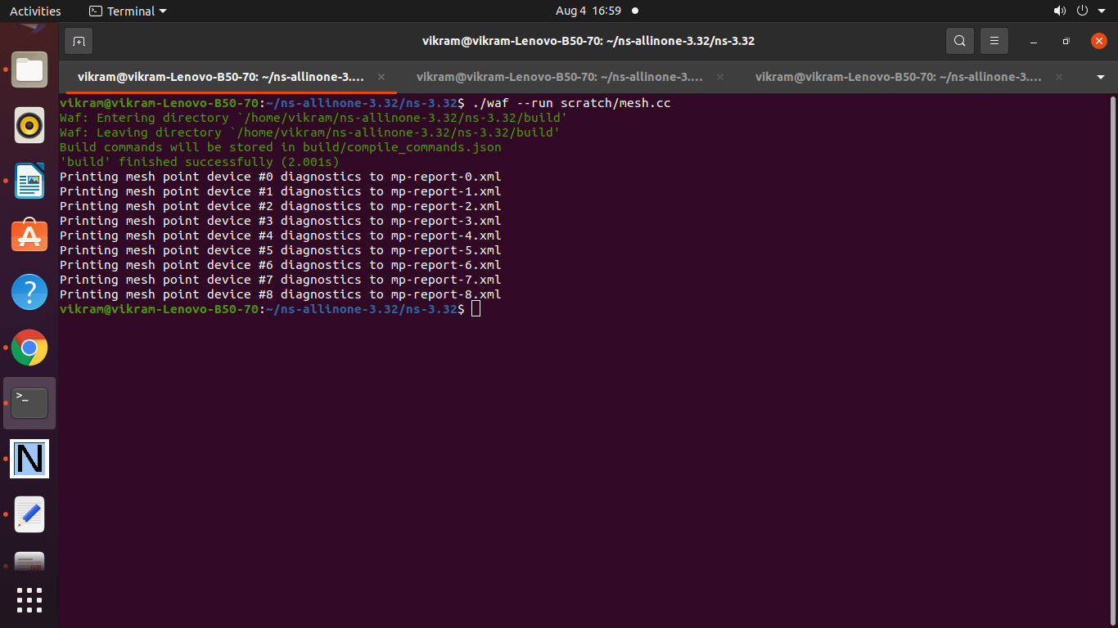

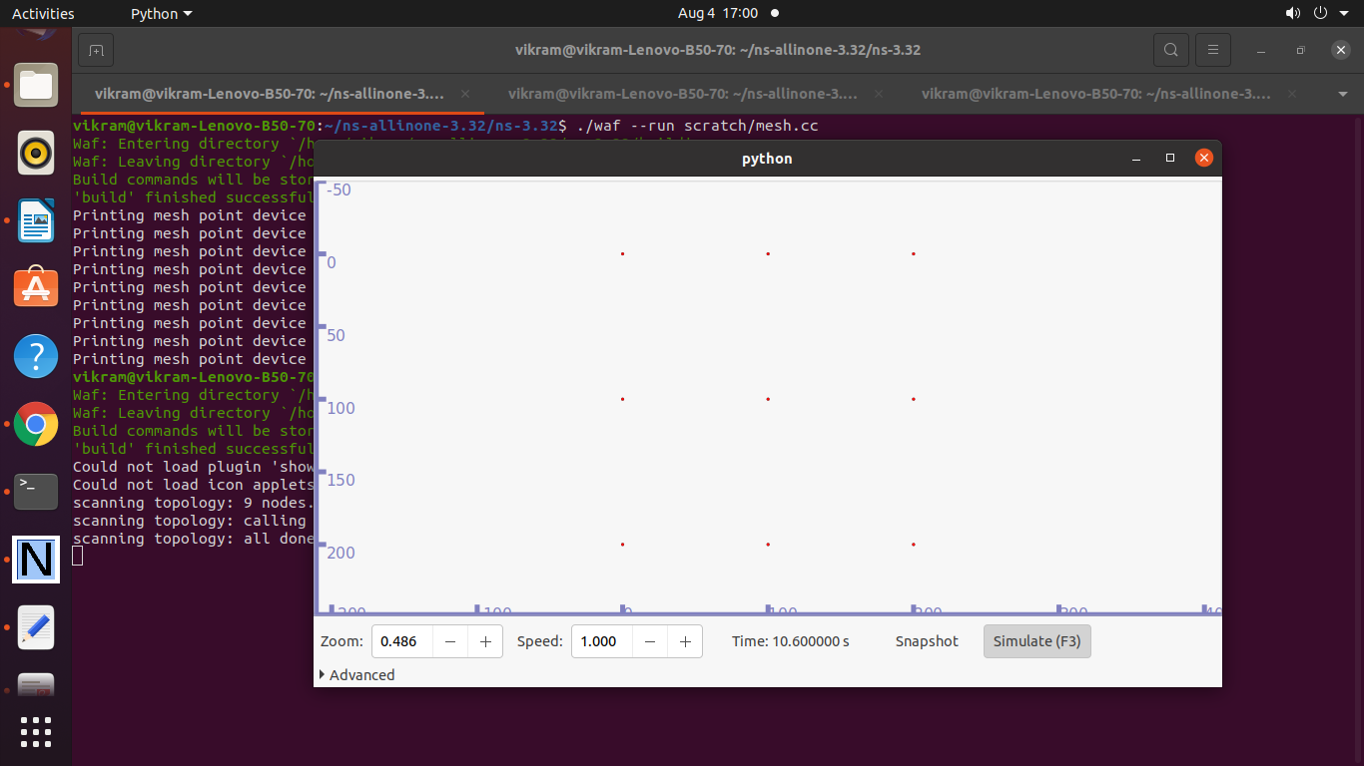

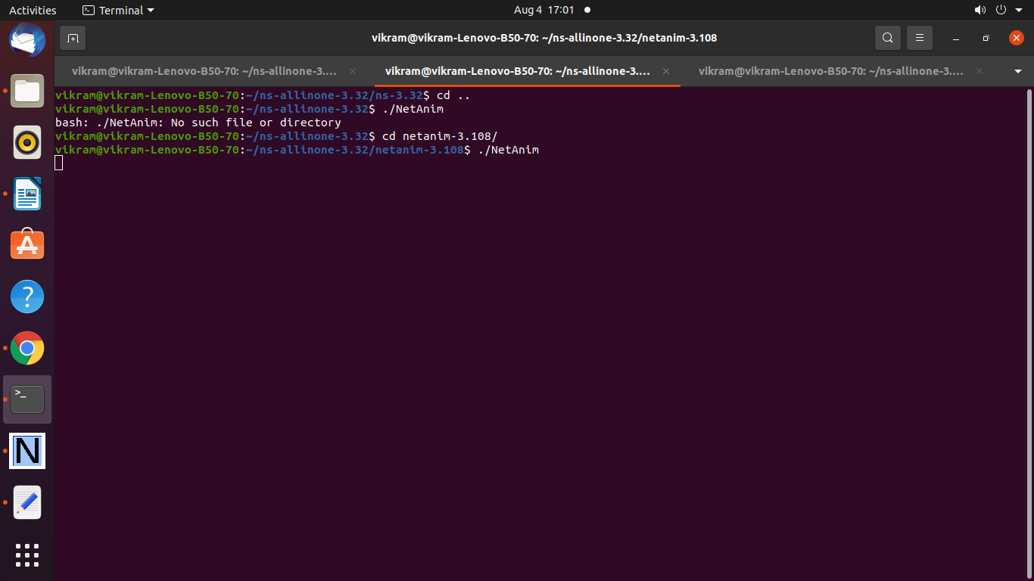

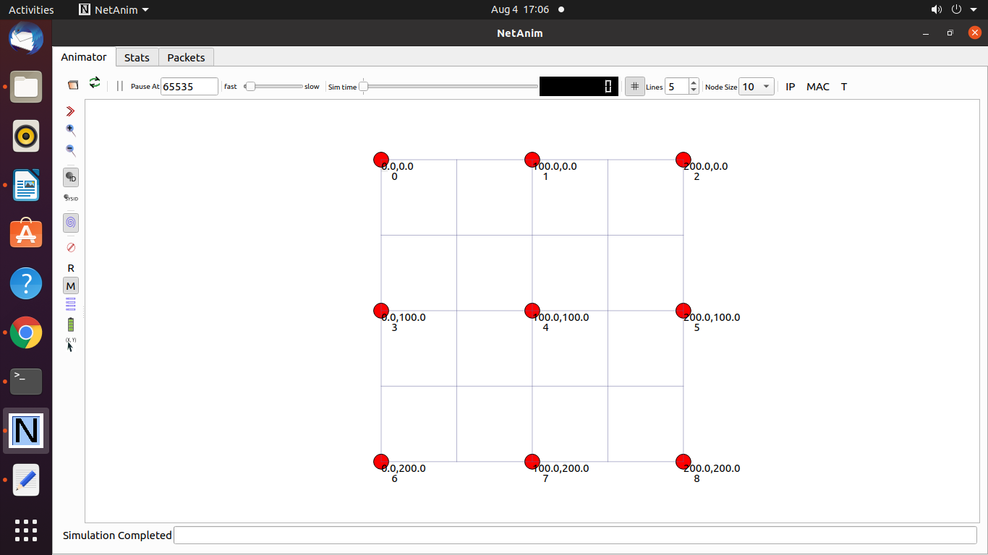

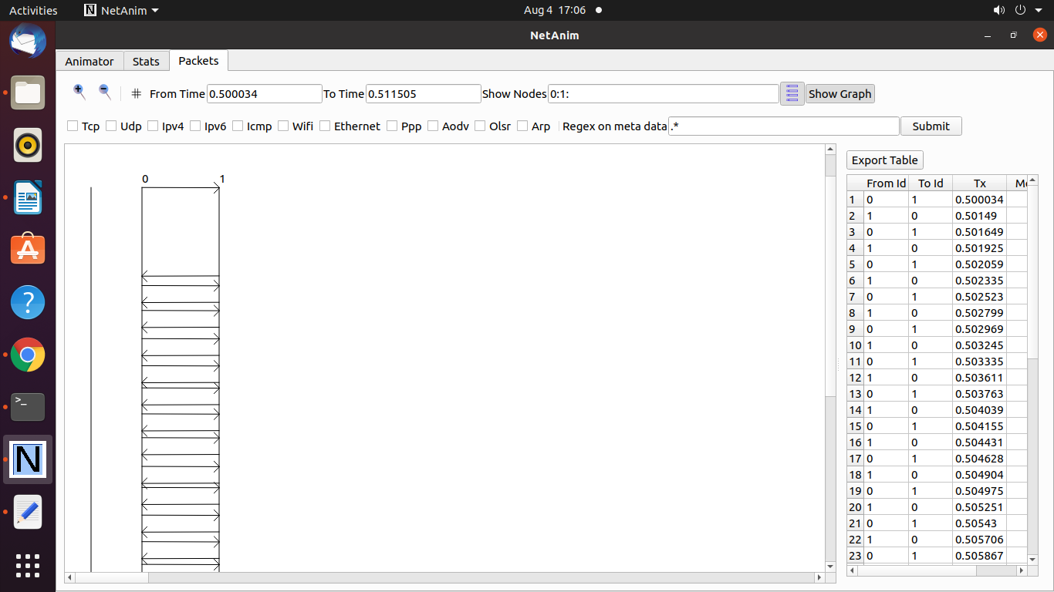

**Practical 21 : Program to Simulate handover in Mesh Topology**

/* Net topology

*

*

*

* With a 3x3 mesh grid (size can vary):

*

* n2 n3 n4

*

*

* n0----n1 ))) n5 n6 n7

*

*

* n8 n9 n10

*

* n0: Internet node

* n1: access node (a static mesh node with a P2P link)

* n2-n10: mesh nodes

*

*/

#include "ns3/core-module.h"

#include "ns3/internet-module.h"

#include "ns3/network-module.h"

#include "ns3/applications-module.h"

#include "ns3/wifi-module.h"

#include "ns3/mesh-module.h"

#include "ns3/mobility-module.h"

#include "ns3/mesh-helper.h"

#include "ns3/point-to-point-module.h"

#include "ns3/ipv4-global-routing-helper.h"

#include "ns3/netanim-module.h"

#include "ns3/olsr-helper.h"

#include "ns3/v4ping-helper.h"

#include "ns3/olsr-helper.h"

#include "ns3/aodv-helper.h"

#include "ns3/ipv4-global-routing-helper.h"

#include "src/core/model/string.h"

#include "myapp.h"

#include <iostream>

#include <sstream>

#include <fstream>

// Needed for ping and test

#include "ns3/test.h"

#include "ns3/abort.h"

#include "ns3/v4ping.h"

#include "ns3/config.h"

#include "ns3/names.h"

#include "src/core/model/log.h"

using namespace ns3;

NS_LOG_COMPONENT_DEFINE ("iMesh-handover");

static void

SetPosition (Ptr<Node> node, double x, double y)

{

Ptr<MobilityModel> mobility = node->GetObject<MobilityModel> ();

Vector pos = mobility->GetPosition();

pos.x = x;

pos.y = y;

mobility->SetPosition(pos);

}

class MeshTest

{

public:

/// Init test

MeshTest ();

/// Configure test from command line arguments

void Configure (int argc, char ** argv);

/// Run test

int Run ();

private:

int m_xSize;

int m_ySize;

double m_step;

double m_randomStart;

double m_totalTime;

double m_packetInterval;

uint16_t m_packetSize;

uint32_t m_nIfaces;

bool m_chan;

bool m_pcap;

std::string m_stack;

std::string m_root;

NodeContainer nc_all; // Contains every node (starting with internet node, access nodes and then mesh nodes

NodeContainer nc_mesh; // Contains mesh nodes

NodeContainer nc_wireless; // Contains access and mesh nodes

NodeContainer nc_internet; // Contains internet nodes

NodeContainer nc_destination; // Contains nodes with sink for apps (internet and mesh nodes)

/// List of all mesh point devices

NetDeviceContainer meshDevices;

NetDeviceContainer internetDevices;

//Addresses of meshInterfaces:

Ipv4InterfaceContainer meshInterfaces;

Ipv4InterfaceContainer p2pInterfaces; /// Needed for n0-----n1

// MeshHelper. Report is not static methods

MeshHelper meshHelper;

PointToPointHelper p2pHelper;

MobilityHelper mobility;

private:

/// Create nodes and setup their mobility

void CreateNodes ();

/// Install internet m_stack on nodes

void InstallInternetStack ();

/// Install applications

void InstallApplication ();

/// Print mesh devices diagnostics

void Report ();

};

MeshTest::MeshTest () :

m_xSize (3),

m_ySize (3),

m_step (100.0),

m_randomStart (0.1),

m_totalTime (30.0),

m_packetInterval (1.0),

m_packetSize (1024),

m_nIfaces (1),

m_chan (true),

m_pcap (true),

m_stack ("ns3::Dot11sStack"),

m_root ("ff:ff:ff:ff:ff:ff") { }

void

MeshTest::Configure (int argc, char *argv[])

{

CommandLine cmd;

cmd.AddValue ("x-size", "Number of nodes in a row grid. [6]", m_xSize);

cmd.AddValue ("y-size", "Number of rows in a grid. [6]", m_ySize);

cmd.AddValue ("step", "Size of edge in our grid, meters. [100 m]", m_step);

/*

* As soon as starting node means that it sends a beacon,

* simultaneous start is not good.

*/

cmd.AddValue ("start", "Maximum random start delay, seconds. [0.1 s]", m_randomStart);

cmd.AddValue ("time", "Simulation time, seconds [100 s]", m_totalTime);

cmd.AddValue ("packet-interval", "Interval between packets in UDP ping, seconds [0.001 s]", m_packetInterval);

cmd.AddValue ("packet-size", "Size of packets in UDP ping", m_packetSize);

cmd.AddValue ("meshInterfaces", "Number of radio interfaces used by each meshHelper point. [1]", m_nIfaces);

cmd.AddValue ("channels", "Use different frequency channels for different meshInterfaces. [0]", m_chan);

cmd.AddValue ("pcap", "Enable PCAP traces on meshInterfaces. [0]", m_pcap);

cmd.AddValue ("stack", "Type of protocol stack. ns3::Dot11sStack by default", m_stack);

cmd.AddValue ("root", "Mac address of root meshHelper point in HWMP", m_root);

cmd.Parse (argc, argv);

NS_LOG_DEBUG ("Grid:" << m_xSize << "*" << m_ySize);

NS_LOG_DEBUG ("Simulation time: " << m_totalTime << " s");

LogComponentEnable ("UdpEchoClientApplication", LOG_LEVEL_INFO);

LogComponentEnable ("UdpEchoServerApplication", LOG_LEVEL_INFO);

}

void

MeshTest::CreateNodes ()

{

// Node container creation (all node containers starts with "nc_")

/*

* Create m_ySize*m_xSize stations to form a grid topology

*/

nc_all.Create (2);

nc_mesh.Create (m_ySize * m_xSize);

/// Needed to add mesh nodes and wireless nodes to the internet nodes

nc_all.Add (nc_mesh);

nc_mesh.Add (nc_all.Get (1)); /// n1---{meshHelper nodes}

nc_wireless.Add (nc_all.Get (1));

nc_wireless.Add (nc_mesh);

nc_internet.Add (nc_all.Get (0));

nc_internet.Add (nc_all.Get (1));

nc_destination.Add (nc_all.Get (0));

nc_destination.Add (nc_mesh);

//Create P2P links between n0 <-> n1 (all devices starts with "de_")

p2pHelper.SetDeviceAttribute ("DataRate", StringValue ("1Mbps"));

p2pHelper.SetChannelAttribute ("Delay", StringValue ("10ms"));

internetDevices = p2pHelper.Install (nc_internet);

// Configure YansWifiChannel

YansWifiPhyHelper wifiPhy = YansWifiPhyHelper::Default ();

YansWifiChannelHelper wifiChannel = YansWifiChannelHelper::Default ();

wifiPhy.SetChannel (wifiChannel.Create ());

/*

* Create mesh helper and set stack installer to it

* Stack installer creates all needed protocols and install them to

* meshHelper point device

*/

meshHelper = MeshHelper::Default ();

if (!Mac48Address (m_root.c_str ()).IsBroadcast ())

{

meshHelper.SetStackInstaller (m_stack, "Root", Mac48AddressValue (Mac48Address (m_root.c_str ())));

}

else

{

//If root is not set, we do not use "Root" attribute, because it

//is specified only for 11s

meshHelper.SetStackInstaller (m_stack);

}

if (m_chan)

{

meshHelper.SetSpreadInterfaceChannels (MeshHelper::SPREAD_CHANNELS);

}

else

{

meshHelper.SetSpreadInterfaceChannels (MeshHelper::ZERO_CHANNEL);

}

meshHelper.SetMacType ("RandomStart", TimeValue (Seconds (m_randomStart)));

// Set number of interfaces - default is single-interface meshHelper point

meshHelper.SetNumberOfInterfaces (m_nIfaces);

// Install protocols and return container if MeshPointDevices

meshDevices = meshHelper.Install (wifiPhy, nc_mesh);

// Setup mobility - static grid topology

#if 0

MobilityHelper mobilityHelper;

mobilityHelper.SetPositionAllocator ("ns3::GridPositionAllocator",

"MinX", DoubleValue (0.0),

"MinY", DoubleValue (0.0),

"DeltaX", DoubleValue (m_step),

"DeltaY", DoubleValue (m_step),

"GridWidth", UintegerValue (m_xSize),

"LayoutType", StringValue ("RowFirst"));

mobilityHelper.SetMobilityModel ("ns3::RandomWalk2dMobilityModel", "Bounds", RectangleValue(Rectangle(-1000, 1000, -1000, 1000)));

mobilityHelper.Install (nc_mesh);

#endif

#if 0

MobilityHelper mobility;

Ptr<ListPositionAllocator> positionAlloc = CreateObject <ListPositionAllocator>();

positionAlloc ->Add(Vector(0, 0, 0)); // node1

positionAlloc ->Add(Vector(37, 0, 0)); // node2

positionAlloc ->Add(Vector(75, 75, 0)); // node3

positionAlloc ->Add(Vector(150, 75, 0)); // node0

positionAlloc ->Add(Vector(225, 75, 0)); // node1

positionAlloc ->Add(Vector(75, 150, 0)); // node2

positionAlloc ->Add(Vector(150, 150, 0)); // node3

positionAlloc ->Add(Vector(225, 150, 0)); // node0

positionAlloc ->Add(Vector(75, 0, 0)); // node1

positionAlloc ->Add(Vector(150, 0, 0)); // node2

positionAlloc ->Add(Vector(225, 0, 0)); // node3

mobility.SetPositionAllocator(positionAlloc);

mobility.SetMobilityModel("ns3::ConstantPositionMobilityModel");

mobility.Install(nc_all);

Simulator::Schedule (Seconds (15.0), &SetPosition, nc_all.Get (3), 37.0, 75.0);

AnimationInterface animation ("iMesh-handover.xml");

#endif

if (m_pcap)

wifiPhy.EnablePcapAll (std::string ("mp-"));

/*AnimationInterface animation("iMesh.xml");

animation.SetConstantPosition(nc_internet.Get(0), -200.0, 100.0);

animation.SetConstantPosition(nc_internet.Get(1), -100.0, 100.0);*/

}

void

MeshTest::InstallInternetStack ()

{

InternetStackHelper internetStackHelper;

OlsrHelper routingProtocol;

internetStackHelper.SetRoutingHelper (routingProtocol);

internetStackHelper.Install (nc_mesh);

internetStackHelper.Install (nc_all.Get (0)); /// Setting up protocol stack on node 0

Ipv4AddressHelper meshAddress;

meshAddress.SetBase ("10.1.1.0", "255.255.255.0");

meshInterfaces = meshAddress.Assign (meshDevices);

Ipv4AddressHelper p2pAddress;

p2pAddress.SetBase ("1.1.1.0", "255.255.255.0");

p2pInterfaces = p2pAddress.Assign (internetDevices);

}

void

MeshTest::InstallApplication ()

{

UdpEchoServerHelper echoServer (9);

ApplicationContainer serverApps = echoServer.Install (nc_all.Get (0));

serverApps.Start (Seconds (0.0));

serverApps.Stop (Seconds (m_totalTime));

UdpEchoClientHelper echoClient (p2pInterfaces.GetAddress (0), 9);

//echoClient.SetAttribute ("MaxPackets", UintegerValue ((uint32_t) (m_totalTime * (1 / m_packetInterval))));

echoClient.SetAttribute ("MaxPackets", UintegerValue (20));

echoClient.SetAttribute ("Interval", TimeValue (Seconds (m_packetInterval)));

echoClient.SetAttribute ("PacketSize", UintegerValue (m_packetSize));

ApplicationContainer clientApps1 = echoClient.Install (nc_mesh.Get (m_xSize * m_ySize - 1));

//ApplicationContainer clientApps2 = echoClient.Install (nc_mesh.Get (m_xSize * m_ySize - 2));

clientApps1.Start (Seconds (0.0));

clientApps1.Stop (Seconds (m_totalTime));

// clientApps2.Start (Seconds (12));

// clientApps2.Stop (Seconds (m_totalTime));

/*for (tmp_x = 2; tmp_x < m_xSize * m_ySize + 2; tmp_x++)

{

sprintf (tmp_char, "%d-STA", tmp_x);

AnimationInterface::SetNodeDescription (nc_all.Get (tmp_x), tmp_char);

}

AnimationInterface::SetNodeDescription (nc_all.Get (0), "0-Internet");

AnimationInterface::SetNodeDescription (nc_all.Get (1), "1-AP");

AnimationInterface::SetNodeColor (nc_mesh, 0, 255, 0);

AnimationInterface::SetNodeColor (nc_internet.Get (0), 255, 0, 0);

AnimationInterface::SetNodeColor (nc_internet.Get (1), 0, 0, 255);

*/

}

int

MeshTest::Run ()

{

CreateNodes ();

InstallInternetStack ();

InstallApplication ();

Ptr<ListPositionAllocator> positionAlloc = CreateObject <ListPositionAllocator>();

positionAlloc ->Add(Vector(0, 0, 0)); // node1

positionAlloc ->Add(Vector(37, 0, 0)); // node2

positionAlloc ->Add(Vector(75, 75, 0)); // node3

positionAlloc ->Add(Vector(150, 75, 0)); // node0

positionAlloc ->Add(Vector(225, 75, 0)); // node1

positionAlloc ->Add(Vector(75, 150, 0)); // node2

positionAlloc ->Add(Vector(150, 150, 0)); // node3

positionAlloc ->Add(Vector(225, 150, 0)); // node0

positionAlloc ->Add(Vector(75, 0, 0)); // node1

positionAlloc ->Add(Vector(150, 0, 0)); // node2

positionAlloc ->Add(Vector(225, 0, 0)); // node3

mobility.SetPositionAllocator(positionAlloc);

mobility.SetMobilityModel("ns3::ConstantPositionMobilityModel");

mobility.Install(nc_all);

Simulator::Schedule (Seconds (12.0), &SetPosition, nc_mesh.Get (m_xSize * m_ySize - 1), 37.0, 75.0);

Simulator::Stop (Seconds (m_totalTime));

AnimationInterface animation ("iMesh-handover.xml");

animation.EnablePacketMetadata (false);

animation.EnableIpv4RouteTracking ("mesh-handover-route.xml", Seconds (0), Seconds (50), Seconds (100));

// animation.SetConstantPosition (nc_all.Get (0), 0.0, 0.0);

// animation.SetConstantPosition (nc_internet.Get (1), 37.0, 0.0);

// animation.SetConstantPosition (nc_mesh.Get (0), 75.0, 75.0);

// animation.SetConstantPosition (nc_mesh.Get (1), 150.0, 75.0);

// animation.SetConstantPosition (nc_mesh.Get (2), 225.0, 75.0);

// animation.SetConstantPosition (nc_mesh.Get (3), 75.0, 150.0);

// animation.SetConstantPosition (nc_mesh.Get (4), 150.0, 150.0);

// animation.SetConstantPosition (nc_mesh.Get (5), 225.0, 150.0);

// animation.SetConstantPosition (nc_mesh.Get (6), 75.0, 0.0);

// animation.SetConstantPosition (nc_mesh.Get (7), 150.0, 0.0);

// animation.SetConstantPosition (nc_mesh.Get (8), 225.0, 0.0);

//animation.EnablePacketMetadata(false);

//animation.EnableIpv4RouteTracking ("iMesh-handover.xml", Seconds (0), Seconds (m_totalTime), Seconds (0.25));

//Simulator::Schedule (Seconds (m_totalTime), &MeshTest::Report, this);

//Simulator::Stop (Seconds (m_totalTime));

Simulator::Run ();

Simulator::Destroy ();

return 0;

}

void

MeshTest::Report () {

unsigned n (0);

for (NetDeviceContainer::Iterator i = meshDevices.Begin (); i != meshDevices.End (); ++i, ++n)

{

std::ostringstream os;

os << "mp-report-handover-true-" << n << ".xml";

std::cerr << "Printing meshHelper point device #" << n << " diagnostics to " << os.str () << "\n";

std::ofstream of;

of.open (os.str ().c_str ());

if (!of.is_open ())

{

std::cerr << "Error: Can't open file " << os.str () << "\n";

return;

}

meshHelper.Report (*i, of);

of.close ();

}

}

int

main (int argc, char *argv[])

{

ns3::PacketMetadata::Enable ();

MeshTest t;

t.Configure (argc, argv);

return t.Run ();

}

**Output :**

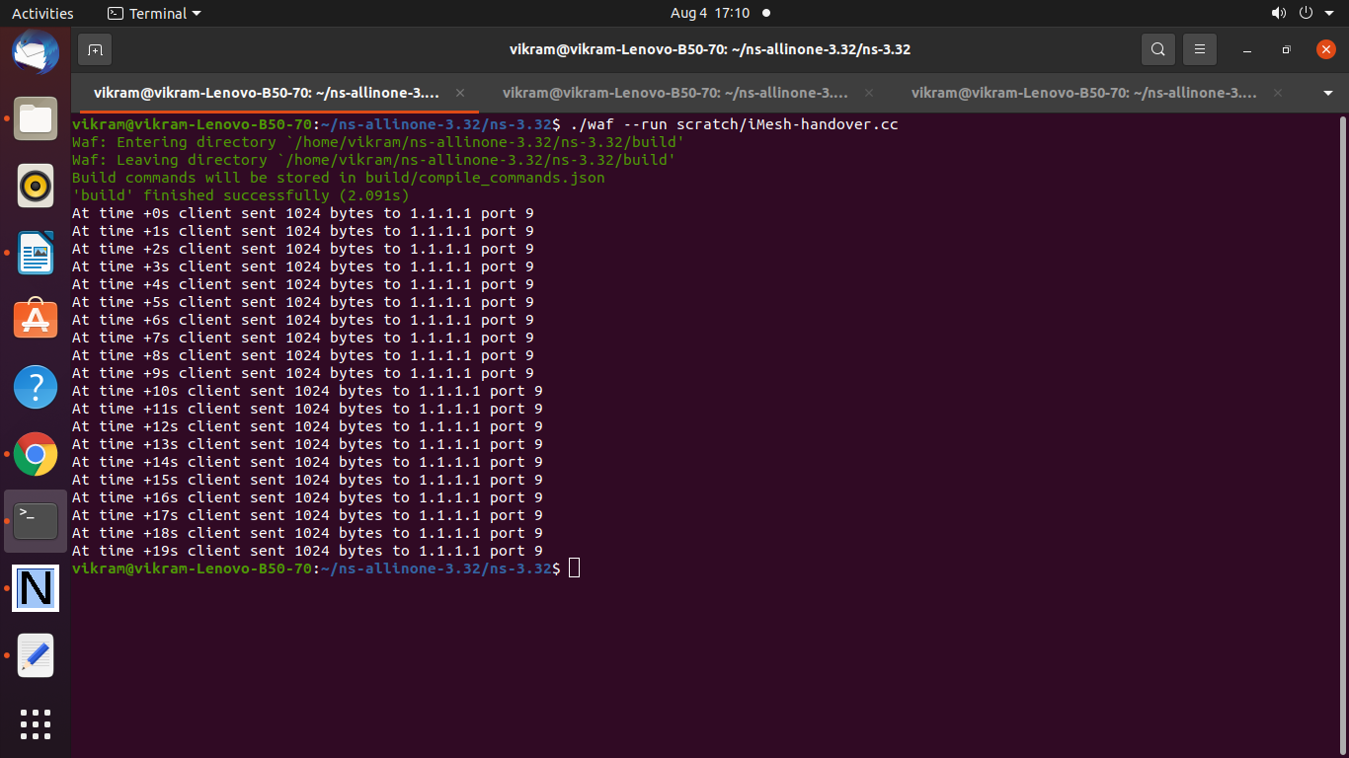

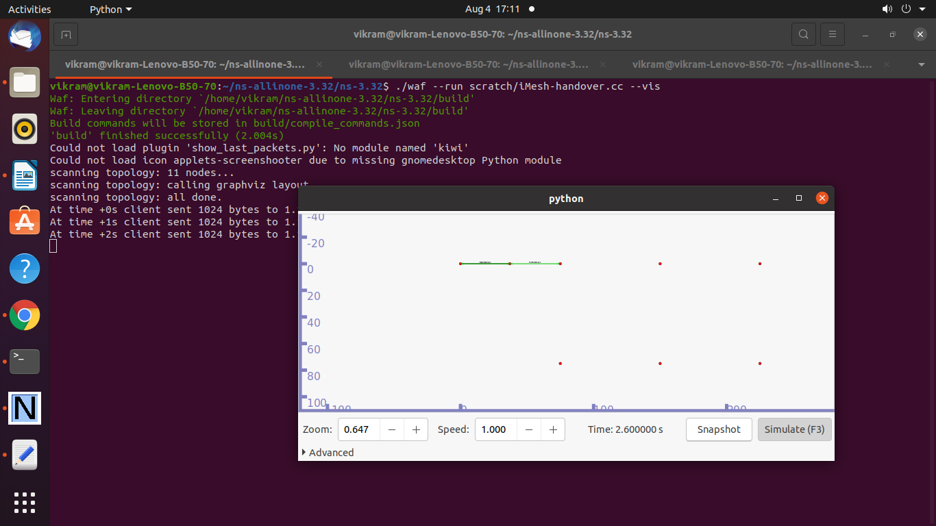

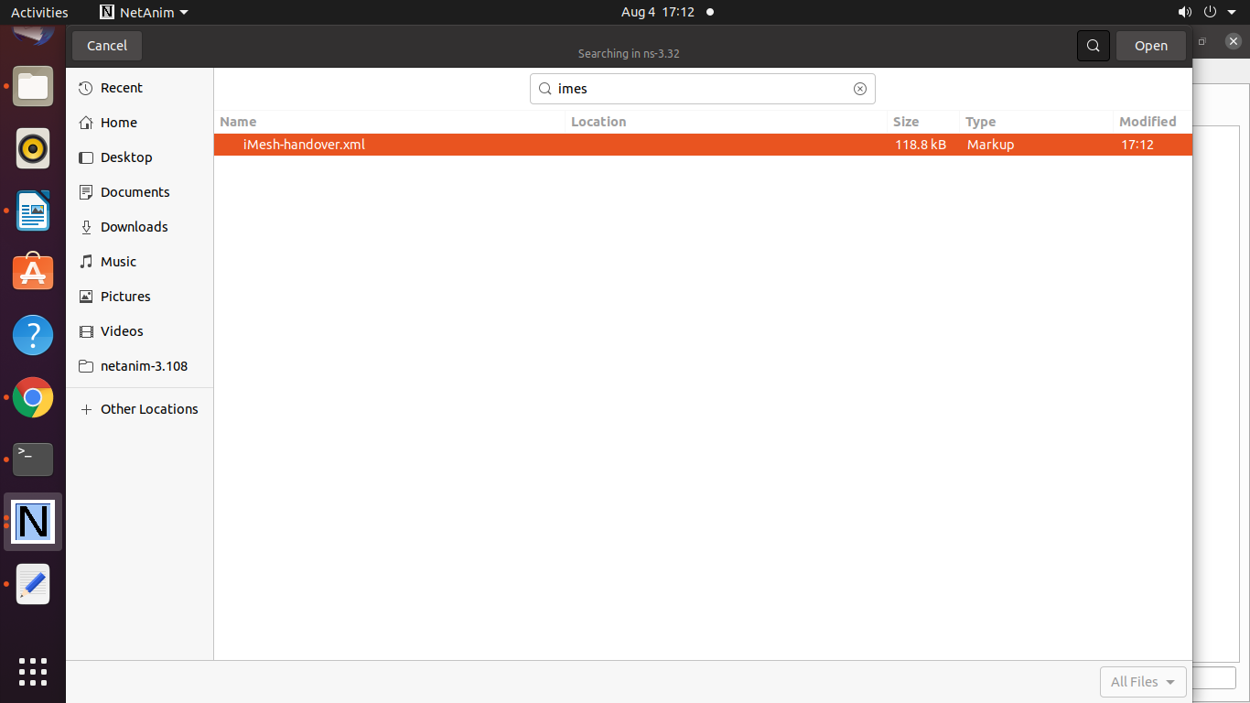

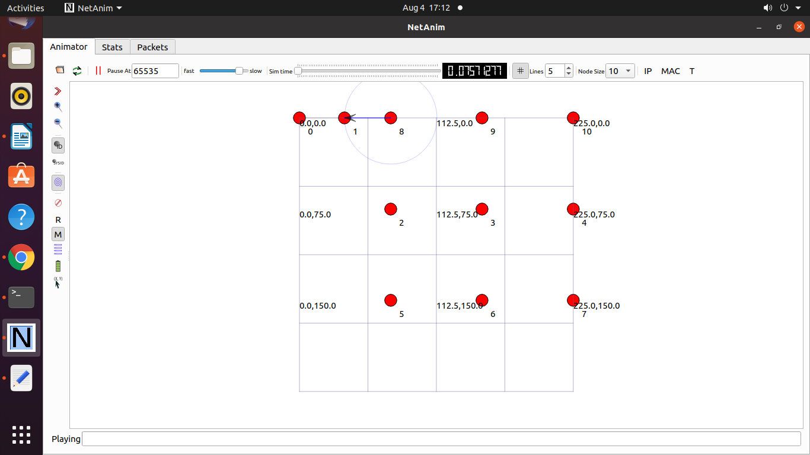

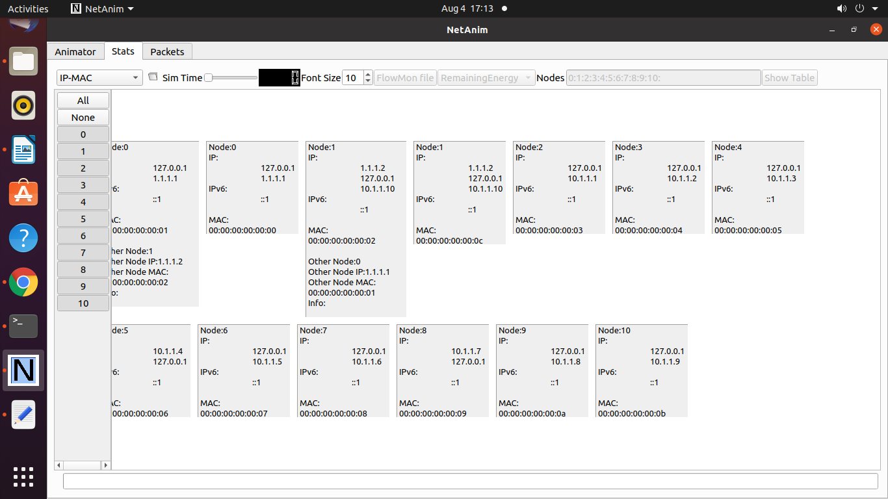

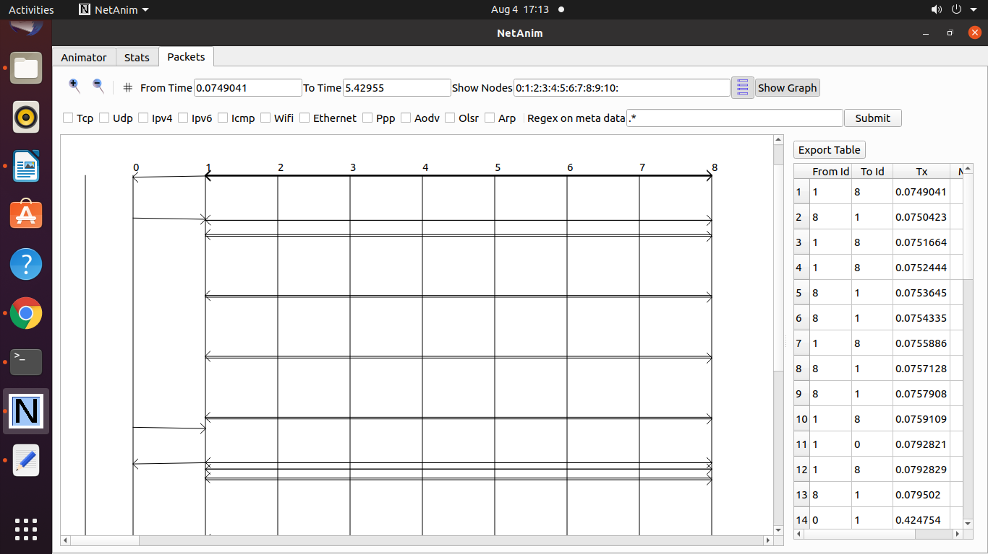

**Program 22 : Program to simulate FTP using TCP protocol.**

**tcp-large-transfer.cc**

/* -*- Mode:C++; c-file-style:"gnu"; indent-tabs-mode:nil; -*- */

/*

* This program is free software; you can redistribute it and/or modify

* it under the terms of the GNU General Public License version 2 as

* published by the Free Software Foundation;

*

* This program is distributed in the hope that it will be useful,

* but WITHOUT ANY WARRANTY; without even the implied warranty of

* MERCHANTABILITY or FITNESS FOR A PARTICULAR PURPOSE. See the

* GNU General Public License for more details.

*

* You should have received a copy of the GNU General Public License

* along with this program; if not, write to the Free Software

* Foundation, Inc., 59 Temple Place, Suite 330, Boston, MA 02111-1307 USA

*

*/

//

// Network topology

//

// 10Mb/s, 10ms 10Mb/s, 10ms

// n0-----------------n1-----------------n2

//

//

// - Tracing of queues and packet receptions to file

// "tcp-large-transfer.tr"

// - pcap traces also generated in the following files

// "tcp-large-transfer-$n-$i.pcap" where n and i represent node and interface

// numbers respectively

// Usage (e.g.): ./waf --run tcp-large-transfer

#include <iostream>

#include <fstream>

#include <string>

#include "ns3/core-module.h"

#include "ns3/applications-module.h"

#include "ns3/network-module.h"

#include "ns3/internet-module.h"

#include "ns3/point-to-point-module.h"

#include "ns3/ipv4-global-routing-helper.h"

#include "ns3/netanim-module.h"

using namespace ns3;

NS_LOG_COMPONENT_DEFINE ("TcpLargeTransfer");

// The number of bytes to send in this simulation.

static const uint32_t totalTxBytes = 2000000;

static uint32_t currentTxBytes = 0;

// Perform series of 1040 byte writes (this is a multiple of 26 since

// we want to detect data splicing in the output stream)

static const uint32_t writeSize = 1040;

uint8_t data[writeSize];

std::string animFile = "ftp-animation.xml";

// These are for starting the writing process, and handling the sending

// socket's notification upcalls (events). These two together more or less

// implement a sending "Application", although not a proper ns3::Application

// subclass.

void StartFlow (Ptr<Socket>, Ipv4Address, uint16_t);

void WriteUntilBufferFull (Ptr<Socket>, uint32_t);

static void

CwndTracer (uint32_t oldval, uint32_t newval)

{

NS_LOG_INFO ("Moving cwnd from " << oldval << " to " << newval);

}

int main (int argc, char *argv[])

{

// Users may find it convenient to turn on explicit debugging

// for selected modules; the below lines suggest how to do this

// LogComponentEnable("TcpL4Protocol", LOG_LEVEL_ALL);

// LogComponentEnable("TcpSocketImpl", LOG_LEVEL_ALL);

// LogComponentEnable("PacketSink", LOG_LEVEL_ALL);

// LogComponentEnable("TcpLargeTransfer", LOG_LEVEL_ALL);

CommandLine cmd (__FILE__);

cmd.Parse (argc, argv);

// initialize the tx buffer.

for(uint32_t i = 0; i < writeSize; ++i)

{

char m = toascii (97 + i % 26);

data[i] = m;

}

// Here, we will explicitly create three nodes. The first container contains

// nodes 0 and 1 from the diagram above, and the second one contains nodes

// 1 and 2. This reflects the channel connectivity, and will be used to

// install the network interfaces and connect them with a channel.

NodeContainer n0n1;

n0n1.Create (2);

NodeContainer n1n2;

n1n2.Add (n0n1.Get (1));

n1n2.Create (1);

// We create the channels first without any IP addressing information

// First make and configure the helper, so that it will put the appropriate

// attributes on the network interfaces and channels we are about to install.

PointToPointHelper p2p;

p2p.SetDeviceAttribute ("DataRate", DataRateValue (DataRate (10000000)));

p2p.SetChannelAttribute ("Delay", TimeValue (MilliSeconds (10)));

// And then install devices and channels connecting our topology.

NetDeviceContainer dev0 = p2p.Install (n0n1);

NetDeviceContainer dev1 = p2p.Install (n1n2);

// Now add ip/tcp stack to all nodes.

InternetStackHelper internet;

internet.InstallAll ();

// Later, we add IP addresses.

Ipv4AddressHelper ipv4;

ipv4.SetBase ("10.1.3.0", "255.255.255.0");

ipv4.Assign (dev0);

ipv4.SetBase ("10.1.2.0", "255.255.255.0");

Ipv4InterfaceContainer ipInterfs = ipv4.Assign (dev1);

// and setup ip routing tables to get total ip-level connectivity.

Ipv4GlobalRoutingHelper::PopulateRoutingTables ();

///////////////////////////////////////////////////////////////////////////

// Simulation 1

//

// Send 2000000 bytes over a connection to server port 50000 at time 0

// Should observe SYN exchange, a lot of data segments and ACKS, and FIN

// exchange. FIN exchange isn't quite compliant with TCP spec (see release

// notes for more info)

//

///////////////////////////////////////////////////////////////////////////

uint16_t servPort = 50000;

// Create a packet sink to receive these packets on n2...

PacketSinkHelper sink ("ns3::TcpSocketFactory",

InetSocketAddress (Ipv4Address::GetAny (), servPort));

ApplicationContainer apps = sink.Install (n1n2.Get (1));

apps.Start (Seconds (0.0));

apps.Stop (Seconds (3.0));

// Create a source to send packets from n0. Instead of a full Application

// and the helper APIs you might see in other example files, this example

// will use sockets directly and register some socket callbacks as a sending

// "Application".

// Create and bind the socket...

Ptr<Socket> localSocket =

Socket::CreateSocket (n0n1.Get (0), TcpSocketFactory::GetTypeId ());

localSocket->Bind ();

// Trace changes to the congestion window

Config::ConnectWithoutContext ("/NodeList/0/$ns3::TcpL4Protocol/SocketList/0/CongestionWindow", MakeCallback (&CwndTracer));

// ...and schedule the sending "Application"; This is similar to what an

// ns3::Application subclass would do internally.

Simulator::ScheduleNow (&StartFlow, localSocket,

ipInterfs.GetAddress (1), servPort);

// One can toggle the comment for the following line on or off to see the

// effects of finite send buffer modelling. One can also change the size of

// said buffer.

//localSocket->SetAttribute("SndBufSize", UintegerValue(4096));

//Ask for ASCII and pcap traces of network traffic

AsciiTraceHelper ascii;

p2p.EnableAsciiAll (ascii.CreateFileStream ("tcp-large-transfer.tr"));

p2p.EnablePcapAll ("tcp-large-transfer");

// Create the animation object and configure for specified output

AnimationInterface anim (animFile);

// Finally, set up the simulator to run. The 1000 second hard limit is a

// failsafe in case some change above causes the simulation to never end

Simulator::Stop (Seconds (1000));

Simulator::Run ();

Simulator::Destroy ();

}

//-----------------------------------------------------------------------------

//-----------------------------------------------------------------------------

//-----------------------------------------------------------------------------

//begin implementation of sending "Application"

void StartFlow (Ptr<Socket> localSocket,

Ipv4Address servAddress,

uint16_t servPort)

{

NS_LOG_LOGIC ("Starting flow at time " << Simulator::Now ().GetSeconds ());

localSocket->Connect (InetSocketAddress (servAddress, servPort)); //connect

// tell the tcp implementation to call WriteUntilBufferFull again

// if we blocked and new tx buffer space becomes available

localSocket->SetSendCallback (MakeCallback (&WriteUntilBufferFull));

WriteUntilBufferFull (localSocket, localSocket->GetTxAvailable ());

}

void WriteUntilBufferFull (Ptr<Socket> localSocket, uint32_t txSpace)

{

while (currentTxBytes < totalTxBytes && localSocket->GetTxAvailable () > 0)

{

uint32_t left = totalTxBytes - currentTxBytes;

uint32_t dataOffset = currentTxBytes % writeSize;

uint32_t toWrite = writeSize - dataOffset;

toWrite = std::min (toWrite, left);

toWrite = std::min (toWrite, localSocket->GetTxAvailable ());

int amountSent = localSocket->Send (&data[dataOffset], toWrite, 0);

if(amountSent < 0)

{

// we will be called again when new tx space becomes available.

return;

}

currentTxBytes += amountSent;

}

if (currentTxBytes >= totalTxBytes)

{

localSocket->Close ();

}

}

**Output:**

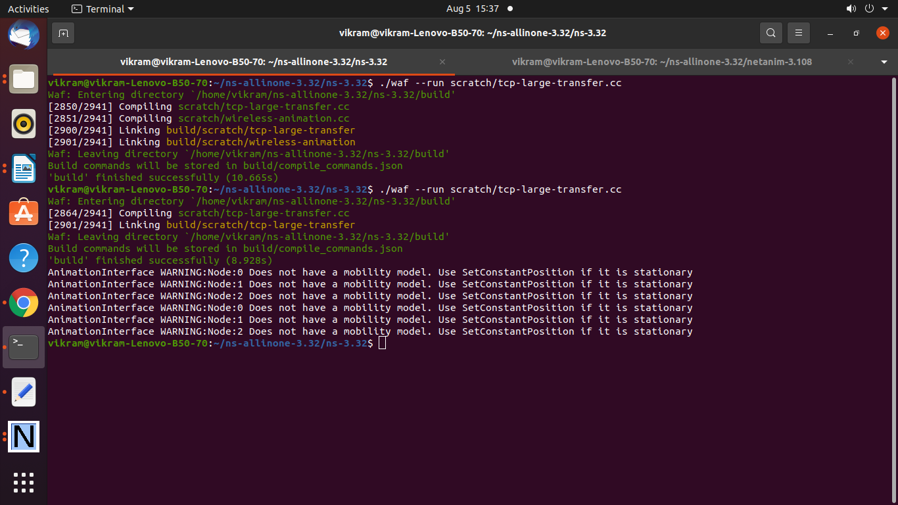

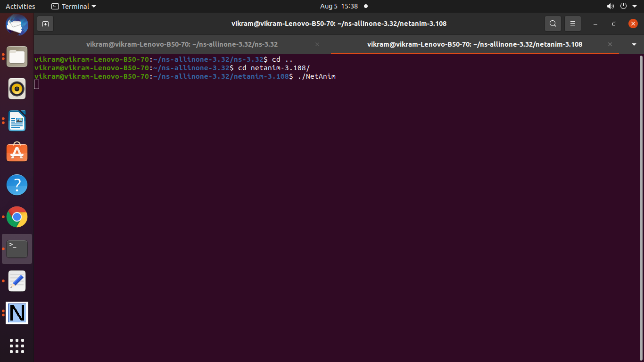

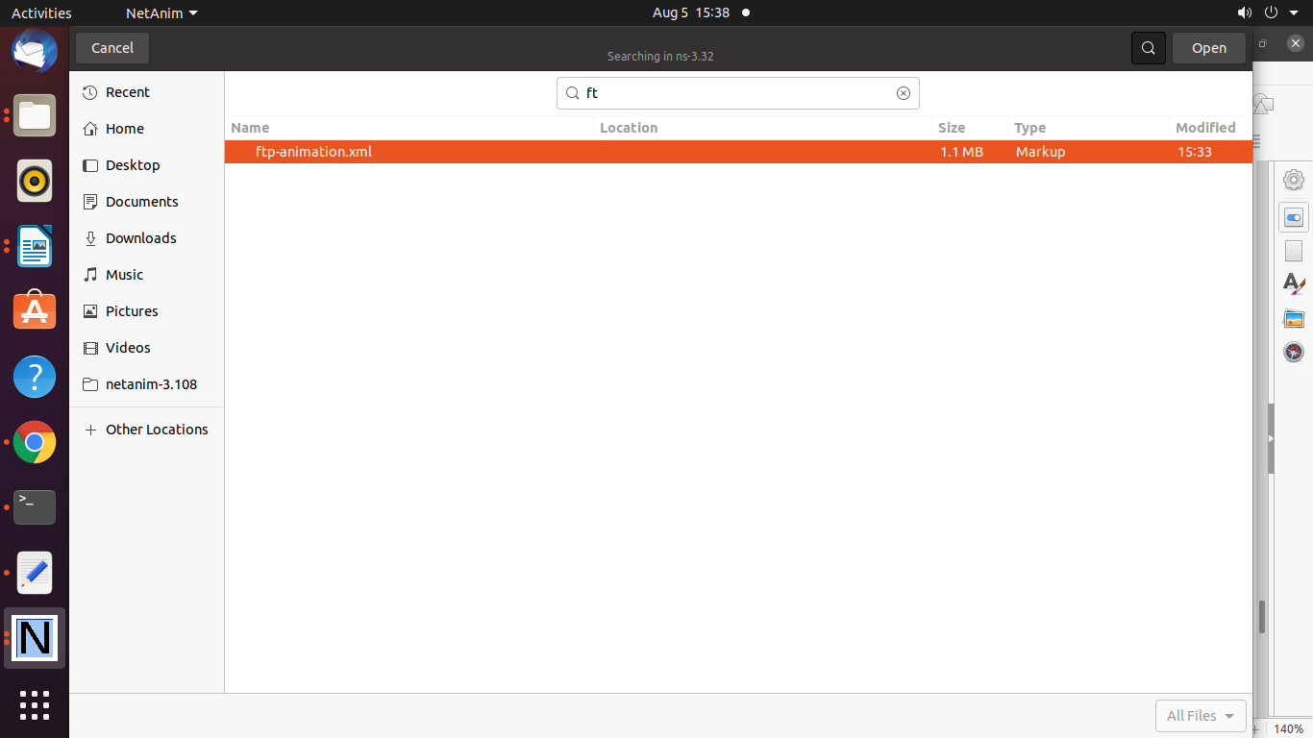

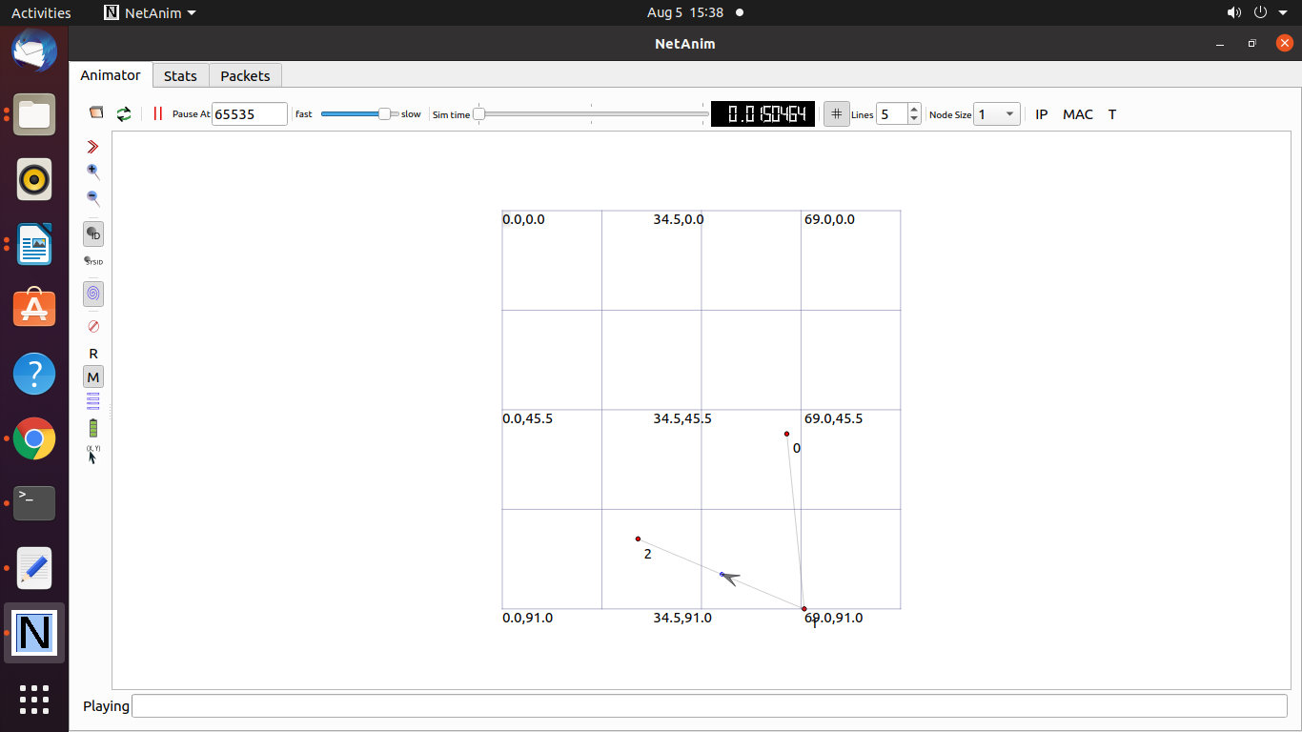

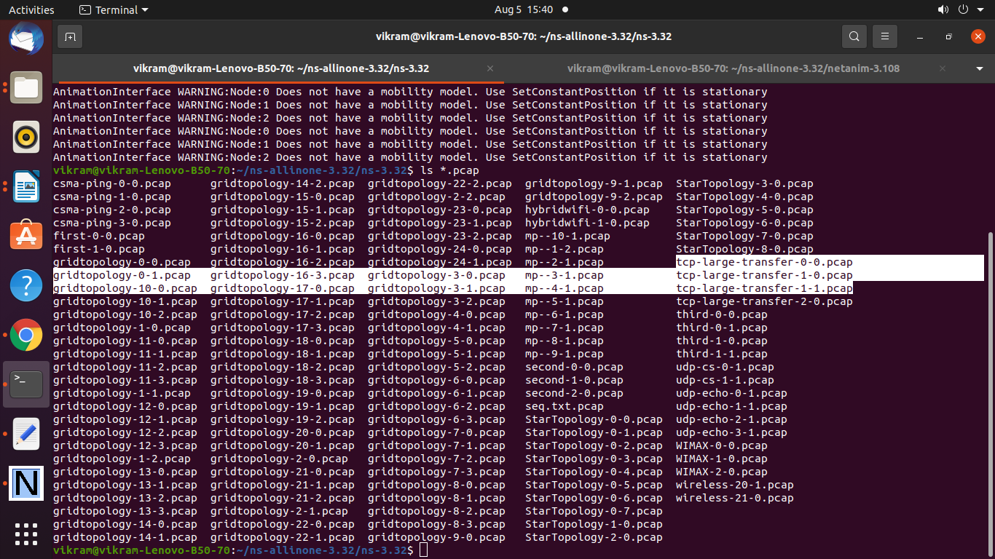

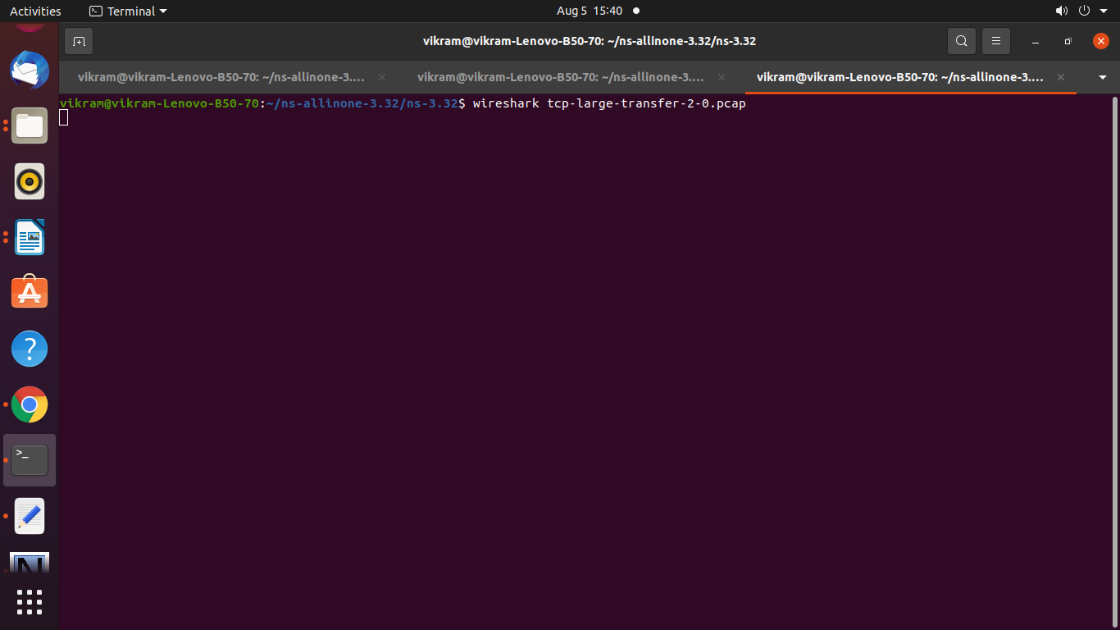

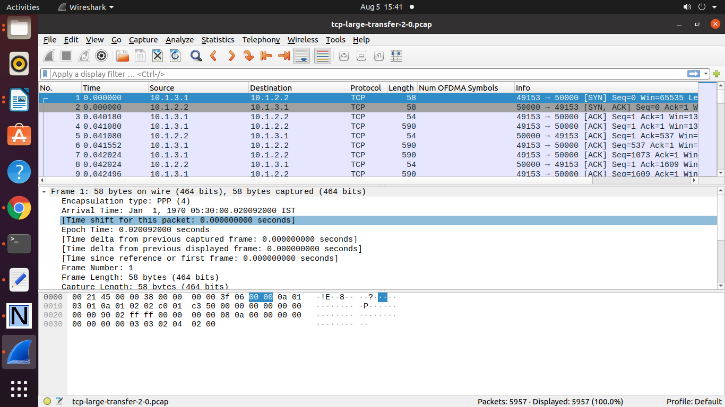

Graph Design for FTP transfer

ftpdemo.txt

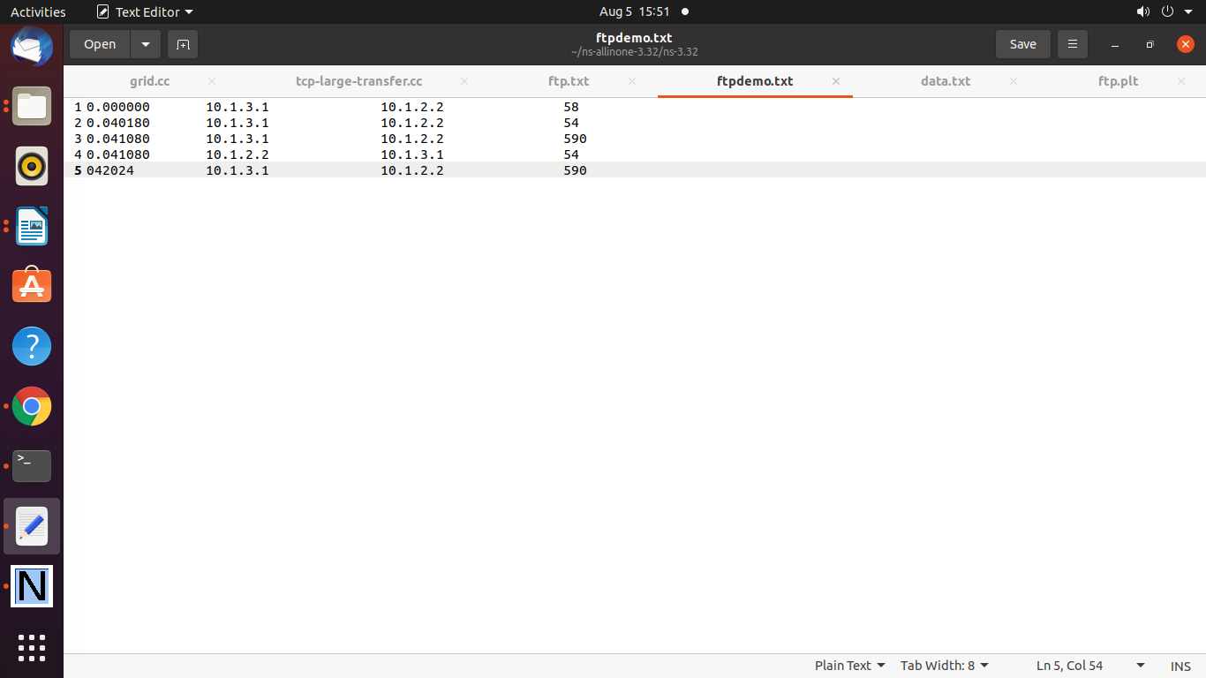

ftp.plt

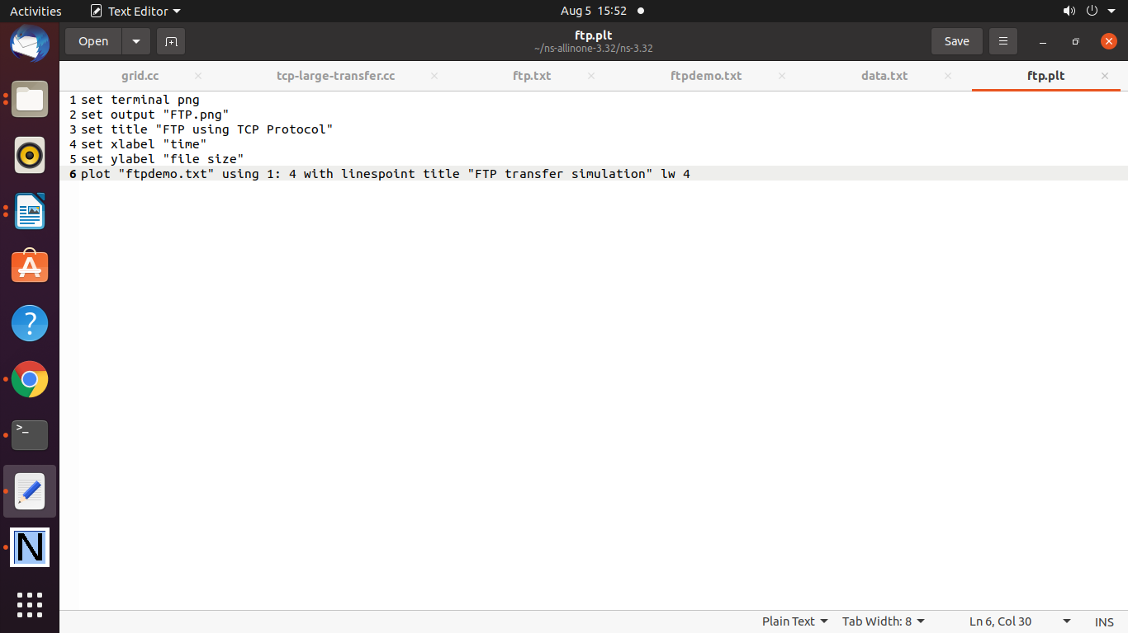

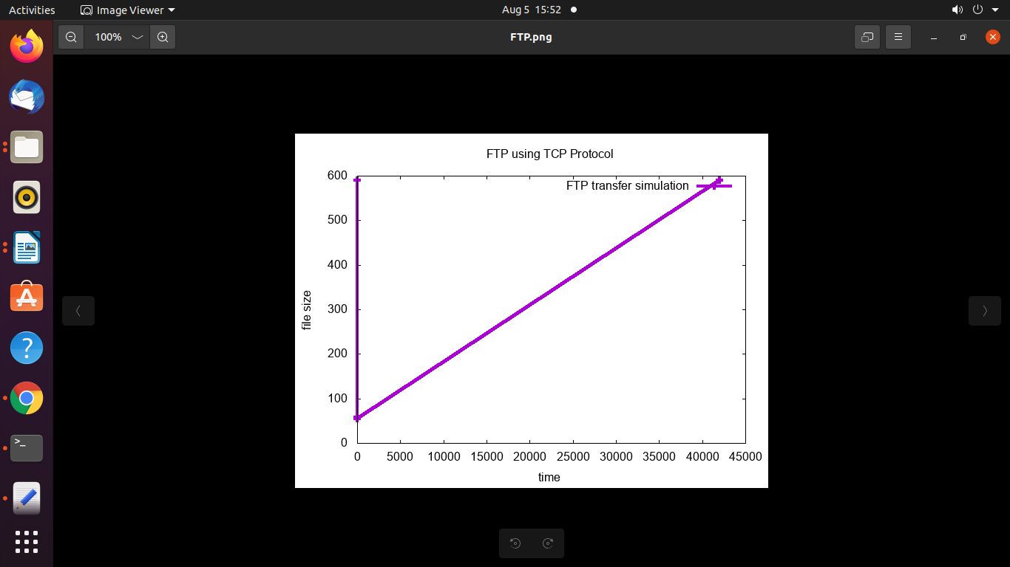

=========================================================

**Program 23 : Program to simulate DHCP server and n clients.**

dhcp-server.cc

/* -*- Mode:C++; c-file-style:"gnu"; indent-tabs-mode:nil; -*- */

/*

* Copyright (c) 2011 UPB

* Copyright (c) 2017 NITK Surathkal

*

* This program is free software; you can redistribute it and/or modify

* it under the terms of the GNU General Public License version 2 as

* published by the Free Software Foundation;

*

* This program is distributed in the hope that it will be useful,

* but WITHOUT ANY WARRANTY; without even the implied warranty of

* MERCHANTABILITY or FITNESS FOR A PARTICULAR PURPOSE. See the

* GNU General Public License for more details.

*

* You should have received a copy of the GNU General Public License

* along with this program; if not, write to the Free Software

* Foundation, Inc., 59 Temple Place, Suite 330, Boston, MA 02111-1307 USA

*

* Author: Radu Lupu <rlupu@elcom.pub.ro>

* Ankit Deepak <adadeepak8@gmail.com>

* Deepti Rajagopal <deeptir96@gmail.com>

*

*/

/*

* Network layout:

*

* R0 is a DHCP server. The DHCP server announced R1 as the default router.

* Nodes N1 will send UDP Echo packets to node A.

*

*

* ┌-------------------------------------------------┐

* | DHCP Clients |

* | 172.30.0.14 |

* | DHCP static |

* | ┌──────┐ ┌──────┐ ┌──────┐ |

* | │ N0 │ │ N1 │ │ N2 │ | ┌──────┐

* | └──────┘ └──────┘ └──────┘ | ┌────│ A │

* | │ │ │ | │ └──────┘

* └-------│--------------│---------------│----------┘ │ 172.30.1.2

* DHCP Server │ │ │ │

* ┌──────┐ │ │ │ ┌──────┐ │

* │ R0 │────────┴──────────────┴───────────────┴──────│ R1 │────┘

* └──────┘ └──────┘172.30.1.1

* 172.30.0.12 172.30.0.17

*

* Things to notice:

* 1) The routes in A are manually set to have R1 as the default router,

* just because using a dynamic outing in this example is an overkill.

* 2) R1's address is set statically though the DHCP server helper interface.

* This is useful to prevent address conflicts with the dynamic pool.

* Not necessary if the DHCP pool is not conflicting with static addresses.

* 3) N2 has a dynamically-assigned, static address (i.e., a fixed address assigned via DHCP).

*

*/

#include "ns3/core-module.h"

#include "ns3/internet-apps-module.h"

#include "ns3/csma-module.h"

#include "ns3/internet-module.h"

#include "ns3/point-to-point-module.h"

#include "ns3/applications-module.h"

#include "ns3/netanim-module.h"

using namespace ns3;

NS_LOG_COMPONENT_DEFINE ("DhcpExample");

int

main (int argc, char *argv[])

{

CommandLine cmd (__FILE__);

bool verbose = false;

bool tracing = false;

std::string animFile = "dhcp-server-client-animation.xml";

cmd.AddValue ("verbose", "turn on the logs", verbose);

cmd.AddValue ("tracing", "turn on the tracing", tracing);

cmd.Parse (argc, argv);

// GlobalValue::Bind ("ChecksumEnabled", BooleanValue (true));

if (verbose)

{

LogComponentEnable ("DhcpServer", LOG_LEVEL_ALL);

LogComponentEnable ("DhcpClient", LOG_LEVEL_ALL);

LogComponentEnable ("UdpEchoServerApplication", LOG_LEVEL_INFO);

LogComponentEnable ("UdpEchoClientApplication", LOG_LEVEL_INFO);

}

Time stopTime = Seconds (20);

NS_LOG_INFO ("Create nodes.");

NodeContainer nodes;

NodeContainer router;

nodes.Create (3);

router.Create (2);

NodeContainer net (nodes, router);

NS_LOG_INFO ("Create channels.");

CsmaHelper csma;

csma.SetChannelAttribute ("DataRate", StringValue ("5Mbps"));

csma.SetChannelAttribute ("Delay", StringValue ("2ms"));

csma.SetDeviceAttribute ("Mtu", UintegerValue (1500));

NetDeviceContainer devNet = csma.Install (net);

NodeContainer p2pNodes;

p2pNodes.Add (net.Get (4));

p2pNodes.Create (1);

PointToPointHelper pointToPoint;

pointToPoint.SetDeviceAttribute ("DataRate", StringValue ("5Mbps"));

pointToPoint.SetChannelAttribute ("Delay", StringValue ("2ms"));

NetDeviceContainer p2pDevices;

p2pDevices = pointToPoint.Install (p2pNodes);

InternetStackHelper tcpip;

tcpip.Install (nodes);

tcpip.Install (router);

tcpip.Install (p2pNodes.Get (1));

Ipv4AddressHelper address;

address.SetBase ("172.30.1.0", "255.255.255.0");

Ipv4InterfaceContainer p2pInterfaces;

p2pInterfaces = address.Assign (p2pDevices);

// manually add a routing entry because we don't want to add a dynamic routing

Ipv4StaticRoutingHelper ipv4RoutingHelper;

Ptr<Ipv4> ipv4Ptr = p2pNodes.Get (1)->GetObject<Ipv4> ();

Ptr<Ipv4StaticRouting> staticRoutingA = ipv4RoutingHelper.GetStaticRouting (ipv4Ptr);

staticRoutingA->AddNetworkRouteTo (Ipv4Address ("172.30.0.0"), Ipv4Mask ("/24"),

Ipv4Address ("172.30.1.1"), 1);

NS_LOG_INFO ("Setup the IP addresses and create DHCP applications.");

DhcpHelper dhcpHelper;

// The router must have a fixed IP.

Ipv4InterfaceContainer fixedNodes = dhcpHelper.InstallFixedAddress (devNet.Get (4), Ipv4Address ("172.30.0.17"), Ipv4Mask ("/24"));

// Not really necessary, IP forwarding is enabled by default in IPv4.

fixedNodes.Get (0).first->SetAttribute ("IpForward", BooleanValue (true));

// DHCP server

ApplicationContainer dhcpServerApp = dhcpHelper.InstallDhcpServer (devNet.Get (3), Ipv4Address ("172.30.0.12"),

Ipv4Address ("172.30.0.0"), Ipv4Mask ("/24"),

Ipv4Address ("172.30.0.10"), Ipv4Address ("172.30.0.15"),

Ipv4Address ("172.30.0.17"));

// This is just to show how it can be done.

DynamicCast<DhcpServer> (dhcpServerApp.Get (0))->AddStaticDhcpEntry (devNet.Get (2)->GetAddress (), Ipv4Address ("172.30.0.14"));

dhcpServerApp.Start (Seconds (0.0));

dhcpServerApp.Stop (stopTime);

// DHCP clients

NetDeviceContainer dhcpClientNetDevs;

dhcpClientNetDevs.Add (devNet.Get (0));

dhcpClientNetDevs.Add (devNet.Get (1));

dhcpClientNetDevs.Add (devNet.Get (2));

ApplicationContainer dhcpClients = dhcpHelper.InstallDhcpClient (dhcpClientNetDevs);

dhcpClients.Start (Seconds (1.0));

dhcpClients.Stop (stopTime);

UdpEchoServerHelper echoServer (9);

ApplicationContainer serverApps = echoServer.Install (p2pNodes.Get (1));

serverApps.Start (Seconds (0.0));

serverApps.Stop (stopTime);

UdpEchoClientHelper echoClient (p2pInterfaces.GetAddress (1), 9);

echoClient.SetAttribute ("MaxPackets", UintegerValue (100));

echoClient.SetAttribute ("Interval", TimeValue (Seconds (1.0)));

echoClient.SetAttribute ("PacketSize", UintegerValue (1024));

ApplicationContainer clientApps = echoClient.Install (nodes.Get (1));

clientApps.Start (Seconds (10.0));

clientApps.Stop (stopTime);

Simulator::Stop (stopTime + Seconds (10.0));

// Create the animation object and configure for specified output

AnimationInterface anim (animFile);

if (tracing)

{

csma.EnablePcapAll ("dhcp-csma");

pointToPoint.EnablePcapAll ("dhcp-p2p");

}

NS_LOG_INFO ("Run Simulation.");

Simulator::Run ();

Simulator::Destroy ();

NS_LOG_INFO ("Done.");

}

**Output:**

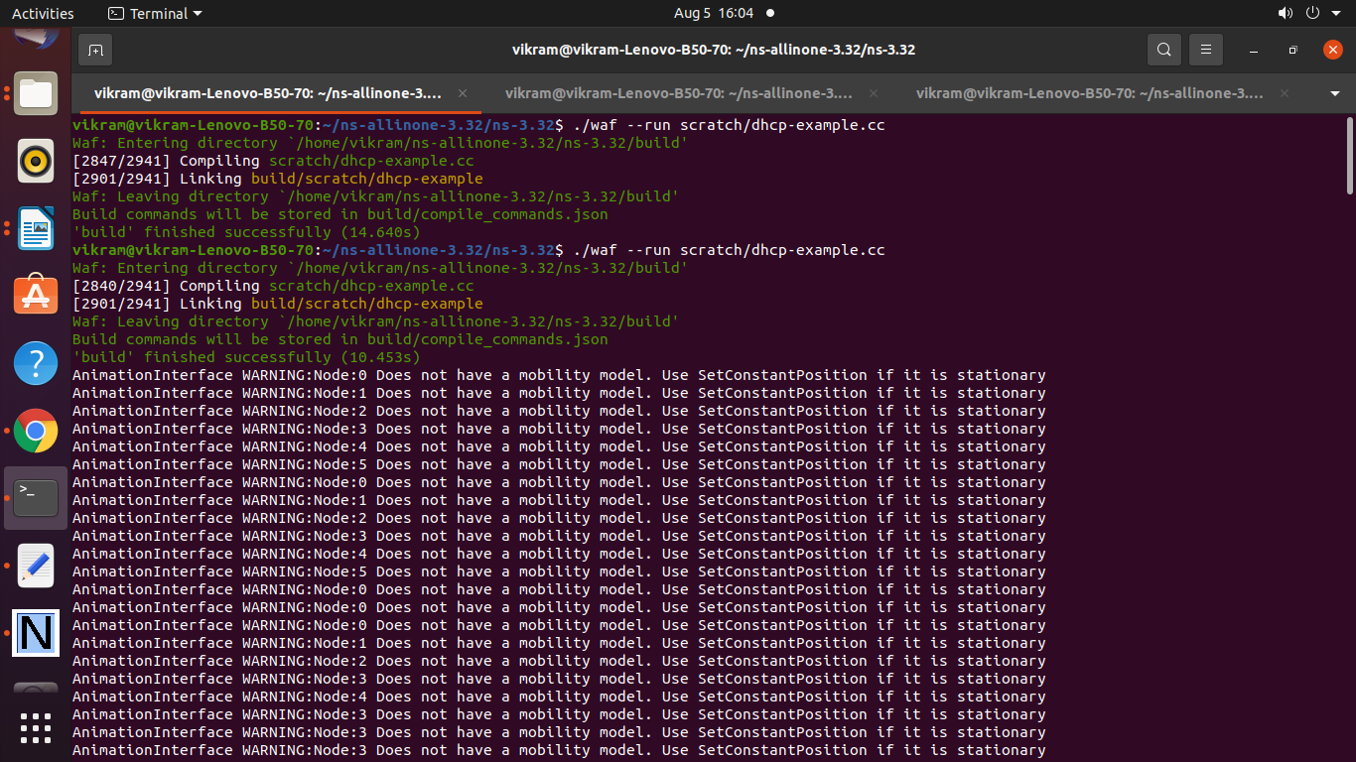

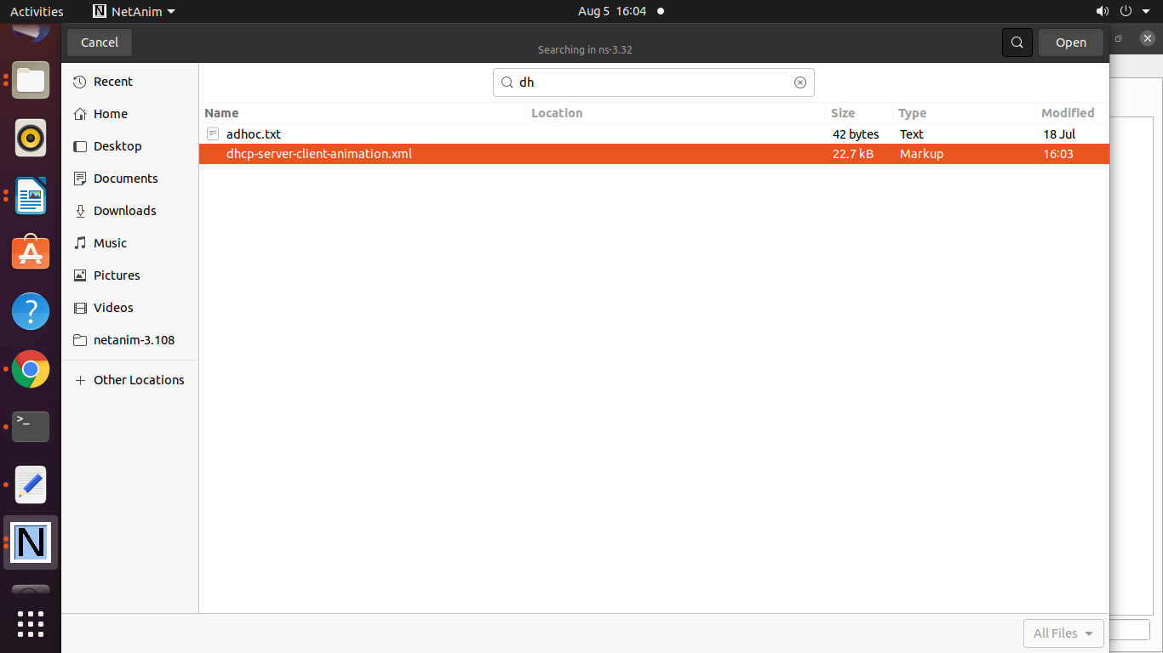

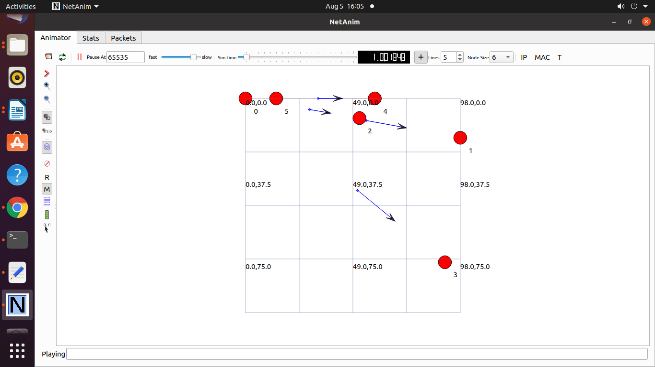

**Program 23 : Evaluate the performance of the network using flow monitor**

third.cc

/* -*- Mode:C++; c-file-style:"gnu"; indent-tabs-mode:nil; -*- */

/*

* This program is free software; you can redistribute it and/or modify

* it under the terms of the GNU General Public License version 2 as

* published by the Free Software Foundation;

*

* This program is distributed in the hope that it will be useful,

* but WITHOUT ANY WARRANTY; without even the implied warranty of

* MERCHANTABILITY or FITNESS FOR A PARTICULAR PURPOSE. See the

* GNU General Public License for more details.

*

* You should have received a copy of the GNU General Public License

* along with this program; if not, write to the Free Software

* Foundation, Inc., 59 Temple Place, Suite 330, Boston, MA 02111-1307 USA

*/

#include "ns3/core-module.h"

#include "ns3/point-to-point-module.h"

#include "ns3/network-module.h"

#include "ns3/applications-module.h"

#include "ns3/mobility-module.h"

#include "ns3/csma-module.h"

#include "ns3/internet-module.h"

#include "ns3/yans-wifi-helper.h"

#include "ns3/ssid.h"

#include "ns3/flow-monitor.h"

#include "ns3/flow-monitor-helper.h"

#include "ns3/flow-monitor-module.h"

// Default Network Topology

//

// Wifi 10.1.3.0

// AP

// * * * *

// | | | | 10.1.1.0

// n5 n6 n7 n0 -------------- n1 n2 n3 n4

// point-to-point | | | |

// ================

// LAN 10.1.2.0

using namespace ns3;

NS_LOG_COMPONENT_DEFINE ("ThirdScriptExample");

int

main (int argc, char *argv[])

{

bool verbose = true;

uint32_t nCsma = 3;

uint32_t nWifi = 3;

bool tracing = false;

CommandLine cmd (__FILE__);

cmd.AddValue ("nCsma", "Number of \"extra\" CSMA nodes/devices", nCsma);

cmd.AddValue ("nWifi", "Number of wifi STA devices", nWifi);

cmd.AddValue ("verbose", "Tell echo applications to log if true", verbose);

cmd.AddValue ("tracing", "Enable pcap tracing", tracing);

cmd.Parse (argc,argv);

// The underlying restriction of 18 is due to the grid position

// allocator's configuration; the grid layout will exceed the

// bounding box if more than 18 nodes are provided.

if (nWifi > 18)

{

std::cout << "nWifi should be 18 or less; otherwise grid layout exceeds the bounding box" << std::endl;

return 1;

}

if (verbose)

{

LogComponentEnable ("UdpEchoClientApplication", LOG_LEVEL_INFO);

LogComponentEnable ("UdpEchoServerApplication", LOG_LEVEL_INFO);

}

NodeContainer p2pNodes;

p2pNodes.Create (2);

PointToPointHelper pointToPoint;

pointToPoint.SetDeviceAttribute ("DataRate", StringValue ("5Mbps"));

pointToPoint.SetChannelAttribute ("Delay", StringValue ("2ms"));

NetDeviceContainer p2pDevices;

p2pDevices = pointToPoint.Install (p2pNodes);

NodeContainer csmaNodes;

csmaNodes.Add (p2pNodes.Get (1));

csmaNodes.Create (nCsma);

CsmaHelper csma;

csma.SetChannelAttribute ("DataRate", StringValue ("100Mbps"));

csma.SetChannelAttribute ("Delay", TimeValue (NanoSeconds (6560)));

NetDeviceContainer csmaDevices;

csmaDevices = csma.Install (csmaNodes);

NodeContainer wifiStaNodes;

wifiStaNodes.Create (nWifi);

NodeContainer wifiApNode = p2pNodes.Get (0);

YansWifiChannelHelper channel = YansWifiChannelHelper::Default ();

YansWifiPhyHelper phy;

phy.SetChannel (channel.Create ());

WifiHelper wifi;

wifi.SetRemoteStationManager ("ns3::AarfWifiManager");

WifiMacHelper mac;

Ssid ssid = Ssid ("ns-3-ssid");

mac.SetType ("ns3::StaWifiMac",

"Ssid", SsidValue (ssid),

"ActiveProbing", BooleanValue (false));

NetDeviceContainer staDevices;

staDevices = wifi.Install (phy, mac, wifiStaNodes);

mac.SetType ("ns3::ApWifiMac",

"Ssid", SsidValue (ssid));

NetDeviceContainer apDevices;

apDevices = wifi.Install (phy, mac, wifiApNode);

MobilityHelper mobility;

mobility.SetPositionAllocator ("ns3::GridPositionAllocator",

"MinX", DoubleValue (0.0),

"MinY", DoubleValue (0.0),

"DeltaX", DoubleValue (5.0),

"DeltaY", DoubleValue (10.0),

"GridWidth", UintegerValue (3),

"LayoutType", StringValue ("RowFirst"));

mobility.SetMobilityModel ("ns3::RandomWalk2dMobilityModel",

"Bounds", RectangleValue (Rectangle (-50, 50, -50, 50)));

mobility.Install (wifiStaNodes);

mobility.SetMobilityModel ("ns3::ConstantPositionMobilityModel");

mobility.Install (wifiApNode);

InternetStackHelper stack;

stack.Install (csmaNodes);

stack.Install (wifiApNode);

stack.Install (wifiStaNodes);

Ipv4AddressHelper address;

address.SetBase ("10.1.1.0", "255.255.255.0");

Ipv4InterfaceContainer p2pInterfaces;

p2pInterfaces = address.Assign (p2pDevices);

address.SetBase ("10.1.2.0", "255.255.255.0");

Ipv4InterfaceContainer csmaInterfaces;

csmaInterfaces = address.Assign (csmaDevices);

address.SetBase ("10.1.3.0", "255.255.255.0");

address.Assign (staDevices);

address.Assign (apDevices);

UdpEchoServerHelper echoServer (9);

ApplicationContainer serverApps = echoServer.Install (csmaNodes.Get (nCsma));

serverApps.Start (Seconds (1.0));

serverApps.Stop (Seconds (10.0));

UdpEchoClientHelper echoClient (csmaInterfaces.GetAddress (nCsma), 9);

echoClient.SetAttribute ("MaxPackets", UintegerValue (1));

echoClient.SetAttribute ("Interval", TimeValue (Seconds (1.0)));

echoClient.SetAttribute ("PacketSize", UintegerValue (1024));

ApplicationContainer clientApps =

echoClient.Install (wifiStaNodes.Get (nWifi - 1));

clientApps.Start (Seconds (2.0));

clientApps.Stop (Seconds (10.0));

Ipv4GlobalRoutingHelper::PopulateRoutingTables ();

Ptr<FlowMonitor> flowMonitor;

FlowMonitorHelper flowHelper;

flowMonitor = flowHelper.InstallAll();

Simulator::Stop (Seconds (10.0));

if (tracing)

{

phy.SetPcapDataLinkType (WifiPhyHelper::DLT_IEEE802_11_RADIO);

pointToPoint.EnablePcapAll ("third");

phy.EnablePcap ("third", apDevices.Get (0));

csma.EnablePcap ("third", csmaDevices.Get (0), true);

}

Simulator::Run ();

flowMonitor->SerializeToXmlFile("thirdflow.xml",true,true);

Simulator::Destroy ();

return 0;

}

Output

This XML file does not appear to have any style information associated with it. The document tree is shown below.

<FlowMonitor>

<FlowStats>

<Flow flowId="1" timeFirstTxPacket="+2000000000.0ns" timeFirstRxPacket="+2012883058.0ns" timeLastTxPacket="+9000000000.0ns" timeLastRxPacket="+9004770608.0ns" delaySum="+49181295.0ns" jitterSum="+8112464.0ns" lastDelay="+4770608.0ns" txBytes="8416" rxBytes="8416" txPackets="8" rxPackets="8" lostPackets="0" timesForwarded="16">

<delayHistogram nBins="13">

<bin index="4" start="0.004" width="0.001" count="1"/>

<bin index="5" start="0.005" width="0.001" count="6"/>

<bin index="12" start="0.012" width="0.001" count="1"/>

</delayHistogram>

<jitterHistogram nBins="8">

<bin index="0" start="0" width="0.001" count="6"/>

<bin index="7" start="0.007" width="0.001" count="1"/>

</jitterHistogram>

<packetSizeHistogram nBins="53">

<bin index="52" start="1040" width="20" count="8"/>

</packetSizeHistogram>

<flowInterruptionsHistogram nBins="5">

<bin index="3" start="0.75" width="0.25" count="5"/>

<bin index="4" start="1" width="0.25" count="2"/>

</flowInterruptionsHistogram>

</Flow>

<Flow flowId="2" timeFirstTxPacket="+2012883058.0ns" timeFirstRxPacket="+2021587116.0ns" timeLastTxPacket="+9004770608.0ns" timeLastRxPacket="+9010026216.0ns" delaySum="+45493295.0ns" jitterSum="+3448472.0ns" lastDelay="+5255608.0ns" txBytes="8416" rxBytes="8416" txPackets="8" rxPackets="8" lostPackets="0" timesForwarded="16">

<delayHistogram nBins="9">

<bin index="5" start="0.005" width="0.001" count="7"/>

<bin index="8" start="0.008" width="0.001" count="1"/>

</delayHistogram>

<jitterHistogram nBins="4">

<bin index="0" start="0" width="0.001" count="6"/>

<bin index="3" start="0.003" width="0.001" count="1"/>

</jitterHistogram>

<packetSizeHistogram nBins="53">

<bin index="52" start="1040" width="20" count="8"/>

</packetSizeHistogram>

<flowInterruptionsHistogram nBins="5">

<bin index="3" start="0.75" width="0.25" count="5"/>

<bin index="4" start="1" width="0.25" count="2"/>

</flowInterruptionsHistogram>

</Flow>

</FlowStats>

<Ipv4FlowClassifier>

<Flow flowId="2" sourceAddress="10.1.2.4" destinationAddress="10.1.3.3" protocol="17" sourcePort="9" destinationPort="49153">

<Dscp value="0x0" packets="8"/>

</Flow>

<Flow flowId="1" sourceAddress="10.1.3.3" destinationAddress="10.1.2.4" protocol="17" sourcePort="49153" destinationPort="9">

<Dscp value="0x0" packets="8"/>

</Flow>

</Ipv4FlowClassifier>

<Ipv6FlowClassifier> </Ipv6FlowClassifier>

<FlowProbes>

<FlowProbe index="0">

<FlowStats flowId="1" packets="8" bytes="8416" delayFromFirstProbeSum="+17927455.0ns"> </FlowStats>

<FlowStats flowId="2" packets="8" bytes="8416" delayFromFirstProbeSum="+30260840.0ns"> </FlowStats>

</FlowProbe>

<FlowProbe index="1"> </FlowProbe>

<FlowProbe index="2">

<FlowStats flowId="1" packets="8" bytes="8416" delayFromFirstProbeSum="+47418655.0ns"> </FlowStats>

<FlowStats flowId="2" packets="8" bytes="8416" delayFromFirstProbeSum="+769640.0ns"> </FlowStats>

</FlowProbe>

<FlowProbe index="3"> </FlowProbe>

<FlowProbe index="4"> </FlowProbe>

<FlowProbe index="5"> </FlowProbe>

<FlowProbe index="6"> </FlowProbe>

<FlowProbe index="7"> </FlowProbe>

<FlowProbe index="8">

<FlowStats flowId="1" packets="8" bytes="8416" delayFromFirstProbeSum="+49181295.0ns"> </FlowStats>

<FlowStats flowId="2" packets="8" bytes="8416" delayFromFirstProbeSum="+0.0ns"> </FlowStats>

</FlowProbe>

<FlowProbe index="9"> </FlowProbe>

<FlowProbe index="10"> </FlowProbe>

<FlowProbe index="11"> </FlowProbe>

<FlowProbe index="12"> </FlowProbe>

<FlowProbe index="13"> </FlowProbe>

<FlowProbe index="14">

<FlowStats flowId="1" packets="8" bytes="8416" delayFromFirstProbeSum="+0.0ns"> </FlowStats>

<FlowStats flowId="2" packets="8" bytes="8416" delayFromFirstProbeSum="+45493295.0ns"> </FlowStats>

</FlowProbe>

<FlowProbe index="15"> </FlowProbe>

</FlowProbes>

</FlowMonitor>

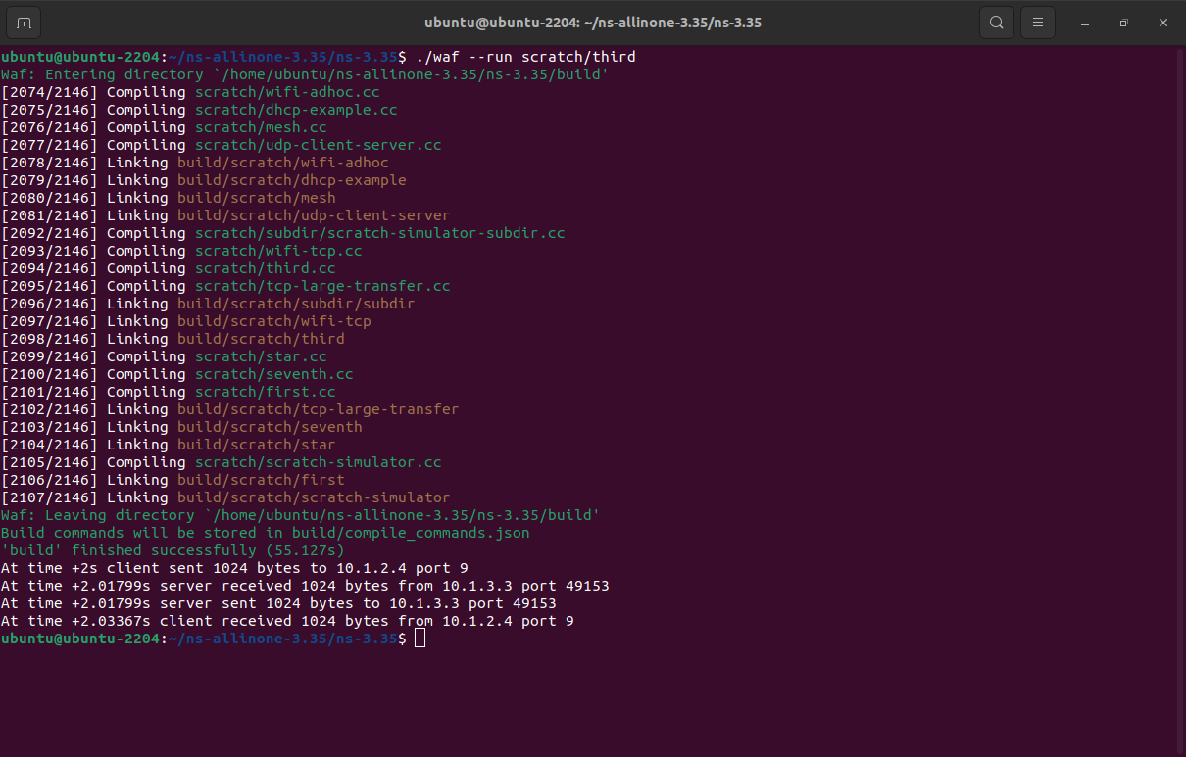

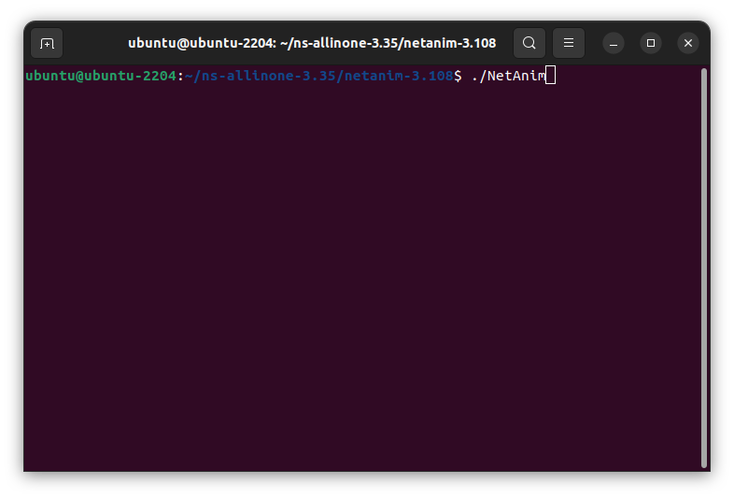

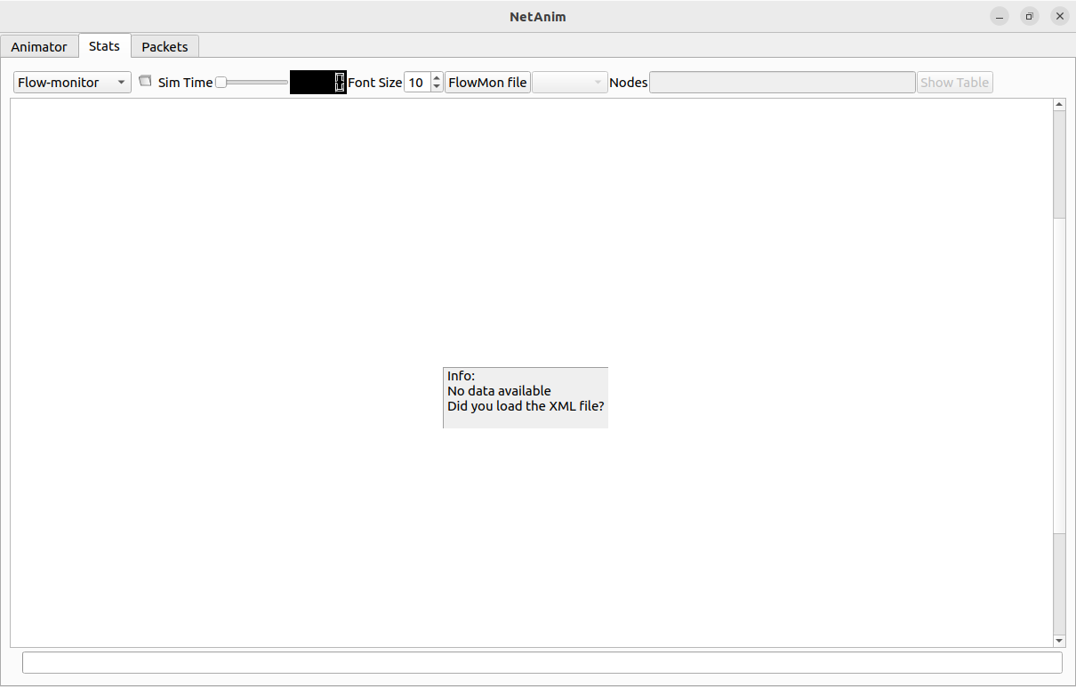

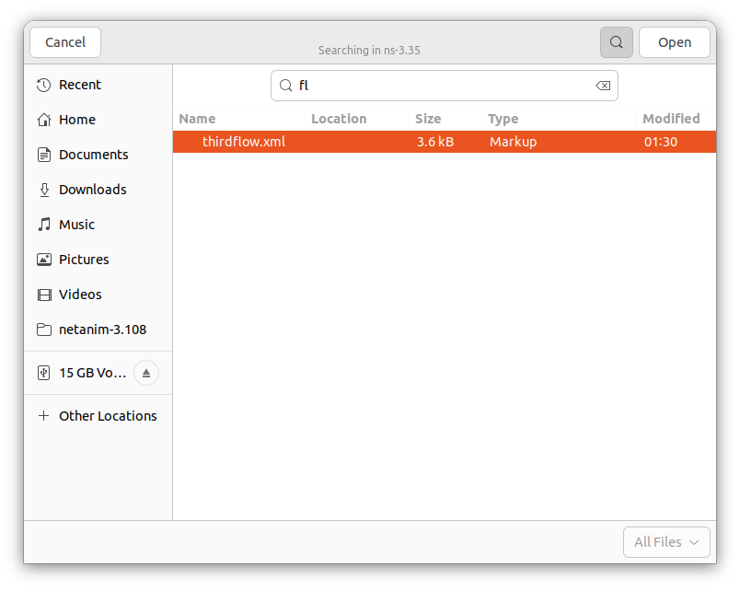

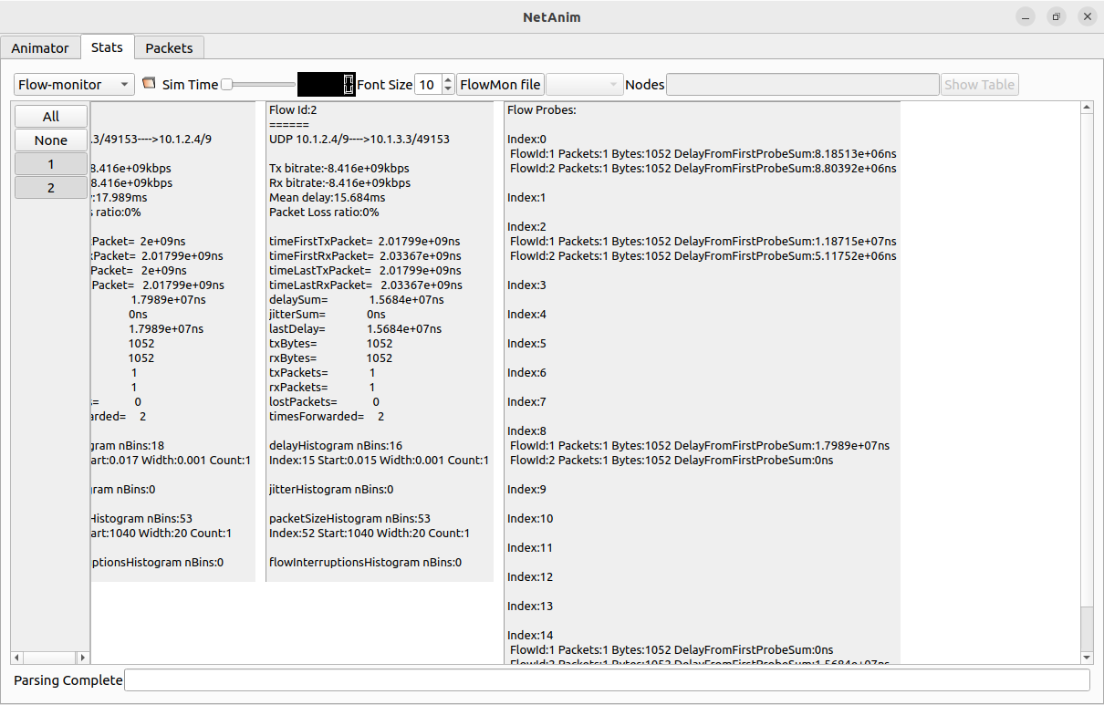

**Program 24: Congestion Control**

**seventh.cc**

**/* -*- Mode:C++; c-file-style:"gnu"; indent-tabs-mode:nil; -*- */**

**/\***

**\* This program is free software; you can redistribute it and/or modify**

**\* it under the terms of the GNU General Public License version 2 as**

**\* published by the Free Software Foundation;**

**\***

**\* This program is distributed in the hope that it will be useful,**

**\* but WITHOUT ANY WARRANTY; without even the implied warranty of**

**\* MERCHANTABILITY or FITNESS FOR A PARTICULAR PURPOSE. See the**

**\* GNU General Public License for more details.**

**\***

**\* You should have received a copy of the GNU General Public License**

**\* along with this program; if not, write to the Free Software**

**\* Foundation, Inc., 59 Temple Place, Suite 330, Boston, MA 02111-1307 USA**

**\*/**

**#include <fstream>**

**#include "ns3/core-module.h"**

**#include "ns3/network-module.h"**

**#include "ns3/internet-module.h"**

**#include "ns3/point-to-point-module.h"**

**#include "ns3/applications-module.h"**

**#include "ns3/stats-module.h"**

**using namespace ns3;**

**NS_LOG_COMPONENT_DEFINE ("SeventhScriptExample");**

**// ===========================================================================**

**//**

**// node 0 node 1**

**// +----------------+ +----------------+**

**// | ns-3 TCP | | ns-3 TCP |**

**// +----------------+ +----------------+**

**// | 10.1.1.1 | | 10.1.1.2 |**

**// +----------------+ +----------------+**

**// | point-to-point | | point-to-point |**

**// +----------------+ +----------------+**

**// | |**

**// +---------------------+**

**// 5 Mbps, 2 ms**

**//**

**//**

**// We want to look at changes in the ns-3 TCP congestion window. We need**

**// to crank up a flow and hook the CongestionWindow attribute on the socket**

**// of the sender. Normally one would use an on-off application to generate a**

**// flow, but this has a couple of problems. First, the socket of the on-off**

**// application is not created until Application Start time, so we wouldn't be**

**// able to hook the socket (now) at configuration time. Second, even if we**

**// could arrange a call after start time, the socket is not public so we**

**// couldn't get at it.**

**//**

**// So, we can cook up a simple version of the on-off application that does what**

**// we want. On the plus side we don't need all of the complexity of the on-off**

**// application. On the minus side, we don't have a helper, so we have to get**

**// a little more involved in the details, but this is trivial.**

**//**

**// So first, we create a socket and do the trace connect on it; then we pass**

**// this socket into the constructor of our simple application which we then**

**// install in the source node.**

**//**

**// NOTE: If this example gets modified, do not forget to update the .png figure**

**// in src/stats/docs/seventh-packet-byte-count.png**

**// ===========================================================================**

**//**

**class MyApp : public Application**

**{**

**public:**

**MyApp ();**

**virtual ~MyApp ();**

**/\*\***

**\* Register this type.**

**\* \return The TypeId.**

**\*/**

**static TypeId GetTypeId (void);**

**void Setup (Ptr<Socket> socket, Address address, uint32_t packetSize, uint32_t nPackets, DataRate dataRate);**

**private:**

**virtual void StartApplication (void);**

**virtual void StopApplication (void);**

**void ScheduleTx (void);**

**void SendPacket (void);**

**Ptr<Socket> m_socket;**

**Address m_peer;**

**uint32_t m_packetSize;**

**uint32_t m_nPackets;**

**DataRate m_dataRate;**

**EventId m_sendEvent;**

**bool m_running;**

**uint32_t m_packetsSent;**

**};**

**MyApp::MyApp ()**

**: m_socket (0),**

**m_peer (),**

**m_packetSize (0),**

**m_nPackets (0),**

**m_dataRate (0),**

**m_sendEvent (),**

**m_running (false),**

**m_packetsSent (0)**

**{**

**}**

**MyApp::~MyApp ()**

**{**

**m_socket = 0;**

**}**

**/* static */**

**TypeId MyApp::GetTypeId (void)**

**{**

**static TypeId tid = TypeId ("MyApp")**

**.SetParent<Application> ()**

**.SetGroupName ("Tutorial")**

**.AddConstructor<MyApp> ()**

**;**

**return tid;**

**}**

**void**

**MyApp::Setup (Ptr<Socket> socket, Address address, uint32_t packetSize, uint32_t nPackets, DataRate dataRate)**

**{**

**m_socket = socket;**

**m_peer = address;**

**m_packetSize = packetSize;**

**m_nPackets = nPackets;**

**m_dataRate = dataRate;**

**}**

**void**

**MyApp::StartApplication (void)**

**{**

**m_running = true;**

**m_packetsSent = 0;**

**if (InetSocketAddress::IsMatchingType (m_peer))**

**{**

**m_socket->Bind ();**

**}**

**else**

**{**

**m_socket->Bind6 ();**

**}**

**m_socket->Connect (m_peer);**

**SendPacket ();**

**}**

**void**

**MyApp::StopApplication (void)**

**{**

**m_running = false;**

**if (m_sendEvent.IsRunning ())**

**{**

**Simulator::Cancel (m_sendEvent);**

**}**

**if (m_socket)**

**{**

**m_socket->Close ();**

**}**

**}**

**void**

**MyApp::SendPacket (void)**

**{**

**Ptr<Packet> packet = Create<Packet> (m_packetSize);**

**m_socket->Send (packet);**

**if (++m_packetsSent < m_nPackets)**

**{**

**ScheduleTx ();**

**}**

**}**

**void**

**MyApp::ScheduleTx (void)**

**{**

**if (m_running)**

**{**

**Time tNext (Seconds (m_packetSize * 8 / static_cast<double> (m_dataRate.GetBitRate ())));**

**m_sendEvent = Simulator::Schedule (tNext, &MyApp::SendPacket, this);**

**}**

**}**

**static void**

**CwndChange (Ptr<OutputStreamWrapper> stream, uint32_t oldCwnd, uint32_t newCwnd)**

**{**

**NS_LOG_UNCOND (Simulator::Now ().GetSeconds () << "\t" << newCwnd);**

**\*stream->GetStream () << Simulator::Now ().GetSeconds () << "\t" << oldCwnd << "\t" << newCwnd << std::endl;**

**}**

**static void**

**RxDrop (Ptr<PcapFileWrapper> file, Ptr<const Packet> p)**

**{**

**NS_LOG_UNCOND ("RxDrop at " << Simulator::Now ().GetSeconds ());**

**file->Write (Simulator::Now (), p);**

**}**

**int**

**main (int argc, char *argv[])**

**{**

**bool useV6 = false;**

**CommandLine cmd (__FILE__);**

**cmd.AddValue ("useIpv6", "Use Ipv6", useV6);**

**cmd.Parse (argc, argv);**

**NodeContainer nodes;**

**nodes.Create (2);**

**PointToPointHelper pointToPoint;**

**pointToPoint.SetDeviceAttribute ("DataRate", StringValue ("5Mbps"));**

**pointToPoint.SetChannelAttribute ("Delay", StringValue ("2ms"));**

**NetDeviceContainer devices;**

**devices = pointToPoint.Install (nodes);**

**Ptr<RateErrorModel> em = CreateObject<RateErrorModel> ();**

**em->SetAttribute ("ErrorRate", DoubleValue (0.00001));**

**devices.Get (1)->SetAttribute ("ReceiveErrorModel", PointerValue (em));**

**InternetStackHelper stack;**

**stack.Install (nodes);**

**uint16_t sinkPort = 8080;**

**Address sinkAddress;**

**Address anyAddress;**

**std::string probeType;**

**std::string tracePath;**

**if (useV6 == false)**

**{**

**Ipv4AddressHelper address;**

**address.SetBase ("10.1.1.0", "255.255.255.0");**

**Ipv4InterfaceContainer interfaces = address.Assign (devices);**

**sinkAddress = InetSocketAddress (interfaces.GetAddress (1), sinkPort);**

**anyAddress = InetSocketAddress (Ipv4Address::GetAny (), sinkPort);**

**probeType = "ns3::Ipv4PacketProbe";**

**tracePath = "/NodeList/*/$ns3::Ipv4L3Protocol/Tx";**

**}**

**else**

**{**

**Ipv6AddressHelper address;**

**address.SetBase ("2001:0000:f00d:cafe::", Ipv6Prefix (64));**

**Ipv6InterfaceContainer interfaces = address.Assign (devices);**

**sinkAddress = Inet6SocketAddress (interfaces.GetAddress (1,1), sinkPort);**

**anyAddress = Inet6SocketAddress (Ipv6Address::GetAny (), sinkPort);**

**probeType = "ns3::Ipv6PacketProbe";**

**tracePath = "/NodeList/*/$ns3::Ipv6L3Protocol/Tx";**

**}**

**PacketSinkHelper packetSinkHelper ("ns3::TcpSocketFactory", anyAddress);**

**ApplicationContainer sinkApps = packetSinkHelper.Install (nodes.Get (1));**

**sinkApps.Start (Seconds (0.));**

**sinkApps.Stop (Seconds (20.));**

**Ptr<Socket> ns3TcpSocket = Socket::CreateSocket (nodes.Get (0), TcpSocketFactory::GetTypeId ());**

**Ptr<MyApp> app = CreateObject<MyApp> ();**

**app->Setup (ns3TcpSocket, sinkAddress, 1040, 1000, DataRate ("1Mbps"));**

**nodes.Get (0)->AddApplication (app);**

**app->SetStartTime (Seconds (1.));**

**app->SetStopTime (Seconds (20.));**

**AsciiTraceHelper asciiTraceHelper;**

**Ptr<OutputStreamWrapper> stream = asciiTraceHelper.CreateFileStream ("seventh.cwnd");**

**ns3TcpSocket->TraceConnectWithoutContext ("CongestionWindow", MakeBoundCallback (&CwndChange, stream));**

**PcapHelper pcapHelper;**

**Ptr<PcapFileWrapper> file = pcapHelper.CreateFile ("seventh.pcap", std::ios::out, PcapHelper::DLT_PPP);**

**devices.Get (1)->TraceConnectWithoutContext ("PhyRxDrop", MakeBoundCallback (&RxDrop, file));**

**// Use GnuplotHelper to plot the packet byte count over time**

**GnuplotHelper plotHelper;**

**// Configure the plot. The first argument is the file name prefix**

**// for the output files generated. The second, third, and fourth**

**// arguments are, respectively, the plot title, x-axis, and y-axis labels**

**plotHelper.ConfigurePlot ("seventh-packet-byte-count",**

**"Packet Byte Count vs. Time",**

**"Time (Seconds)",**

**"Packet Byte Count");**

**// Specify the probe type, trace source path (in configuration namespace), and**

**// probe output trace source ("OutputBytes") to plot. The fourth argument**

**// specifies the name of the data series label on the plot. The last**

**// argument formats the plot by specifying where the key should be placed.**

**plotHelper.PlotProbe (probeType,**

**tracePath,**

**"OutputBytes",**

**"Packet Byte Count",**

**GnuplotAggregator::KEY_BELOW);**

**// Use FileHelper to write out the packet byte count over time**

**FileHelper fileHelper;**

**// Configure the file to be written, and the formatting of output data.**

**fileHelper.ConfigureFile ("seventh-packet-byte-count",**

**FileAggregator::FORMATTED);**

**// Set the labels for this formatted output file.**

**fileHelper.Set2dFormat ("Time (Seconds) = %.3e\tPacket Byte Count = %.0f");**

**// Specify the probe type, trace source path (in configuration namespace), and**

**// probe output trace source ("OutputBytes") to write.**

**fileHelper.WriteProbe (probeType,**

**tracePath,**

**"OutputBytes");**

**Simulator::Stop (Seconds (20));**

**Simulator::Run ();**

**Simulator::Destroy ();**

**return 0;**

**}**

**Output:**

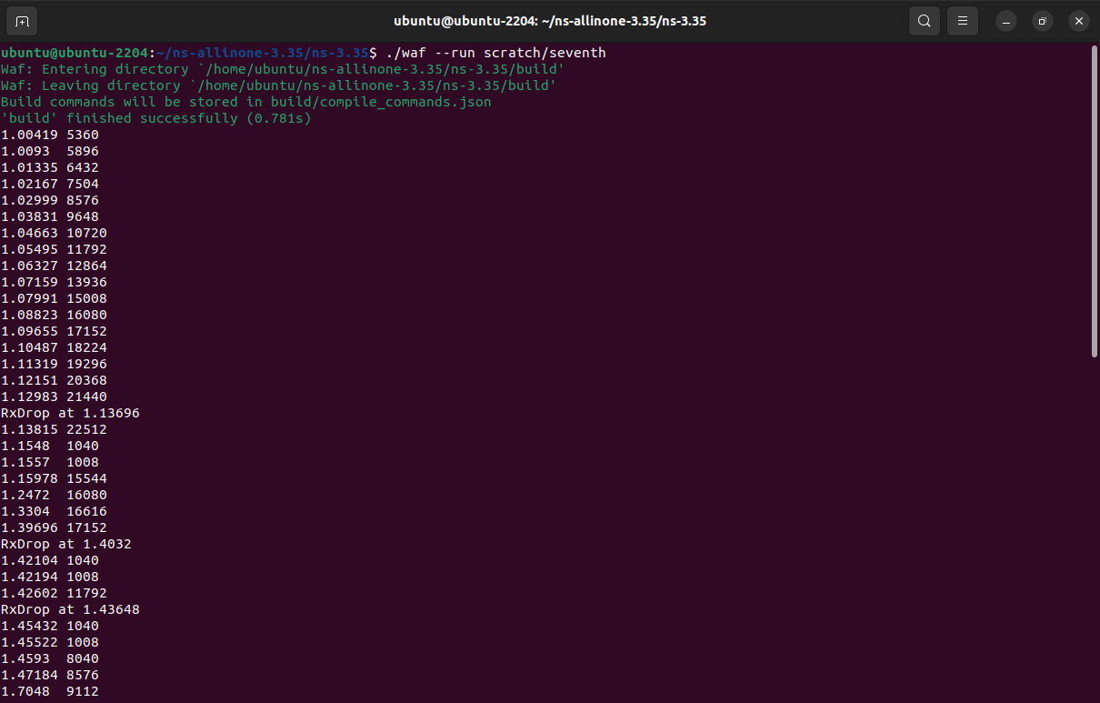

**congestion.plt**

**set terminal pdf**

**set output "Congestion1.pdf"**

**set title "Congestion Window Calculation"**

**set xlabel "Time (in Seconds)"**

**set ylabel "Congestion Window (cwnd)"**

**plot "seventh.cwnd" using 1:3 with linespoint title "Old congestion"**

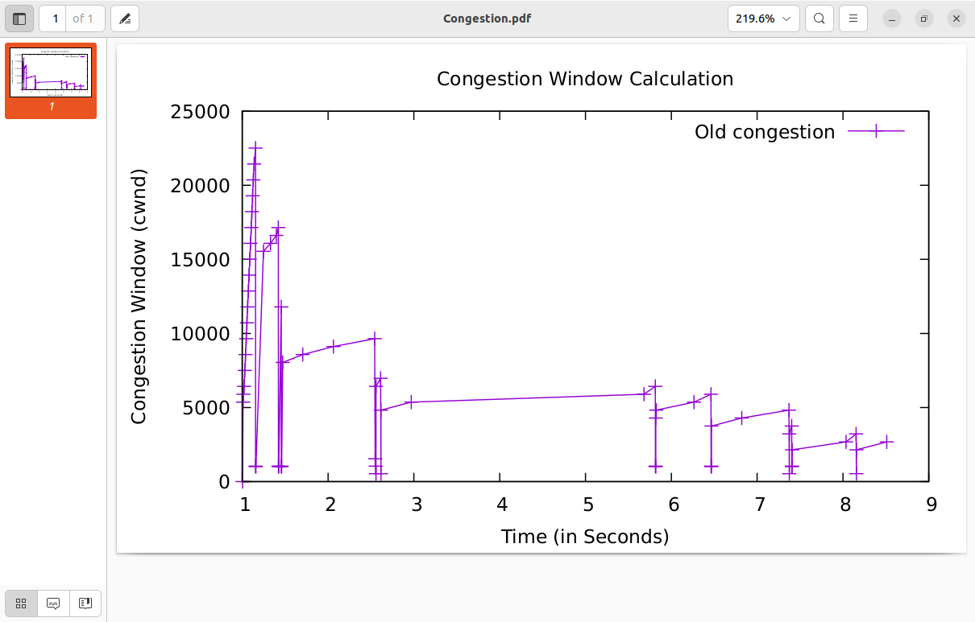

Prog. 25 :

**Monitoring and Analyzing the Network Traffic**

* Analysis of Protocols using Wireshark
* HTTP, HTTPS, DNS
* TCP, UDP
* IP, ICMP
* ARP
* DHCP

HTML Documents with Embedded Objects

Now that we’ve seen how Wireshark displays the captured packet traffic for large HTML files, we can look at what happens when your browser downloads a file with embedded objects, i.e., a file that includes other objects (in the example below, image files) that are stored on another server(s).

Do the following:

* Start up your web browser, and make sure your browser’s cache is cleared, as discussed above.
* Start up the Wireshark packet sniffer

Enter the following URL into your browser  
<http://gaia.cs.umass.edu/wireshark-labs/HTTP-wireshark-file4.html>

. The URL

http://gaia.cs.umass.edu/wireshark-labs/protected_pages/HTTP-wireshark-file5.html is password protected. The username is “wireshark-students” (without the quotes), and the password is “network” (again, without the quotes). So let’s access this “secure” password-protected site. Do the following:

* Make sure your browser’s cache is cleared, as discussed above, and close down your browser. Then, start up your browser
* Start up the Wireshark packet sniffer
* Enter the following URL into your browser  
  <http://gaia.cs.umass.edu/wireshark-labs/protected_pages/HTTP-wireshark-file5.html>  
  Type the requested user name and password into the pop up box.
* Stop Wireshark packet capture, and enter “http” in the display-filter-specification window, so that only captured HTTP messages will be displayed later in the packet-listing window.

*Note:* If you are unable to run Wireshark on a live network connection, you can use the “classic” http-ethereal-trace-5 packet trace, or other additional traces, as notes in footnote 2, to answer the questions below

DNS

**Tracing DNS with Wireshark**

Now that we are familiar with nslookup and clearing the DNS resolver cache, we’re ready to get down to some serious business. Let’s first capture the DNS messages that are generated by ordinary Web-surfing activity.

* Clear the DNS cache in your host, as described above.
* Open your Web browser and clear your browser cache.
* Open Wireshark and enter ip.addr == <your_IP_address> into the display filter, where <your_IP_address> is the IPv4 address of your computer[1]. With this filter, Wireshark will only display packets that either originate from, or are destined to, your host.
* Start packet capture in Wireshark.
* With your browser, visit the Web page: http://gaia.cs.umass.edu/kurose_ross/
* Stop packet capture.

If you are unable to run Wireshark on a live network connection, you can download a packet trace file that was captured while following the steps above on one of the author’s computers[2]. Answer the following questions.

1. Locate the first DNS query message resolving the name gaia.cs.umass.edu. What is the packet number[3] in the trace for the DNS query message? Is this query message sent over UDP or TCP?
2. Now locate the corresponding DNS response to the initial DNS query. What is the packet number in the trace for the DNS response message? Is this response message received via UDP or TCP?
3. What is the destination port for the DNS query message? What is the source port of the DNS response message?
4. To what IP address is the DNS query message sent?
5. Examine the DNS query message. How many “questions” does this DNS message contain? How many “answers” answers does it contain?
6. Examine the DNS response message to the initial query message. How many “questions” does this DNS message contain? How many “answers” answers does it contain?
7. The web page for the base file http://gaia.cs.umass.edu/kurose_ross/ references the image object http://gaia.cs.umass.edu/kurose_ross/header_graphic_book_8E_2.jpg , which, like the base webpage, is on gaia.cs.umass.edu. What is the packet number in the trace for the initial HTTP GET request for the base file http://gaia.cs.umass.edu/kurose_ross/? What is the packet number in the trace of the DNS query made to resolve gaia.cs.umass.edu so that this initial HTTP request can be sent to the gaia.cs.umass.edu IP address? What is the packet number in the trace of the received DNS response? What is the packet number in the trace for the HTTP GET request for the image object http://gaia.cs.umass.edu/kurose_ross/header_graphic_book_8E2.jpg? What is the packet number in the DNS query made to resolve gaia.cs.umass.edu so that this second HTTP request can be sent to the gaia.cs.umass.edu IP address? Discuss how DNS caching affects the answer to this last question.

Now let’s play with nslooku*p*[4].

* Start packet capture.
* Do an nslookup on www.cs.umass.edu
* Stop packet capture.

You should get a trace that looks something like the following in your Wireshark window. Let’s look at the first type A query (which is packet number 19 in the figure below, and indicated by the “A” in the *Info* column for that packet.

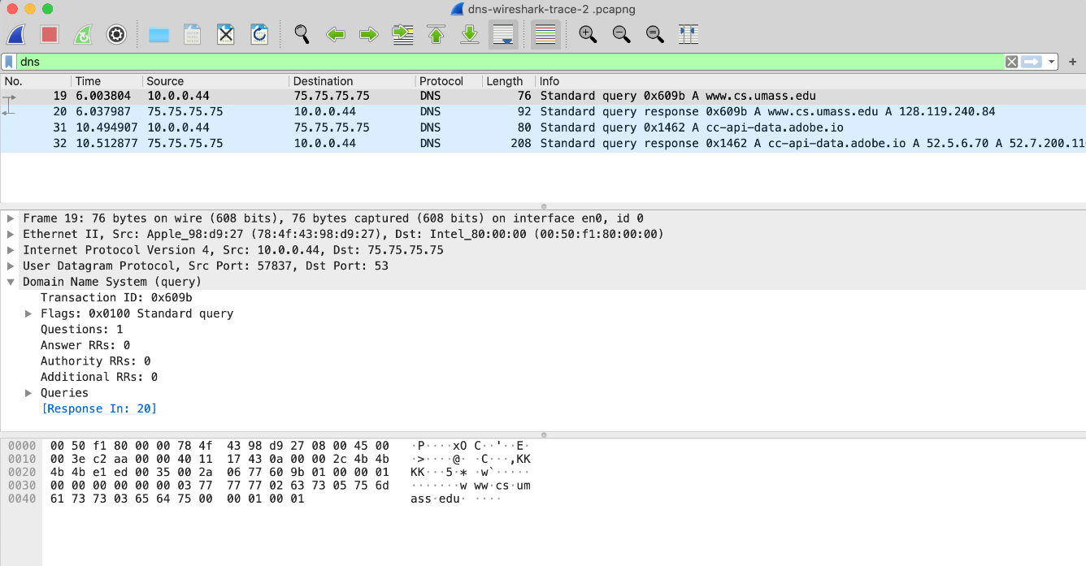

1. What is the destination port for the DNS query message? What is the source port of the DNS response message?
2. To what IP address is the DNS query message sent? Is this the IP address of your default local DNS server?
3. Examine the DNS query message. What “Type” of DNS query is it? Does the query message contain any “answers”?
4. Examine the DNS response message to the query message. How many “questions” does this DNS response message contain? How many “answers”?

Last, let’s use nslookup to issue a command that will return a type NS DNS record, Enter the following command:

nslookup –type=NS umass.edu

and then answer the following questions[5] :

1. To what IP address is the DNS query message sent? Is this the IP address of your default local DNS server?
2. Examine the DNS query message. How many questions does the query have? Does the query message contain any “answers”?
3. Examine the DNS response message (in particular the DNS response message that has type “NS”). How many answers does the response have? What information is contained in the answers? How many additional resource records are returned? What additional information is included in these additional resource records (if additional information is returned)?

TCP

Capturing a bulk TCP transfer from your computer to a remote server

Before beginning our exploration of TCP, we’ll need to use Wireshark to obtain a packet trace of the TCP transfer of a file from your computer to a remote server. You’ll do so by accessing a Web page that will allow you to enter the name of a file stored on your computer (which contains the ASCII text of *Alice in Wonderland*), and then transfer the file to a Web server using the HTTP POST method (see section 2.2.3 in the text). We’re using the POST method rather than the GET method as we’d like to transfer a large amount of data *from* your computer to another computer. Of course, we’ll be running Wireshark during this time to obtain the trace of the TCP segments sent and received from your computer.

Do the following:

* Start up your web browser. Go the <http://gaia.cs.umass.edu/wireshark-labs/alice.txt> and retrieve an ASCII copy of *Alice in Wonderland.* Store this as a .txt file somewhere on your computer.
* Next go to <http://gaia.cs.umass.edu/wireshark-labs/TCP-wireshark-file1.html>.
* You should see a screen that looks like Figure 1.

|  |
| --- |
|  |
| **Figure 1:** Page to upload the alice.txt file from your computer to gaia.cs.umass.edu |

* Use the *Browse* button in this form to the file on your computer that you just created containing *Alice in Wonderland*.Don’t press the “*Upload alice.txt file*” button yet.
* Now start up Wireshark and begin packet capture (see the earlier Wireshark labs if you need a refresher on how to do this).
* Returning to your browser, press the “*Upload alice.txt file*” button to upload the file to the gaia.cs.umass.edu server. Once the file has been uploaded, a short congratulations message will be displayed in your browser window.
* Stop Wireshark packet capture. Your Wireshark window should look similar to the window shown in Figure 2.

|  |
| --- |
|  |
| **Figure 2:** Success! You’ve uploaded a file to gaia.cs.umass.edu and have hopefully captured a Wireshark packet trace while doing so. |

If you are unable to run Wireshark on a live network connection, you can download a packet trace that was captured while following the steps above on one of the author’s computers [6]. In addition, you may well find it valuable to download this trace even if you’ve captured your own trace and use it, as well as your own trace, when you explore the questions below.

2. A first look at the captured trace

Before analyzing the behavior of the TCP connection in detail, let’s take a high-level view of the trace.

Let’s start by looking at the HTTP POST message that uploaded the alice.txt file to gaia.cs.umass.edu from your computer. Find that file in your Wireshark trace, and expand the HTTP message so we can take a look at the HTTP POST message more carefully. Your Wireshark screen should look something like Figure 3.

|  |
| --- |
|  |
| **Figure 3:** expanding the HTTP POST message that uploaded alice.txt from your computer to gaia.cs.umass.edu |

There are a few things to note here:

* The body of your application-layer HTTP POST message contains the contents of the file alice.txt, which is a large file of more than 152K bytes. OK – it’s not *that* large, but it’s going to be too large for this one HTTP POST message to be contained in just one TCP segment!
* In fact, as shown in the Wireshark window in Figure 3 we see that the HTTP POST message was spread across 106 TCP segments. This is shown where the red arrow is placed in Figure 3 [Aside: Wireshark doesn’t have a red arrow like that; we added it to the figure to be helpful ☺]. If you look even more carefully there, you can see that Wireshark is being really helpful to you as well, telling you that the first TCP segment containing the beginning of the POST message is packet #4 in the particular trace for the example in Figure 3, which is the trace *tcp-wireshark-trace1-1* noted in footnote 2. The second TCP segment containing the POST message in packet #5 in the trace, and so on.

Let’s now “get our hands dirty” by looking at some TCP segments.

* First, filter the packets displayed in the Wireshark window by entering “tcp” (lowercase, no quotes, and don’t forget to press return after entering!) into the display filter specification window towards the top of the Wireshark window. Your Wireshark display should look something like Figure 4. In Figure 4, we’ve noted the TCP segment that has its SYN bit set – this is the first TCP message in the three-way handshake that sets up the TCP connection to gaia.cs.umass.edu that will eventually carry the HTTP POST message and the alice.txt file. We’ve also noted the SYNACK segment (the second step in TCP three-way handshake), as well as the TCP segment (packet #4, as discussed above) that carries the POST message and the beginning of the alice.txt file. Of course, if you’re taking your own trace file, the packet numbers will be different, but you should see similar behavior to that shown in Figures 3 and 4.

|  |
| --- |
|  |
| **Figure 4:** TCP segments involved in sending the HTTP POST message (including the file alice.txt) to gaia.cs.umass.edu |

Answer the following questions[7], either from your own live trace, or by opening the Wireshark captured packet file *tcp-wireshark-trace1-1* in <http://gaia.cs.umass.edu/wireshark-labs/wireshark-traces-8.1.zip>

1. What is the IP address and TCP port number used by the client computer (source) that is transferring the alice.txt file to gaia.cs.umass.edu? To answer this question, it’s probably easiest to select an HTTP message and explore the details of the TCP packet used to carry this HTTP message, using the “details of the selected packet header window” (refer to Figure 2 in the “Getting Started with Wireshark” Lab if you’re uncertain about the Wireshark windows).
2. What is the IP address of gaia.cs.umass.edu? On what port number is it sending and receiving TCP segments for this connection?

**UDP**

Start capturing packets in Wireshark and then do something that will cause your host to send and receive several UDP packets. It’s also likely that just by doing nothing (except capturing packets via Wireshark) that some UDP packets sent by others will appear in your trace. In particular, the Domain Name System (DNS) protocol (see section 2.4 in the text; and the DNS Wireshark Lab) typically sends DNS query and response messages inside of UDP, so it’s likely that you’ll find some DNS messages (and therefore UDP packets) in your trace.

Specifically you can try out the nslookup command, which invokes the underlying DNS protocol, which in turn will send UDP segments from/to the host issuing the nslookup. nslookup is available in most Microsoft, Apple IOS, and Linux operating systems. To run nslookup you just type the nslookup command on the command line in a DOS window, Mac IOS terminal window, or Linux shell. Figure 1 is a screenshot of running nslookup on the Linux command line on the newworld.cs.umass.edu host located in the CS Department at the University of Massachusetts (UMass) campus, to display the IP address of www.nyu.edu.

|  |
| --- |
|  |
| **Figure 1:** the basic nslookup command |

We don’t need to go into any more details about nslookup or DNS, as we’re just interested in getting a few UDP segments into Wireshark, and we promised this lab would be short!

After starting packet capture on Wireshark, run nslookup for a hostname that you haven’t visited for a while. Then stop packet capture, set your Wireshark packet filter so that Wireshark only displays the UDP segments sent and received at your host. Pick the first UDP segment and expand the UDP fields in the details window. If you are unable to find UDP segments in your trace or are unable to run Wireshark on a live network connection, you can download a packet trace containing some UDP segments[8].

Answer the following questions[9]. If you’re doing this lab as part of class, your teacher will provide details about how to hand in assignments, whether written or in an LMS.

1. Select the first UDP segment in your trace. What is the packet number[10] of this segment in the trace file? What type of application-layer payload or protocol message is being carried in this UDP segment? Look at the details of this packet in Wireshark. How many fields there are in the UDP header? (You shouldn’t look in the textbook! Answer these questions directly from what you observe in the packet trace.) What are the names of these fields?
2. By consulting the displayed information in Wireshark’s packet content field for this packet (or by consulting the textbook), what is the length (in bytes) of each of the UDP header fields?
3. The value in the Length field is the length of what? (You can consult the text for this answer). Verify your claim with your captured UDP packet.
4. What is the maximum number of bytes that can be included in a UDP payload? (Hint: the answer to this question can be determined by your answer to 2. above)
5. What is the largest possible source port number? (Hint: see the hint in 4.)
6. What is the protocol number for UDP? Give your answer in decimal notation. To answer this question, you’ll need to look into the Protocol field of the IP datagram containing this UDP segment (see Figure 4.13 in the text, and the discussion of IP header fields).
7. Examine the pair of UDP packets in which your host sends the first UDP packet and the second UDP packet is a reply to this first UDP packet. (Hint: for a second packet to be sent in response to a first packet, the sender of the first packet should be the destination of the second packet). What is the packet number[11] of the first of these two UDP segments in the trace file? What is the value in the source port field in this UDP segment? What is the value in the destination port field in this UDP segment? What is the packet number[12] of the second of these two UDP segments in the trace file? What is the value in the source port field in this second UDP segment? What is the value in the destination port field in this second UDP segment? Describe the relationship between the port numbers in the two packets.

**IP**

Capturing packets from an execution of traceroute

In order to generate a trace of IPv4 datagrams for the first two parts of this lab, we’ll use the traceroute program to send datagrams of two different sizes to gaia.cs.umass.edu. Recall that traceroute operates by first sending one or more datagrams with the time-to-live (TTL) field in the IP header set to 1; it then sends a series of one or more datagrams towards the same destination with a TTL value of 2; it then sends a series of datagrams towards the same destination with a TTL value of 3; and so on. Recall that a router must decrement the TTL in each received datagram by 1 (actually, RFC 791 says that the router must decrement the TTL by *at least* one). If the TTL reaches 0, the router returns an ICMP message (type 11 – TTL-exceeded) to the sending host. As a result of this behavior, a datagram with a TTL of 1 (sent by the host executing traceroute) will cause the router one hop away from the sender to send an ICMP TTL-exceeded message back to the sender; the datagram sent with a TTL of 2 will cause the router two hops away to send an ICMP message back to the sender; the datagram sent with a TTL of 3 will cause the router three hops away to send an ICMP message back to the sender; and so on. In this manner, the host executing traceroute can learn the IP addresses of the routers between itself and the destination by looking at the source IP addresses in the datagrams containing the ICMP TTL-exceeded messages.

Let’s run traceroute and have it send datagrams of two different sizes. The larger of the two datagram lengths will require traceroute messages to be fragmented across multiple IPv4 datagrams.

* **Linux/MacOS.** With the Linux/MacOS traceroute command, the size of the UDP datagram sent towards the final destination can be explicitly set by indicating the number of bytes in the datagram; this value is entered in the traceroute command line immediately after the name or address of the destination. For example, to send traceroute datagrams of 2000 bytes towards gaia.cs.umass.edu, the command would be:

%traceroute gaia.cs.umass.edu 2000

* **Windows.** The tracert program provided with Windows does not allow one to change the size of the ICMP message sent by tracert. So it won’t be possible to use a Windows machine to generate ICMP messages that are large enough to force IP fragmentation. However, you can use tracert to generate small, fixed length packets to perform Part 1 of this lab. At the DOS command prompt enter:

>tracert gaia.cs.umass.edu

If you want to do the second part of this lab, you can download a packet trace file that was captured on one of the author’s computers[13].

Do the following:

* Start up Wireshark and begin packet capture. *(Capture->Start* or click on the blue shark fin button in the top left of the Wireshark window).
* Enter two traceroute commands, using gaia.cs.umass.edu as the destination, the first with a length of 56 bytes. Once that command has finished executing, enter a second traceroute command for the same destination, but with a length of 3000 bytes.
* Stop Wireshark tracing.

If you’re unable to run Wireshark on a live network connection, you can use the packet trace file, *ip-wireshark-trace1-1.pcapng*, referenced in footnote 2. You may well find it valuable to download this trace even if you’ve captured your own trace and use it, as well as your own trace, as you explore the questions below.

Part 1: Basic IPv4

In your trace, you should be able to see the series of UDP segments (in the case of MacOS/Linux) or ICMP Echo Request messages (Windows) sent by traceroute on your computer, and the ICMP TTL-exceeded messages returned to your computer by the intermediate routers. In the questions below, we’ll assume you’re using a MacOS/Linux computer; the corresponding questions for the case of a Windows machine should be clear. Your screen should look similar to the screenshot in Figure 2, where we have used the display filter “udp||icmp” (see the light-green-filled display-filter field in Figure 2) so that only UDP and/or ICMP protocol packets are displayed.

|  |
| --- |
|  |
| **Figure 2:** Wireshark screenshot, showing UDP and ICMP packets in the tracefile *ip-wireshark-trace1-1.pcapng* |

Answer the following questions[14]. If you’re doing this lab as part of class, your teacher will provide details about how to hand in assignments, whether written or in an LMS.

1. Select the first UDP segment sent by your computer via the traceroute command to gaia.cs.umass.edu. (Hint: this is 44th packet in the trace file in the *ip-wireshark-trace1-1.pcapng* file in footnote 2). Expand the Internet Protocol part of the packet in the packet details window. What is the IP address of your computer?
2. What is the value in the time-to-live (TTL) field in this IPv4 datagram’s header?
3. What is the value in the upper layer protocol field in this IPv4 datagram’s header? [Note: the answers for Linux/MacOS differ from Windows here].
4. How many bytes are in the IP header?
5. How many bytes are in the payload of the IP datagram? Explain how you determined the number of payload bytes.
6. Has this IP datagram been fragmented? Explain how you determined whether or not the datagram has been fragmented.

Next, let’s look at the *sequence* of UDP segments being sent from your computer via traceroute, destined to 128.119.245.12. The display filter that you can enter to do this is “ip.src==192.168.86.61 and ip.dst==128.119.245.12 and udp and !icmp”. This will allow you to easily move sequentially through just the datagrams containing just these segments. Your screen should look similar to Figure 3.

|  |
| --- |
|  |
| Figure 3: Wireshark screen shot, showing up segments in the tracefile *ip-wireshark-trace1-1.pcapng* using the display filterip.src==192.168.86.61 and ip.dst==128.119.245.12 and udp and !icmp |

1. Which fields in the IP datagram *always* change from one datagram to the next within this series of UDP segments sent by your computer destined to 128.119.245.12, via traceroute? Why?
2. Which fields in this sequence of IP datagrams (containing UDP segments) ﻿﻿﻿﻿﻿﻿﻿﻿﻿﻿﻿stay constant? Why?
3. Describe the pattern you see in the values in the Identification field of the IP datagrams being sent by your computer.

Now let’s take a look at the ICMP packets being returned to your computer by the intervening routers where the TTL value was decremented to zero (and hence caused the ICMP error message to be returned to your computer). The display filter that you can use to show just these packets is “ip.dst==192.168.86.61 and icmp”.

1. What is the upper layer protocol specified in the IP datagrams returned from the routers? [Note: the answers for Linux/MacOS differ from Windows here].
2. Are the values in the Identification fields (across the sequence of all of ICMP packets from all of the routers) similar in behavior to your answer to question 9 above?
3. Are the values of the TTL fields similar, across all of ICMP packets from all of the routers?

Part 2: Fragmentation

In this section, we’ll look at a large (3000-byte) UDP segment sent by the traceroute program that is fragmented into multiple IP datagrams. We recommend that you first consult the material on IP fragmentation from the 7th edition of our textbook (and earlier) at <http://gaia.cs.umass.edu/kurose_ross/Kurose_Ross_7th_edition_section_4.3.2.pdf>

Sort the packet listing from Part 1, with any display filters cleared, according to time, by clicking on the *Time* column.

1. Find the first IP datagram containing the first part of the segment sent to 128.119.245.12 sent by your computer via the traceroute command to gaia.cs.umass.edu, *after* you specified that the traceroute packet length should be 3000. (Hint: This is packet 179 in the *ip-wireshark-trace1-1.pcapng* trace file in footnote 2. Packets 179, 180, and 181 are three IP datagrams created by fragmenting the first single 3000-byte UDP segment sent to 128.119.145.12). Has that segment been fragmented across more than one IP datagram? (Hint: the answer is yes[15]!)
2. What information in the IP header indicates that this datagram been fragmented?
3. What information in the IP header for this packet indicates whether this is the first fragment versus a latter fragment?
4. How many bytes are there in is this IP datagram (header plus payload)?
5. Now inspect the datagram containing the second fragment of the fragmented UDP segment. What information in the IP header indicates that this is *not* the first datagram fragment?
6. What fields change in the IP header between the first and second fragment?
7. Now find the IP datagram containing the third fragment of the original UDP segment. What information in the IP header indicates that this is the last fragment of that segment?

Part 3: IPv6

In this final section we’ll take a quick look at the IPv6 datagram using Wireshark. You’ll probably want to review section 4.3.4 in the text. Because the Internet is still primarily at IPv4 network (see section 4.3.4), and your own computer or your ISP may not be configured for IPv6, let’s look at a trace of already captured packets that contain some IPv6 packets. To generate this trace, our web browser opened the youtube.com homepage. Youtube (and Google) provide fairly widespread support for IPv6.

Open the file *ip-wireshark-trace2-1.pcapng* in the .zip file of traces given in footnote 2. Your Wireshark display should look similar to Figure 4.

|  |
| --- |
|  |
| Figure 4: Wireshark screenshot, showing the first set of captured packets in *ip-wireshark-trace2-1.pcapng*. If you look at the Source column, you’ll see some IPv6 addresses! |

Let’s start by taking a closer look at the 20th packet in this trace, sent at *t=*3.814489. This is a DNS request (contained in an IPv6 datagram) to an IPv6 DNS server for the IPv6 address of youtube.com. The DNS AAAA request type is used to resolve names to IPv6 IP addresses.

Answer the following questions:

1. What is the IPv6 address of the computer making the DNS AAAA request? This is the source address of the 20th packet in the trace. Give the IPv6 source address for this datagram in the exact same form as displayed in the Wireshark window[16].
2. What is the IPv6 destination address for this datagram? Give this IPv6 address in the exact same form as displayed in the Wireshark window.
3. What is the value of the flow label for this datagram?
4. How much payload data is carried in this datagram?
5. What is the upper layer protocol to which this datagram’s payload will be delivered at the destination?

Lastly, find the IPv6 DNS response to the IPv6 DNS AAAA request made in the 20th packet in this trace. This DNS response contains IPv6 addresses for youtube.com.

1. How many IPv6 addresses are returned in the response to this AAAA request?
2. What is the first of the IPv6 addresses returned by the DNS for youtube.com (in the *ip-wireshark-trace2-1.pcapng* trace file, this is also the address that is numerically the smallest)? Give this IPv6 address in the exact same shorthand form as displayed in the Wireshark window.

**ICMP**

. ICMP and Ping

Let’s begin our ICMP adventure by capturing the packets generated by the Ping program. You may recall that the Ping program is simple tool that allows anyone (for example, a network administrator) to verify if a host is live or not. The Ping program in the source host sends a packet to the target IP address; if the target is live, the Ping program in the target host responds by sending a packet back to the source host. As you might have guessed (given that this lab is about ICMP), both of these Ping packets are ICMP packets.

Do the following[17]:

* Let’s begin this adventure by opening the Windows Command Prompt application (which can be found in your Accessories folder).
* Start up the Wireshark packet sniffer, and begin Wireshark packet capture.
* The *ping* command is in c:\windows\system32, so type either “*ping –n 10 hostname*” or “*c:\windows\system32\ping –n 10 hostname*” in the MS-DOS command line (without quotation marks), where hostname is a host on another continent. If you’re outside of Asia, you may want to enter www.ust.hk for the Web server at Hong Kong University of Science and Technology. The argument *“-n 10*” indicates that 10 ping messages should be sent. Then run the Ping program by typing return.
* When the Ping program terminates, stop the packet capture in Wireshark.

At the end of the experiment, your Command Prompt Window should look something like Figure 1. In this example, the source ping program is in Massachusetts and the destination Ping program is in Hong Kong. From this window we see that the source ping program sent 10 query packets and received 10 responses. Note also that for each response, the source calculates the round-trip time (RTT), which for the 10 packets is on average 375 msec.

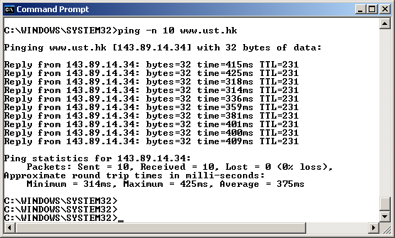

**Figure 1** Command Prompt window after entering Ping command.

Figure 2 provides a screenshot of the Wireshark output, after “icmp” has been entered into the filter display window. Note that the packet listing shows 20 packets: the 10 Ping queries sent by the source and the 10 Ping responses received by the source. Also note that the source’s IP address is a private address (behind a NAT) of the form 192.168/12; the destination’s IP address is that of the Web server at HKUST. Now let’s zoom in on the first packet (sent by the client); in the figure below, the packet contents area provides information about this packet. We see that the IP datagram within this packet has protocol number 01, which is the protocol number for ICMP. This means that the payload of the IP datagram is an ICMP packet.

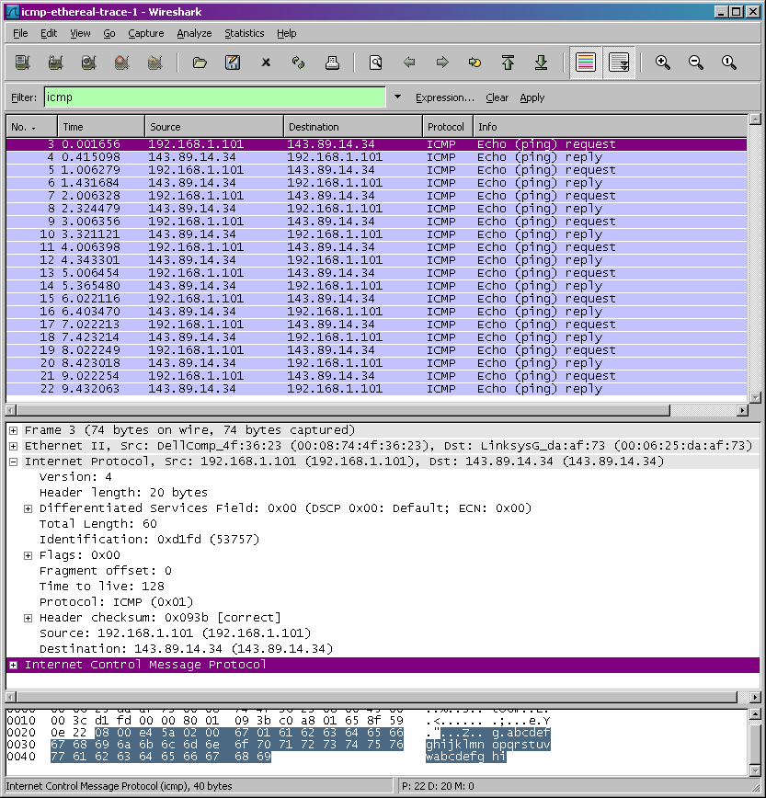

**Figure 2** Wireshark output for Ping program with Internet Protocol expanded.

Figure 3 focuses on the same ICMP but has expanded the ICMP protocol information in the packet contents window. Observe that this ICMP packet is of Type 8 and Code 0 - a so-called ICMP “echo request” packet. (See Figure 5.19 of text.) Also note that this ICMP packet contains a checksum, an identifier, and a sequence number.

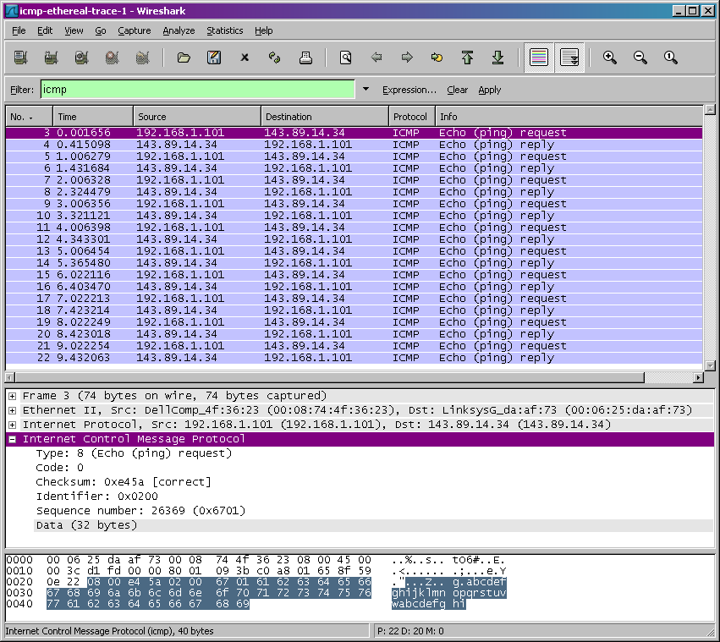

**Figure 3** Wireshark capture of ping packet with ICMP packet expanded.

ARP

Let’s begin by capturing a set of Ethernet frames to study. To do this, of course, you’ll need access to a wired Ethernet connection for your PC or Mac – not necessarily a common scenario these days, given the popularity of wireless WiFi and cellular access. If you’re unable to run Wireshark on a live Ethernet connection, you can download a packet trace that was captured while following the steps below on one of the author’s computers[18]. In addition, you may well find it valuable to download this trace even if you’ve captured your own trace and use it, as well as your own trace, when you explore the questions below.

Do the following:

* First, make sure your browser’s cache of previously downloaded documents is empty.
* Start up Wireshark and enter the following URL into your browser: <http://gaia.cs.umass.edu/wireshark-labs/HTTP-wireshark-file3.html>. Your browser should display the rather lengthy US Bill of Rights.
* Stop Wireshark packet capture.

First, find the packet number (the leftmost column in the upper Wireshark window) of the HTTP GET message that was sent from your computer to gaia.cs.umass.edu, as well as the beginning of the HTTP response message sent to your computer by gaia.cs.umass.edu. You should see a screen that looks something like this (where packet 126 in the screen shot below contains the HTTP GET message)

|  |
| --- |
|  |
| **Figure 1:** Wireshark display showing HTTP GET message for http://gaia.cs.umass.edu/wireshark-labs/HTTP-wireshark-file3.html |

Since this lab is about Ethernet and ARP, we’re not interested in high-level protocols like IP, TCP or HTTP. We’re interested in Ethernet frames and ARP messages!

Let’s start by looking at the Ethernet frame containing the HTTP GET message. (Recall that the HTTP GET message is carried inside of a TCP segment, which is carried inside of an IP datagram, which is carried inside of an Ethernet frame; reread section 1.5.2 in the text if you find this notion of encapsulation a bit confusing). Expand the Ethernet II information in the packet details window. Note that the contents of the Ethernet frame (header as well as payload) are displayed in the packet contents window. Your display should look similar to that shown in Figure 2.

|  |
| --- |
|  |
| **Figure 2:** Wireshark display showing details of the Ethernet frame containing the HTTP GET request. |

In answering the questions below[19], you can use either your own live trace, or use the Wireshark captured packet file *Ethernet-wireshark-trace1* in <http://gaia.cs.umass.edu/wireshark-labs/wireshark-traces-8.1.zip>

* What is the 48-bit Ethernet address of your computer?
* What is the 48-bit destination address in the Ethernet frame? Is this the Ethernet address of gaia.cs.umass.edu? (Hint: the answer is *no*). What device has this as its Ethernet address? [Note: this is an important question, and one that students sometimes get wrong. Re-read pages 483-484 in the text and make sure you understand the answer here.]
* What is the hexadecimal value for the two-byte Frame type field in the Ethernet frame carrying the HTTP GET request?  What upper layer protocol does this correspond to?
* How many bytes from the very start of the Ethernet frame does the ASCII “G” in “GET” appear in the Ethernet frame? Do not count any preamble bits in your count, i.e., assume that the Ethernet frame begins with the Ethernet frame's destination address.

Next, answer the following questions, based on the contents of the Ethernet frame containing the first byte of the HTTP response message.

* What is the value of the Ethernet source address? Is this the address of your computer, or of gaia.cs.umass.edu (Hint: the answer is *no*). What device has this as its Ethernet address?
* What is the destination address in the Ethernet frame? Is this the Ethernet address of your computer?
* Give the hexadecimal value for the two-byte Frame type field. What upper layer protocol does this correspond to?
* How many bytes from the very start of the Ethernet frame does the ASCII “O” in “OK” (i.e., the HTTP response code) appear in the Ethernet frame? Do not count any preamble bits in your count, i.e., assume that the Ethernet frame begins with the Ethernet frame's destination address.
* How many Ethernet frames (each containing an IP datagram, each containing a TCP segment) carry data that is part of the complete HTTP “OK 200 ...” reply message?

**2. The Address Resolution Protocol**

In this section, we’ll observe the ARP protocol in action. We strongly recommend that you re-read section 6.4.1 in the text before proceeding.

**ARP Caching**

Recall that the ARP protocol typically maintains a cache of IP-to-Ethernet address translation pairs on your computer. The *arp* command (in both DOS, MacOS and Linux) is used to view and manipulate the contents of this cache. Since the *arp* command and the ARP protocol have the same name, it’s understandably easy to confuse them. But keep in mind that they are different - the *arp* command is used to view and manipulate the ARP cache contents, while the ARP protocol defines the format and meaning of the messages sent and received, and defines the actions taken on ARP message transmission and receipt.

Let’s take a look at the contents of the ARP cache on your computer. In DOS, MacOS, and Linux, the “arp -a” command will display the contents of the ARP cache on your computer. So at a command line, type “arp -a”. The results of entering this command on one of the authors’ computers is shown in Figure 3.

|  |
| --- |
|  |
| Figure 3: Executing the “arp -a” command from one of the authors’ computers |

* How many entries are stored in your ARP cache?
* What is contained in each displayed entry of the ARP cache?

In order to observe your computer sending and receiving ARP messages, we’ll need to clear the ARP cache, since otherwise your computer is likely to find a needed IP-Ethernet address translation pair in its cache and consequently not need to send out an ARP message. The “*arp –d -a*” command will clear your ARP cache using the command line. In order to run this command on a Mac or Linux machine you’ll need root privileges or use *sudo*. If you don’t have root privileges and can’t run Wireshark on a Windows machine, you can skip the trace collection part of this lab and use the trace file *ethernet-wireshark-trace1* discussed earlier.

**Observing ARP in action**

Do the following[20]:

* Clear your ARP cache, as described above and make sure your browser’s cache is cleared of previously downloaded documents.
* Start up the Wireshark packet sniffer.
* Enter the following URL into your browser:  
  http://gaia.cs.umass.edu/wireshark-labs/HTTP-wireshark-lab-file3.html  
  Your browser should again display the rather lengthy US Bill of Rights.
* Stop Wireshark packet capture.

Again, we’re not interested in IP or higher-layer protocols, so let’s just look at ARPpackets. Your display should look similar to that shown in Figure 3 (note we have entered “arp” into the display filter window at the top of the Wireshark screen).

|  |
| --- |
|  |
| Figure 3: An ARP query being broadcast from the computer of one of the authors’ |

Let’s start by looking at the Ethernet frames containing ARP messages. Answer the following questions:

* What is the hexadecimal value of the source address in the Ethernet frame containing the ARP request message sent out by your computer?
* What is the hexadecimal value of the destination addresses in the Ethernet frame containing the ARP request message sent out by your computer? And what device(if any) corresponds to that address (e.g,, client, server, router, switch or otherwise...)?
* What is the hexadecimal value for the two-byte Ethernet Frame *type* field. What upper layer protocol does this correspond to?

Now let’s dig even a bit deeper into the ARP messages themselves. To answer this question, you will need to dig into ARP. The original RFC (<https://datatracker.ietf.org/doc/html/rfc826>) that defines ARP is a little hard to read. The Wikipedia entry for ARP is pretty good: <https://en.wikipedia.org/wiki/Address_Resolution_Protocol>

Answer the following question about the ARP request message sent by your computer.

* How many bytes from the very beginning of the Ethernet frame does the ARP *opcode* field begin?
* What is the value of the *opcode* field within the ARP request message sent by your computer?
* Does the ARP request message contain the IP address of the sender? If the answer is yes, what is that value?
* What is the IP address of the device whose corresponding Ethernet address is being requested in the ARP request message sent by your computer?

Now find the ARP reply message that was sent in response to the ARP request from your computer.

* What is the value of the *opcode* field within the ARP reply message received by your computer?
* *Finally (!),* let’s look at the **answer** to the ARP request message! What is the Ethernet address corresponding to the IP address that was specified in the ARP request message sent by your computer (see question 18)?

We’ve looked the ARP request message sent by your computer running Wireshark, and the ARP reply sent in reply. But there are other devices in this network that are also sending ARP requests that you can find in the trace.

* We’ve looked the ARP request message sent by your computer running Wireshark, and the ARP reply message sent in response.  But there are other devices in this network that are also sending ARP request messages that you can find in the trace. Why are there no ARP replies in your trace that are sent in response to these other ARP request messages?

**DHCP**

1. In a terminal window/shell, enter the following commands:

       sudo ip addr flush en0

   sudo dhclient -r

where en0 (in this example) is the interface on which you want to capture packets using Wireshark. You can easily find the list of interface names in Wireshark by choosing Capture -> Options.  This command will remove the existing IP address of the interface, and release any existing DHCP address leases.

1. Start up Wireshark, capturing packets in the interface you de-configured in Step 1.
2. In the terminal window/shell, enter the following command:

sudo dhclient en0

where, as with above, en0 is the interface on which you are currently capturing packets. This will cause the DHCP protocol to request and receive an IP address and other information from the DHCP server.

1. After waiting for a few seconds, stop Wireshark capture.

On a PC:

1. In a command-line window enter the following command:

> ipconfig /release

This command will cause your PC to give up its IP address.

1. Start up Wireshark.
2. In the command-line window enter the following command:

> ipconfig /renew

This will cause the DHCP protocol to request and receive an IP address and other information from a DHCP server.

1. After waiting for a few seconds, stop Wireshark capture.

After stopping Wireshark capture in step 4, you should take a peek in your Wireshark window to make sure you’ve actually captured the packets that we’re looking for. If you enter “dhcp” into the display filter field (as shown in the light green field in the top left of Figure 1), your screen (on a Mac) should look similar to Figure 1.

|  |
| --- |
|  |
| **Figure 1:** Wireshark display, showing the capture of DHCP Discover, Offer, Request and ACK messages |

If you’re unable to run Wireshark on a live network connection, are unable to capture all four DHCP messages, or are assigned to do so by your instructor, you can use the Wireshark trace file, *dhcp-wireshark-trace1-1.pcapng[21]* that we’ve gathered following the steps above on one of the author’s computers. You may well find it valuable to download this trace even if you’ve captured your own trace and use it, as well as your own trace, as you explore the questions below.

DHCP Questions

Answer the following questions[22]. If you’re doing this lab as part of class, your teacher will provide details about how to hand in assignments, whether written or in an LMS.

Let’s start by looking at the DHCP Discover message. Locate the IP datagram containing the first Discover message in your trace.

1. Is this DHCP Discover message sent out using UDP or TCP as the underlying transport protocol?
2. What is the source IP address used in the IP datagram containing the Discover message? Is there anything special about this address? Explain.
3. What is the destination IP address used in the datagram containing the Discover message. Is there anything special about this address? Explain.
4. What is the value in the transaction ID field of this DHCP Discover message?
5. Now inspect the options field in the DHCP Discover message. What are five pieces of information (beyond an IP address) that the client is suggesting or requesting to receive from the DHCP server as part of this DHCP transaction?

Now let’s look at the DHCP Offer message. Locate the IP datagram containing the DHCP Offer message in your trace that was sent by a DHCP server in the response to the DHCP Discover message that you studied in questions 1-5 above.

1. How do you know that this Offer message is being sent in response to the DHCP Discover message you studied in questions 1-5 above?
2. What is the *source* IP address used in the IP datagram containing the Offer message? Is there anything special about this address? Explain.
3. What is the *destination* IP address used in the datagram containing the Offer message? Is there anything special about this address? Explain. [Hint: Look at your trace carefully. The answer to this question may differ from what you see in Figure 4.24 in the textbook. If you really want to dig into this, consult the [DHCP RFC](https://www.ietf.org/rfc/rfc2131.txt), page 24.﻿﻿﻿﻿﻿﻿﻿﻿﻿﻿﻿﻿﻿﻿﻿﻿﻿﻿﻿﻿]
4. Now inspect the options field in the DHCP Offer message. What are five pieces of information that the DHCP server is providing to the DHCP client in the DHCP Offer message?

It would appear that once the DHCP Offer message is received, that the client may have all of the information it needs to proceed. However, the client may have received OFFERs from multiple DHCP servers and so a second phase is needed, with two more mandatory messages – the client-to-server DHCP Request message, and the server-to-client DHCP ACK message is needed. But at least the client knows there is at least one DHCP server out there! Let’s take a look at the DHCP Request message, remembering that although we’ve already seen a Discover message in our trace, that is not always the case when a DHCP request message is sent.

Locate the IP datagram containing the first DHCP Request message in your trace, and answer the following questions.

1. What is the UDP source port number in the IP datagram containing the first DHCP Request message in your trace? What is the UDP destination port number being used?
2. What is the source IP address in the IP datagram containing this Request message? Is there anything special about this address? Explain.
3. What is the destination IP address used in the datagram containing this Request message. Is there anything special about this address? Explain.
4. What is the value in the transaction ID field of this DHCP Request message? Does it match the transaction IDs of the earlier Discover and Offer messages?
5. Now inspect the options field in the DHCP Discover message and take a close look at the “Parameter Request List”. The [DHCP RFC](https://www.ietf.org/rfc/rfc2131.txt) notes that

“The client can inform the server which configuration parameters the client is interested in by including the 'parameter request list' option. The data portion of this option explicitly lists the options requested by tag number.”

What differences do you see between the entries in the ‘parameter request list’ option in this Request message and the same list option in the earlier Discover message?

Locate the IP datagram containing the first DHCP ACK message in your trace, and answer the following questions.

1. What is the source IP address in the IP datagram containing this ACK message? Is there anything special about this address? Explain.
2. What is the destination IP address used in the datagram containing this ACK message. Is there anything special about this address? Explain.
3. What is the name of the field in the DHCP ACK message (as indicated in the Wireshark window) that contains the assigned client IP address?
4. For how long a time (the so-called “lease time”) has the DHPC server assigned this IP address to the client?
5. What is the IP address (returned by the DHCP server to the DHCP client in this DHCP ACK message) of the first-hop router on the default path from the client to the rest of the Internet?

Reference:

<https://gaia.cs.umass.edu/kurose_ross/wireshark.php>

1. If you’re not sure how to find the IP address of your computer, you can search the Web for articles for your operating system. Windows 10 info is [here](https://support.microsoft.com/en-us/windows/find-your-ip-address-f21a9bbc-c582-55cd-35e0-73431160a1b9); Mac info is [here](https://www.hellotech.com/guide/for/how-to-find-ip-address-on-mac); Linux info is [here](https://www.linuxtrainingacademy.com/determine-public-ip-address-command-line-curl/)

  
2. You can download the zip file <http://gaia.cs.umass.edu/wireshark-labs/wireshark-traces-8.1.zip> and extract the trace file dns-wireshark-trace1-1. These trace files can be used to answer these Wireshark lab questions without actually capturing packets on your own. Each trace was made using Wireshark running on one of the author’s computers, while performing the steps indicated in the Wireshark lab. Once you’ve downloaded a trace file, you can load it into Wireshark and view the trace using the *File* pull down menu, choosing *Open*, and then selecting the trace file name.
3. Remember that this “packet number” is assigned by Wireshark for listing purposes only; it is NOT a packet number contained in any real packet header.
4. If you are unable to run Wireshark and capture a trace file, or are using an LMS, use the trace file dns-wireshark-trace-2 in the zip file of traces in the footnote above to answer questions 12-16 below.
5. If you are unable to run Wireshark and capture a trace file, or are using an LMS, use the trace file *dns-wireshark-trace-3* in the zip file of traces in the footnote above to answer questions 17-19 below.
6. You can download the zip file <http://gaia.cs.umass.edu/wireshark-labs/wireshark-traces-8.1.zip> and extract the trace file *tcp-wireshark-trace1-1*. This trace file can be used to answer this Wireshark lab without actually capturing packets on your own. This trace was made using Wireshark running on one of the author’s computers, while performing the steps indicated in this Wireshark lab. Once you’ve downloaded a trace file, you can load it into Wireshark and view the trace using the *File* pull down menu, choosing *Open*, and then selecting the trace file name.
7. For the author’s class, when answering the following questions with hand-in assignments, students sometimes need to print out specific packets (see the introductory Wireshark lab for an explanation of how to do this) and indicate where in the packet they’ve found the information that answers a question. They do this by marking paper copies with a pen or annotating electronic copies with text in a colored font. There are also learning management system (LMS) modules for teachers that allow students to answer these questions online and have answers auto-graded for these Wireshark labs at <http://gaia.cs.umass.edu/kurose_ross/lms.htm>
8. You can download the zip file <http://gaia.cs.umass.edu/wireshark-labs/wireshark-traces-8.1.zip> and extract the trace file dns-wireshark-trace1-1. This trace file can be used to answer this Wireshark lab without actually capturing packets on your own. This trace was made using Wireshark running on one of the author’s computers, while performing the steps indicated in this Wireshark lab. Once you’ve downloaded a trace file, you can load it into Wireshark and view the trace using the *File* pull down menu, choosing *Open*, and then selecting the trace file name.
9. For the author’s class, when answering the following questions with hand-in assignments, students sometimes need to print out specific packets (see the introductory Wireshark lab for an explanation of how to do this) and indicate where in the packet they’ve found the information that answers a question. They do this by marking paper copies with a pen or annotating electronic copies with text in a colored font. There are also learning management system (LMS) modules for teachers that allow students to answer these questions online and have answers auto-graded for these Wireshark labs at <http://gaia.cs.umass.edu/kurose_ross/lms.htm>
10. Remember that this “packet number” is assigned by Wireshark for listing purposes only; it is NOT a packet number contained in any real packet header.
11. Remember that this “packet number” is assigned by Wireshark for listing purposes only; it is NOT a packet number contained in any real packet header.
12. Remember that this “packet number” is assigned by Wireshark for listing purposes only; it is NOT a packet number contained in any real packet header.
13. You can download the zip file <http://gaia.cs.umass.edu/wireshark-labs/wireshark-traces-8.1.zip> and extract the trace file *ip-wireshark-trace1-1.pcapng*. This trace file can be used to answer these Wireshark lab questions without actually capturing packets on your own. The trace was made using Wireshark running on one of the author’s computers, while performing the steps in this Wireshark lab. Once you’ve downloaded a trace file, you can load it into Wireshark and view the trace using the *File* pull down menu, choosing *Open*, and then selecting the trace file name.
14. For the author’s class, when answering the following questions with hand-in assignments, students sometimes need to print out specific packets (see the introductory Wireshark lab for an explanation of how to do this) and indicate where in the packet they’ve found the information that answers a question. They do this by marking paper copies with a pen or annotating electronic copies with text in a colored font. There are also learning management system (LMS) modules for teachers that allow students to answer these questions online and have answers auto-graded for these Wireshark labs at <http://gaia.cs.umass.edu/kurose_ross/lms.htm>
15. Note: if you find your packet has not been fragmented, you should download the zip file in footnote 2 and extract the trace file *ip-wireshark-trace1-1.pcapng* . If your computer has an Ethernet or WiFi interface, a packet size of 3000 *should* cause fragmentation.
16. Recall that an IPv6 address is shown as 8 sets of 4 hexadecimal digits, with each set separated by colons, and with leading zeros omitted. If an IPv6 address has two colons in a row (‘::’), this is shorthand meaning that all of the intervening bytes between the two colons are zero. Thus, for example, fe80::1085:6434:583:e79 is shorthand for fe80:0000:0000:0000:1085:6434:0583:0e79. Make sure you understand this example.
17. If you are unable to run Wireshark live on a computer, you can download the zip file [http://gaia.cs.umass.edu/wireshark-labs/wireshark-traces.zip](http://gaia.cs.umass.edu/ethereal-labs/ethereal-traces.zip) and extract the file *ICMP-ethereal-trace-1*. The traces in this zip file were collected by Wireshark running on one of the author’s computers, while performing the steps indicated in the Wireshark lab. Once you have downloaded the trace, you can load it into Wireshark and view the trace using the *File* pull down menu, choosing *Open*, and then selecting the *ICMP-ethereal-trace-1* trace file. You can then use this trace file to answer the questions below.
18. You can download the zip file <http://gaia.cs.umass.edu/wireshark-labs/wireshark-traces-8.1.zip> and extract the trace file *ethernet-wireshark-trace1*. This trace file can be used to answer this Wireshark lab without actually capturing packets on your own. This trace was made using Wireshark running on one of the author’s computers, while performing the steps indicated in this Wireshark lab. Once you’ve downloaded a trace file, you can load it into Wireshark and view the trace using the *File* pull down menu, choosing *Open*, and then selecting the trace file name.
19. For the author’s class, when answering the following questions with hand-in assignments, students sometimes need to print out specific packets (see the introductory Wireshark lab for an explanation of how to do this) and indicate where in the packet they’ve found the information that answers a question. They do this by marking paper copies with a pen or annotating electronic copies with text in a colored font. There are also learning management system (LMS) modules for teachers that allow students to answer these questions online and have answers auto-graded for these Wireshark labs at <http://gaia.cs.umass.edu/kurose_ross/lms.htm>
20. The *ethernet-wireshark-trace-1* trace file in <http://gaia.cs.umass.edu/wireshark-labs/wireshark-traces-8.1.zip> and was created using the steps below (in particular after the ARP cache had been flushed).
21. You can download the zip file <http://gaia.cs.umass.edu/wireshark-labs/wireshark-traces-8.1.zip> and extract the trace file *dhcp-wireshark-trace1-1.pcapng.* These trace files can be used to answer these Wireshark lab questions without actually capturing packets on your own. Each trace was made using Wireshark running on one of the author’s computers, while performing the steps indicated in the Wireshark lab. Once you’ve downloaded a trace file, you can load it into Wireshark and view the trace using the *File* pull down menu, choosing *Open*, and then selecting the trace file name.
22. For the author’s class, when answering the following questions with hand-in assignments, students sometimes need to print out specific packets (see the introductory Wireshark lab for an explanation of how to do this) and indicate where in the packet they’ve found the information that answers a question. They do this by marking paper copies with a pen or annotating electronic copies with text in a colored font. There are also learning management system (LMS) modules for teachers that allow students to answer these questions online and have answers auto-graded for these Wireshark labs at <http://gaia.cs.umass.edu/kurose_ross/lms.htm>